 | Board Meeting: |  | 26 March 2020
 | Subject: |  | Bed capacity planning and interim performance monitoring
 | Recommendation: |  | Board members are asked to:  Discuss and Note x  Discuss and Approve  Note for Information only

1 Background
The Golden Jubilee National Hospital will be used as part of the national plan in the following ways:
- NHS GJ will be sustained as a primarily NON COVID-19 site for as long as possible to enable it to support NHS Scotland

- NHS GJ has indicated to Scottish Government via its mobilisation plan that it will provide the following life essential services on a National and Regional basis as follows:
- Urgent and Emergency Cardiac and Thoracic Surgery for all Regions in Scotland
- Heart attack centre for West of Scotland Region - Optimal Reperfusion Service (ORS) and NSTEMI Service
- Urgent Upper GI and Colorectal Cancer Surgical Service for West of Scotland Region
- Osteosarcoma Surgery for West of Scotland Region
- Continue to provide Urgent Orthopaedic Surgery (dislocations, infected arthroplasty revisions etc.) – for West of Scotland and offer support to all regions as required
- Other key services where there is an urgent requirement for surgical services
All NHS GJ staff will remain at GJNH site and work flexibly to support the delivery of the above services. Some additional and specialist staffing support will require to be transferred from Territorial Boards to augment existing knowledge and skills where this is mutually agreed.

2 Proposals
Release of Significant Bed Capacity in NHS Scotland
This plan will release significant bed capacity within other parts of NHS Scotland, through the period of crisis – to enable other NHS Boards to focus on scaling up to provide care for those patients requiring care for COVID-19.
The current state of bed allocation within GJ (as at 24th March) was as follows:
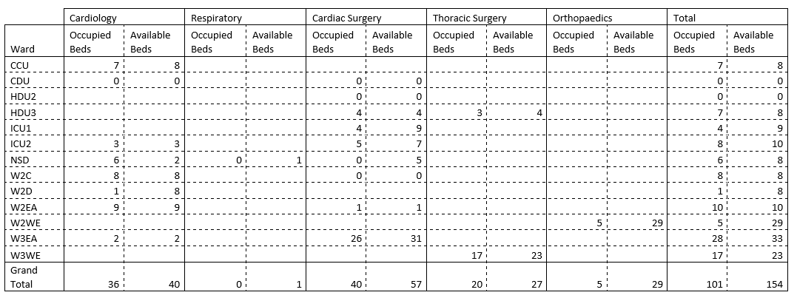

This represents the position following the cessation of elective activity and the initiation of admitting NSTEMI patients from across the West of Scotland, who are no longer being repatriated to their host Board, but discharged home from NHS GJ. These patients are being admitted to Ward 2E (formerly an Orthopaedic ward).

Subject to Estates work, infrastructure moves and equipment deployment, Level 4 East and West will be made available for ward beds in addition to the area formerly used as the Surgical Day Unit. The timeline for Level 4 ward bed availability is as follows:
- 11 patient rooms in L4 West will be available for use by end of day Friday 27th March
- A further 13 patient rooms in L4 West will be available by 3rd April
- The ability to bring on-stream the additional 35 rooms on Level 4 is dependent on a range of issues, such as contractor availability, estates work to be carried out, relocation of current users, and availability of supplies.
This is a priority for the Infrastructure Accommodation Group who are working hard to enable clinical use as soon as possible.
The chart overleaf demonstrates the potential future state bed capacity (by specialty and location) with these changes implemented:
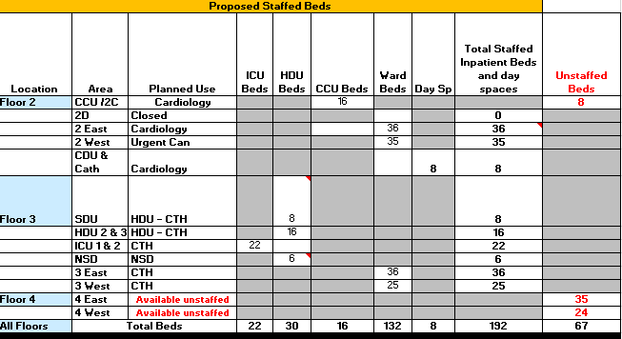

The associated nursing workforce planning process and accelerated training is underway but current assumptions on nursing workforce are as follows:
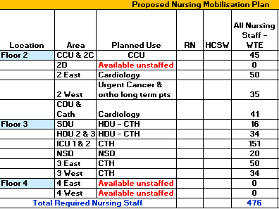
Hotel capacity
96 hotel bedrooms have been ring-fenced for patient use, potentially as a step down to reduce pressure on acute beds. In addition, the hotel continues to provide 11 on call rooms for GJ staff and a further 21 beds are regularly used by patient families.

3 Performance Monitoring

A daily return is submitted to Scottish Government by the Performance and Planning Team which provides data on the following:
Total Number of C19 Inpatients In Hospital at Midnight
Total Number of C19 Inpatients in ICU at Midnight
Total Number of C19 Inpatients in ICU at Midnight Admitted in the last 24 Hours
Total Number of General Inpatients in ICU at Midnight
Total Number of Unoccupied Staffed Beds in ICU at Midnight
Total C19 Deaths in Hospital Since Outbreak Began
Total C19 Recovered Inpatients and Discharged From Hospital Since Outbreak Began
Theatre Cancellations

In addition, the Performance Team has developed a bespoke report, which is available on a daily basis (and can be aggregated on a mean weekly basis). This report provides data in the form of:
- A stacked bar chart of midnight bed census by specialty and by date.
- A table which provides:
  - Occupancy by ward.
  - Patients in ICU/HDU by specialty and referring board
  - Admissions by specialty and priority
  - Discharges and deaths
  - Occupied bed variance from previous day
This report is provided in draft as an appendix to this report. It should be noted that development of this report is iterative and will develop over the coming days and weeks.

4 Conclusion
It is proposed that Board and Executive members are provided with a weekly performance dashboard report laying out the occupied, staffed and available bed capacity by specialty over time. Staff absence reporting is currently reported in depth within a separate dashboard; and it is intended that consideration will be given to merging key performance indicators, where indicated to provide integrated oversight of priority metrics.
Gareth Adkins
Director of Quality, Innovation and People
25th March 2020

