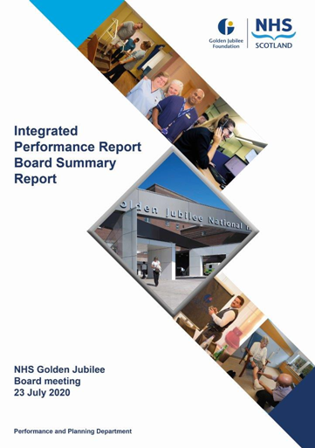

# Contents

**Introduction 2**

**Performance Summary Dashboard 4**

**Integrated Performance Report: Executive Summaries 6**

# Section A: Introduction

The purpose of the Integrated Performance Report (IPR) is to provide assurance on NHS Golden Jubilee’s performance relating to National Standards, local priorities and significant risks.

The IPR comprises four section with each section being considered in detail by the appropriate Standing Committee:

* Section A Introduction
* Section B:1 Clinical Governance
* Section B:2 Staff Governance
* Section B:3 Finance, Performance & Planning

This Board Summary Report of the IPR is presented to the Board and contains the summaries from each section of the full IPR.

**Jann Gardner Colin Neil June Rogers**

**Chief Executive Director of Finance Deputy Chief Executive**

Performance Summary Dashboard – Guidance



Board Performance Dashboard – Part 1



Board Performance Dashboard – Part 2



At each meeting, the Standing Committees of NHS Golden Jubilee consider targets and standards specific to their area of remit using the Integrated Performance Report (IPR). There is a section of the IPR which provides a summary of performance Standards and targets identified as areas of note which is reproduced below. Topics are grouped under the heading of the Committee responsible for scrutiny of performance.

# Section B: 1 Clinical Governance

|  |  |  |
| --- | --- | --- |
| **Clinical Governance** | | |
| **KPI** | **RAG** | **Position:** |
| Total complaints (Stage 1 and 2) as a percentage of activity |  | In May 2020 there was one complaint reported which maintained the position for April 2020. |
| Stage 1 complaints response time |  | In May 2020 there was one Stage 1 complaints which did meet the 5 day response time threshold. |
| Stage 2 complaints response time |  | In May 2020 there were zero Stage 2 complaints |
| Mortality |  | The mortality figure for May 2020 was reported as 11. There were 16 deaths in April 2020. |
| Significant adverse events |  | There was one significant adverse event reviews in May 2020. |
| MRSA/MSSA cases |  | There were two instances of Staphylococcus aureus Bacteraemia (SAB) reported in May 2020. |
| Clostridiodes Difficile |  | There was one Clostridiodes Difficile Infection (CDI) reported in May 2020. |

**Clinical Governance Executive Summary**

GJNH had one stage 1 and no stage 2 complaints during May; the one stage 2 in April was responded to on day 24; sign off for complaints is still challenging at present but improving. There were 4 events reviewed as potential SAE Reviews during May.

Of these two have been reviewed and are not progressing for SAER and two have had Level 1 reviews commissioned.

Both relate to deaths and one was identified from an M&M review of cardiology deaths during April.

**Key Healthcare Associated Infection Headlines**

* *Staphylococcus aureus* Bacteraemia- 2 SAB to report in May 2020. Source probable IABP and PVC. As per CE Letter 25/03/2020 Enhanced SAB surveillance has been paused until further notice. However, given these recent SAB the PCIT will resume this in June.

* *Clostridioides difficile* infection (previously known as *Clostridium difficile*)- 1 CDI to report in May 2020. No patient crossover noted.
* Gram Negative/E.coli Bacteraemia (ECB)- No ECB to report in May.
* Hand Hygiene- The bimonthly report from May demonstrates an overall compliance of 100% with hand hygiene opportunity and technique. Due to NHSGJNH COVID 19 reduced activity 10 areas submitted data as opposed to 15. Next update July.
* Cleaning and the Healthcare Environment- Facilities Management Tool

Housekeeping Compliance: 98.29% Estates Compliance: 99.03%

* Surgical Site Infection- As per CE Letter 25/03/2020 SSI surveillance has been paused until further notice.

Other HAI Related Activity

A national multidisciplinary COVID 19 Nosocomial Review Group has been established, this group will focus on IPC indicators.

The Centre of Excellence for Reducing risk of Infection in the HealthCare Built Environment have submitted their operational model to Scottish Governance and formal feedback awaited. The center will continue to learn lessons from new build.

# Section B:2 Staff Governance

|  |  |  |
| --- | --- | --- |
| **Staff Governance** | | |
| Disciplinaries & Grievances |  | There were zero Disciplinary or Grievances reported in May 2020. |
| Bullying and harassment |  | There were 4 bullying cases reported in May 2020. Three Corporate, one HLD. The highest reported monthly position since reporting commenced. |
| Local Sickness absence |  | Sickness levels remained constant in May 2020 at 4.7%.  A 5.4% Special Leave – Covid related rate was also reported, a decrease of 1.7% from April 2020 |
| Medical appraisal with completed interview and form 4 |  | Last reported position was end of February 2020 was 58.4% (73/125) against a target of 70%. Appraisals are currently suspended. |
| TURAS Appraisal rates |  | An updated position for May 2020 reports the position at 50%. |
| Job Planning: Elective Services |  | Last reported position was 85.7% (60/70) of consultants having an approved job plan. Job planning is currently suspended. |
| Job Planning: Heart, Lung and Diagnostic |  | Last reported position was 80% (12/15) Job planning is currently suspended. |

**Staff Governance Executive Summary**

**Staff Governance Executive Summary May 2020**

Within the Staff Governance section of the IPR we report on the following:

* sickness absence rates;
* appraisal rates for those under Agenda for Change and medical pay scales; and
* medical job planning.

From March 2020 and for the foreseeable future we will also summarise absence due to COVID-19.

**Sickness absence**

In May 2020 the Board’s sickness absence rate stood at 4.7%, the same as the previous month. Across the Directorates absence was as follows:

* Corporate: 3.8%, up from 2.9% the previous month;
* Golden Jubilee Conference Hotel: 0.9%, up from 0.7%;
* Heart, Lung and Diagnostic Services: 5.0%, up from 4.9%; and
* National Elective Services: 6.1%, down from 6.9%.

As with previous months, a large proportion of sickness absence was due to “Anxiety/stress/ depression/other psychiatric illnesses”, which accounted for 35.2% of the Board’s sickness absence. It was the main cause of sickness absence in Corporate (46.3% of sickness absence), Heart, Lung and Diagnostic Services (20.0%) and National Elective Services (45.2%). In the Hotel “Gastro-intestinal problems” accounted for 39.3% of sickness absence.

**COVID-19**

Absences from work due to the Coronavirus are recorded as special leave under one of six headings:

|  |  |
| --- | --- |
| Coronavirus | This will record those who have caring responsibilities and are absent due to these. |
| Coronavirus – COVID-19 positive | As it says employees who have tested positive for the virus. |
| Coronavirus – household related – self isolating | Someone in the household of the staff member is displaying symptoms. |
| Coronavirus – self displaying systems – self isolating | This will record a staff member who is displaying symptoms and allow testing of key workers to be targeted. |
| Coronavirus – underlying health conditions | Staff member has underlying health conditions putting them in the at risk category. |
| Coronavirus – test and protect isolation | Staff member has been told to isolate following contact by test and protect staff |

In May COVID-19 special leave accounted for 5.4% of all contracted hours. The Directorate breakdown was:

* Corporate: 4.6%;
* Golden Jubilee Conference Hotel: 11.6%;
* Heart, Lung and Diagnostic Services: 4.1%; and
* National Elective Services: 7.0%.

We will continue to provide a monthly summary of COVID-19 absences until the end of the pandemic.

**Agenda for Change appraisal**

Within the year to 31 April 2020 50% of staff who come under the Agenda for Change terms and conditions completed their appraisal using TURAS. The Directorate breakdown is as follows:

Corporate: 43%;

Golden Jubilee Conference Hotel: 31%;

Heart, Lung and Diagnostic Services: 52%; and

National Elective Services: 59%.

**Medical appraisal**

The appraisal year for medical staff runs from 1 April to 31 March. Prior to the end of the appraisal year the requirement for doctors to complete appraisals was temporarily suspended due to the COVID-19 pandemic. The appraisal process has not yet started for 2020/2021.

**Medical job planning**

Due to COVID-19 medical job planning has been temporarily suspended. It will recommence when it is considered safe and appropriate to do so.

# Section B:3 Finance, Performance and Resources

|  |  |  |
| --- | --- | --- |
| **Finance, Performance and Resources** | | |
| Finance – Manage within annual budget limit |  | A surplus of 109k was reporting April however budgets have yet to be agreed |
| Cancer 31 Day |  | In March 2020 the Monthly Cancer Waiting Times report, issued by the Scottish Government, reported performance of 86.0% (37/43) which is below the threshold of 95%. This remains the latest position. |
| TTG: Number of patients who have breached the TTG |  | In May 2020 there were 964 patients who exceeded their twelve week treatment time guarantee. This included 38 cardiac surgery patients, 13 thoracic surgery patients,36 coronary patients,46 electrophysiology patients,16 device patients,3 lead extraction patients,7 respiratory patients,306 orthopaedic patients,499 ophthalmology patients. |
| TTG: Percentage of patients admitted within 12 weeks |  | The percentage of patients who were admitted within their twelve week treatment time guarantee decreased by 11.2% from 81.9% in April 2020 to 70.6% in May 2020. This reflects an increase in the number of patients admitted over twelve weeks (+22). |
| Stage of Treatment Guarantee – Inpatient and DC cases (Heart & Lung only) |  | Position was 81.8% in May 2020 however this represents minimal numbers of patients seen (234/286) |
| DOSA rate: Cardiac Surgery |  | In May 2020 there were no DOSA cases with a minimal level of elective activity (27 cases). |
| DOSA rate: Orthopaedics |  | Elective Orthopaedic cases were suspended in late March 2020. |
| DOSA rate: Thoracic Surgery |  | In May 2020 there were no DOSA cases with an elective activity count of 67. |
| Theatre Cancellation Rates |  | Both cancellations and overall activity remain greatly reduced in May 2020. There were 22 cancellations against 316 scheduled cases (6.96%) |
| Hospital Bed Occupancy |  | Hospital wide bed occupancy was reported as 59.1% in May 2020, an increase from 53.7% in April 2020. |
| Hotel KPIs |  | Hotel target thresholds for 2020/2021 are currently under review due to the Covid 19 emergency. |
| Research and Innovation |  | Research indicators will next be updated in the July IPR |
| National Comparison Table, Corporate Dashboard, Waiting list & Productivity table | | |
| The GJNH nationally reported elective cancellation rate increased from 13.4% in March 2020 to 20% in Apr 2020. This ranked GJNH as 13 out of 15. The Scotland rate was 13.4%. Analysis shows a large number of Ophthalmology cancellations were reported in error which were not corrected. | | |
| Golden Jubilee comparative performance against the national 31 Day Cancer target is reported using the Information Services Division (ISD) nationally published position. For Quarter 4 2019 GJNH dropped to 6th at 96% (4 breaches). This remains the latest position available. | | |
| Health Protection Scotland published figures for Quarter 4 2019 report a GJNH incidence rate (per 100,000 total occupied bed days) of 8.6 for both SAB and CDiff incidence. The Scotland rates were 15.2 and 14.9 respectively. This remains the latest position available. | | |
| Corporate sickness rates deteriorated in May 2020 (+1.1% to 3.8%) The number of departments over the 4% threshold increased to: Performance and Planning, Research, Business Services, Housekeeping and Catering. | | |
| The total inpatient waiting list month end position decreased by 7 from 4020 to 4013.  The total outpatient waiting list decreased by 53 to 1734. This reflects the large drop in referrals received. For current waiters the number waiting between 12-26 increased significantly from 1045 to 11953 (+908) This is due to large increases in Orthopaedics and Ophthalmology for which elective activity is currently paused. | | |

**NHS Golden Jubilee**

**Summary Finance Report**

**As at 31 May 2020 – Month 2**

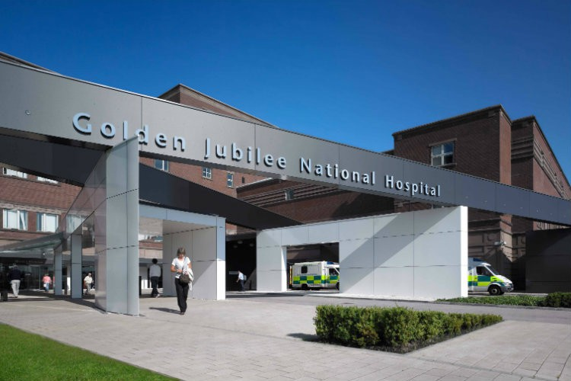

**Financial Position as at 31 May 2020, Month 2**

This summary finance report provides a brief overview of the financial position as at Month 2, for the period ending 31 May 2020.

Close dialogue with Scottish Government finance colleagues has been maintained on issues surrounding mobilisation plans and recovery plans, with key assumptions being made regarding Service Level Agreement (SLA) income, Other Health Boards income, inflation assumptions and Finance Plan assumptions associated with the Boards previous AOP. The landscape across NHS Scotland is in a similar position and given the significant level of change programmes, mobilisation plans and re-mobilisation / recovery plans, it has been indicated that the main allocations from Scottish Government (SG) are likely to follow the first quarter reporting where national co-ordination and validation can be completed. This in turn will allow a refresh of the Boards AOP and Finance Plan to capture these key aspects.

The table below represents an extract of the summary financial report in line with reporting to the Scottish Government Health and Social Care Directorate. It can be noted that formal Finance Performance Reporting (FPR) via the FPR templates to Scottish Government for month 2 was not required due to COVID-19 measures.



**Summary Points**

Income (£1.486m) under-recovered – The current position reflects under-activity during the first 2 months of the financial year due to the direct impact of service provision as a consequence of Covid-19. Income assumptions will be subject to greater definition following the quarter 1 review across NHS Scotland.

Expenditure £1.585m underspend – A core element within non-pay is a direct consequence of reduced activity and expenditure during the first 2 months of the financial year. Within pays there have been reductions in supplementary spend for some specialties due to reduced service provision together with some historical vacancies which have active recruitment plans.

|  |
| --- |
| **The Board are asked to**   * Note the financial position for Month 2, as at 31 May 2020 for the financial year 2020/21 * Note the key messages as highlighted below |
| **Key Messages**   * Total surplus as at Month 2, May 2020 of £109k (includes core, non-core and income). * As a result of the COVID-19 mobilisation and subsequent recovery planning in response to Scottish Government communication to all NHS Boards, the first Revenue Resource (RRL) Allocation to Boards will not be received until quarter 1 reporting i.e. due week commencing 6th July 2020. * Therefore, the GJ financial reporting as at May 2020 takes into consideration planned funding allocations from the GJ Annual Operating Plan (AOP) submission, COVID-19 Local Mobilisation Plans (LMP) template and the Boards recently approved Recovery Plan submission. * Although formal RRL allocation letters will not be received until Quarter 1 reporting, discussions to date with Scottish Government have provided a level of financial assurance for the Board to be reporting the £98k core revenue surplus as at May 2020. * The information presented represents a reasonable financial platform for the beginning of the financial year 2020/21.   **Additional Areas to Note**   * Capital Resource Limit (CRL) allocation. Expenditure programmes associated with GJ CRL funding allocations are at early stages of planning and therefore it is intended to produce the first Capital financial report as at quarter 1 reporting. This will incorporate further funding agreements associated with the Boards recovery plan. * The focus on the Efficiency Savings agenda has been preceded over the last 3-4 months by the Boards response to supporting the safety of staff and patients and realigning activity and services to meet the needs of the COVID-19 pandemic and the detailed planning required to implement and manage the re-start activity programme. The successful achievement of the £3.813m AOP efficiency savings target is still a financial aim of the Board, however there is recognition of the additional challenge to attain this within the COVID-19 LMP template return to Scottish Government. * Formal Performance Review Groups (PRG’s) will be re-established to monitor performance both operationally and financially against our recovery plan ambitions and will also consider any efficiency savings opportunities. |

**Director of Finance**

**NHS Golden Jubilee**