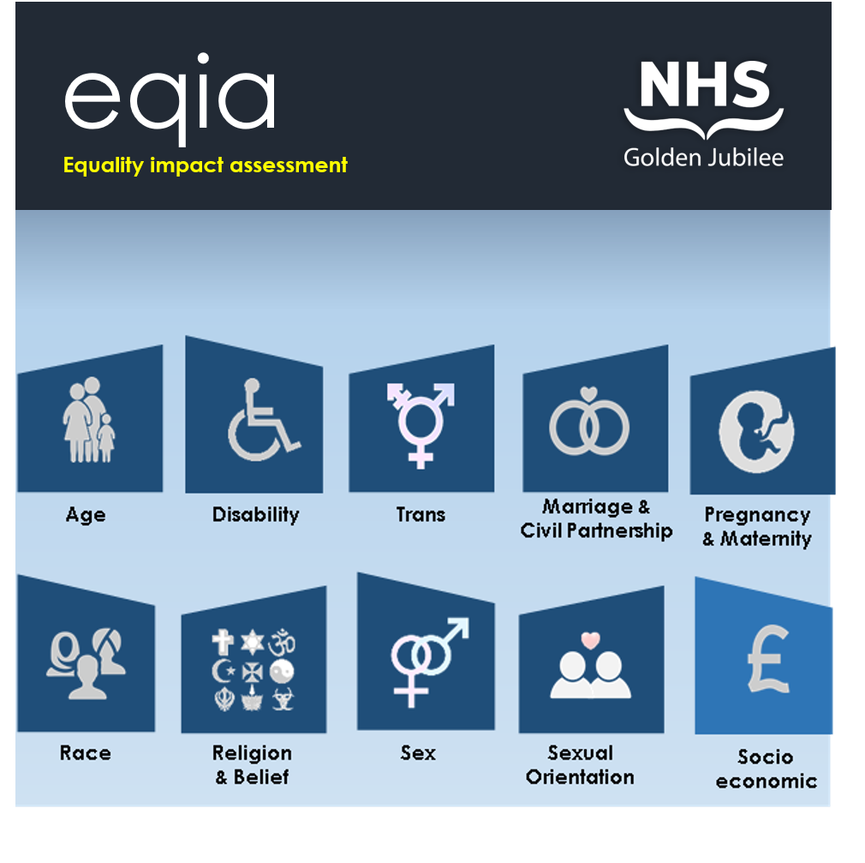
Name:  (policy/ procedure/ practice/ function) | Procurement Strategy  Period 2021-2024
Department: | Procurement Services
Lead Contact: | Angela Smith
EQI Assessor: | Jane Christie Flight
Date: | 09/03/2021
Use this section to provide details about the status (new or existing) of the policy/practice/procedure/function and provide an outline of the proposal including aims, objectives and outcomes.
Please note: All tables within this report are expandable.
Status | New | Existing
Aims objectives & outcomes | Aims objectives& outcomes The Procurement Strategy has been developed to reflect and embed the requirements laid out in the Procurement Reform (Scotland) Act 2014. This legislation applies to all Public Bodies in Scotland including the NHS. Each Health Board in Scotland is required to produce a Procurement Strategy, have it available for public view, and report the publication to the Scottish Ministers. The Strategy subject of this Equality Impact Assessment reflects the Period 2021 -2024. The Procurement Strategy includes within Section 4 C, – Tackling Equalities, a statement referencing the commitment by the Board to adhere to the legal requirements of the Equalities Act 2010. It recognises that mechanisms are in place and will be built upon to ensure that the Board and Suppliers of Goods and Services to the Board will comply with the Act and the Public Sector Equality Duty. The Board is committed to meet the requirements of The Equalities Act 2010 and The Public Sector Duty by actively promoting the needs and the rights of those groups currently impacted by inequalities including those disadvantaged by Age, Disability, Gender, Race. Community benefits will be sought through contract opportunities to help tackle existing inequalities by for example the employment of apprentices drawn from the local community. This example emphasises the Board’s commitment as detailed in the Procurement strategy to young people by the creation of local employment opportunities. Within Section 5 Policies the strategy touches upon the Boards commitments on ensuring the payment of the living wages to those involved in producing, providing or constructing the subject matter of regulated procurements. The commitment to promote ethically traded goods and services is also made. To augment the above information contained within the Procurement Strategy Procurement Services have developed in conjunction with the Head of Strategy and Performance a detailed section (11) in the Boards Invitation to Tender Document Set that covers the Equalities in greater detail. This section includes a statement on Diversity and Equality, and outlines the Boards Vision in respect of this. It provides additional detail on the Public Sector Equality Duty, and includes links to further information that services providers can access on this topic. This section further outlines the intention of the Board to gather and log market compliance with equality legislation and best practice. It also includes a statement of the Boards intention to work with suppliers who can effectively demonstrate how they promote diversity and inclusion as an employer. Engagement with key suppliers (approx 25), i.e. those representing the highest level of expenditure or those providing goods and services of a critical nature, are scheduled throughout the year. The topic of their compliance with the Equalities Act 2010 and the Public Sector Equality Duty is a standard agenda point. This has led to positive dialogue on this subject.

The Golden Jubilee Foundation has a legal requirement under the Public Sector Equality Duty to have due regard to the need to:
- Eliminate unlawful discrimination, harassment and victimisation and other conduct prohibited by the Act.
- Advance equality of opportunity between people who share a protected characteristic and those who do not.
- Foster good relations between people who share a protected characteristic and those who do not.
Provide details of how the policy/procedure/practice/function will impact positively, negatively or neutrally on people who share a protected characteristic
 | Age
Positive impact |  | The Procurement Strategy and Invitation to Tender Document set together provide a positive impact to each of the protected characteristics group identified within Equality Act 2010. Both documents aim to raise awareness of the entire supplier base of both the Board’s focus to ensure compliance of the Act , and to promote and share that vision and advise
Negative impact |  | No issues were identified
Neutral impact |  | No issues were identified
 | Disability
Positive impact |  | The Procurement Strategy and Invitation to Tender Document set together provide a positive impact to each of the protected characteristics group identified within Equality Act 2010. Both documents aim to raise awareness of the entire supplier base of both the Board’s focus to ensure compliance of the Act , and to promote and share that vision and advise suppliers of their obligation under the Act.
Negative |  | No issues were identified
Neutral impact |  | No issues were identified
 | Trans
Positive impact |  | The Procurement Strategy and Invitation to Tender Document set together provide a positive impact to each of the protected characteristics group identified within Equality Act 2010. Both documents aim to raise awareness of the entire supplier base of both the Board’s focus to ensure compliance of the Act , and to promote and share that vision and advise suppliers of their obligation under the Act.
Negative impact |  | No issues were identified
Neutral impact |  | No issues were identified
 | Marriage & Civil Partnership
Positive impact |  | The Procurement Strategy and Invitation to Tender Document set together provide a positive impact to each of the protected characteristics group identified within Equality Act 2010. Both documents aim to raise awareness of the entire supplier base of both the Board’s focus to ensure compliance of the Act , and to promote and share that vision and advise suppliers of their obligation under the Act.
Negative impact |  | No issues were identified
Neutral impact |  | No issues were identified
 | Pregnancy & Maternity
Positive impact |  | The Procurement Strategy and Invitation to Tender Document set together provide a positive impact to each of the protected characteristics group identified within Equality Act 2010. Both documents aim to raise awareness of the entire supplier base of both, the Board’s focus to ensure compliance of the Act , and to promote and share that vision and advise suppliers of their obligation under the Act.
Negative impact |  | No issues were identified
Neutral impact |  | No issues were identified
 | Race
Positive impact |  | The Procurement Strategy and Invitation to Tender Document set together provide a positive impact to each of the protected characteristics group identified within Equality Act 2010. Both documents aim to raise awareness of the entire supplier base of both the Board’s focus to ensure compliance of the Act , and to promote and share that vision and advise suppliers of their obligation under the Act.
Negative impact |  | No issues were identified
Neutral impact |  | No issues were identified
 | Religion or Belief
Positive impact |  | The Procurement Strategy and Invitation to Tender Document set together provide a positive impact to each of the protected characteristics group identified within Equality Act 2010. Both documents aim to raise awareness of the entire supplier base of both the Board’s focus to ensure compliance of the Act , and to promote and share that vision and advise suppliers of their obligation under the Act.
Negative impact |  | No issues were identified
Neutral impact |  | No issues were identified
 | Sex
Positive impact |  | The Procurement Strategy and Invitation to Tender Document set together provide a positive impact to each of the protected characteristics group identified within Equality Act 2010. Both documents aim to raise awareness of the entire supplier base of both the Board’s focus to ensure compliance of the Act , and to promote and share that vision and advise suppliers of their obligation under the Act.
Negative impact |  | No issues were identified
Neutral impact |  | No issues were identified
 | Sexual Orientation
Positive impact |  | The Procurement Strategy and Invitation to Tender Document set together provide a positive impact to each of the protected characteristics group identified within Equality Act 2010. Both documents aim to raise awareness of the entire supplier base of both the Board’s focus to ensure compliance of the Act , and to promote and share that vision and advise suppliers of their obligation under the Act.
Negative impact |  | No issues were identified
Neutral impact |  | No issues were identified
 | Socio-economic
Positive impact |  | The Procurement Strategy and Invitation to Tender Document set together provide a positive impact to each of the protected characteristics group identified within Equality Act 2010. Both documents aim to raise awareness of the entire supplier base of both the Board’s focus to ensure compliance of the Act, and to promote and share that vision and advise suppliers of their obligation under the Act. They focus on ensuring that all Procurements are made from ethical supply chains that are geared ensure that products and services come from sources that are subject to regular and routine scrutiny. This greatly reduces the risk of the Board indirectly contributing to the use of child, forced or slave labour within the supply chain.
Negative impact |  | No issues were identified
Neutral impact |  | No issues were identified

Where the policy/practice/procedure/function was identified to adversely affect (discriminate) people who share a protected characteristic; provide details of how this impact will be eliminated, minimised or managed.
Protected Characteristic |  | Actions | Person Responsible
All Characteristics |  | No issues were identified | Click or tap here to enter text.
 | Age | No issues were identified | Click or tap here to enter text.
 | Disability | No issues were identified | Click or tap here to enter text.
 | Trans | No issues were identified | Click or tap here to enter text.
 | Marriage/Civil Partnership | No issues were identified | Click or tap here to enter text.
 | Pregnancy & Maternity | No issues were identified | Click or tap here to enter text.
 | Race | No issues were identified | Click or tap here to enter text.
 | Religion or Belief | No issues were identified | Click or tap here to enter text.
 | Sex | No issues were identified | Click or tap here to enter text.
 | Sexual Orientation | No issues were identified | Click or tap here to enter text.
 | Socio-economic | No issues were identified | Click or tap here to enter text.

Provide an impact rating based on the degree to which the policy/practice/procedure/function will negatively impact people who share a protected characteristic.

Impact Rating Key
Low
There is little or no evidence that some people are (or could be) differently affected by the policy/practice/procedure/function.

Medium
There is some evidence that people are (or could be) differently affected by the policy/practice/procedure/function.

High
There is substantial evidence that people are (or could be) differently affected by the policy/procedure/decision

Protected Characteristic |  | Low | Medium | High
 | Age
 | Disability
 | Trans
 | Marriage/Civil Partnership
 | Pregnancy & Maternity
 | Race
 | Religion or Belief
 | Sex
 | Sexual Orientation
 | Socio-economic

Provide details of stakeholder collaboration and consultation.
Refer to Appendix B for details of local and national charities and user groups which represent the Protected Characteristics defined by the Equality Act 2010.
Name and  Job title | Department or Organisation | Contact details
Angela Smith – Head of Procurement | Procurement | 0141 951 5062
Regular reviews ensure that policy, procedure and practice is kept up to date, and meets the requirements of current equality legislation. Where a negative impact has been identified and remedial actions are being implemented, the policy owner should define a timescale for review.
Identified  Issue | Assigned contact | Review Date
Continuation of promotion of the Vision of Board in Respect of the Equality Act 2010 to all suppliers through Key Supplier Meetings and assessment of tender returns to ensure that suppliers can and will comply with their specific duties under the Act. | Angela Smith | Quarterly Review

Please detail all evidence and research utilised in order to support the rationale for this EQIA. (Include attachments where available).
Equalities Evidence Finder

Evidence & Research
Click or tap here to enter text.
Please return this completed EQIA to the Equalities Group via email (including any supporting evidence) to the following address:
equalities@gjnh.scot.nhs.uk

If you need any advice on completing this form, or any aspect of the Equality Impact Assessment process, please contact any member of the Equalities Group. Contact details can be found in Appendix A or via the link below:
Jubilee STAFFnet Equalities

EQI Assessor: | Click or tap here to enter text.
Equalities Group Representative: | Click or tap here to enter text.
Sign-Off Date: | Click or tap here to enter text.

