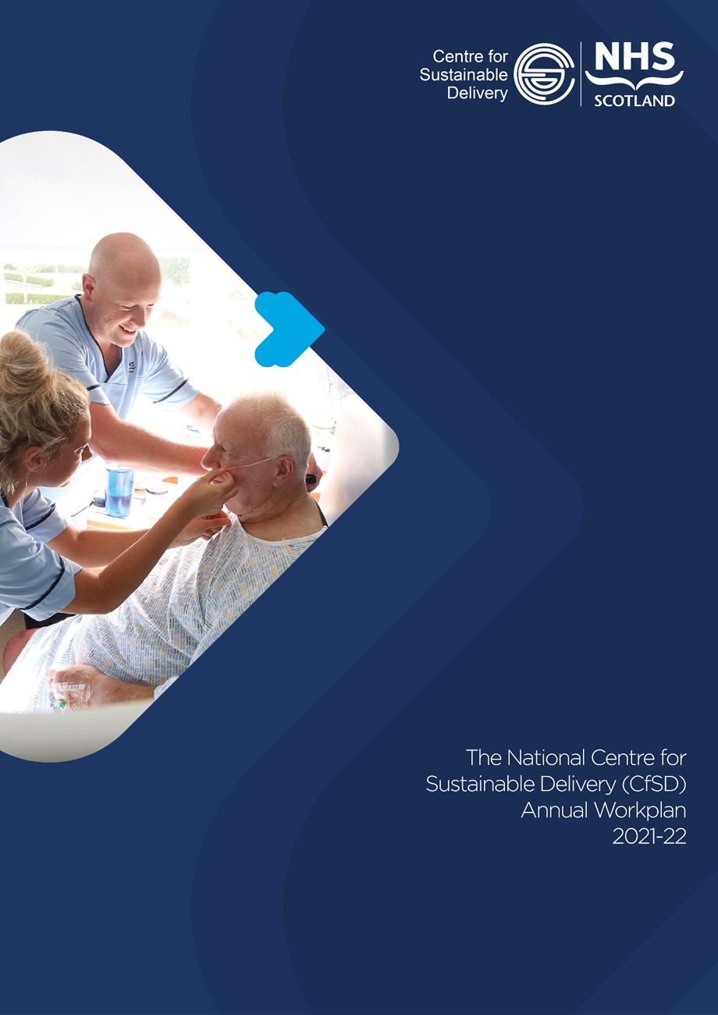
DRAFT FOR CONSIDERATION & COMMENT
V6 – Monday 29th March 2021

March 2021

Contents

Contents
1. Introduction 4
2. Governance 5
3. Strategic Context 6
4. Vision and Strategic Objectives 7
5. Key Priorities 8
5.1 Supporting Strategic Redesign through Care Programmes 10
5.2 Optimising Impact of CfSD National Programmes 12
5.3 Collaboration with key strategic partners 16
5.4 Designing and Establishing New Programmes 17
5.5 Bespoke Support for NHS Boards 18
5.6 Supporting Best Practice & Realistic Medicine 19
6. Questions 20
7. Appendices 21
Appendix 1- Centre for Sustainable Delivery Structures, Governance & Financial flows 21
Appendix 2 – CfSD Heat Map 25
Appendix 3 – Cancer Performance and Early Diagnosis – Objectives and Outcomes 26
Appendix 4 – Scottish Access Collaborative and Modernising Patient Pathways – Objectives and Outcomes 29
Appendix 5 – Planned Care Programmes – Objectives and Outcomes 38
Appendix 6 – Comments from Strategic Partners 39
Appendix 7 – 6 Essential Actions - Objectives and Outcomes 41
Appendix 8 – Current CfSD Research 43
Appendix 9 – Data Collection, Analysis and Reporting Capability 44

Foreword
Caroline Lamb, Director General & Chief Executive NHS Scotland

TO BE CONFIRMED

Despite the significant challenges over the last year our health and care system have responded with strength, resilience and agility to find new ways to provide the care that our patients and citizens need.
I want us to build on this success, ensuring that we use technology and new healthcare pathway design to sustain this innovative approach.
To support this work Scottish Government commissioned the establishment of the Centre for Sustainable Delivery (CfSD) – a national unit which will provide improvement programmes incorporating new tools and techniques and bespoke assistance to help tackle areas of challenge. I am delighted to support both the launch of the Centre and it’s first annual workplan, which outlines the blueprint for the coming year and beyond.
Working alongside key strategic partners the Centre will play a vital role in supporting our national efforts to remobilise, recover and redesign, towards a better health care system, and will build on the significant progress and developments which have been achieved through redesign and transformation. This includes the rapid rollout of new techniques, technology and clinically safe, faster and more efficient pathways for our patients. Notably, this included the expansion on a national scale of digital methods to access primary and secondary care such as NHS Near Me, which has grown from 5,000 consultations per year to approximately 500,000 in just 12 months.
National programmes supported by the CfSD have also rapidly increased Active Clinical Referral Triage all across Scotland, helping people access optimal, evidence based, locally agreed pathways. This has significantly reduced the need for face-to-face consultations during a period where this was essential for ensuring sustainable and consistent care for patients across the country.
I welcome the contribution that the Centre will make to not only maintain the gains we have made, but ensure we are well placed to share and embed the learning, improvement and transformation our health and social care staff have delivered during our emergency response. The adaptability and flexibility our staff have shown, along with their ability to embrace rapid change in the delivery of healthcare in times of adversity is truly amazing.
The priorities of this workplan will support our national efforts and support best practice to be developed and spread for the benefit of patients and families all across NHSScotland. The work of the Centre is important as part of the initiatives to support NHS Scotland ‘Redesign for Recovery’, through the delivery of valuable existing national redesign and transformation programmes and responding to the emerging needs of our health and social care system, aligning with the remobilise, recover and redesign framework. This will include supporting delivery of the new national Integrated Care Programme and working with other key national partners to deliver sustainable change including Healthcare Improvement Scotland, NHS National Education for Scotland , Public Health Scotland and NHS National Services Scotland.
I support the commitment of the Centre to working with health and social care professionals through a collaborative network approach, ensuring national programmes of work both involve and are led by those who are critical to the future of our national health and wellbeing.
It has never been more important or compelling that we come together across NHSScotland and share the best practice we have developed, and ensure these are firmly embedded in how we deliver services now and in the future.
I believe the Centre for Sustainable Delivery, working with strategic partners, will play a key role in supporting our vision for health and social care to remobilise, recover and redesign towards a better health and care system.

1. Introduction

In May 2020, the Cabinet Secretary for Health and Sport launched the Remobilise, Recover and Redesign Framework for NHSScotland. This was accompanied by the Director General for Health and Social Care and Chief Executive of NHSScotland, establishing the 3Rs Portfolio to oversee national Care Programmes which will drive sustainable recovery of Health and Social Care.
The Scottish Government requested that the NHS Golden Jubilee (NHS GJ) establish the new national Centre for Sustainable Delivery (CfSD) to support the Care Programmes and enable NHS Boards to adopt the Remobilise, Recover and Redesign approach through sustainable transformation programmes across health and social care.
The Scottish Government, through the Director General (DG) for Health and Social Care and the Chief Executive (CEO) of NHS Scotland will commission the CfSD through the approval of an annual work plan which will set out details of the national programme design and infrastructure including bespoke support requested by individual Boards to achieve the ambitions of the 3Rs reform agenda and ‘Redesign for Recovery’. The Scottish Government will also put in place arrangements for on-going monitoring of delivery against the annual work plan.
NHS GJ Chief Executive will provide accountable officer leadership for the CfSD and will support the Centre to align with national priorities under the direction of Scottish Government to design, develop and support ‘Redesign for Recovery’ transformation programmes. The CfSD will play a key role in underpinning the evolving 3R’s Care Programmes to support the strategic and policy intent of the Care Programmes aligned with the Programme for Government.
The CfSD aspires to provide support that will result in NHS Scotland to be internationally recognised for promoting and embedding best practice in the sustainable delivery of healthcare. The CfSD will build on the annual workplan throughout the year, and look to further develop measurable aims and objectives. These will be linked with the portfolio of programmes, tools and techniques which have been laid out, and will be agreed with Scottish Government to ensure that CSfD and NHS Boards will demonstrate an aligned position within RMP4 (September 2021). This will show the local level of CfSD Programme implementation and the associated future workplan, optimising recovery and potentially allow for additional CfSD support.
The Centre, hosted by NHS Golden Jubilee, will, as agreed with Scottish Government, bring current programmes of work under one umbrella that compliments the existing national direction of travel to high levels of quality, outcomes and performance. The Centre’s purpose is to:

- Design and drive national redesign and transformation programmes to enable a sustainable health and care system providing world class excellence in care experience, outcomes through optimal care pathways.
- Create a national unit to drive the objectives of the 3Rs Care Programmes taking learning from best practice in Scotland, the UK and across the world.
- Undertake research and publish evidence based learning to establish the CfSD as an internationally recognised unit for supporting system change.
- Drive redesign and transformation through collaboration and partnership working – developing and maintaining networks of clinicians and senior leaders across different specialities and settings across health and social care, including primary, secondary and social care.
- Assess, monitor and redesign through data analysis – use national and local data to inform system understanding, prioritisation and programme design to optimally achieve key objectives.

As the first workplan of the CfSD this document will cover:
- The strategic context and key priorities of the newly formed unit.
- The relationship with the Care Programmes and Key Collaborative Partners.
- The Programmes of Work with a commitment to evolve by RMP4 in September to define key measures of success.

2. Governance
Sponsorship and Annual Workplan
The CfSD will operate under the sponsorship and direction of Scottish Government through the DG for Health and Social Care and Chief Executive of NHSScotland.
The CfSD will agree an annual workplan for redesign and transformation with Scottish Government (function 1 described further below). The workplan will set out priorities, aligned to the Programme for Government, that will support the 3Rs reform agenda. This will include commissions from Scottish Government to develop and deliver national redesign and transformation programmes aligned to the 3Rs portfolio and Care programmes, building on the achievements of existing national programmes of redesign and transformation.
Development of Annual Workplan
The CfSD will also stand ready to respond to the emerging needs of health and social care under the direction of Scottish Government through the DG for Health and Social Care and Chief Executive of NHSScotland. This will require ongoing development of the annual workplan throughout the year and will include further work to:
- Develop and evolve implementation plans for national programmes including more detailed and specific objectives and outcome measures
- Build collaboration with key strategic partners and develop joint initiatives and programmes
Operational Arrangements
The work of CfSD is delivered through Function 1 described below, however, part of the resources within CfSD also undertake a second role to support the SG led performance management. As outlined these functions are provided and monitored in different ways.
Function 1 – Transformation via the Centre for Sustainable Delivery (CfSD)
The transformation, programme and bespoke services of CfSD are defined within an Annual Work Plan (AWP) which is aligned with the 3R’s Reform agenda, the Integrated Planned and Unscheduled Care Programmes and the associated NHS Board Remobilisation Plans. The AWP will be agreed annually between Scottish Government and CfSD with regular progress reports and required agile changes in response to evolving needs and Care Programme direction through the year.
Where commissioning is referred to in this workplan, this is explicitly relates to function 1 of CfSD and will be through the sponsorship and direction of Scottish Government through the DG for Health and Social Care and Chief Executive of NHSScotland.
Elements of bespoke work which will be required on a reactive basis will also be reflected in the monthly progress reports and any significant changes in this regard. The aim is to develop an approach for the requesting bespoke work with NHS Boards to work with them to understand system challenges and opportunities and enable effective and resilient change.
NHS GJ will, through the Chief Executive as accountable officer for CfSD function 1, ensure that CfSD provides regular assurance reports for function 1 to Scottish Government, in line with existing NHS GJ corporate governance mechanisms.
Function 2 – SG Performance Support via SLA to SG
The NHSScotland COO is responsible for performance management of NHS Boards on behalf of the Director General for Health and Social Care and Chief Executive of NHSScotland. Support for performance management will be provided via Service Level Agreement with Scottish Government for specific staff to work under the direction of the NHSScotland Chief Operating Officer (COO).
Performance Management of NHS Boards remains entirely the responsibility and remit of SG and NHS GJ plays no role in these matters beyond their duty of care as the employer of CfSD staff.
Further details of CfSD governance arrangements are provided in Appendix 1.

3. Strategic Context

In May 2020, the Cabinet Secretary for Health launched the Remobilise, Recover and Redesign Framework for NHSScotland which set out the key objectives described below:

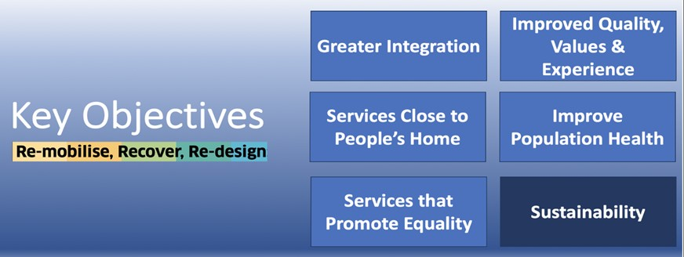

To deliver these strategic objectives the Director General for Health and Social Care and Chief Executive of NHSScotland has established the Remobilise, Recover and Redesign portfolio with associated remobilisation plans from NHS Board to drive sustainable recovery of across Health and Social Care. The 3Rs work will support redesign and transformation as services recover to build on the positive changes seen in health and social care during the emergency response to Covid-19.
Reporting to the H&SCMB, Care Programmes are in development which will bring together key programmes of prioritised work (encompassing policy, strategy and delivery) which effectively support the objectives of the 3R’s reform agenda.
The portfolio and Care Programmes will be aligned with the overarching objectives of the Programme for Government (PfG), which advocates a greater focus on population health and wellbeing, a strong community orientation, linked with the tackling of inequalities and a determination to have a world class public health system. It is essential that the citizen must be at the heart of the design, development and delivery of the portfolio and Care Programmes.

The CfSD will work to an annual workplan, determined by Scottish Government that will set out priorities, aligned to the Programme for Government, that will support the 3Rs reform agenda. This will include commissions from Scottish Government to develop and deliver national redesign and transformation programmes aligned to the 3Rs portfolio and Care programmes, building on the achievements of existing national programmes of redesign and transformation.

The CfSD will also stand ready to respond to the emerging needs of health and social care under the direction of Scottish Government through the Director General for Health and Social Care and Chief Executive of NHSScotland.

4. Vision and Strategic Objectives
Vision
The CfSD aspires to be an internationally recognised centre of excellence, promoting and embedding best practice through a ‘Once for Scotland’ approach and enabling redesign programmes to support a sustainable health and care system which is aligned with the priorities of Scottish Government.
The CfSD will collaborate with NHS Boards, health and social care partners, third sector, academia and industry to identify and implement new opportunities for sustainability through the design of programmes and the provision of expert thinking in complex system challenges. The CfSD will work in collaboration with key strategic partners including NES, NSS, HIS, PHS and others to achieve a streamlined and joined up approach to transforming and redesigning health and social care looking for synergistic opportunities and avoiding duplication.
The CfSD will provide support and advice, system assessment from a data driven perspective, to support senior leaders across the health and social care system to shape programmes of work which help address national priorities to be delivered through whole system redesign and transformation.
The CfSD brings together a highly skilled and experienced unit able to lead and promote reform and change, and to enable excellence and innovation in healthcare. It is therefore ideally placed to lead the development and delivery of national programmes of work centred around redesign and sustainability. Core to the success will be the collaborative relationship between CfSD, key partners and NHS Boards.
A key strength of the CfSD model is the significant involvement of clinicians and stakeholders at all stages from conception and design, through to delivery of all programmes of work. The bringing together of expertise from clinicians, patients, health and social care partners and other relevant stakeholders to maximise health outcomes is a central priority. This will remain a fundamental approach going forward, to achieve shared ownership and the motivation to succeed. It is however recognised that the scope of work undertaken by the CfSD needs to widen to include greater focus in primary, community and the social care setting.
Strategic Objectives
This vision will be delivered through the following strategic objectives:

5. Key Priorities
5.1 Supporting Strategic Redesign through Care Programmes
Scottish Government will agree an annual workplan with CfSD that will set out priorities, aligned to the Programme for Government, that will support the 3Rs reform agenda. This will include commissions from Scottish Government to develop and deliver national redesign and transformation programmes aligned to the 3Rs portfolio and Care programmes, building on the achievements of existing national programmes of redesign and transformation.
5.2 Optimising impact of national programmes
The CfSD will become a collaborative taskforce, networked across Scotland, to optimise the impact of existing national programmes to support remobilisation and recovery and enable redesign, improvement and transformation of the health and social care system. In the first instance, under the oversight and guidance of the Integrated Care Programmes, this will include:

- Integrated Planned Care Programme Oversight:-
  - Cancer Performance and Early Diagnosis Programmes
  - Scottish Access Collaborative
  - Other Planned Care Programmes
  - Modernising Patient Pathways Programmes

- Integrated Unscheduled Care Programme Oversight- as commissioned by Scottish Government
  - This is currently being considered by Scottish Government
  - CfSD stand ready to support as directed by Scottish Government

- Other Integrated Care Programmes - as commissioned by Scottish Government
  - This is currently under review
  - CfSD stand ready to support as directed by Scottish Government

5.3 Collaboration with key strategic partners
The CfSD will build on existing networks and relationships to develop and support a collaborative network to drive redesign and transformation across NHSScotland. The CfSD will work in collaboration with key strategic partners to achieve a streamlined and joined up approach to transforming and redesigning health and social care. The leadership of individual programmes of work, and the contribution to be made by each partner will be determined between the collaborating parties on a case by case basis.

5.4 Designing and establishing new programmes
The CfSD will be commissioned to deliver new programmes of work aligned to the priorities set by national steering groups and under the direction of Scottish Government. It will draw on capacity and expertise from partners to deliver rapid exploration of known challenges, and to identify solutions to develop, test and implement across Scotland through:
Data and Intelligence – The CfSD will use data and analytics to understand and present the challenge to be addressed, to quantify the anticipated impact of redesign, and to define the measures that will be used to track delivery. It will also work with partners to identify where solutions have been developed already that could be scaled up.
International Best Practice – The CfSD will work with partners through an advisory board to research and identify best practice to incorporate into designing solutions to implement across Scotland.
Innovation and Technology – The CfSD will work with partners to identify innovation that can be implemented at scale to accelerate transformation and to support the commissioning of new innovation projects to address key priorities.
Education & Skills – CfSD will work with NES and the joint venture NHS Scotland Academy to develop training and skills development to ensure the workforce is able to support the delivery of transformed services

5.5 Provide bespoke support for NHS Boards
The Centre will further develop capability to provide timely bespoke support for NHS Boards. It will work with and listen to key stakeholders, analysing data, financials and pathways and consider the potential for programmes, innovations and digital opportunities to refresh and refocus remobilisation plans. The CfSD will work in partnership with NHS Boards and strategic partners to maximise collaboration across health and social care leadership teams to provide powerful insights to how services can be redesigned and transformed.

5.6 Supporting Best Practice & Realistic MedicineSupporting Best Practice & Realistic Medicine
The CFSD will provide internationally recognised research, development and innovation support for redesign and transformation of health and social care. The CfSD will work with partners across Scotland including industry, academia and health and social care to promote and expand the international role Scotland has in leading redesign and transformation of health and social care.
The following sections of this document will continue to expand on these key areas.



5.1 Supporting Strategic Redesign through Care Programmes

The Remobilise, Recover and Redesign portfolio (3Rs Portfolio) is underway under with oversight of key areas of work by the national Care Programmes who in turn report through the Health and Social Care Management Board and Care Programme Steering Groups as illustrated below.

The first Care Programme – Integrated Planned Care Programme has been established with the Integrated Unscheduled Care Programme in development and further Care programmes being considered.

The CfSD will support the Integrated Planned Care Programme (alongside other key delivery/collaboration partners) and will stand ready to respond to the emerging needs of health and social care and requests to support other Care Programmes. The Scottish Government through the Director General for Health and Social Care and Chief Executive of NHSScotland will, where required, commission additional support from CfSD to support the 3Rs portfolio and Care Programmes.

NATIONAL STRATEGY and POLICY SETTING CARE PROGRAMMES
H&SC Management Board
Integrated Unscheduled
Care Programme
Steering Group
PROPOSED
Integrated Planned
Care Programme
Steering Group
ESTABLISHED
Potential Other
Care Programme
Steering Groups
UNDER REVIEW
CfSD SUPPORTS THE WORK OF THE CARE PROGRAMMES, DESIGNS & SUPPORTS NATIONAL PROGRAMMES AND PROVIDES BESPOKE SUPPORT
SAC & MPPP
Detect Cancer Early
Bespoke Requests from NHS Boards
Unscheduled Care Redesign
Planned Care Redesign

Role of CfSD in Care Programmes

The CfSD will support the strategic intent and delivery plan of the 3R’s Care Programmes with an initial focus on the Integrated Planned Care Programme This will require the CfSD to work with key partners and to be agile and flexible in its approach to realign, and where required, re-evaluate and reprioritise existing CfSD national redesign and transformation work as well as respond to bespoke requests for support from NHS Boards.

As SG develops the role and remit of the Care Programmes, CfSD will require to work with key partners including Healthcare Improvement Scotland, Public Health Scotland, NHS National Education for Scotland, NHS National Services Scotland, NHS Boards and Integration Joint Boards to provide support.

Integrated Planned Care Programme

The Integrated Planned Care Programme Steering Group (IPCP SG) was established in January 2021 under the Chair of the NHSScotland Chief Operating Officer (COO), on behalf of the Director General (DG) / NHSScotland Chief Executive, with a diverse membership coming from senior SG Directors, Policy, NHS Boards, Professional and Public representation. The IPCP SG will set the strategic direction ensuring alignment of policy and Programme for Government. The CfSD will work to underpin the work of the IPCP SG along with other key delivery partners.

The aim is to work collaboratively, and at pace, with clinicians and stakeholders to develop and deliver meaningful redesign programmes using a programme management approach, that promotes the reform of healthcare, maximises the value to patients, and builds capability to deliver better healthcare through evidence-based practice, clinical improvement and clinical innovation.

The programmes of work will focus on short, medium and long term improvement plans, that build capacity and capability, and deliver positive impacts for patients, clinicians, and the broader health system as a whole. The approach will enable and support better health outcomes; improved patient experience; and increased confidence in the healthcare system.

The purpose of the Steering Group is to support and steer collaboration of the planned care services within NHSScotland. This covers primary, secondary and community care including rehabilitation. The Integrated Planned Care Programme Steering Group will:

- Work with PHS to determine and quantify the magnitude and spectrum of the planned care challenges facing NHSScotland in relation to the delivery of planned care.
- Support the development of an Elective strategy and Recovery Plan for NHSScotland. This will adopt a national approach, based on a collaboration of recovery across Boards. The developed plan will be subject to ministerial approval.
- Support PHS to develop a National Analytical Dashboard to support scenario modelling in relation to demand and capacity; treatment of patients in line with Clinical Prioritisation; and the optimization of equitable service delivery.
- Determine the strategic development and management of the Elective Centres to optimise utilisation of national capacity for planned care and ensure consistent implementation of best practice and quality of care across Scotland. This will include directing an action plan for workforce development, financial model, operational and quality framework for effective and standardised deliver.
- Consider and advise on refreshed delivery standards and monitoring aligned with the clinical prioritisation work.
- Provide oversight and direction to improvement programmes that are specifically focused on short, medium and long term priorities, within the most challenging specialties, in order to support the recovery, enhancement and sustainability of Planned Care.
- Support proactive working with Primary Care, to ensure the mutually beneficial alignment of objectives and actions, to streamline patient pathways and enhance efficient utilisation of resources.
- Support NHS Education for Scotland (NES) to determine and quantify the extent and specific Workforce challenges associated with the delivery of Planned Care and explore potential solutions.
- Support PHS to develop a National Analytical Dashboard to support scenario modelling in relation to demand and capacity; treatment of patients in line with Clinical Prioritisation and the optimization of equitable service delivery.
- Work with partners including PHS to ensure that services being redesigned improve access and uptake from those typically furthest away from them and redesign and transformation programmes to support national priorities to reduce health inequalities
- Work with partners including NHS National Services Scotland to build green healthcare principles into the redesign and delivery of services including sustainable procurement, building design and energy use.

5.2 Optimising Impact of CfSD National Programmes

The role of CfSD is to support the implementation of the Care Programmes through the delivery of current and future national programmes of work, and to provide bespoke support when requested by NHS Boards. The next phase of this will be to develop a more structured and collaborative approach with key partners and NHS Boards to optimise the utilisation of tools and techniques to achieve optimal service redesign with the positive quality, flow and sustainability outcomes associated with success.

CfSD as a new National Unit brings these national programmes together increasing the opportunity for cross fertilisation and cohesiveness with the development, in parallel, of an agile approach to respond to bespoke requests for support.

The following key national programmes will continue to form the core portfolio of CfSD to support remobilisation and recovery and enable redesign, improvement and transformation of the health and social care system:

- Support for the Scottish Government Commissioned Unscheduled Care Programmes
- Cancer Performance and Early Diagnosis Programmes
- Scottish Access Collaborative and other planned care programmes
- Modernising Patient Pathways Programmes

These programmes will become part of the Integrated Planned Care Programme along with key initiatives currently supported through the planned care performance team. This will require further work with Scottish Government and partners to develop and agree:

- A national portfolio approach that clearly articulates the key programmes of work to support redesign and transformation and the delivery responsibilities of partners
- Alignment and coordination of existing national programmes for redesign and transformation to avoid duplication and maximise the benefits of working together to support health and social care
The output of this work will be an update to the CfSD workplan clearly setting out the key programmes CfSD will be responsible for and any key changes to the design and delivery of existing initiatives and programmes of work.

The updated CfSD workplan will support ongoing work to optimise the impact of national programmes through a refreshed set of redesign and transformation priorities aligned with the integrated planned care programme including renewed national objectives for scale up and spread of change and redesign to support Redesign for Recovery.

To support the development of the integrated planned care programme a National CfSD Programme Heat Map has been developed for Integrated Planned Care, which gives an overview and a future measure of impact of focussed deployment of existing initiatives and programmes. Shown below and in a larger scale in Appendix 2 the National Programme Heat Map shows at the top of the diagram the key steps within the patient pathway.

Mapped below each step are the current and evolving programmes aligned with the point in the patient pathway where it is deployed. Each programme is depicted as a circle with 3 layers each coloured using a RAG approach:

- the inner layer circle illustrates the Readiness in relation to deployment Status – Green – ready to be deployed, Amber-close to being ready, Red – significant work required and blue – still in conceptual stage.
- the middle layer illustrates the potential or actual impact for NHSScotland through successful deployment – Green- significant, Amber – reasonable, Red – low impact.
- The outer layer illustrated the current level of successful national deployment.

The purpose of the heat map is to provide a strategic overview of programmes to help identify areas of synergy, duplication and opportunity. In addition, it provides a clear description of where the greatest opportunities lie from programmes and indeed where efforts should be focused. In addition, this also provides the opportunity to layer onto the map potential future opportunities as they are identified.

It is envisaged that CfSD will work with each NHS Board to develop a ‘Board Level Heat Map’ with associated measures and action plan as part of RMP4 to assist in developing redesign and transformation priorities for each Board.

The CfSD will work with NHS PHS and key partners to bring together a range of information sources and data analytics capability to create a comprehensive suite of metrics to assess progress in terms of implementation and impact, at a local and a national level, and to support prioritisation and planning of new programmes of work. This will support further work to design and establish a ‘score-card’ and ‘heat map’ approach that can be utilised at national and health board level. This will feature within RMP4.

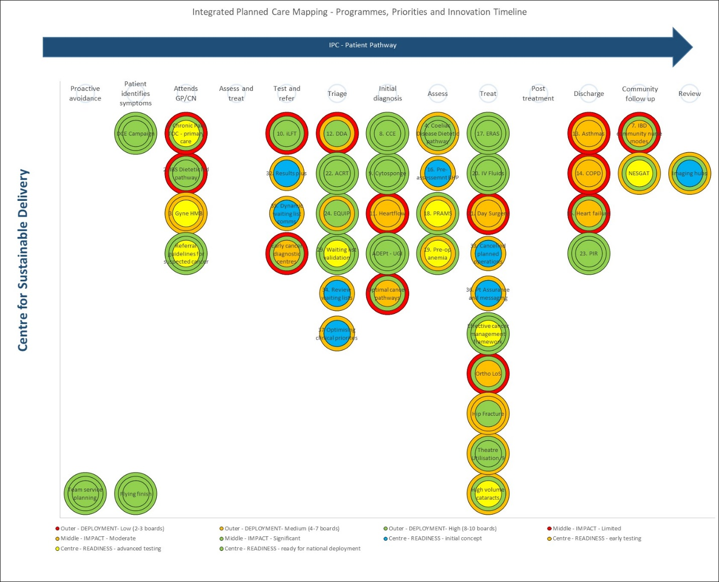

Supporting Cancer Performance and Early Diagnosis Programmes

The Cancer Performance and Early Diagnosis Programmes work collaboratively with academics, wider UK nations, senior leaders, patient representatives, third sector, NHSScotland’s clinical community and beyond to improve outcomes for cancer patients by increasing earlier detection rates of cancer, improving waiting times and enhancing patient experience.
The work streams are driven by the Scottish Government cancer policy and can be broadly categorised into the following areas:
- Cancer Waiting Times Performance Support
- Improving Early Diagnosis
- ‘Once for Scotland’ optimal cancer pathways
- Optimising Diagnostic Capacity
- Data to drive improvements in outcomes

Appendix 3 summarises the workplan for Cancer Performance and Early Diagnosis Programmes including objectives and outcomes.
Scottish Access Collaborative (SAC) and Modernising Patient Pathways Programmes (MPPP)

The SAC and MPPP have developed networks of clinicians and senior leaders across specialities and from different settings including Primary and Secondary Care. This approach has secured clinical engagement in the design and delivery of a number of high impact changes to support redesign and improvement.

The work streams supporting these changes are broadly categorised into the following areas:

- ‘Once for Scotland’ pathways and processes that can be applied across specialities and settings
- Innovation based transformation of pathways
- Workforce Development
Appendix 4 summarises the workplan for SAC and MPP programmes including detailed objectives and outcomes.

Other Planned Care Programmes

There are several workstreams delivered within the Planned Care performance team, who work collaboratively with senior leaders and NHSScotland’s clinical community and wider stakeholders to improve productivity, efficiency and outcomes for elective care services across Scotland.

The work streams are driven by Scottish Government elective care policies and to support improvements in waiting times and access to elective care. The planned care programmes work on a regional and speciality basis across NHSScotland with a focus on specialities with high volumes of elective care procedures including:

- Endoscopy
- Diagnostics
- Orthopaedics
- Ophthalmology
- Clinical Prioritisation

These workstreams will be reviewed in line with development of the Integrated Planned Care Programme and through further work with Scottish Government and key partners as outlined above to develop a national portfolio approach and agree an updated workplan for CfSD.

Appendix 5 summarises the workplan for Planned Care Programmes including detailed objectives and outcomes.

Supporting Unscheduled Care Programmes
The Unscheduled Care programmes remain under the direction of Scottish Government to support delivery of the four-hour Emergency Access Target, which continues to be seen as the barometer of the secondary care system. The Unscheduled Care Performance team use a collaborative improvement methodology, working with senior leaders and unscheduled care professionals, to optimise delivery of unscheduled care and improve health outcomes.
The key workstreams of the Unscheduled Care Programme are:

- 6 Essential Actions to improve unscheduled care
- Redesign of urgent care

The Unscheduled Care Performance Team also provide performance support for NHS Boards to achieve the four-hour access target including winter planning support to manage seasonal variation that impacts on unscheduled care and the health and social care system.
6 Essential Actions to improve unscheduled care
Building on the firm foundations of the Six Essential Actions performance improvement programme, which has been successful in improving compliance with the 4 Hour emergency access target this programme focuses on enhancing capacity across the acute system to minimise delays and support recovery.
Appendix 6 summarises the workplan for the 6 Essential Actions including objectives and outcomes.
Redesign of Urgent Care
The Redesign of Urgent Care (RUC) programme enhances the 6 Essential Actions by focussing on providing care as close to home as possible and ensuring patients are seen in the most appropriate clinical environment for their healthcare need. The programme is delivered under the direction of the Scottish Government and focuses on collaboration across the whole system to design and implement a safe, sustainable, patient and outcome focused system of urgent care access, and treatment.
Principles of the redesign are:
- Access to urgent care will be made available through a national Single Point of Access through NHS 24 / 111 (this will be available 24/7 for urgent care)
- Local Boards will implement a Flow/Navigation Centre that will directly receive clinical referrals from NHS 24 and offer rapid access to a senior decision maker – optimising digital health where possible and signposting to available local services such as MIU, AEC and ED if required,
- All attendances will be as scheduled an approach as possible
- Optimise local pathways of care in response to local needs, demand and capacity, such as Musculoskeletal presentations, elderly care and minor injuries
- Improve referral pathways of care from and to GP in hours; community pharmacy; mental health pathway; and other interface care

The Unscheduled Care Programmes are being developed through further work with Scottish Government and key partners and the CfSD stands ready to support these programmes including alignment with the integrated planned care programme and emerging national portfolio approach workplan for CfSD.

5.3 Collaboration with key strategic partners
The CfSD will work with strategic partners to ensure a collaborative approach to driving redesign and transformation across NHSScotland with a strong focus on engagement and involvement of health and social care professionals. The CfSD will work with partners using the following key principles to achieve effective collaboration:
- Develop a national portfolio approach that clearly articulates the key programmes of work to support redesign and transformation and the delivery responsibilities of partners
- Alignment and coordination of existing national programmes for redesign and transformation to avoid duplication and maximise the benefits of working together to support health and social care
- Adopt collaborative leadership model that sets out lead organisation role for different elements of national portfolio and agrees support for delivery required from partners
- Establish mechanism to enable partners to monitor and manage delivery of national portfolio including holding to account for nationally agreed actions
- Provide support and mutual aid across national portfolio to address challenges in delivery of national redesign and transformation of health and social care
- Ensure engagement and collaboration across secondary, primary, community and social care settings to support a holistic approach across health and social care
- Ensure the citizen is at the heart of the design, development and delivery of the portfolio and Care Programmes.
Statements of intent and support from key strategic partners are included in Appendix 7

5.4 Designing and Establishing New Programmes

The CfSD will support the development of new programmes commissioned by the Scottish Government informed by the Care Programme Steering Groups or via the AWP. A key tool for this work will be based on the Design Council Double Diamond approach illustrated below which uses 2 phases to support redesign and transformation.

Discover and Define – Review with stakeholders, including people who use services, how these are currently delivered and agree how they should be delivered in the future to meet the needs of service users and optimise quality, outcomes and performance.

Develop and Deliver – Explore and evaluate ideas for redesign and transformation and agree solutions to develop, test and implement across Scotland.

This approach will be used to rapidly explore known challenges to clearly define the scale and scope of the challenge and identify solutions to develop, test and implement across Scotland. Proposals would be submitted to the Care Programme steering groups for endorsement and to Scottish Government for formal commissioning.

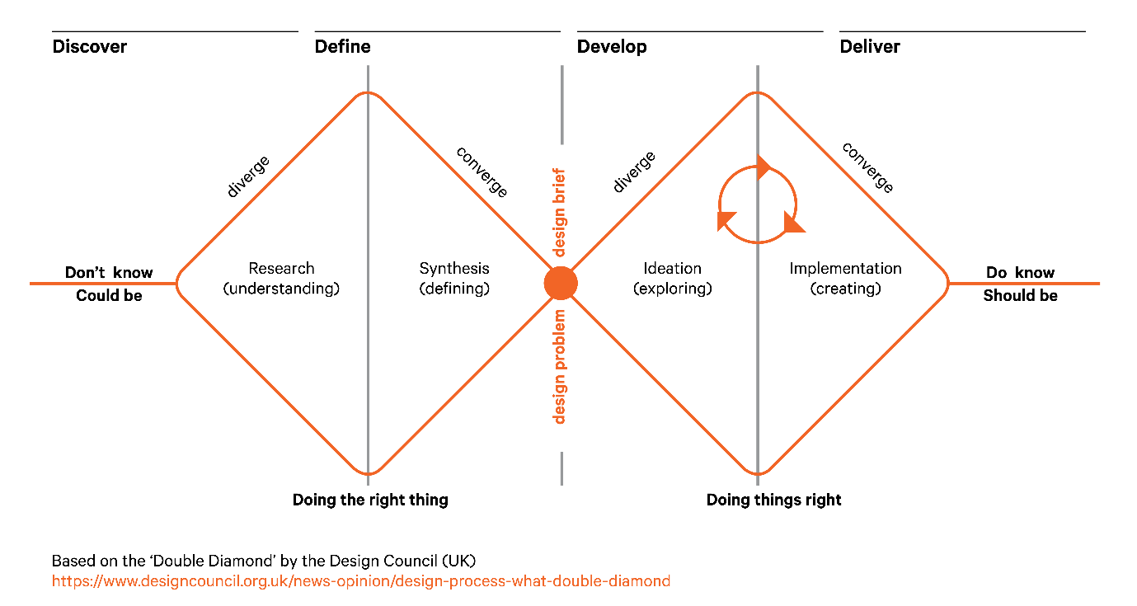
This approach will use:

- Data and Intelligence – The CfSD will use data and analytics to understand and present the challenge to be addressed, to quantify the anticipated impact of redesign, and to define the measures that will be used to track delivery. It will also work with partners to identify where solutions have been developed already that could be scaled up.
- International Best Practice – The CfSD will work with partners through an advisory board to research and identify best practice to incorporate into designing solutions to implement across Scotland.
- Innovation and Technology – The CfSD will work with partners to identify innovation that can be implemented at scale to accelerate transformation and to support the commissioning of new innovation projects to address key priorities.
- Workforce development - New programmes will also need to take into account changes to our workforce and maximise the opportunities to develop job roles to support new care pathways. This will require new approaches to workforce development.

Working with NES and the NHSScotland Academy – a joint venture between NHS Education for Scotland and NHS Golden Jubilee - we will, not only develop opportunities for critical skills developments, but consider novel solutions to attracting young people to produce a skilled, resilient NHS workforce for the future.

5.5 Bespoke Support for NHS Boards

The Centre will further develop capability to provide timely bespoke support for NHS Boards. It will work with and listen to key stakeholders, analysing data, financials and pathways and consider the potential for programmes, innovations and digital opportunities to refresh and refocus remobilisation plans.

The CfSD will work in partnership with NHS Boards and strategic partners to maximise collaboration across health and social care leadership teams to provide powerful insights to how services can be redesigned and transformed

This is an evolving piece of work and a fuller outline of the methodology will be developed in due course incorporating the feedback from key stakeholders.

5.6 Supporting Best Practice & Realistic Medicine

Developing the CfSD as an internationally recognised centre of excellence will include further work and collaboration with key partners to ensure that research, development and innovation are central to the design and delivery of its workplan. Working with partners to develop data collection, analysis and reporting will also be essential to capturing data once to use for multiple purposes including planning and delivery of redesign and transformation and evaluating the impact on health outcomes and population health.
Developing Academic Partnerships and Publishing Research
The CfSD will build on existing academic partnerships to integrate commissioning and publication of research across its portfolio and ensure expansion of the knowledge base to support redesign and transformation. This will drive evidence based accelerated change and identify areas for further research, innovation and development.

Appendix 8 gives further details of current research underway within the CfSD programmes of work and illustrates the range of academic partnerships already in place. However, a key ambition of the CfSD is to work with partners to grow research associated with redesign and transformation and the knowledge base that will inform future programme design and delivery and grow the reputation of NHS Scotland as a leader in health and social care redesign and transformation.
National Data and Performance Analysis
CfSD has a key requirement for access to data, analytics and modelling to support:
- monitoring progress and measuring impact of national redesign and transformation programmes
- Research and evaluation
- Analysis of performance and identifying opportunities for improvement
- Developing scenarios to support consideration of service redesign
- Understanding changes in capacity and demand at national level and locally

CfSD will work with partners to define the datasets required to be able to deliver on their annual work plan. Where this requires additional data capture and storage this will be delivered by partners across the system as agreed through the National Care Programmes and with Scottish Government.

Appendix 9 provides a short summary of the key developments underway to support CfSD in accessing the data that it requires.
Supporting Innovation
The CfSD is already supporting innovation through its national programmes including roll-out of SCOTCAP, Cytosponge and the testing of Heartflow. The CfSD will provide a delivery mechanism through national programmes for redesign and transformation to accelerate adoption of innovations as they become ready. The CfSD is also well placed to identify the innovation requirements for health and social care and support commissioning of innovation projects.
Key priorities for innovation are:
- Through the national Innovation Steering Group, work with key partners including NHS National Services Scotland, to map the innovation landscape and develop an ‘innovation pipeline’ to plan delivery and implementation.
- Ensure the innovation pipeline is aligned with national programmes for redesign and transformation to accelerate adoption of innovation.
- Identify key priorities for commissioning health and social care innovation to support redesign and transformation.

6. Questions
How will CfSD support Health and Care Recovery through Redesign?
A programme of engagement with NHS Boards and key stakeholders will be undertaken in Q1/Q2 2021/22 to understand current understanding and perceived value of the CfSD programmes and to ask a number of critical questions to form a revised workplan in Q3/Q4 2021/22 and shape the evolving work of the new national unit to best support Scotland. In particular, there will be a focus on the development of CfSD as a collaborative taskforce capable of both designing and supporting national programmes but also on a new iteration of bespoke support to work with NHS Boards to understand challenges and develop more effective focused solutions.
How is CfSD Commissioned and Monitored?
CfSD is commissioned by annual workplan by Director General/CEO NHS Scotland with agile updates throughout the year. A monthly workplan progress report including key agile changes is produced and monitored. A refreshed approach will also be developed for bespoke commissions as described above.
What are the reporting lines for CfSD?

How will updates be provided and how can I get more information?
A comprehensive approach to providing information and updates to stakeholders will be developed including:
- A CfSD Website
- CfSD Social Media channels
- Email and Sway Communications

In addition, regular updates will be provided through key national forums via National Directors and Associate Directors of CfSD.

7. Appendices
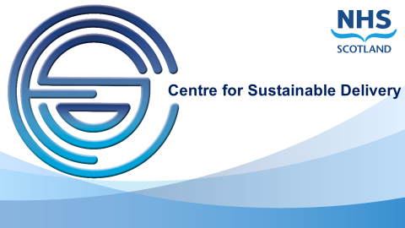

Appendix 1- Centre for Sustainable Delivery Structures, Governance & Financial flows

- Purpose
This document outlines the arrangements for the newly formed CfSD in terms of:
- Reporting Lines
- Roles and Responsibilities in relation to:-
  - Performance under SLA to SG
  - CfSD via annual work plan and monthly report
- Governance arrangements for:
  - Performance SLA Element
  - CfSD Improvement Element
- Financial Flows for:-
  - Board allocations from SG to Boards
  - Staff Resources hosted by NHS GJ
  - CfSD Programme Resources held by NHS GJ for CfSD to support Boards.

- Context
Over recent years there have been a suite of programmes and performance support functions embedded within Scottish Government Management Structures reporting to the Director of Performance for NHS Scotland. These programmes have led on important areas of work to promote improvement in pathways and performance including:
- Scheduled Care Performance and Delivery Team
- Unscheduled Care Performance and Improvement Team
- Scottish Access Collaborative
- Cancer Performance and Early Diagnosis Performance & Delivery
- Modernising Patient Pathways Programme
In January 2020, the NHS Scotland Chief Executive and Director of Performance commissioned NHS Golden Jubilee to work with Scottish Government, Health Performance and Delivery Directorate leaders to develop the programmes into a new cohesive national unit under the employment of NHS Golden Jubilee. This new unit is the Centre for Sustainable Delivery (CfSD).
The CfSD governance framework has been agreed between Scottish Government and NHS Golden Jubilee, taking three main areas into account
- Managerial Accountability
- Direction from Scottish Government
- Financial Flows

- Managerial Accountability

All team members are employees of NHS GJ and work within the policies of the organisation. In addition, they are also required for their work with SG to follow the required SG code of conduct and confidentiality.
As described within Figure 1 below, the National CfSD unit delivers either via SLA to SG with direction from the NHS Scotland COO or via an agreed annual workplan under the oversight of NHS GJ Chief Executive. The annual workplan is also agreed with the NHS Scotland COO with regular progress reports provided by the NHS GJ Chief Executive.

Figure1. CfSD Organisational Chart

Operational Arrangements
The work of CfSD is delivered through Function 1 described below, however, part of the resources within CfSD also undertake a second role to support the SG led performance management. As outlined these functions are provided and monitored in different ways.
Function 1 – Transformation via the Centre for Sustainable Delivery (CfSD)
The transformation, programme and bespoke services of CfSD are defined within an Annual Work Plan (AWP) which is aligned with the 3R’s Reform agenda, the Integrated Planned and Unscheduled Care Programmes and the associated NHS Board Remobilisation Plans. The AWP will be agreed annually between Scottish Government and CfSD with regular progress reports and required agile changes in response to evolving needs and Care Programme direction through the year.
Elements of bespoke work which will be required on a reactive basis will also be reflected in the monthly progress reports and any significant changes in this regard. The aim is to develop an approach for the requesting bespoke work with NHS Boards to work with them to understand system challenges and opportunities and enable effective and resilient change.
NHS GJ will, through the Chief Executive as accountable officer for CfSD function 1, ensure that CfSD provides regular assurance reports for function 1 to Scottish Government, in line with existing NHS GJ corporate governance mechanisms.
For those elements delegated to the CfSD, overall progress of the Annual Work Plan (AWP) will be scrutinised by the NHS GJ Strategic Portfolio Governance Committee every two months. In turn the SPGC will produce an assurance statement which will be noted at NHS GJ Board and to the DG/NHS Scotland CE & COO.

Weekly Senior Team Business meetings of the CfSD will be in place to ensure robust ongoing programme monitoring and review. The meetings will include the NHSS COO, NHS GJ CEO and CfSD National Directors and Associate National Directors. These meetings will be strategic in nature to optimise the role of CfSD.
Function 2 – SG Performance Support via SLA to SG

The NHSScotland COO is responsible for performance management of NHS Boards on behalf of the Director General for Health and Social Care and Chief Executive of NHSScotland. Support for performance management will be provided via Service Level Agreement with Scottish Government for specific staff to work under the direction of the NHSScotland Chief Operating Officer (COO).

Performance Management of NHS Boards remains entirely the responsibility and remit of SG and NHSGJ plays no role in these matters.

  - Direction from Scottish Government

For those elements delegated to the CfSD, strategic direction will be set by the DG/NHS Scotland CE delegated to the NHS Scotland Chief Operating Officer and will be reflected within the AWP and monitored via corresponding progress reports.

For the elements related to NHS Board Performance this will be achieved through a Service Level Agreements (SLA) between NHS Golden Jubilee and Scottish Government to define the scope of service to be provided on a routine basis. NHS Golden Jubilee will be responsible for ensuring the appropriate skills and workforce capacity are available to fulfil the SLA. Performance Management of NHS Boards remains entirely the responsibility and remit of SG and NHSGJ plays no role in these matters.
The following is a non-exhaustive list of what will be included via the SLA:

- Providing critical review and analysis of NHS Boards’ performance to address specific Scottish Government enquiries including ministerial requests for information
- Routine analysis and reporting of NHS Boards’ performance to Scottish Government defined within an agreed reporting framework including frequency
- Providing information to meet the needs of civil servants managing parliamentary questions

The SLA will also confirm the following:
- the Performance roles which will be undertaken by individuals under the direction of the NHS Scotland COO.
- those CfSD staff will continue have access to Scottish Government buildings and to Scottish Government information systems, including provision of Scottish Government IT equipment to enable them to undertake their roles and provide the services outlined above
- On-call arrangements for ensuring appropriate daily and weekend provision of services as outlined above

Access to buildings and information systems will be managed through existing Scottish Government policies including provision of individual security passes/accounts and management of information governance through individually assigned IT equipment and accounts.

In addition to routine performance management functions agreed within the SLA there may be additional direction from Scottish Government to undertake commissioned performance management. These may include for example:
- Direct performance management support for NHS Boards in response to the NHS board performance escalation framework
- In depth analysis and review of NHS Board performance requiring working for extended period(s) with one or more boards
- Providing advice to the NHS Scotland COO on annual Board allocations
Financial Flow

Staffing Resource and Programme Funding

To ensure clear lines of responsibility, accountability, assurance and scrutiny it is important that consideration is given to the best approach to be able to effectively fulfil all required elements in a clear manner. The CfSD financial flows and governance are outlined below:
Funding Flow 1 – CfSD Staff Resource - CfSD staffing resource will be covered by recurring budget transfer to NHSGJ. This will be adjusted annual to provide additional resource where required aligned to the Annual Work Plan.

Funding Flow 2 – SG Programme funding for direct allocation to NHS Boards – this will remain within SG for direct allocation by SG under the advice of the CfSD Directors. Direct allocation to NHS Boards would continue as is currently the case following the advice to SG from CfSD National Directors. Direct allocation funding would be retained within existing Scottish Government financial governance arrangements with NHS Scotland Chief Operating Officer retaining accountability for the timetable and allocation of funding to NHS Boards. The CfSD will provide advice and recommendations to NHS Scotland Chief Operating Officer to inform the allocation process as part of the SLA described.

Funding Flow 3 – Transformation/ Improvement Programme funding for CfSD – this will be set and passed annually to NHSGJ and will be allocated by CfSD Directors in line with the annual workplan and will be monitoring within the monthly performance reports and onward scrutiny by the NHSGJ SPC.

This will be transferred to NHSGJ for deployment in line with the AWP and/or as per any formally updated instruction from SG in the event of essential change. This programme funding would be associated with defined improvement and redesign programmes to be delivered by CfSD and would exclude funding allocated directly to NHS Boards in relation to performance management. For elements delegated to NHSGJ, the programme funding would be subject to review and scrutiny via progress reports within the NHSGJ governance arrangements. An assurance statement would be provided to the DG/NHS Scotland CE and NHS Scotland COO.

This enables clear demarcation between policy decision and operational delivery and is proposed as the best option.

Appendix 2 – CfSD Heat Map
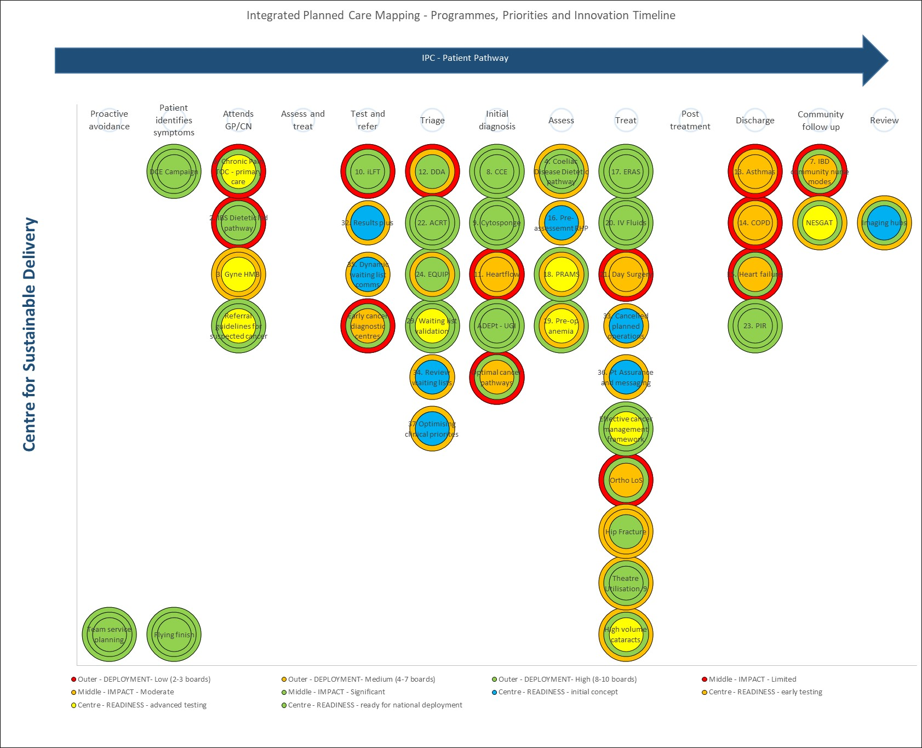

Appendix 3 – Cancer Performance and Early Diagnosis – Objectives and Outcomes

Early Diagnosis
Workstream | Description | Objectives | Expected Outcomes
Lung Cancer | To raise awareness of lung cancer signs and symptoms that cross over with COVID-19 symptoms. | - Attitudinal research around lung cancer and awareness of symptoms.  - Commission creative agency to develop creative routes for TV campaign.  - Engage clinical community to shape campaign messaging and content.  - Update and review content/copy for DCE’s public facing website – getcheckedearly.org  - Support the third sector’s public facing messaging and campaigns, wherever relevant/possible. | USC lung referrals return to pre-COVID levels and, longer term, staging improves.
Early Diagnosis Strategy | To direct and improve upon Scotland’s early detection efforts over the next two years while adopting a whole systems approach’ | - Develop and deliver national early diagnosis strategy for Scotland.  - Strengthen links to SG screening policy.  - Carry out gap analysis for cancer prevention as potential new area of focus. | Increase in the proportion of cancer patients being diagnosed quicker and at an earlier stage in NHSScotland.
Early Diagnosis Campaigns | To raise awareness of the improvement around cancer outcomes and reduce fear of cancer. | - Revisit the role of existing ‘Survivors’ – ‘pan tumour’ - campaign in a post COVID environment.  - Explore development of new tumour specific campaign activity to support recovery efforts. | More people participating in national screening programmes and presenting to primary care with potential signs of cancer.

Optimal Pathways
Workstream | Description | Objectives | Expected Outcomes
Establish Scotland’s first Early Cancer Diagnostic Centres (ECDCs) | To introduce at least two Early Cancer Diagnostics Centres (ECDCs) in NHSScotland. | - Establish ECDC Oversight Group.  - Support the establishment of at least two pilot sites by Spring 2021 with regular meetings/status updates with Boards.  - Agree independent evaluation requirements with University of Strathclyde.  - Develop patient information and support elements of the new pathway with key third sector organisations inc. Macmillan Cancer Support and CRUK.  - Continue to build and maintain strong relationships with other UK nations to develop RDC/ ECDC network. | A shortened diagnostic pathway for those with symptoms suspicious of cancer and a conversion rate to cancer that aligns to similar models in wider UK nations.
Referral pathways | To work with primary care professionals to promote referral or investigation at the earliest reasonable opportunity for people with symptoms suspicious of cancer, whilst making the most effective use of NHS resources and avoiding adverse impact on access. | - Review use of Scottish Referral Guidelines for Suspected Cancer.  - Fund CRUK’s Clinical Engagement Team to support the lung cancer pathway recovery with primary care education (inc. webinars)  - Continue to feed into NCDA Scotland steering group.  - Commission University of Aberdeen to undertaking analysis of upcoming NCDA data to better understand referral patterns and avoidable delays in relation to lung cancer and non-specific symptomatic cohort.  - Continue membership of Scottish Primary Care Cancer Group (SPCCG).  - Fund NCA to undertake innovative pharmacy referral pilot.  - Commission national guidance to support effective referral patterns (i.e. USC lung cancer referral guidance). | Ensure referral guidelines reflect up to date evidence and best practice and supporting the primary and secondary care interface.
Challenged 62 day pathways | Support improvement to the primary and secondary care interface through service redesign methodologies. | - Review outputs from the DCE funded Head and Neck and Melanoma pilot projects to ensure scale up of any best practice.  - Support tests of change where measurable outcomes clearly demonstrated and facilitate roll-out where relevant. | sharing of best practice and development of new optimal pathways for cancer patients.

Diagnostic Capacity
Workstream | Description | Objectives | Expected Outcomes
qFIT for use in symptomatic patients | Ensure that those patients with highest clinical risk are triaged to diagnostics timeously. | - Maintain an overview of the use of FIT in the symptomatic population, ensuring FIT prioritisation guidance is embedded across endoscopy services.  - Development of qFIT outcome dataset.  - Support the development of the Endoscopy Recovery and Renewal Plan. | ‘Once for Scotland’ qFIT guidance embedded into SRGs.
Direct Access to CT | Ensure that those patients with highest clinical risk of cancer are triaged to diagnostics timeously. | - Support Boards to implement guidance for direct access to CT CAP for Cancer of Unknown Malignancy. | Annual SCIN audit of direct access to radiology leading to improvements in diagnostic waiting times.
Lung Health Checks | To explore feasibility of lung health checks in high risk populations. | - Feed into national discussions and decisions around emerging lung screening evidence.  - Attend steering group for The University of Edinburgh’s feasibility study in relation to high risk screening in Scotland. | To inform NHSScotland approach to lung health checks.

Data
Workstream | Description | Objectives | Expected Outcomes
Cancer outcomes post COVID-19 | To understand changes in presentation, referral and treatment of cancer as a direct result of COVID-19. | - Work with PHS to define new cancer datasets to feed into the SCRIS cancer intelligence platform.  - Collaboration with Alan Turing Institute and IHDP to explore cancer outcomes pre and post COVID.  - Develop clinical datasets for qFIT, NMIMC and Barretts surveillance. | Improved data to inform future public awareness campaigns and clinical guidance.
CWT Data and Definitions | To support NHS Boards in application of CWT rules equitably. | - Ensure the Data and Definitions Manual is reflective of practice across NHSScotland.  - Annual review of CWT D&D manual.  - Commission PHS Audit of application of CWT D&D manual.  - Produce final report from Cancer Waiting Times Recommendations Implementation Group (CWT RIG). | Consistent approach to application of CWT data and definitions across NHSScotland.
Innovation and Best Practice | Support dissemination of good practice throughout NHSScotland, submitting abstracts to relevant conferences and journals. | - Present at CRUK Virtual Early Diagnosis Series.  - Abstract submission to CAPRI.  - NHSScotland event – plenary or parallel session. | Greater collaboration across UK cancer teams.

Appendix 4 – Scottish Access Collaborative and Modernising Patient Pathways – Objectives and Outcomes

Innovation
Workstream | Description | Objectives | Expected Outcomes
SCOTCAP - Colon Capsule Endoscopy (CCE) | Roll out of Colon Capsule Endoscopy as an alternative investigation for a proportion of Colonoscopy demand. | - Continue roll out of CCE across Scotland.  - Increase CCE activity in line with anticipated demand to support increased diagnostic capacity. | - Increase CCE activity in line with anticipated demand.  - Current data suggests around 25% of new Colonoscopy referrals would be suitable for CCE.  - Anticipated that ~5k procedures per annum achievable.
Cytosponge | Roll out Cytosponge as an alternative investigation for a proportion of Upper GI Endoscopy demand. | - Continue roll out of Cytosponge across Scotland.  - Increase Cytosponge activity across all Boards to support endoscopy capacity. | - Increase Cytosponge activity across all Boards to support endoscopy capacity.  - Current data suggests up to 30% of new referrals for Upper GI Endoscopy would be suitable for Cytosponge.  - Anticipated that ~8k procedures per annum achievable.
Remote Health Pathways (RHP) | Supporting a reduction in face to face attendances via technology enabled pathways. | - Increase use of remote consultations.  - Redesign speciality pathways to incorporate remote health monitoring and assessment where appropriate. | - Further details on specific initiatives outlined in speciality pathway redesign projects detailed below.

Once for Scotland Pathways
Workstream | Description | Objectives | Expected Outcomes
Active Clinical Referral Triage (ACRT) | Senior clinical decision maker reviews of all relevant electronic patient records, including imaging, lab results to triage to optimal, evidence-based, locally agreed pathways reducing the need for face-to-face (F2F) attendances. | - Support spread and scale up of ACRT across all Health Boards and specialties using the already established Specialty Groups as a mechanism to drive implementation. | - ACRT embedded across key specialties in all Health Boards.  - Reduction in face to face attendances.  - Working towards reduction of up to 15% face to face appointments.
Discharge Patient Initiated Reviews (PIR) | Conversion of pre-arranged routine follow up appointments where clinically appropriate to patient initiated requests for review. | - Support spread and scale up of Discharge PIR across all Health Boards and all specialities using the already established Specialty Groups to drive implementation. | - Discharge PIR embedded across key specialties in all Health Boards.  - Reduction in face to face attendances.  - Working towards reduction of up to 15% face to face appointments.
Equality Interventions Pathways (EQuIP) | Redesign of pathways for procedures which benefit relatively small numbers of people and redirect those who are not likely to benefit, to alternative options. | - Spread following pathways across Scotland:  - hernia and haemorrhoids  - benign skin lesion pathway  - Develop and test tonsillectomy pathway.  - Identify further pathways for testing via Specialty Groups. | - Hernia, haemorrhoid and skin lesion pathways rolled out across all Health Boards working towards associated 16k reduction in appointments.  - Testing of tonsillectomy pathway in two Health Boards complete with data available re. scale up potential.  - Further pathways identified for testing and testing initiated.
Enhanced Recovery After Surgery (ERAS): | Evidence based pathways to help people recover more quickly after having major surgery or procedures. ERAS aims to ensure that people:  - are as healthy as possible before receiving treatment.  - receive the best possible care during their operation.  - receive the best possible care while recovering. | - Support boards across Scotland to implement and embed ERAS pathways for the following specialities:  - Orthopaedics  - Colorectal  - Emergency Laparotomy  - Obstetrics  - Expand and develop ERAS datasets and data collection systems to support quality, performance and outcomes.  - Develop Urology ERAS pathway and dataset. | - Improved data collection and therefore pathway management across multiple specialities via online data collection system  - Significant improvements in research capabilities across Scotland.  - Maintenance of reduced LoS (5 days for Colorectal).  - Continued lower rate of reduction of 85% in 30 day mortality.  - Continued Emergency Laparotomy outcomes data which demonstrates equitable outcomes to rest of UK. Median LoS 10 days, Mortality = 9%.  - Embedding of national pathway and minimum dataset for Joint Replacement surgery making it the first country in the world to embed international guidelines into practice  - Progress towards a reduction in LoS from 4 days to 2 (freeing up 30,000 bed days).  - Widespread implementation of EROSS across all Health Boards with increase towards Day 1 discharge rate for elective c-sections from 4/10 to 6/10 nationally.
Day Surgery | Supporting improved rates of Day Surgery across Scotland focusing on a once for Scotland approach. | - Re-convening of multi-disciplinary national day surgery group.  - Clinical lead to support work.  - Identify nurse-led pathways for Day Surgery ensuring delivery of safe, effective and person-centred care.  - Develop competency frameworks for Nurse Led Pathways and development of training and education resources to support the same.  - Develop career Framework for nurses working within Day Surgery utilising Transformation of Nursing Roles Methodology.  - Ensure nursing contribution to improved patient outcomes for Same Day Surgery practice. | - Once for Scotland nurse-led pathways tested and implemented.  - Reduction in bed days for key high volume day surgery procedures as identified in the British Association of Day Surgery Hand Book.  - Competency framework developed and available.  - Career Framework developed and available.
Pre-Operative Anaemia | Supporting improved patient outcomes and blood management across NHSScotland. | - Re-establish programme to support remobilisation in major surgery.  - Publish annual report to show benefit in patient outcome and blood management across NHSScotland.  - Work with Haematology Scotland Network to reduce blood test and standardise lab system to improve utilisation and testing of blood samples.  - Work with SBTS (Scottish Blood Transfusion Service) to review impact of programme at population level. | - Improved patient outcomes.  - Reduced cancelled operations.  - Improved blood management.
Intravenous Fluids | Supporting spread and embedding of best practice in prescription and management of intravenous fluids to reduce variation. | - Continue to support reliable implementation of NICE Guidelines for intravenous fluids across boards.  - Implement and embed RedCap Audit system. | - Improved compliance with NICE Guidelines.  - Reduced spend for IV Fluids with potential 35-45% saving in spending on large bag fluids.
Bringing it together programme | Supporting NHS Boards to combine multiple elements of redesigned pathways including ACRT, PIR and Remote Consulting to achieve greater impact. | - Complete delivery of Bringing it Together 2 with NHS Greater Glasgow and Clyde Gastroenterology and NHS Highland Urology services.  - Deliver Bringing it Together 3 virtual development programme for all of Scotland Health and Social Care | - Reduced demand for face to face appointments.  - Improved access for patients.  - Increase in virtual attendances.  - Optimisation of capacity.

Speciality Pathways
Workstream | Description | Objectives | Expected Outcomes
Gastro-intestinal | Supporting spread of nationally agreed symptom based pathways for five most common GI presenting symptoms to reduce avoidable referrals from Primary to Secondary Care including avoidable diagnostics. | - Endorsement, spread and implementation of the five symptom based pathways to support reduced secondary care demand (OP appointments and diagnostics). | - Reduced secondary care demand, face to face appointments and diagnostics in the five high volume pathways.
Coeliac Disease | Once for Scotland Pathway for Coeliac Disease to support improved time to diagnosis and community based dietetic led management. | - Increase number of Health Boards embedding the redesigned Coeliac Pathway.  - Further development of ‘No Scope’ Diagnosis Pathway to reduce demand for scopes and time to diagnosis for patients. | - Reduced time to diagnosis for patients.  - Reduced demand for GI consultant appointments.  - Reduced demand for Upper GI Endoscopy.
Inflammatory Bowel Disease (IBD) | Supporting spread of guided self-management to reduce exacerbations and need for primary or secondary care intervention. | - Enhancement, spread and embedding of guided self-management service model across Scotland.  - Explore opportunities to enable national Care Plan and Flare Card to be utilised through digital platforms.  - Conclude testing of community nurse model and publish results to support further spread. | - Reduced secondary input for IBD patients.  - Enhanced access to patient self-management tools.  - Further roll out of Nurse-Led community based IBD model of care.
Irritable Bowel Syndrome (IBS) | Once for Scotland Pathway development to support diagnosis and treatment in Primary Care with support from dietitians for 2nd line intervention. | - Further roll out of IBS pathway across Scotland.  - Publication of test of change site data.  - Toolkit available to support local Board implementation. | - 25% reduction in GI outpatient appointments.  - Primary Care access to dietetic-led FODMAP intervention (current success rate of 89%).
Intelligent Liver Function Testing (Ilft) | Streamlined laboratory process to ensure appropriate information regarding patient management provided to Primary Care. Ensuring timely and appropriate referrals to Secondary Care. | - Implementation and evaluation of the Ilft pathway in 2 further Boards across Scotland.  - Establish national group to consider Scotland wide adoption and potential models for delivery.  - Engage with national laboratories programme to support implementation | - To improve time to diagnosis of liver disease.  - To reduce avoidable referrals to secondary care by providing advice to support Primary Care management.  - To increase number of timely referrals to secondary care for those patients at higher risk of developing significant liver disease
Dermatology | Supporting spread of once for Scotland pathways including digitally enabled dermatology pathway to support diagnosis and treatment in primary care where possible and reduce secondary care referrals. | - Support roll out of Digital Dermatology Assessments across further Health Boards.  - Finalise Dermatology online Education modules for trained nurse and health care support worker roles.  - Further develop Dermatology Pathways app including addition of 5 further pathways.  - Digital Clinical Images: Development of principles agreed at national level and support for progress of the national digital media store. | - Reduced requirement for face to face secondary care appointments both new and return.  - Availability of educational modules supporting development of dermatology workforce.  - Once for Scotland approach to digital media storage agreed.
Cardiology and Cardiac | Supporting testing and spread of once for Scotland pathways including digitally enabled pathways to support improved access for patients. | - Testing of HeartFlow enabled coronary heart disease pathway using artificial intelligence analysis of CT scans in two further Health Boards.  - Design and build of Heart Failure Remote Health Pathway (RHP) to reduce face to face contacts and reduce time to optimisation of therapy for newly diagnosed heart failure patients.  - Host virtual learning event Q2 2021 re: outpatient management during pandemic and identify key priorities moving forwards. | - Evaluation of HeartFlow in two further Health Boards complete.  - Business case developed with respect to potential further roll out of HeartFlow across Scotland.  - Heart Failure RHP available for use across Scotland.  - Further redesign opportunities identified for development.
Respiratory | Supporting testing and spread of once for Scotland pathways including digitally enabled pathways to support improved access for patients. | - Testing of RHP for Asthma in two health boards.  - Testing of RHP for COPD in two health boards.  - Testing of remote delivery of spirometry model.  - Testing of respiratory hot clinic approach.  - Initiate national sleep studies group to consider opportunities to redesign pathways on a once for Scotland basis. | - RHPs for asthma and Chronic Obstructive Pulmonary Disease (COPD) available in Health Boards.  - Outcomes from test of change models available and opportunities for further scale up identified and implementation supported.  - Further tests of change opportunities identified and implemented (sleep studies).

Chronic Pain | Supporting redesign of chronic pain service model across Scotland including self-management and primary care specialist services. | - Support 9 Boards to test and implement primary care specialist service model.  - Develop shared decision making app.  - Develop RHP.  - Develop and implement effective prescribing toolkit. | - Nine Test of change models reviewed and opportunities for scale up identified with support for implementation provided.  - Increased provision of self-management and primary care services to support chronic pain services.  - Reduced demand for secondary care specialist pain services.  - Shared decision making app available.  - RHP developed and tested.  - Effective prescribing toolkit available for use.
Neurology | Redesign of neurology pathways to include referral management support for primary care and reduce demand on secondary care and provide easier follow up access for chronic conditions. | - Develop and test national headache pathway.  - Support spread of clinical nurse specialist service model.  - Spread ACRT and PIR models across neurology services. | - Once for Scotland headache pathway agreed and implemented.  - Reduced demand for secondary care neurology services.  - Clinical nurse specialist model implemented more widely across Scotland.
Urology | Supporting testing and spread of once for Scotland pathways to support improved access for patients. | - Redesign of urology pathways, including implementation support for haematuria and lower urinary tract.  - Referral management support for primary care and reduced demand for cystoscopies in secondary care.  - Support implementation of non-invasive bladder cancer surveillance guidelines across Scotland.  - Support further spread of ACRT and Discharge PIR.  - Investigate potential for One Stop Clinic models.  - Standardisation of clinic lists (i.e. number of cystoscopies/session), and review opportunities for workforce development (enhanced nurse-led roles), linking in with NES on nurse cystoscopy training developments. | - Reduced variation across Health Boards for patient management across high volume pathways.  - Reduced demand for secondary care including diagnostics.  - Increase in number of one stop clinic services available.
Breast Services | Supporting testing and spread of once for Scotland pathways to support improved access for patients. | - Redesign of Breast care pathways including referral management support for primary care to support reduced referrals to secondary care.  - Development of a once for Scotland breast pain pathway.  - Wide spread implementation of ACRT and Discharge PIR across Health Boards. | - Implementation of national breast pain pathway across Scotland.  - Reduction in referrals to secondary care  - Improved patient information available providing reassurance including via NHS inform.  - Enhanced referral management support for Primary Care.
General Surgery | Supporting testing and spread of once for Scotland pathways to support improved access for patients. | - Redesign of inguinal hernia and right upper quadrant pain pathways to include referral management support for primary care and nurse led secondary care support.  - Implementation of ACRT and Discharge PIR. | - Reduced referrals to secondary care.  - Nurse-led services implemented and tested in two Health Boards with opportunities for further roll out identified.
Gynaecology | Supporting testing and spread of once for Scotland pathways to support improved access for patients. | - Implementation of ACRT and Discharge PIR.  - Spread of redesigned pathways for heavy menstrual bleeding and pelvic pain including referral management support for primary care.  - Identification of further pathways for redesign. | - Reduced referrals to secondary care.  - Widespread adoption of already developed pathways for heavy menstrual bleeding and pelvic pain.  - Identification and testing of further high volume pathways underway.
Ear Nose and Throat | Supporting testing and spread of once for Scotland pathways to support improved access for patients. | - Development of self-management support and referral management support for primary care including asynchronous questionnaire for priority conditions (Chronic cough, anosmia, chronic nosebleeds, otitis externa, ear pain and hole in eardrum).  - Support adoption of head and neck cancer risk calculator.  - Pilot with 2 boards self-management support including asynchronous questionnaire for dizziness and facial pain.  - Test asynchronous outpatients with one board. | - Reduced referrals to secondary care with improved support for primary care.  - Availability of asynchronous questionnaires to support ACRT process.  - Widespread adoption of head and neck risk calculator.  - Pilot site data available and opportunities of further spread identified.
Vascular | Supporting testing and spread of once for Scotland pathways to support improved access for patients. | - Develop and test redesigned pathways for Venous Leg Ulcer and Chronic Limb, Threatening Ischaemia, Abdominal Aortic Aneurysm.  - Provision of training to support Venous Leg Ulcer Pathway. | - Test site data available to determine potential impact of scale up including improving access for patients.

Workforce
Workstream | Description | Objectives | Expected Outcomes
Accelerating the Development of Enhanced Practitioners (ADEPt) | Supporting spread of enhanced roles across Scotland to increase capacity for priority specialities. | - Continue support for nurse endoscopy programme.  - Deliver pilot programmes for:  - Endoscopy suite Healthcare Support Workers  - Nurse cystoscopy | - 16 nurse endoscopists trained.  - Outcomes from pilots available.  - ADEPt resources developed and available on a ‘Once for Scotland’ basis.  - ADEPt pilot cohort training leads to a recognised transferable qualification.  - ADEPt cohorts are aligned to the highest national capacity pressures.  - Increased consistency of education, development and practice.  - Cohort based training with accompanying economies of scale.  - Regional or national workforce planning for roles with smaller numbers.
Team Service Planning | Support implementation of team service planning for medical workforce to support improved capacity, productivity and workforce wellbeing. | - Deliver Team Service Planning Development Programme.  - Support Bringing it Together sites with Team Service Planning. | - Via the Bringing it Together Virtual Development Programme over 160 participants will have developed knowledge and skills to support local implementation of Team Service Planning.
Flying Finish | Delivery of flying finish programme to support staff in later stages of career. | - Delivery of flying finish recommendations:  - career milestones review, later career planning, flexible working,  - Age Positive workforce  - Flying Finish endorsed programmes including Professional Practice Adviser (PPA) Pilot | - An increase in staff retention.  - Reduced burnout.  - Reduced locum / agency use and costs.  - The provision of greater options for flexible working.

Appendix 5 – Planned Care Programmes – Objectives and Outcomes

Workstream | Description | Objectives | Expected Outcomes
Trauma and Orthopaedics | Embedding national agreed standards and pathways in elective orthopaedics and trauma including hip fracture. | - Spread of ACRT and PIR across orthopaedics services in Scotland.  - Spread of same day treat and discharge for hip and knee arthroplasty.  - Delivery of Scottish Hip Fracture Audit to identify and address areas for improvement and improve hip fracture outcomes. | - ACRT embedded across all Orthopaedic services seeking to reduce the requirement for face to face attendances of up to 30%Target figures for elective:  - reduction in waiting lists,  - reduction in follow ups,  - decrease average length of stay/number of same day cases.  - Target figures for SHFA – mortality reduction, bed days/length of stay etc.  - Reduce variation across Scotland
Ophthalmology | Implementation of integrated primary and secondary ophthalmology pathways to deliver more community based eye care. | - Spread of community optometrist service model for glaucoma and macular disease including workforce development.  - Support development of national eyecare digital solution to support integrated primary and secondary care model.  - Roll out national eyecare digital solution across 4 health boards. | - 50000 additional community optometrist appointments by December 2021.  - 4500 reviews by 18 NESGAT community optometrist for stable glaucoma in 2021.  - 40 additional NESGAT optometrists to be trained across all mainland boards in 2021/202 and further 60 in following years to reach over 100 NESGAT optometrists by 22/23.  - 25,000 stable glaucoma reviews in community by 2024.
Clinical Prioritisation | Implementation of a system to treat patients on the basis of their clinical need. | - To have a national Clinical Prioritisation system implemented, that consistently treats patients on the basis of their clinical urgency.  - To support the measurement of service performance on the basis of when patients are treated. | - Removal of variation across Scotland in regard to the treatment of patients.  - Implementation of a Performance Framework to support the delivery of care across all Specialties.
Endoscopy | Development of an Endoscopy Training Academy. | - To ensure that sufficient staff are trained across Scotland to support the delivery of an enhanced Endoscopy Service.  - To ensure staff are upskilled with regard to best practice, and work to the extent of their licence. | - Trained endoscopists that will support the enhancement of Endoscopy services.  - Reduction in the length of wait that patients experience, as a sustainable service is delivered.
Diagnostics - Imaging | Enhancement of efficiencies and pathway redesign within CT and MRI services. | - To develop a sustainable imaging service to timely and effectively support the wider healthcare provision.  - To provide access to diagnostics in a timely and effective manner. | - The increase in activity delivered by imaging services as they move towards a sustainable position.  - Implementation of innovation to support more effective utilisation of imaging services.

Appendix 6 – Comments from Strategic Partners
NHS National Education for Scotland
NHS Education for Scotland (NES) is the national NHS Board with responsibility for education, training and workforce development. Having the right numbers of skilled, trained and supported staff, in the right place, at the right time and in the right roles is essential to providing high quality health and social care. In addition to providing national workforce and digital services which play a key role in supporting those who deliver frontline health and care, NES directly funds and manages learners who comprise a significant element of the NHS Scotland patient-facing workforce. NES aims to play a fundamental role in learning and development across the whole of the social care workforce. As an official provider of statistics NES provides workforce data and information to inform the future planning requirements of the NHS workforce.
NES will work with the National Centre for Sustainable Delivery (CfSD) to make sure that the education, training and workforce development of those who work in health and social care is integral in supporting service redesign, transformation, innovation and workforce planning. NES, Golden Jubilee and the NHS Academy will work with CfSD to provide accelerated learning opportunities for a wide range of subjects and professions, including residential and simulated virtual reality learning, to support a resilient and skilled workforce for NHS health and care in Scotland.
Working with CfSD and other partners, NES will contribute to the development of digital tools and solutions that enable innovation and improvements across health and social care leading to a digitally literate workforce, technology enabled services and improved outcomes for people. This will support NHS Boards to contribute to Remobilise, Recover and Redesign (3Rs) and enable the sustainable transformation of health and social care.

Karen Reid, Chief Executive, National Education for Scotland

Public Health Scotland

It is clear that Public Health Scotland with its significant data and analytical assets has a vital role in collaborating with the Centre for Sustainable Development. However, to deliver on the aims of the Centre it will be necessary to work as part of that collaboration to redevelop and transform these assets; the traditional retrospective focus on just healthcare activity data will not suffice. There is a need to create a stronger forward looking perspective with more capability in predictive analytics and scenario modelling. We need also to be able to look at the dynamics of remobilisation, recovery and redesign across the wider health and care system. This needs to include the ability to assess the impact of design choices at national level and for communities. This all aligns well with the direction of travel for data and analysis in Public Health Scotland; collaborating with the Centre for Sustainable Development provides an exciting opportunity to bring greater impetus to this work.

Angela Leitch, Chief Executive, Public Health Scotland

Healthcare Improvement Scotland

Healthcare Improvement Scotland
TO BE CONFIRMED WITH Robbie Pearson

NHS National Services Scotland
NHS National Services Scotland (NSS) welcomes the creation of the Centre for Sustainable Delivery (CfSD) and the clinical leadership and patient focus it will bring to health and care transformation. As a major infrastructure provider to NHSScotland and an organisation that aims to be integral to a world leading health and care service, we recognise the important role we can play in delivering sustainable service redesign and transformation through collaboration with the Centre. We are fully committed to partnering with the Centre and recognise the important role we can play in supporting its aims including:
- Our extensive programme management capability and programmes we manage on behalf of Scottish Government and health boards will require CfSD and NSS to work closely to align our respective efforts.
- Supporting innovation through development of a ‘Delivery Mechanism for Innovation’ in health and care in Scotland which can align and support the innovative approaches being commissioned and driven by CfSD which are ready to be rolled out at pace and scale.
- Through NSS Seer, our data science platform, we are able to store structured and unstructured data that can be used to deliver insight and performance reports that support redesign and transformation.
- Our national digital infrastructure that underpins NHSScotland’s clinical services. Working closely with the Centre ensures that all new redesign and transformation activity is fully integrated with this infrastructure. The Centre can also benefit from our investment in artificial intelligence tools that can be used within the existing infrastructure.

Mary Morgan
Chief Executive, NHS National Services Scotland

Appendix 7 – 6 Essential Actions - Objectives and Outcomes
Essential Action | Objectives | Outcomes
1. Clinically Focussed and Empowered Management | - Establishing a leadership team that is responsive to day to day management of whole system activity to avoid silo working and competing priorities.  - Ensuring that clinicians have adequate support to make timely decision.  - Reduce silo working and ensure whole system response across departments and multi-disciplinary teams.  - Improved Whole System working and communication leading to whole system response. | - Daily bed balance prediction.  - Balanced capacity against demand.  - Four hour EAS.  - Elective cancellations.  - Workforce data.  - Reduced staffing gaps reported as cause of patient delay.  - Escalation policy in place in every acute site.  - All departments familiar with triggers and actions.  - Predicted bed balance capacity – three times a day
2. Building Capacity and Flow | - Understanding barriers to flow and discharge, length of stay, re-admission.  - Managing capacity and demand to understand trends across by hour, day, week, month and year.  - Establish a robust data and information interface that feeds national trends and supports planning at local level.  - Building capacity and capability for planning and operational delivery. | - Breach Analysis by time of day, day of week, by flow.  - DCAQ checklist.  - Gearing App analysis.  - Number of attendances.  - Flow measures, time in assessment, time to bed request etc.  - Number of admissions.  - Admission rates.  - Ready for discharge rates, length of stay.  - Bed census.  - Consistency and completeness of modelling approach.  - Local recovery and successful implementation of local plan.
3. Optimising Patient Flow | - Optimising the flow of patients through emergency and acute assessment to minimise delays.  - Reduce delay across the discharge pathway, ensuring length of stay in inpatient bedded facilities is limited to what is clinically and functionally necessary, and patients are discharged to the most appropriate area of care as soon as they are well enough.  - Survey of all in-patients against set criteria to understand capacity constraints.  - Acute and community hospital. | - Reduce ambulance turnaround times.  - Reduced eight and 12 hour waits.  - Length of stay  - Planned date of discharge  - Reduction in delayed transfer of care  - No of in-patients who could be cared for in alternative setting.  - No of in-patients awaiting discharge home.
4. Managing Medical and Surgical Process for Optimal Flow | - Reducing LOS and admissions by integrating care and providing care closer to home. | - Monitor where care is provided for the defined groups – episodes of care at home, Primary or secondary care.

Essential Action | Objectives | Outcomes
5. Seven day services – reducing variation and minimising delays | - Minimising the delays from decision to admit and arrival at a bed.  - Utilising and balancing diagnostic capacity to match demand across diagnostics, and interventional and discharge decision.  - Admissions require discharges to be as early in the day as possible. | - Reduced time to bed.  - Reduced wait for bed breaches.  - Reduced wait for diagnostic breaches.  - Reduced length of stay.  - % pre-noon discharges.  - Reduced wait for bed breaches.
6. Ensuring Care Close to Home | - Reduce attendance and admissions to Accident and Emergency Departments (A&E) in a safe way ensuring that patients get the right care, in the right place at the right time, minimising delays and improving the staff and patient experience of Unscheduled Care. | - Reduction in attendances.  - Reduction in admission.

Appendix 8 – Current CfSD Research

CfSD Programme | Research Topic | Academic Partners
Cancer Performance and Early Diagnosis | To explore cancer outcomes for those patients who meet or fail the 62 and 31 day performance standards | Alan Turing Institute and IHDP
Cancer Performance and Early Diagnosis | The Second Cancer Research UK National Cancer Diagnosis Audit (NCDA) in Scotland: Analysing NCDA data to support the adoption of Early Cancer Diagnostic Centres in Scotland | University of Aberdeen
Cancer Performance and Early Diagnosis | Evaluating Scotland’s first early Cancer Diagnostic Centres | University of Strathclyde
Cancer Performance and Early Diagnosis | How should Scotland respond to the challenge of lung cancer screening? A mixed-methods feasibility study – members of Advisory Panel | University of Edinburgh
Modernising Patient Pathways and Scottish Access Collaborative | Health Foundation Adopting Innovation Hubs funding application | University of Strathclyde and NHS Lanarkshire
 | evidence base for development of redesigned outpatient pathways – safety/efficacy/cost-effectiveness | University of Strathclyde
 | impact of national enhanced recovery after surgery pathway on colorectal surgery population | University of Edinburgh
 | Impact of national orthopaedic enhanced recovery pathway on outcomes following joint arthroplasty | Bournemouth University
 | Evaluation of Flying Finish | Institute for Employment Research, University of Warwick
 | Evaluation of Bringing it Together SAC programme | University of Strathclyde

Appendix 9 – Data Collection, Analysis and Reporting Capability

CfSD Programme | Development Area
Modernising Patient Pathways | In conjunction with PHS, Design and develop RedCap data capture system to replace approved national data capture across Enhanced Recovery After Surgery work streams (NERCI/ARISE/ELLSA/EROSS/Pre-operative Anaemia).
Modernising Patient Pathways | Continue collaboration with PHS on bespoke report from the Hospital Medicines Utilisation Data (HMUD) to support national IV Fluids Programme (collaboration with PHS).
Modernising Patient Pathways | Implement approved Colon Capsule Endoscopy Registry (collaboration with PHS and Industry Partners).
Modernising Patient Pathways | Develop Cytosponge Registry and implement following amendment approval under existing approved mechanism (collaboration with PHS and Industry Partners).
Modernising Patient Pathways | Design and implement national data set for new surgical specialities in conjunction with RAS (Robotic assisted Surgery) National Delivery Group e.g. Urology – radical prostatectomy
Modernising Patient Pathways | Trial automated capture of Patient Reported Outcome Measures in RedCap in Urology Surgical Cancer patients (collaboration with NHSS and PHS).
Modernising Patient Pathways | Development of Outpatient specific dataset to underpin national uptake of ACRT/PIR/EQUIP pathways (in collaboration with PHS and NHSS).
Modernising Patient Pathways | Design and implement national data set for anaemia in pregnancy (PRAMS programme) in collaboration with PHS and Industry Partners.
Cancer Performance and Early Diagnosis | Development of national dataset for qFIT outcomes (PHS).
Cancer Performance and Early Diagnosis | Development of national dataset for Barretts Oesophagus (PHS).
Cancer Performance and Early Diagnosis | Development of dataset for Non-muscular Invasive Bladder Cancer patients (PHS).
Cancer Performance and Early Diagnosis | Development of datasets for Urgent Suspicion of Cancer Referrals (PHS).

95% of people are admitted, discharged or transferred within four hours of arriving at Accident and Emergency (A&E) with commitment of all boards working towards delivery of the 98% standard.

