Overview | Status | Green
Key milestones within this reporting period include:
- Assurance Review (Stage 4) report issued for factual accuracy checking

Progress Summary | Status | Green
Works on site
Progress summary: -
- Precast superstructure & precast facade complete
- L3 – Flooring is progressing to rooms as are furniture base units, and ceiling grid installation has commenced where above ceiling services are practically complete. Canopy installations are complete with pendant installation imminent
- L2 – All builderswork holes have been formed and are now being taped, first coat decoration has commenced as has 1st and 2nd fix M&E runs into rooms, Module connections awaited due to dirty extract ductwork installation. Module leave down walls are being installed following modules being erected in position
- L1 – Flooring has just commenced to L1, electrical switchgear is now predominantly on site, 1st & 2nd fix M&E above ceilings is well progressed in general
- Stairs 1&2 plasterboard complete with taping and handrail installation has commenced to stair 2
- All AHU’s except AHU7 now delivered
- Roof finishes predominantly complete
- Roof plant screen steelwork & louvres / acoustic louvres are now complete
- Curtain walling frame and glass to east elevation now installed
- Curtain walling frame and glass to the south elevation has now commenced
- Stair 2 roof steelwork is now installed with cladding & roof deck sheets now installed and roof finishes
- All lifts are now installed, commissioning to take place at a later date
- Floor finishes have been installed to 2no plant rooms on L3
- External doors are now installed

Works to progress in next 4 weeks:-
- Continuation of builderswork holes & 2nd side boarding L2 leave down walls
- Ductwork & modules to L2
- Stair finishes to Stairs 1 & 2
- Decoration to all floors
- 1st & 2nd fix M&E L3 & L1 & L2
- Ceilings & flooring to L3
- Floor finishes to L1
- Hygienic wall finishes L3 & L1
- Doors to L3
- Steelwork to large NHS signage area
- Roof works – Parapet capping & hot melt, slabs
- Lift installation 1 & 2
- Floor screeds
- Hoist removal & curtain walling works north elevation
- Mains cable and modular wiring install L1 & L3

Assurance Review
The draft report was issued on 19 August 2022 for factual accuracy checking. Following review by Programme Team, Advisor Team and Kier Team comments have been provided to NHS Scotland Assure Team for review and final report issue. This is expected by end September 2022.

Gateway Review
Engagement has commenced with Scottish Government in relation to the scheduling of the next Gateway Review. The previous review was held during October 2019. This has been delayed due to the stage 4 assurance review.

Implementation Stage
As the programme moves into the year ahead until handover, a review of the workstream groups has been undertaken to allow teams to transition from the design/construction stage to bringing the building into operational use.

The State of Readiness Group has been established to undertake strategic leadership to oversee the delivery of Phase 2 Surgical Centre through the transitional stages of construction to handover and then operational use. The group will provide strategic leadership to the delivery of Phase 2 Surgical Centre and associated refurbishment projects, overseeing the work of the teams, including the wider project team and delivery groups

The breakthrough work on Level 1 junction 3 has now been completed. The next stage of work will be Junction 2 to form the middle breakthrough on Level 1.
The areas for Level 2 breakthroughs have been handed over to the contractor to complete survey work for service isolation and diversions.

Work is also progressing with
- WTO 1 – Refurbishment of existing hospital accommodation to provide additional Orthopaedic Out Patient space. The contractors have now taken over the area following decant and the waiting area has been moved to the Conservatory.
- WTO 2 – Planning for service surveys is now underway within the main theatre area.
- WTO 3 – Refurbishment of areas on the periphery of theatre to provide Theatre Administration Space and Perfusion Set up Space. Survey work is now complete and construction work is due to commence over the next few weeks.
Workforce and Recruitment
3.00wte Orthopaedic Consultants have been recruited 2 of these will take up post next year. We currently have 48.5 wte nursing posts at different stages in the recruitment process, some of these posts are NQP’s and will not be available to start till later in the year. Recruitment for Endoscopy nursing posts has been encouraging however, peri-operative Band 5 posts continue to be hard to fill and we are currently advertising for Band 4 scrub practitioners. Recruitment to perioperative posts remains a high risk. We have an Orthopaedic Recruitment Event planned with a specific focus on theatres and ward areas.
The CSPD deputy manager has been appointed, this is a key role required to support the commissioning of the new department. Recruitment is now progressing with Clinical and Non Clinical roles taking into account the time required to train staff ahead of the new facilities opening.

Key Risks and Mitigation
Regular risk updates are received via the Programme Team on the PSCP register and via PSCP reports to the Senior User Group.
There is no change to the high risks as noted in the table below.

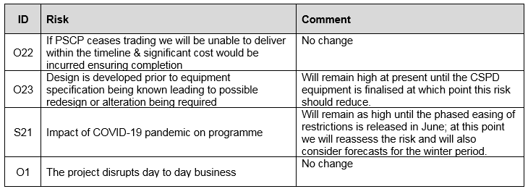

Programme Budget | Status | Green
The Cost Control Group continue to review progress against cash flow and meet monthly. The Group last met on 26 July 2022.
Issues Affecting the Programme | Status | Amber
The PSCP has intimated that the supply of some materials is being impacted due to the national shortage for certain items i.e. cement, steel and timber. Fan coil units (ventilation) are on a 50 week lead in period and the team are actively reviewing alternative solutions and engaging with HFS / NHS Scotland Assure on these. Engagement continues with HFS to ensure a consistent position is being taken nationally.

Access to Level 2 Endoscopy Decontamination Area. Work is almost complete to isolate and divert services within this area. A review of the overall programme will then be undertaken.

Works to areas adjacent to L3 theatres have been stopped due to noise. The Programme Team continue to engage with operational teams.

Communications and Stakeholder Engagement | Status | Green
Continuing engagement of stakeholders with refurbishment design.

Multidisciplinary approach for Orthopaedic Recruitment event

Continued quarterly newsletters issued to local residents directly from PSCP updating them on the works and any possible disruption.

Key Tasks for between now and next reporting period
Key tasks for the forthcoming period include:
- Stage 4 Assurance Review final report to be issued.
- Work to commence for Level 1 breakthroughs (junction 2)
- Commence removal of stairway 11
- HAI SCRIBE’s for Level 2 and 3
- Completion of survey work within existing theatres

John M Scott

Director of Facilities & Capital Projects

Susan McLaughlin

Clinical Programme Manager

August 2022

