Duty of Candour Annual Report

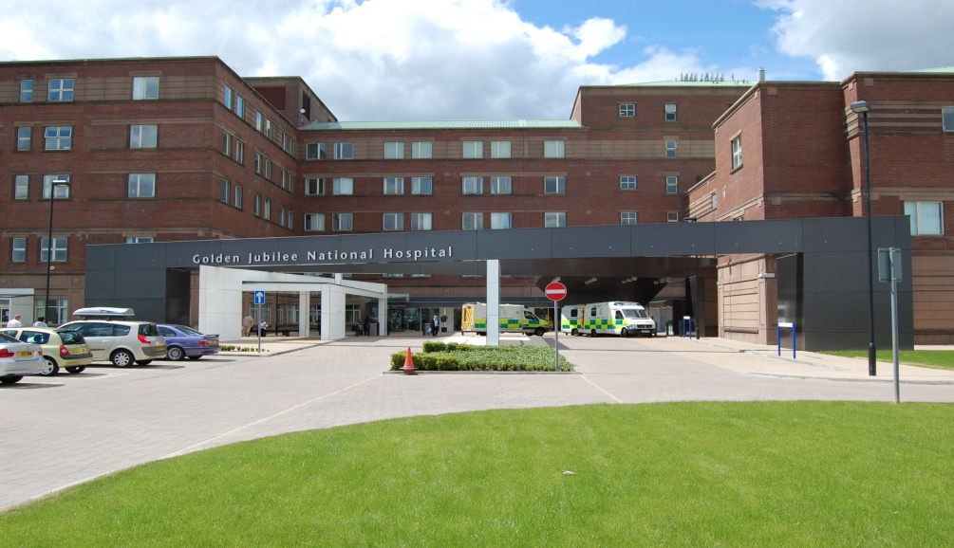

2021 – 2022

- Introduction

All health and social care services in Scotland have a Duty of Candour (DoC). This is a legal requirement which means that when unintended or unexpected events happen that result in death or harm as defined in the Act, the people affected understand what has happened, receive an apology, and that organisations learn how to improve for the future.

An important part of this duty is that we provide an annual report about how the DoC is implemented in our services. This report describes how we have operated the DoC during the time between 1 April 2021 and 31 March 2022.

- About Golden Jubilee National Hospital

NHS Golden Jubilee has always aimed to ensure that we support the delivery of NHS Scotland’s national health priorities. Our focus since our establishment has been to meet NHS Board demands and deliver equity of access to high quality healthcare for as many patients as possible so that they benefit from our clinical expertise and excellent facilities.

- COVID-19 Impact

During the COVID-19 pandemic, non-urgent services were paused in line with government guidelines. This had a significant impact on the activity within the hospital. All elective activity was paused and during this time clinical governance activity was temporarily paused until it was known what level of support was manageable taking into account clinician availability. Any open Significant Adverse Event Reviews (SAERs) were placed on hold and the patients/families were contacted and advised of this.

It was acknowledged that adverse events had the potential to still occur and this meant that normal processes for reporting adverse events were encouraged however a revised assessment process for Significant Adverse Event Reviews was implemented. This involved the development of a Brief Assessment Tool which was adapted from our SAER initial assessment tool and our SAER report template to support prompt review and investigation of any immediate issues and actions required. This tool also identified if any subsequent review was required when COVID restrictions were eased and business as usual (or as close to this) resumed.

During the reporting period the Initial Assessment Tool was used for forty-seven adverse events, with thirty-two of these progressing to an SAER investigation when appropriate to do so. The Duty of Candour procedure was applied in twenty-two of these events.

NHS Golden Jubilee have not triggered the Duty of Candour procedure for any events directly attributed to COVID-19.

During this period there were no families that requested to meet to discuss the findings of an SAER investigation.

- Our Policies and Procedures

Each Adverse Event is reported and reviewed via the Datix system. The procedure for reviewing each level of incident is set out in the Adverse Events Management policy. The Adverse Events Management policy and supporting tools/ guidance have been updated to reflect the introduction of DoC.

The decision on DoC is built into the Significant Adverse Event Review (SAER) process. All severity 4 and 5 adverse events are automatically escalated as potential SAER. Legislation requires that a clinical person must make the final decision on Duty of Candour. The Initial Assessment Tool (IAT) that supports review of SAERs is completed by the Clinical Governance Lead and/ or Clinical Nurse Manager depending on the type of event. This includes a specific question relating to the Duty of Candour status. The completed assessment and recommendation of Duty of Candour is then approved by the Division Management Team (DMT) which includes an Associate Nurse and Medical Director. Any IATs that do not progress for review are discussed at the service Clinical Governance Forum with multi-disciplinary representation to ensure learning is captured and tis offers further opportunity for any challenge on the level of review and DoC status.

Each adverse event is reviewed with a focus on learning from what has happened, regardless of the level of harm. If there is potential to learn from an error this should be harnessed and taken forward. On completion of an adverse event review actions are identified and these are monitored to completion via the Clinical Governance reporting framework.

All staff receive training regarding adverse event reporting and the implementation of DoC at via the corporate induction e-learning package. More in depth training is delivered to those responsible for reviewing incidents on Datix and a programme of investigation training is being refreshed for staff who could potentially take part in a Significant Adverse Event investigation; this will take the form of blended learning utilising webinars, MS Teams sessions and in-person training where possible.

We know that being involved in a significant adverse event can be difficult for staff as well as those affected by the event. We have support available to staff in the form of the formal line management structure. In addition to this we have the Spiritual Care and Diversity Lead and the Occupational Health team who are available to provide staff support in different forms following significant adverse events, where required. Further to this, patients/families are offered the support of our Spiritual Care Lead and clinicians where required.

- Significant Adverse Event (SAE) Activity 2021-2022

Between the period 1 April 2021 and 31 March 2022, there were thirty-two SAE’s reported; this is an increase of three events compared to the previous year.

Of these SAE’s, twenty-two events triggered the organisational Duty of Candour; table 1 below shows the breakdown of these in relation to the outcome of the event, specific detail regarding the events is documented in appendix 2.

Nature of unexpected or unintended incident where Duty of Candour applies | Number
A person died | 7
A person suffered permanent lessening of bodily, sensory, motor, physiologic or intellectual functions | 0
Harm which is not severe harm but results or could have resulted in:
An increase in the person’s treatment | 14
Changes to the structure of the person’s body | 1
The shortening of the life expectancy of the person | 0
An impairment of the sensory, motor or intellectual functions of the person which has lasted, or is likely to last, for a continuous period of at least 28 days | 0
The person experiencing pain or psychological harm which has been, or is likely to be, experienced by the person for a continuous period of at least 28 days. | 0
The person required treatment by a registered health professional in order to prevent:
The person dying
An injury to the person which, if left untreated, would lead to one or more of the outcomes mentioned above.
Total | 22

Table 1: Duty of Candour rationale

Regardless of DoC status, when adverse events occur, the appropriate clinician makes contact with patients and/or families to advise of an event and the investigation process.

- DoC Events

Of the twenty-two events that triggered the DoC, twelve reviews remain open at the time of reporting; these reviews are projected to breach timeframes, however effective communication will continue with those involved in the process. In all of the DoC cases, relevant parties were advised a review was taking place and they were also given a copy of the final report and an offer made to meet to discuss the content of the report.

Of the nine reviews that have concluded, two fully met the DoC process requirements including meeting the 90-day timescale for completion of the review process.

- Learning

Further to the review of the events that triggered the DoC various learning points were identified. Some of this learning currently being implemented includes:

- Lockable storage facilities should be explored for the Critical care bed spaces, which will include a separate compartment for controlled drugs.
- A refresh of the staff induction guidance booklet should be undertaken to include commonly used medications and their administration and preparation guidance.
- Marks on the patient’s body to identify the site of surgery must always be as close to the surgery site as possible and as big as possible.
- A policy for the delivery of steroid injections must be developed and ratified via the Drugs and Therapeutics Committee.
- Education around the hospital wide protocol for the Management of Hyperkalaemia is required within the Cardiology wards. The panel acknowledged that this is now printed and displayed in CCU drug cupboard but wider education around the policy, it’s content and accessibility of this is required.
- A group of nursing staff will be trained to undertake and interpret blood gas analysis. The existing competency training from Critical Care will be rolled out to this small group by the Clinical Educators
- Clarification will be sought from the labs team regarding adding ranges for abnormal venous blood gases to the system to enabling automatic flagging of abnormal results.

It is acknowledged that meeting the timescales for DoC has been challenging during this period. The Clinical Governance team work closely with the Divisional Management Teams to improve compliance with timeframes and will monitor this throughout the year making necessary amendments where indicated.

- Conclusion

This is the fourth year of the DoC being in operation. The organisation continues to learn and refine processes to ensure adherence to the DoC process.

This report will be disseminated via the Clinical Governance reporting structure for internal information and will also be published on our public website as per the DoC legislation. The Scottish Government will be made aware of the publication of this report and we are aware that they may, for the purposes of compliance with the DoC provision, request information regarding the content of this report.

Appendix 1 – DoC Criteria

Incident which activates the duty:
The DoC procedure must be carried out by the responsible person as soon as practicable after becoming aware that an individual who has received a health, social care or social work service has been the subject of an unintended or unexpected incident, and in the reasonable opinion of a registered health professional has resulted in or could result in:

- death of the person
- a permanent lessening of bodily, sensory, motor, physiologic or intellectual functions
- an increase in the person’s treatment
- changes to the structure of the person’s body
- the shortening of the life expectancy of the person
- an impairment of the sensory, motor or intellectual functions of the person which has lasted, or is likely to last, for a continuous period of at least 28 days
- the person experiencing pain or psychological harm which has been, or is likely to be, experienced by the person for a continuous period of at least 28 days
- the person requiring treatment by a registered health professional in order to prevent –

  - the death of the person, or
  - any injury to the person which, if left untreated, would lead to one or more of the outcomes mentioned above.

Appendix 2 – Events that triggered DoC

Ref | SAER Short Title | Duty of Candour Rationale | Category | Severity | Outcome code | Status
DW-7002 | Actrapid overdose | Increase in patients treatment | Medication/Biologics/Fluids | Moderate | 4 | Closed - breached timeframe
DW-7171 | Missing osteosarcoma specimen | Increase in patients treatment | Diagnostic Processes/Procedures | Moderate | 4 | Closed - breached timeframe
DW-7192 | Complications following cardiac surgery | Increase in patients treatment | Therapeutic Processes/Procedures | Major | 2 | Closed - breached timeframe
DW-7193 | Review of TAVI referral pathway | The patient died | Therapeutic Processes/Procedures | Moderate | 3 | Closed - breached timeframe
DW-7198 | Sudden Cardiac Arrest Death - joint review with GGC | The patient died | Unexpected Deaths or Severe Harm | Major | TBC | Open - being reviewed NHSGGC joint SAER
DW-7348 | Death following complex PCI | The patient died | Unexpected Deaths or Severe Harm | Major | 3 | Open - being reviewed
DW-7380 | Wrong side LA steroid injection | Increase in patients treatment | Medication/Biologics/Fluids | Moderate | 4 | Closed - completed within timeframe
DW-7420 | Cardiology retained swab | Increase in patients treatment | Diagnostic Processes/Procedures | Major | 3 | Open - being reviewed
DW-7447 | Missing specimen - leg | Increase in patients treatment | Communication | Major | 3 | Closed - completed within timeframe
DW-7493 | Patient Death - from complaint | The patient died | Unexpected Deaths or Severe Harm | Major | 4 | Closed - breached timeframe
DW-7640 | General surgery patient deterioration communication issue | Increase in patients treatment | Communication | Minor | 2 | Closed - breached timeframe
DW-7704 | 4ways discrepancy - Category 2 | Increase in patients treatment | Diagnostic Processes/Procedures | Moderate | 2 | Open - being reviewed
DW-7716 | Mesenteric bleed following robotic surgery | Increase in patients treatment | Therapeutic Processes/Procedures | Moderate | 3 | Open - being reviewed
DW-7829 | Remifentanil medication error | Increase in patients treatment | Medication/Biologics/Fluids | Major | 3 | Closed - breached timeframe
DW-7894 | Colostomy resulting in bowel obstruction - return to theatre | Increase in patients treatment | Therapeutic Processes/Procedures | Major | 2 | Open - being reviewed
DW-7895 | Patient fall CCU - fracture | Changes to the patients body structure | Patient Accidents/Falls | Moderate | 3 | Open - being reviewed
DW-7900 | Laprascopic choleycystectomy with resulting bile leak and readmission to hospital | Increase in patients treatment | Therapeutic Processes/Procedures | Major | 2 | Open - being reviewed
DW-7906 | Wrong side popliteal block | Increase in patients treatment | Anaesthesia Care | Moderate | 4 | Closed - breached timeframe
DW-7924 | Patient death following repatriation | The patient died | Administrative Processes | Moderate | 3 | Open - being reviewed
DW-8131 | Incorrect anaesthetic medication injected | Increase in patients treatment | Anaesthesia Care | Moderate | 3 | Open - being reviewed
DW-8191 | MCS Death | The patient died | Unexpected Deaths or Severe Harm | Major | 3 | Open - being reviewed
DW-8296 | Transplant patient death | The patient died | Unexpected Deaths or Severe Harm | Major | 3 | Open - being reviewed

