NHS Golden Jubilee

Meeting: NHS Golden Jubilee Board Meeting

Meeting date: 25 July 2023

Title: Board and Committee Meetings 2023/24

Responsible Executive/Non-Executive: Gordon James, Chief Executive

Report Author: Nicki Hamer, Head of Corporate Governance and Board Secretary

1 Purpose

This is presented to the NHS Golden Jubilee Board Meeting for:

Discussion

Decision

This report relates to a:
- Legal requirement
- Local policy

This aligns to the following NHS Scotland quality ambition(s):
- Safe
- Effective
- Person Centred

This report relates to all NHS GJ Corporate Objectives

2 Report summary

2.1 Situation
This report recommends a change to the number of Board and Committee meetings during 2023/24. The report also presents the new schedule of meetings and Committee Work Plans for 2023/24 for approval.

2.2 Background
NHS Boards are expected to create a coordinated timetable for Board meetings, Board Seminars and Governance Committee meetings. This programme seeks to ensure that an appropriate level of scrutiny can be delivered and that business is undertaken in a logical sequence.

As part of the Corporate Governance Update presented to the Board on 30 March 2023, a timetable for Board and Governance Committee meeting dates was presented and approved for the financial year 2023/24.

2.3 Assessment
This report now presents the recommendations from a review of Governance and Board Committees to accommodate one less Board/Governance Committee cycle.

To facilitate this change, the November Board meeting would move to 14 December 2023 with the Board Seminar in December moving into the original Board meeting date, 25 January 2023.

The table shown in Appendix 1 to this report indicates the new meeting date changes for 2023/24 which have been approved by the relevant Governance Committees.

The new Board Work Plans for 2023/24, taking into account the change of dates, are included in Appendices 2 and 3.

The table shown in Appendix 4 to this report presents the revised Work Plans that have been approved by the Governance Committees.

The table below shows an at a glance view of the proposed re-sequencing and schedule of meetings reducing the Board and Committee meetings by one cycle.

Meeting | Changes Proposed
Board Meeting | Remove 25 January 2024 meeting  Change date of board meeting from 23 November 2023 to 14 December 2023
Board Seminar | Change Board Seminar from 14 December 2023 to 25 January 2024
Audit and Risk Committee | Remove Tuesday 16 January 2024  Change Committee meeting from 7 November 2023 to Tuesday 28 November 2023
Endowment Sub Committee | Change Committee meeting from 20 February 2023 to Tuesday 30 January 2024
Board of Trustees | 28 June 2023  Creation of new date 26 October 2023  Creation of new date 22 February 2024
Clinical Governance Committee | Remove Thursday 11 January 2024  Change Committee meeting from Thursday 2 November 2023 to Thursday 14 November 2023
Finance and Performance Committee | Remove Thursday 11 January 2024  Change Committee meeting from Tuesday 31 October 2023 to Tuesday 14 November 2023
Staff Governance and Person Centred Committee | Remove Wednesday 10 January 2024  Change Committee meeting from Thursday 2 November 2023 to Thursday 9 November 2023
Strategic Portfolio Governance Committee | Remove Tuesday 16 January 2024  Change Committee meeting from Tuesday 24 October 2023 to Tuesday 7 November 2023

2.3.1 Quality/ Patient Care
The impact on quality/patient care is a key consideration for governance.

2.3.2 Workforce
The impact on quality/patient care is a key consideration for governance.

2.3.3 Financial
The provision of robust governance arrangements is key to NHS GJ delivering on its key objectives and to improving workforce, clinical and financial governance.

2.3.4 Risk Assessment/Management
Risk management is a key component of the Board’s Assurance Framework and Integrated Performance Report which is considered at each Board and governance Committee meeting throughout the year.

2.3.5 Equality and Diversity, including health inequalities
There are no specific issues arising from this paper.

2.3.6 Other impacts
Climate Emergency and Sustainability
No impacts were identified in relation to climate emergency and sustainability when preparing this paper.

Communication, involvement, engagement and consultation
NHS GJ Board and Governance Committee proposed meeting date and workplan changes have been produced in collaboration with all Governance Committees.

Route to the Meeting
This paper has been discussed and approved at the following Committee meetings:

- Audit and Risk Committee
- Finance and Performance Committee
- Strategic Portfolio Governance Committee
- Staff Governance and Person Centred Committee
- Clinical Governance Committee
- Endowment Sub Committee
- Board of Trustees

2.4 Recommendation

NHS Golden Jubilee Board is asked to:

- Discuss the proposed timetable of Board and Committee meetings for 2023/2024.
- Approve the reduction of one cycle of the Board and Governance Committees
- Approve the new meeting dates, subject to any final changes
- Approve the Board Meeting and Board Seminar revised Work Plans for 2023/24

List of appendices
The following appendices are included with this report:

- Appendix 1, Proposed Timetable of Meetings for 2023/24
- Appendix 2, Revised Board Work Plan 2023/24
- Appendix 3, Revised Board Seminar Work Plan 2023/24
- Appendix 4, Revised Governance Committee Work Plans 2023/24

APPENDIX 1

Proposal for Change to Board and Governance Committee Meeting Dates 2023/24

Below is the reviewed cycle of meeting dates for Board and Governance Committees for 2023/24 subject to any final changes.

Meeting | Date
Board Meeting | Thursday 25 May 2023  Wednesday 28 June 2023(Extraordinary Annual Accounts)  Tuesday 25 July 2023  Thursday 28 September 2023  Thursday 14 December 2023  Thursday 28 March 2024
Board Seminar | Thursday 27 April 2023  Thursday 31 August 2023  Thursday 26 October 2023  Thursday 25 January 2024  Thursday 22 February 2024
Audit and Risk Committee | Wednesday 19 April 2023  Thursday 15 June 2023  Tuesday 12 September 2023  Tuesday 28 November 2023  Tuesday 13 February 2024  Thursday 14 March 2024
Endowment Sub Committee | Tuesday 9 May 2023  Thursday 15 June 2023  Thursday 12 October 2023  Tuesday 20 February 2024
Board of Trustees | Wednesday 28 June 2023  Thursday 26 October 2023  Thursday 29 February 2024
Clinical Governance Committee | Thursday 11 May 2023  Thursday 6 July 2023  Thursday 7 September 2023  Thursday 14 November 2023  Thursday 7 March 2024
Finance and Performance Committee | Thursday 11 May 2023  Tuesday 4 July 2023  Tuesday 5 September 2023  Tuesday 14 November 2023  Tuesday 12 March 2024
Staff Governance and Person Centred Committee | Thursday 4 May 2023  Thursday 6 July 2023  Tuesday 5 September 2023  Thursday 9 November 2023  Tuesday 12 March 2024
Strategic Portfolio Governance Committee | Thursday 4 May 2023  Tuesday 4 July 2023  Tuesday 29 August 2023  Tuesday 7 November 2023  Tuesday 5 March 2024

APPENDIX 2
Board Work Plan 2023/24

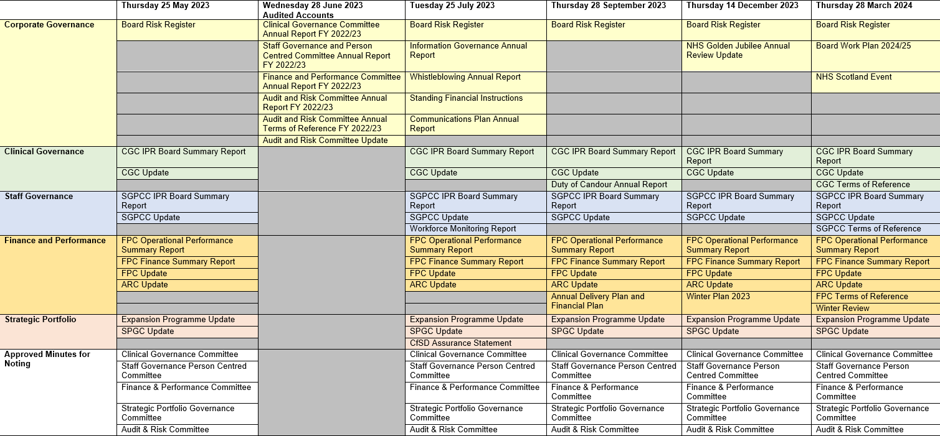
N.B. Remuneration Committee meets twice yearly in May and November

APPENDIX 3
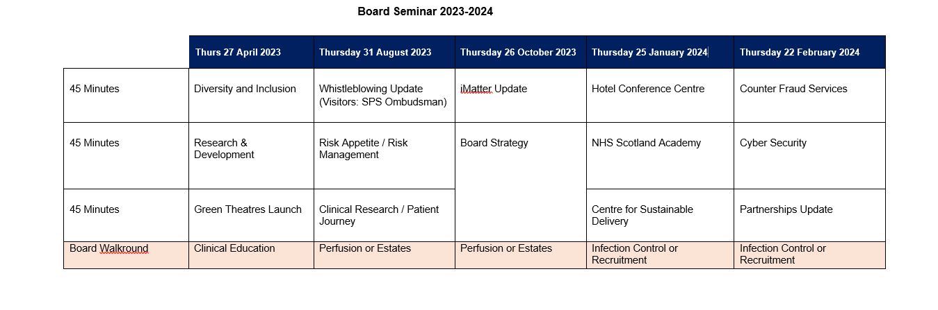

APPENDIX 4
Revised Governance Committee Work Plans 2023/24

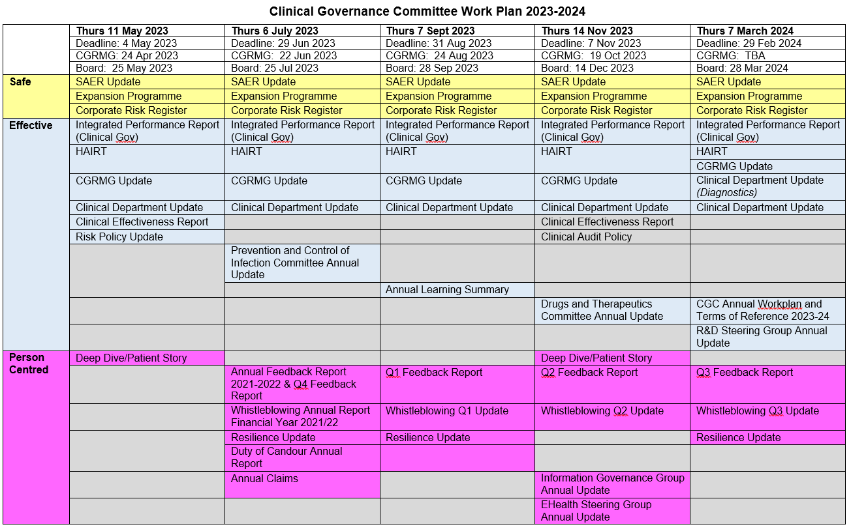
Finance and Performance Committee Work Plan 2023/24
