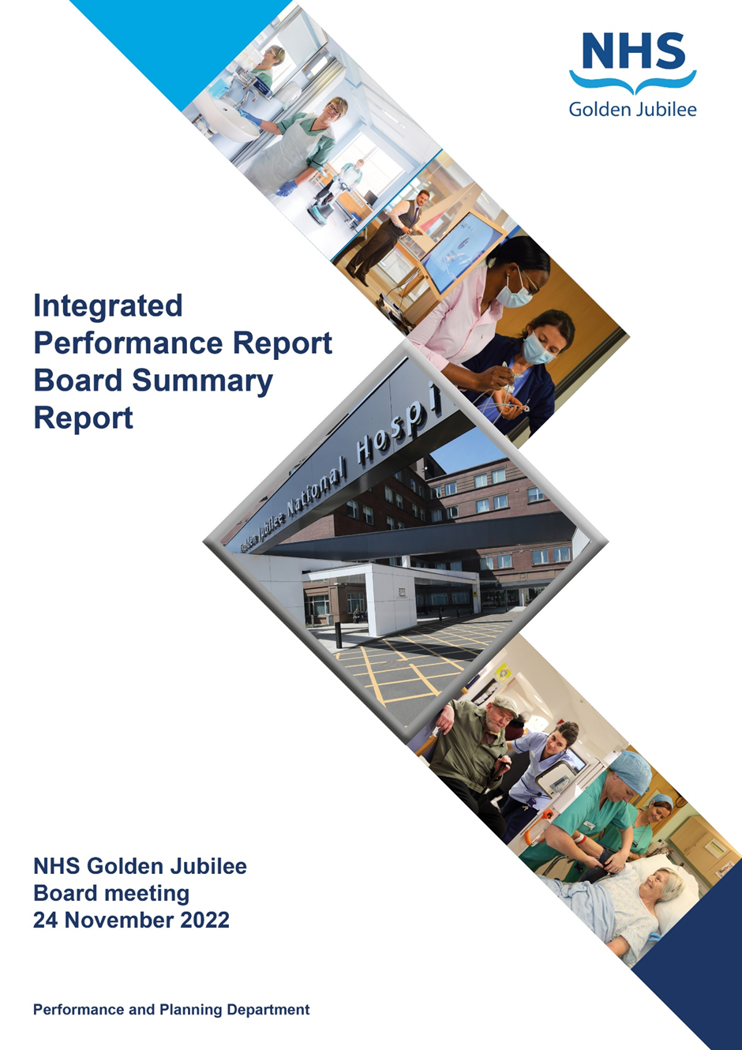

**25 May 2023**

**BoARD SUmMARy Report**

**Produced in April 2023**

**Data reported up to END of MArch 2023**

**For submission to:**

* **Board Meeting – 25 May 2023**

# Contents

**Introduction 2**

**Performance Summary Dashboard 5**

**Integrated Performance Report: Executive Summaries 7**

# Section A: Introduction

The purpose of the Integrated Performance Report (IPR) is to provide assurance on NHS Golden Jubilee’s performance relating to National Standards, local priorities and significant risks.

The IPR comprises four section with each section being considered in detail by the appropriate Standing Committee:

* Section A Introduction
* Section B:1 Clinical Governance
* Section B:2 Staff Governance
* Section B:3 Finance, Performance & Planning

This Board Summary Report of the IPR is presented to the Board and contains the summaries from each section of the full IPR.

**Gordon James Michael Breen Carolynne O’Connor**

**Chief Executive Director of Finance Director of Operations & Deputy CEO**

Performance Summary Dashboard – Guidance



Statistical Process Control – Guidance



Board Performance Dashboard – Part 1





Board Performance Dashboard – Part 2





At each meeting, the Standing Committees of NHS Golden Jubilee consider targets and standards specific to their area of remit using the Integrated Performance Report (IPR). There is a section of the IPR which provides a summary of performance Standards and targets identified as areas of note which is reproduced below. Topics are grouped under the heading of the Committee responsible for scrutiny of performance.

# Section B: 1 Clinical Governance

|  |  |  |
| --- | --- | --- |
| **Clinical Governance** | | |
| **KPI** | **RAG** | **Position:** |
| Total complaints (Stage 1 and 2) by volume |  | In February 2023 there were ten complaints reported. Latest position available. |
| Stage 1 complaints response time |  | In February 2023, there were five Stage 1 complaints, three were responded to within the five day target (60%). Latest position available. |
| Stage 2 complaints response time |  | In February 2023 there were five Stage 2 complaints, zero were responded to within the twenty day target. Latest position available. |
| Mortality |  | The mortality figure for March 2023 was reported as seven. |
| Significant adverse events |  | There was one significant adverse event review in March 2023. |
| MRSA/MSSA cases |  | There was two instances of Staphylococcus aureus Bacteraemia (SAB) reported in March 2023. |
| Clostridiodes Difficile |  | There were zero Clostridiodes Difficile Infections (CDI) reported in March 2023. |
| Gram Negative Bacteraemia |  | There were two reported instances of Gram Negative Bacteraemia in March 2023. |
| SSI: Hips & Knees |  | Surveillance recommenced in July with zero SSI reported in March 2023. |
| SSI: Cardiac |  | Surveillance recommenced in October with one SSI reported in March 2023. |

**Clinical Governance Executive Summary**

In February, we received five stage 2 complaints and five stage 1 complaints.  None of the stage 2 complaints were closed within the guidance timescale (20 days). Three of the stage 2 complaints are still open at the time of pulling the data for this report (13th April 2023).

60% of stage 1 complaints were responded to within guidance timescale (5 days) n = 3.

The average time to respond to stage 1 complaints was 5.2 working days to be completed and closed.  The average time to respond to stage 2 complaints was 20.5 days.

Mortality data remained within control limits for March 2023 (n=7)

No whistleblowing concerns have been raised during March 2023**.**

**Key Healthcare Associated Infection Headlines**

* ***Staphylococcus aureus* Bacteraemia-** 11 cases in total 22-23 / 21.37 per 100,000 total occupied bed days. Ortho SSI accounted for 30% of these cases.

This exceeds the local trajectory of 11.22 per 100,000 total occupied bed days, but below national quarterly rates ranging between 17-19 per 100,000 total occupied bed days.

* ***Clostridioides difficile* infection (previously known as *Clostridium difficile***) - 1 case in total 22-23 / 1.9 per 100,000 total occupied bed days.

This meets the local trajectory of 1.9 per 100,000 total occupied bed days and well below national quarterly rates ranging between 13-14 per 100,000 total occupied bed days.

* **Gram Negative/E.coli Bacteraemia (ECB)** - 11 cases in total 22-23 / 21.37 per 100,000 total occupied bed days.

This exceeds the local trajectory of 9.3 per 100,000 total occupied bed days, but below national quarterly rates ranging between 34-36 per 100,000 total occupied bed days.

DL(2023) 06 acknowledges the difficulty Boards are facing achieving the ECB target at a Scottish and UK level. The move to 50% reduction is been paused and will remain at 25%. Future year targets beyond 22/23 are being reviewed at a UK level.

* **Hand Hygiene**- The **bimonthly** report from Mar 23 indicates an overall compliance of 98% with hand hygiene opportunity and technique. NHS GJ compliance was sustained above 95% compliance over 2022 -23, with the lowest bi monthly compliance reported at 97% during this period.

**2022-23 HAI Activity Overview**

2022-23 continued to be a challenging year for NHS Scotland returning to business as usual. As NHS GJ Prevention Control Team, our key role in this period continued to be advisers to the Board on the prevention and control of infection response to COVID 19 aligned to evolving national guidance. As the epidemiology of COVID 19 changed so too did our national and local approach with a final move back to Transmission Based Precautions Oct 22

Beyond COVID, our team’s main focus has been to resume key national and local priorities. Our local activity has focused on meeting the objectives within the 2022/23 Prevention and Control of Infection Planned Programme. These activities centred on surveillance, compliance monitoring, policy review and development, provision of a safe built environment, education, antimicrobial stewardship and team development.

As Hospital Expansion moves closer to handover, PCI support and activity has increased. In previous years PCI activity had almost exclusively focused on the design and construction of Phase 2. In 2022/23, construction activity has further extended into our hospital footprint with breakthroughs from Phase 2 and associated redevelopment construction to support planned activity and flow. To support the planning around operational delivery of Phase 2, there has also been a marked increase in all PCI team activity in various delivery groups.

**National influencing factors**

During 2022/23 national priorities /publication have also influenced the work of the PCIT and NHS GJ, these include:

* The revised HAI Standards for Scotland which were launched by HIS in May 2022, these standards form the basis of HEI inspection.
* IPC Workforce Strategy 2022-2024
* Review of COVID 19 control measures and guidance
* HCAI Strategy 2023-2025 official launch June 2023

# Section B: 2 Staff Governance

|  |  |  |
| --- | --- | --- |
| **Staff Governance** | | |
| Disciplinaries |  | There were two disciplinary cases raised in March. |
| Grievances |  | There were no grievance cases raised in March 2023. |
| Dignity of work |  | There were zero dignity case raised in March 2023. |
| Local Sickness absence |  | Sickness absence in March 2023 was reported at 6.6%. This is within control limit. In March, absence due to COVID-19 reasons was 0.6% (+0.3%) |
| Turnover |  | Turnover in March 2023 was reported as within control limits at 1.1%. |
| Medical appraisal with completed interview & form |  | A new round of appraisals began in April 2022.  Performance is 77.5% (124/160) for March 2023. |
| TURAS Appraisal rates |  | Position for March 2023 reported as 70% (+1% on last month.) |
| Job Planning: All hospital |  | We have closed almost all medical job plans on the Allocate job planning system for 2022/2023 and started new job plans for the year starting 1 April 2023. To date, 8 of the 123 job plans for 2023/4 have been signed off, 63 are in discussion, with the remainder at various stages of the process. |

**Staff Governance Executive Summary**

**Sickness absence**

In March 2023, the Board’s sickness absence rate stood at 6.6%, up 1.0% on the previous month.

**Sickness absence**

In March 2023, NHS Golden Jubilee’s sickness absence rate stood at 6.6%, up 1.0%% on the previous month. Across the Directorates, sickness absence was as follows:

* Corporate: 5.2% (+0.9% on February);
* Golden Jubilee Conference Hotel: 3.9% (+0.7%);
* Heart, Lung and Diagnostic Services: 7.3% (+1.4%); and
* National Elective Services: 7.7% (+0.9%).

The rolling 12-month sickness absence rate for the Board was 5.5%. The 12-month breakdown for the Directorates was:

* Corporate: 4.5%;
* Golden Jubilee Conference Hotel: 3.1%;
* Heart, Lung and Diagnostic Services: 6.0%; and
* National Elective Services: 6.1%.

“Anxiety/stress/ depression/other psychiatric illnesses” continued to be the highest cause of sickness absence in March, accounting for 31.0% of all sickness absence, 1.6% higher than February’s figure of 29.4%. It was the main cause of absence in three Directorates:

* Corporate: 30.3%;
* Heart, Lung and Diagnostic Services: 24.6%; and
* National Elective Services: 38.8%.

In the Hotel “Injury, fracture” accounted for 30.8% of sickness absence, with “Anxiety/stress/ depression/other psychiatric illnesses” responsible for 25.5% of sickness absence.

“Injury, fracture” was the second top cause of sickness absence overall in March, accounting for 10.7% of sickness absence (up from 10.0% the previous month). The third top reason for sickness absence was “Cold, cough, flu - influenza”, coming in at 7.9%, down on February’s 8.4%.

**COVID-19**

In March, COVID-19 special leave accounted for 0.6% of all contracted hours, double the 0.3% of the previous month. The Directorate breakdown was:

* Corporate: 0.3% (+0.2% on February);
* Golden Jubilee Conference Hotel: 0.2% (same);
* Heart, Lung and Diagnostic Services: 0.9% (up from 0.5%); and
* National Elective Services: 0.7% (up from 0.4%).

Covid-related illness under sickness absence accounted for 0.4% of contracted hours in March. The Directorate breakdown was:

* Corporate: 0.2%;
* Golden Jubilee Conference Hotel: 1.0%;
* Heart, Lung and Diagnostic Services: 0.6%; and
* National Elective Services: 0.3%.

**Agenda for Change appraisal**

Within the twelve months to 31 March 2023, 70% of staff who come under the Agenda for Change terms and conditions completed their appraisal using TURAS, which is 1% lower than the previous month. The Directorate breakdown is as follows:

* Corporate: 65% (same as February);
* Golden Jubilee Conference Hotel: 33% (-13%);
* Heart, Lung and Diagnostic Services: 72% (same); and
* National Elective Services: 78% (-2%).

**Medical appraisal**

The appraisal year for medical staff runs from 1 April to 31 March. As at 4 April 2023, 124 doctors out of 160 (77.5%) had completed their 2022/2023 appraisal or had an ARCP. This is an increase of 35 on the previous month. 12 doctors are at some point in the appraisal process, and 24 have yet to start their appraisal.

**Medical job planning**

In February 2023 we closed almost all medical job plans on the Allocate job planning system for 2022/2023, and started new job plans for the year starting 1 April 2023. At the time of writing this report 7 of the 123 job plans for 2023/2024 had been signed off, 72 were in discussion, 20 were awaiting sign off by the doctor, 9 were awaiting sign off by the first manager, 14 were awaiting sign off by the second manager, and 1 was awaiting sign off by the third manager.

# Section B:3 Finance, Performance and Resources

|  |  |  |
| --- | --- | --- |
| **Finance & Performance** | | |
| Cancer 31 Day |  | In February 2023, nationally reported performance was 95% (39/41). Latest position available. |
| TTG: Number of patients who have breached the TTG |  | In March 2023 there were 115 patients who exceeded their twelve week treatment time guarantee. |
| TTG: Percentage of patients admitted within 12 weeks |  | The percentage of patients admitted within their twelve week treatment time guarantee was reported at 90.3% during March. |
| SoT Guarantee – Inpatient and DC cases (H & L only) |  | 73.6% of Heart and Lung patients were admitted within 12 weeks in March 2023. |
| DOSA rate: Cardiac Surgery |  | There were two DoSA cases in March 2023 (4.7%). A new profile for the year has been agreed. |
| DOSA rate: Thoracic Surgery |  | There were 26 DoSA cases in March 2023 (28.9%). A new profile for the year has been agreed. |
| DOSA rate: Orthopaedics |  | In March 2023 there were 232 Orthopaedic primary joint admissions, 125 (53.9%) of which were on the day of surgery. |
| Theatre Cancellation Rates |  | In March 2023, the overall hospital cancellation rate was 7.0% (185/2660). Within Control Limits. |
| Hospital Bed Occupancy |  | Hospital wide bed occupancy was reported as 76.3% in March 2023. Within Control Limits. |
| Hotel: Income |  | Reporting for March 2023, position was on plan (44%). |
| Hotel: Room Occupancy |  | March 2023 reported position 78.8% against target of 67.5%. |
| Hotel: Conference Room Occupancy |  | March 2023 reported position 87.6% against target of 66.2%. |
| Hotel: Delegates |  | March 2023 reported -1.9% against target of >-5%. |
| Hotel: Patient Bed Usage |  | February 2023 reported 10.4% against target of >-5%. |
| Hotel: Not for Profit % |  | March 2023 reported 48.3%, against target of 50-60%. |
| Hotel: Pro Quality Score |  | March 2023 reported 88.4% against target of >86%. |
| National Comparison Table, Corporate Dashboard, Waiting list & Productivity table | | |
| The GJNH nationally reported elective cancellation rate, in February 2023, was reported as 5.3%. This ranked GJNH as 2 out of 15. The Scotland rate was 8.5%. | | |
| Golden Jubilee comparative performance against the national 31 Day Cancer target is reported using the Information Services Division (ISD) nationally published position. In February 2023 GJNH reported 95% of eligible patients treated within the target (Ranked 9 out of 22). | | |
| Health Protection Scotland published figures for Quarter 3 2022 report a GJNH incidence rate (per 100,000 total occupied bed days) of 15.8 for CDiff incidence and 31.6 for SAB. The Scotland rates were 13.1 and 17.1 respectively. | | |
| Corporate sickness rate in March 2023 was 5.2% up 0.9% on the previous month. Departments over the 4% threshold were: Business Services, Catering, Clinical Governance, Estates, Finance, Housekeeping and Pharmacy. | | |
| Referral numbers in March 2023 were 3721 (+370).  The total outpatient waiting list decreased by 385 from 2316 to 1931  The total inpatient waiting list month end position increased by 461 from 4508 to 4969.e number of patients waiting over 52 weeks | | |
| For current inpatient waiters the number waiting between 12-26 weeks decreased to 353 (-15).  The number of patients waiting 26-52 weeks increased to 394 (+50).  The number of patients waiting >52 weeks increased to 534 (+84). | | |