NHS Golden Jubilee
Summary Finance Report
As at 31 July 2023 – Month 4

Finance Position as at 31st July 2023 – Month 4 Report

EXECUTIVE SUMMARY

1.1 | Delivery of Financial Plan | The year to date (YTD) core revenue position as at the end of July 2023 is an adverse variance of (£0.407m).
1.2 | Efficiency Performance | There is a (£6.66m) efficiency requirement within the Financial Plan to achieve the targeted break even position for 2023/24.  To date non-recurrent savings of £4.58m have been identified through a mixture of applying a ‘vacancy factor’ of £3.814 m across the divisions which recognises and reflects financially the current workforce challenges being experienced across the Board. In addition, due to decisions/slippage in initiatives funded as part of the 2023/24 financial plan a further £0.766m of in-year savings has been recognised at Month 3.  This results in a balance of £2.085m of unidentified savings still to be identified by the year-end.  The focus from Month 3 onwards has to identify recurring efficiency savings. A more structured programme management approach is being taken forward in the identification and delivery of savings in 2023/24 with recruitment to the Sustainability and Value programme. This approach is designed to achieve at least 3% on a recurring basis (as required by SG guidance).
1.3 | Capital Income and Expenditure | At Month 4 only core capital funding has been confirmed by Scottish Government with the allocation letters expected for other capital allocations to be finalised in August 2023.  The following has been ‘indicated’ by SG as their level of capital support for 2023/24  - Core Capital £2.691m  - 2022/23 Capital Allocation ‘returned’ £1.887m  - Academy Capital £1.084m (including ‘returned’ £190k)  - Water Source Heat Pump £4.1m  - Phase 2 £23m
1.4 | Income | Income is £0.722m above the Financial Plan at Month 4. Hotel income is £0.207m ahead of the expected position and Cardiac and Cardiology across Non WoS Boards are under performing by a total of (£0.129m).  All other income sources are recording an over performance of £0.644m.
1.5 | Expenditure | Expenditure is (£1.129m) overspent at Month 4. Pay costs are underspent by £238k with Non-Pay costs overspent by (£1.367m). In terms of Non-Pay, the largest pressure reported is within FM of (£699k) - main driver is related to a higher than expected charge for Rates and Utilities with an overspend of (£452k) YTD.
1.6 | Annual Delivery Plan 2022/23 to 2024/25 | The Financial Plan now reflects the final version of the ADP submitted to SG, with income, allocations and expenditure areas updated to reflect any final changes.
1.7 | Recovery Workforce Budget in post, and Release review | Significant progress has been made on the identification of funding that can be returned to the centre from HLD. However, there remains ongoing funding pressures within the Division and as such no funding will be returned  Until the impact on the Division in 2023/24 is understood.
1.8 | Agreement of final outstanding allocation from SG | Scottish Government have confirmed YTD RRL allocations of £83.552m and capital Formula of £2.691m as at the end of July 2023.
1.9 | 2023/2024 to 2025/26 Financial Plan and Annual Delivery Plan | The Board approved the three year Financial Plan for 2023/24 to 2025/26 at their meeting in March 2023.  This three year plan identified that to continue to achieve a break even position significant levels of recurring financial savings would be required over the life time of this plan. As noted above, the break-even position agreed for 2023/24 requires NHS Golden Jubilee to deliver (£6.66m) of savings in-year through a combination of recurring and non-recurring measures.  Further analysis and work with Divisional colleagues is required to finalise the programme of Sustainability  And Value projects required to reduce the current 2023/24 financial gap.

SECTION 1: CORE REVENUE FINANCIAL PERFORMANCE AT JULY 2023 (MONTH 4)

The net revenue core position for July 2023 reflects an overall adverse variance of £ (0.407m).
- Income to date of £71.143m is ahead of the year to date budget of £70.421m resulting in a positive variance of £0.722m.
- Expenditure to date of £71.550m is ahead of the year to date budget of £70.421m resulting in an adverse variance of £ (1.129) m.

Table 1 below provides further detail on Income (Core RRL Income and Other Income) and Expenditure (including an analysis of Pay and Non Pay costs)
Table 1
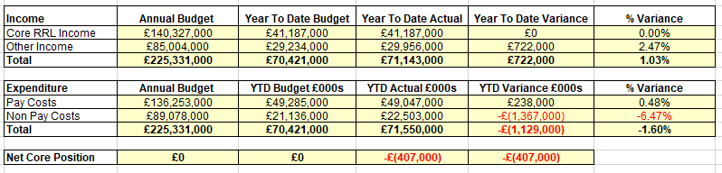
Appendix 1 provides a full analysis of the position outlined in Table 1 above including the position in Month

SECTION 1A: INCOME PERFORMANCE AT JULY 2023 (MONTH 4)

Income to date of £71.143m is ahead of the year to date budget of £70.421m resulting in a positive variance of £0.722m.
Table 2 below shows the summary financial position for Income. This comprises the Core RRL (Revenue Resource Limit) and Other Income as at Month 4.
Table 2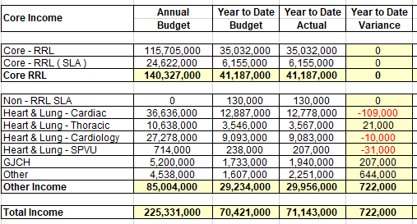
Key Points:
- Core RRL released at Month 4 is £41.197m which is matched by the expected year to date budget resulting in a zero variance

- Cardiac has underperformed by (£109k) due to non Non WoS activity and reduction in the Medical training posts due to recruitment challenges.
- The GJCH income performance is higher than expected by £0.207m
- Other income over recovery of £644k predominantly relates to a VAT rebate of £264k and over-performance on the SNRSS contract (YTD of £311k).

SECTION 1B: EXPENDITURE PERFORMANCE AT JULY 2023 (MONTH 4)
Expenditure to date of £71.550m is ahead of the year to date budget of £70.421m resulting in an adverse variance of £ (1.129) m.

Table 3 provides an overview of key expenditure variances based on the Board reporting categories.

Table 3
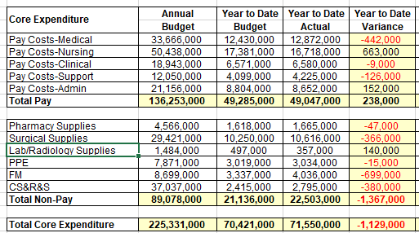

Key Points-Pay Costs

- Pay costs remain underspent overall -£238k YTD mainly reflecting the ongoing high level of vacancies within the budgeted establishment

- Medical pay costs are ahead of expected budget at Month 3 by £(0.442)m

This is in the main due to both short and long term sickness absence. This situation has required the use of Agency staff and WLIs to cover service gaps and maintain levels of activity.

In terms of the use of Agency Medical Staff
- HL&D - Radiology Consultants (£52k) YTD and Cardiac Registrars (£100k) YTD
- NES – Ophthalmology Consultants (£104k) YTD - Gen Anaesthetics Registrar (£20k) YTD – Orthopaedic (£16k) YTD.

- Nursing pay costs are underspend by £663k at Month 3. This reflects the underlying position in relation to Nursing WTEs. This is a net financial position due to the use of overtime and Agency nurses. Further work is being completed in this area by the Workforce Team and the linkages to Phase 2 expansion.

- Clinical pay costs are slightly ahead of budget resulting in a net overspend of £(9)k

- Support pay costs are ahead of budget by £ (126k) at Month 3 with the Hotel being overspent by (£110k).This area will be considered for Month 5.

- Admin pay costs have an overall positive variance of £152k reflecting a number of key vacancies across function including Finance.

- Incremental Drift was calculated and £145k allocated into Corporate, HL&D and NES divisions in Month 4 to reflect actual pay grades within Departmental budgets.

Key Points-Non Pay Costs

- Total Non-Pay costs are overspent at Month 3 by £ (1.367m).

- There are a number of Board categories showing overspends and work is currently being completed by Finance and Divisions/Services to better understand the costs pressures and underlying reasons

Surgical Supplies (£366k) YTD

Surgical Supplies are a complex area for the Board and better data, systems and analysis are required to allow a fuller ability to understand changes to these budget lines. The work required to ensure this area is addressed will be considered as part of the ‘deep dives’ and the Sustainability and Value work programmes scheduled for FY 2023/24.

FM (£699k) YTD

The main driver of FM is the increase in charges for Rates & Utilities and this is being investigated by the Estates team who are liaising with our energy supplier directly to confirm the accuracy of charges and consumption levels applied

CS&R&S (£380k) YTD

CS&R&S the majority of the (£380k) pressure relates to the increased activity around GJCH patient rooms (£79k) as well as consultancy costs within E-health of (£111k), postage relating to increased patient activity (£43k) and Laboratory costs within Haematology in HLD of (£57k).

SECTION 2: ANNUAL DELIVERY PLAN 2023/24 TO 2024/25

The Financial Plan has been updated to reflect the final changes identified from the version of the ADP submitted to Scottish Government at the end of June 2023. Discussions are on-going with SG to finalise funding arrangements relating to the staffing requirements for Phase 2, CfSD and the NHSSA. It is expected that these discussions will not be agreed until later in the year once there is further clarity on the requirements for each area
for 2023/24.

SECTION 3: IN YEARS SAVINGS AND SUSTAINABILITY AND VALUE PROJECTS

- In-Year Position

The Financial Plan assumes c. (£6.66m) of budget savings / in-year efficiency savings.

To date non-recurrent savings of £4.58m have been identified through a mixture of applying a 2022/23 total ‘vacancy factor’ of £3.814 m across the divisions which recognises and reflects financially the current workforce challenges being experienced across the Board. In addition, due to decisions/slippage in initiatives funded as part of the 2023/24 financial plan a further £0.766m of in-year savings has been recognised at Month 4.

This results in a balance of £2.085m of unidentified savings still to be identified by the year-end.

Table 4 below provides details on the £1.271m achieved YTD across each of the Staff categories against the 2023/24 target.

Table 4
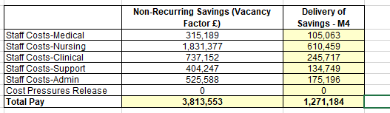

- Sustainability and Value Programmes

Additional staffing resources have now agreed across Finance, Procurement, Programme Management, Quality Improvement and Services to drive forward our Sustainability and Value Programme.

The Key areas of focus during 2023/2024:-

  - Digital transformation initiatives e.g. PECOS
  - NHS Golden Jubilee Conference Hotel
  - Other Trading income – Dining, Vending and Shop
  - HLD Division (including NSD services)
  - Research Institute

SECTION 4: NON CORE PERFORMANCE

The main elements of Non-Core performance and funding are
- Depreciation for core capital items – this is a transfer from core RRL funding based on a detailed depreciation schedule being prepared annually in line with our approved capital plan and existing capital commitments. This area is structured on a breakeven position for the year.

- Depreciation for capital items purchased using donated funds– this is an annual budget and forms part of Exchequer funding.

- Depreciation for Right of Use Assets (this follows the introduction of IFRS16). Boards receive a non-core allocation to cover depreciation for Right of Use Assets (formally leased items)

- AME Provisions – this is part of AME (Annually Managed Expenditure) and is monitored and funded centrally by SG. The original £40k estimate in 2023/24 will fluctuate throughout the year with the final amount being identified prior to year-end (based on movement in claims and estimates from the CLO)

At the end of Month 4 the Board specific provisions decreased by £45k.

- AME Debtor (required by Accounting Standards) this is the corresponding entry for the AME provisions recognising that the Board will receive income upon settlement of claims.

- Impairment Charges– this also is part of Annually Managed Expenditure and is monitored and funded centrally. Impairment charges arise where valuations of land and buildings fall below the carrying amount in the Balance Sheet. There has been no budget included at this stage for 2023/24 but work will be undertaken with SG colleagues on Phase 2.

SECTION 5: CAPITAL INCOME AND EXPENDITURE

At Month 4 only Core Capital funding of £2.691m has been confirmed by Scottish Government with the allocation letters expected for other capital allocations to be finalised in August 2023.

The following has been ‘indicated’ by SG as their level of capital support for 2023/24

- Core Capital £2.691m
- 2022/23 Capital Allocation ‘returned’ £1.887m
- Academy Capital £1.084m (including ‘returned’ £190k)
- Water Source Heat Pump £4.1m
- Phase 2 £23m

SECTION 6: RRL ALLOCATIONS AT MONTH 4 AND 2023/24 ANTICIPATED ALLOCATIONS

Scottish Government have confirmed an allocation letter as of the end of July of £83.552m for RRL and core capital of £2.691m. Appendix 2 provides a more detailed analysis at Month 4.

Decision–

(1) Approve the Summary Financial Report as at 31 July 2023 (Month 4)

Michael Breen
Director of Finance
NHS Golden Jubilee

APPENDIX 1
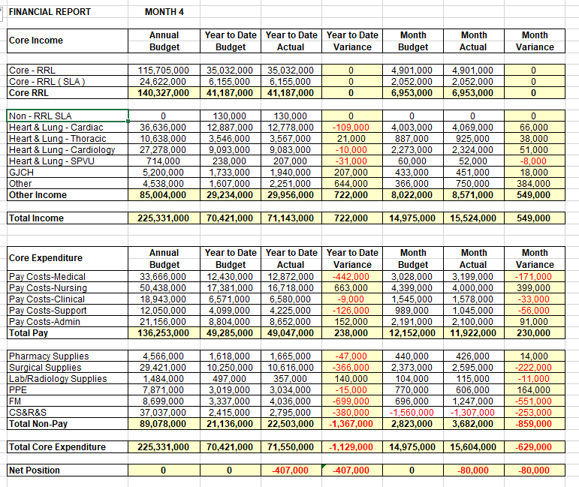

APPENDIX 2
RRL Financial Report for July 2023 (Month 4)
Financial Plan Summary | Received | Anticipated | Total RRL Funding
Core SG Income | 79,849,200 | 32,234,404 | 112,083,604
Project Funding | 0 | 844,064 | 844,064
CFSD | 85,500 | 14,756,199 | 14,841,699
Academy | 614,037 | 685,963 | 1,300,000
Phase 1 and 2 | 554,930 | 6,561,299 | 7,116,229
Other SG Allocations | 2,448,758 | 1,691,889 | 4,140,647
Non-Core | 0 | 10,723,000 | 10,723,000
Total RRL | 83,552,425 | 67,496,818 | 151,049,243

