Dear Prof Ellis

**Realistic medicine Funding offer 2023-24**

Thank you for your letter dated 5th April 23, we would like to accept the £30000 to fund Realistic medicine clinical lead posts. We have two individuals who share this role. Rupinder Kaur and Anna O’Donnell. We are currently unable to accept your offer of funding for a Realistic medicine programme manager as we have a vacancy against that post. If our situation changes and we are successful in recruiting a replacement we trust we can have further discussions about this funding offer.

You have asked for the following commitments which we agree to and have included a copy of our current action plan.

1. **Nominating and Executive sponsor** for Realistic medicine and value based health and care.
   1. Mark MacGregor MD is exec sponsor for RM
2. **Setting up a local realistic medicine Network**
   1. We have established at GJ Realistic medicine steering group chaired by our AMD, which includes our Clinical leads, Quality Improvement Fellow, Head of Quality Improvement and representation from clinical Governance.
   2. The GJ RM steering group reports via our Clinical Governance structure to the hospital Clinical Governance and Risk management committee twice each year and to the board Clinical Governance group annually.
   3. The GJRM steering group also links to the GJ Climate change and Sustainability board.

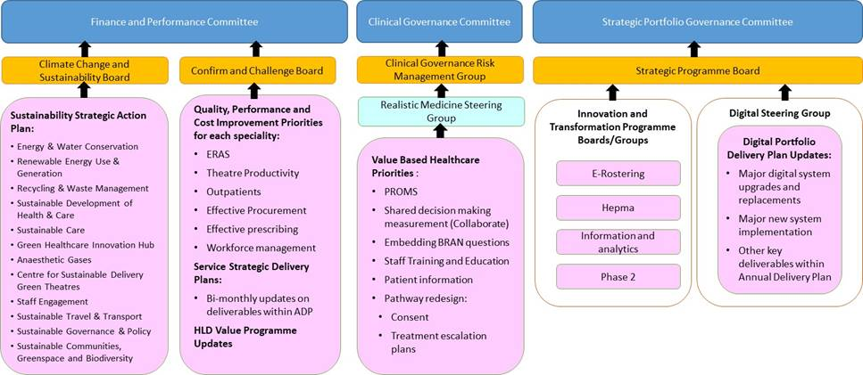

1. **Providing Six monthly reports**
2. **Ensure our local RM plan sets out how we will deliver the 5 specific actions**