
Board Public Item 4.1

Integrated Performance Report

Produced in February 2024

Data reported up to END of January 2024

Performance and Planning Department
Contents
Section A Overview and Executive Summary Page
Introduction - Overview 3
Performance Summary Dashboard Guidance 4
Statistical Process Control Guidance 5
Performance Summary Dashboard 6
Executive Summary 8

Section B:1 Clinical Governance
Executive Summary 10
Performance Summary Table 11

Infection Control
HAIRT Report 12

Section B:2 Staff Governance
Executive Summary 32
Performance Summary Table 34

Section C KPI Glossary 48

Section B:3 Finance, Performance & Planning

Performance Summary Dashboard 35
Waiting Times & Productivity Dashboard 36
Corporate Departments Dashboard 41
National Comparators Table 42
Financial Report Summary 44

Section A: Introduction
Overview
The purpose of the Integrated Performance Report (IPR) is to provide assurance on NHS Golden Jubilee’s performance relating to National Standards, local priorities and significant risks.

The IPR comprises the following sections:
- Section A Introduction
- Section B:1 Clinical Governance
- Section B:2 Staff Governance
- Section B:3 Finance, Performance & Planning
- Section C Glossary

Performance Summary Dashboard – Guidance

Statistical Process Control – Guidance

Board Performance Dashboard

Board Performance Dashboard Summary Table

Clinical Governance
KPI | RAG | Position:
Total complaints (Stage 1 and 2) by volume |  | In December 2023 there were 8 complaints reported. Latest position available.
Stage 1 complaints response time |  | In December 2023, there were six Stage 1 complaints, five were responded to within the five day target (83.3%). Latest position available.
Stage 2 complaints response time |  | In December 2023 there were two Stage 2 complaints, zero were responded to within the twenty day target (0%). Latest position available.
Mortality |  | The mortality figure for January 2024 was reported as 12.
Significant adverse events |  | There were two significant adverse event reviews in January 2023.
MRSA/MSSA cases |  | There were no instances of Staphylococcus aureus Bacteraemia (SAB) reported in January 2024. The rate per 100,000 bed days was 0 in January.
Clostridiodes Difficile |  | There were zero Clostridiodes Difficile Infections (CDI) reported in December 2023.
Gram Negative Bacteraemia |  | There was one reported instance of Gram Negative Bacteraemia in January 2024.
SSI: Hips & Knees |  | There were zero reported SSIs in January 2024.
SSI: Cardiac |  | There was one reported SSI in January 2024.
Staff Governance
Disciplinaries |  | There were zero disciplinary cases raised in January 2024.
Grievances |  | There were zero grievance cases raised in January 2024.
Dignity of work |  | There was one dignity case raised in January 2024.
Local Sickness absence |  | Sickness absence in January 2024 was reported at 6.3%. This is within control limits.
Turnover |  | Turnover in January was reported as within control limits at 0.7%.
Medical appraisal with completed interview & form |  | The appraisal year for medical staff runs from 1 April to 31 March. To date, 51 doctors out of 168 had completed their 2023/2024 appraisal, and one had an ARCP.
TURAS Appraisal rates |  | Position for January 2024 reported as 58% (same as previous month.)
Job Planning: All hospital |  | To date, 101 of the 131 job plans for 2024/2025 were sitting in discussion; 9 were awaiting the clinician’s sign off; 6 were awaiting first manager sign off; 13 were awaiting second manager sign off; and 2 had been signed off.
Finance & Performance
Lung Cancer 31 Day |  | In December 2023, nationally reported performance was 100% (26/26). Latest position available.
TTG: Number of patients who have breached the TTG |  | In January 2024 there were 186 patients who exceeded their twelve week treatment time guarantee.
TTG: Percentage of patients admitted within 12 weeks |  | The percentage of patients admitted within their twelve week treatment time guarantee was reported at 86.5% during January.
SoT Guarantee – Inpatient and DC cases (H & L only) |  | 69.8% of Heart and Lung patients were admitted within 12 weeks in January 2024.
DOSA rate: Cardiac Surgery |  | There were two DoSA cases in January 2023 (3.1%)
DOSA rate: Thoracic Surgery |  | There were 12 DoSA cases in January 2023 (14.8%).
DOSA rate: Orthopaedics |  | In January 2024 there were 214 Orthopaedic primary joint admissions, 157 (73.4%) of which were on the day of surgery.
Theatre Cancellation Rates |  | In January 2024, the overall hospital cancellation rate was 7.2% (182/2537) Within Control Limits.
Hospital Bed Occupancy |  | Hospital wide bed occupancy was reported as 71.5% in January 2024. Below Lower Control Limits.
National Comparison Table, Corporate Dashboard, Waiting list & Productivity table
The GJNH nationally reported elective cancellation rate, in December 2023, was reported as 6.5%. This ranked GJNH as 2 out of 15. The Scotland rate was 9.7%.
Golden Jubilee comparative performance against the national 31 Day Lung Cancer target is reported using the Information Services Division (ISD) nationally published position. In December 2023 GJNH reported 100% of eligible patients treated within the target (Ranked 1 out of 22).
Health Protection Scotland published figures for Quarter 3 2023 report a GJNH incidence rate (per 100,000 total occupied bed days) of 7.5 for CDiff incidence, 7.5 for SAB and 15.1 for Ecoli. The Scotland rates were 15.5, 18.1 and 37.8 respectively. Latest position available.
Corporate sickness rate in January 2024 was 5.1% (down 0.5% from December). Departments over the 4% threshold were: Business Services, Catering, Clinical Governance, Finance, Housekeeping, L&OD, Procurement and Security.
Referral numbers in January 2024 were 3836 (+754).
The total outpatient waiting list increased by 335 from 2325 to 2660.
The total inpatient waiting list month end position decreased by 185 from 5239 to 5054.
For current inpatient waiters the number waiting between 12-26 weeks increased to 664 (+71).
The number of patients waiting 26-52 weeks increased to 429 (+26).
The number of patients waiting >52 weeks increased to 630 (+8).

Section B: 1 Clinical Governance
Executive Summary
In December 2023 we received six Stage 1 complaints and two Stage 2 complaints.
83.3% of the Stage 1 complaints that were investigated were responded to within guidance timescale (5 days) n=5. The timescale for the remaining 16.7% of the Stage 1 complaints was extended (10 days). This was investigated and responded to within extended guidance timescale (10 days) n=1. The reason for the extension was due to the public holidays over the festive period.

The average time taken to complete and respond to the Stage 1 complaints, was 4.6 working days.

0% of the Stage 2 complaints were investigated and responded to within 20 working days therefore none were compliant with the guidance timescale (20 days) n=0. The two Stage 2 complaints from December are ongoing and have therefore already breached the 20 day timescale.

Mortality data for January 2024 breached the 1st control limit (n=12).

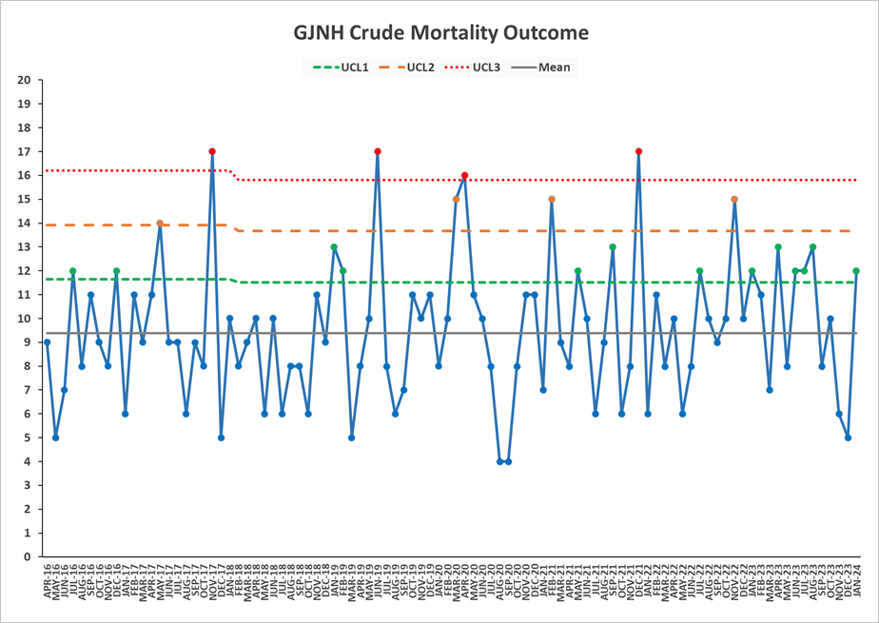
No whistleblowing concerns have been raised during January 2024.

Clinical Governance Performance Dashboard

Based on Statistical Process Control (SPC) methodology the following indicators are showing evidence of Special Cause Variation:
- All indicators are currently reporting within normal control limits

Healthcare Associated Infection Report
January 2024
Section 1 – Board Wide Issues
Key Healthcare Associated Infection Headlines
- Staphylococcus aureus Bacteraemia- 0 cases report in January.

- Clostridioides difficile infection (previously known as Clostridium difficile) – 0 cases to report in January.

- Gram Negative/E.coli Bacteraemia (ECB) – 1 case to report in January.

- Hand Hygiene- The bimonthly report from January 24 indicates a combined compliance score of 98%.

- Cleaning and the Healthcare Environment -Facilities Management Tool
Housekeeping Compliance: 98.9% Estates Compliance: 94.01%

- Orthopaedic Surgical Site Surveillance- No SSI to report in January. Remains within control limits.

- Cardiac Surgical Site Surveillance- One cardiac SSI to report in January. Remains within control limits.

- Other HAI Activity Overview

Transfer of key HAI data to Sharepoint
PCIT have been working with Clinical Governance to build and transfer key HAI data to Sharepoint. Aligning HAI data location with SPSP data, will facilitate ease of access, data entry and review of HAI data for clinical colleagues.

This key data includes-
- Standard Infection Control Precautions (SICPs) compliance data entry and outcome data allowing both individual and service overview
- Alert organism data by clinical area
- Prevention and Control of Infection Annual Review data by clinical area and service.
Testing was completed in January with an aim of site transfer March.

PVC Bundle
Working closely with Clinical Governance and Nurse Education, the updated PVC bundle testing is complete. The 5 day PVC bundle and 24 hr PVC bundle documents are now available for areas to order via stores.

Section 1 of the HAIRT covers Board wide infection prevention and control activity and actions. For reports on individual departments, please refer to the ‘Healthcare Associated Infection Report Cards’ in Section 2.

Staphylococcus aureus (including MRSA)
Staphylococcus aureus is an organism which is responsible for a large number of healthcare associated infections, although it can also cause infections in people who have not had any recent contact with the healthcare system. The most common form of this is Meticillin Sensitive Staphylococcus aureus (MSSA), but the more well-known is MRSA (Meticillin Resistant Staphylococcus aureus), which is a specific type of the organism which is resistant to certain antibiotics and is therefore more difficult to treat.
NHS Boards carry out surveillance of Staphylococcus aureus blood stream infections, known as bacteraemias. These are a serious form of infection and there is a national target to reduce them.
More information can be found at: Staphylococcus aureus bacteraemia | National Services Scotland (nhs.scot)

NHS GJ approach to SAB prevention and reduction
It is accepted within ARHAI that care must be taken in making comparisons with other Boards’ data because of the specialist patient population within NHS GJ. All SAB isolates identified within the laboratory are subject to case investigation to determine future learning and quality improvement.

Small numbers of cases can quickly change our targeted approach to SAB reduction.

Broad HAI initiatives which influence our SAB rate include-
- Hand Hygiene compliance and monitoring
- MRSA screening at pre-assessment clinics and admission
- Compliance with National Cleaning Standards Specifications
- Audit of the environment and practices via Prevention and Control of Infection Annual Reviews, monthly SCN led Standard Infection Control Precautions audit and CNM Peer Review monitoring
- Participation in National Enhanced SAB surveillance- gaining further intelligence on the epidemiology of SAB locally and nationally.

SSI Related SAB
- MSSA screening for cardiac surgery and subsequent treatment pre and
post op as a risk reduction approach
- Surgical Site Infection Surveillance in collaboration with ARHAI to allow rapid identification of increasing and decreasing trends of SSI.

Device Related SAB
- Implementation of PVC, CVC, PICC and IABP bundles; assessment of compliance locally aids targeting of interventions accordingly.

NHS GJ SAB HAI Standards /AOP Trajectories
NHS Boards are expected to achieve a reduction of 10% in the national rate of healthcare associated SAB from 2019 to 2023, with 2018/19 used as the baseline for the SAB reduction target this year. The percentage reductions will be measured against individual NHS Scotland Boards’ current levels, rather than taking a “best in class” approach as previous.

For NHS GJ this target is 11.22 per 100,000 TOBD. This remains a challenging target given NHS GJ existing low SAB rate and high risk patient population.

The data above reflects NHS GJ SAB isolates beyond 48hrs of admission.

Sources of SAB
The Prevention and Control of Infection Team work closely with the clinical teams, CG and clinical educators to gain insight into the sources of SAB acquisition and associated learning. Each SAB is subject to an enhanced surveillance process involving the PCIT, SCN and responsible consultant to determine any learning from the source of the SAB. Thereafter the Enhanced SAB surveillance reports are submitted to the relevant service clinical governance group to share potential learning and note actions required.

CCU
March 23- IABP & Excoriated skin
Jun 23- Arterial line

HDU2
Dec 23- SSI Sternum

NSD
Dec 23- Vascath

ICU1
Apr 23- Line. Site unknown. Multiple lines removed with clinical improvement.

ICU2
Aug 23-Central line

3East
May 23- SSI

2 East
June 23- PVC

MRSA Screening Compliance
MRSA screening promotes early identification of patients colonised or infected with MRSA. This facilitates early implementation of decolonisation / treatment with the aim of reducing the reservoir of MRSA and therefore the risk of transmission to other vulnerable patients.

Within NHS GJ MRSA screening must be completed for all elective admissions within high impact specialities e.g. ORTHOPAEDIC /CARDIAC/CARDIOTHORACIC/CARDIOLOGY. Thereafter patients whose length of stay is 10 days or more are subject to additional screening on:
- Day 10
- And each 7 days thereafter

Screening must be completed at pre assessment where applicable, and on admission into NHS GJ. The purpose of this additional screening is to ensure that healthcare associated interventions have not significantly altered the patients’ normal flora and resistant.

Day 10 screen was identified as the initial screen date as it captures patient stay beyond routine pathways. Compliance is monitored via reviewing a sample of eligible patients against submitted MRSA screens. SCNs are informed of results at the time of audit and informed an action plan is required to improve compliance should be submitted.

Jan-24 | Sample Size | Sample Type | Number of omissions | Board Total
 | 91 | ADMIT SCREEN COMPLIANCE | n=3 | 97%
 | 33 | 10 DAY SCREEN COMPLIANCE | n=3 | 91%
 | 13 | 7 DAY SCREEN COMPLIANCE | n=2 | 85%

In all cases, screens were not obtained. This has been highlighted to Clinical Nurse Managers for further discussion.

Clostridioides difficile infection (previously known as Clostridium difficile)
Clostridioides difficile is an organism which is responsible for a large number of healthcare associated infections, although it can also cause infections in people who have not had any recent contact with the healthcare system. NHS Boards carry out surveillance of Clostridioides difficile infections (CDI), and there is a national target to reduce these.
More information on Clostridioides difficile infections can be found at: Clostridioides difficile infection | National Services Scotland (nhs.scot)

NHS GJ approach to CDI prevention and reduction
Our numbers of CDI cases are low in comparison with other Boards, which is likely to relate to our specialist patient population.

Actions to reduce CDI-
- Ongoing alert organism surveillance and close monitoring of the severity of cases by the PCIT.
- Unit specific reporting and triggers.
- Implementation of ARHAI Severe Case Investigation Tool if the case definition is met.
- Typing of isolates when two or more cases occur within 30 days in one unit.

NHS GJ CDI HAI Standards/ AOP Trajectories

Reduction of 10% in the national rate of healthcare associated CDI from 2019 to 2023, with 2018/19 used as the baseline for the CDI reduction target. The percentage reductions will be measured against individual NHS Scotland Boards’ current levels, rather than taking a” best in class” approach as previously. For NHS GJ this target is 1.9 per 100,000 TOBD.
This remains a challenging target given NHS GJ exceptionally low CDI rates, small numbers of cases will influence the achievement of this target.

Gram Negative/E.coli Bacteraemia
Escherichia coli (E. coli) is a bacterium that forms part of the normal gut flora that helps human digestion. Although most types of E. coli live harmlessly in your gut, some types can cause illness. E. coli bacteraemias can be as a result of an infection such as:
•urinary tract
•surgery
•inappropriate use of medical devices

E. coli is currently the most common cause of bacteraemia in Scotland. As a result, its reduction has been added as a new HAI Standard target. More information can be found at: HPS Website - Protocol for National Enhanced Surveillance of Bacteraemia (scot.nhs.uk)

NHS GJ ECB HAI Standards/ AOP Trajectories
In recognition of Boards difficulty in achieving the previous target, DL 2023 06 requests Board to achieve a reduction of 25% in healthcare associated E. coli bacteraemia by 2023/24 year end.
For NHS GJ, this 25% reduction is target based on 22/23 data and is 15.5 per 100,000 TOBD.
All ECB isolates identified within the laboratory are subject to case investigation to determine future learning and quality improvement.

Hand Hygiene
Good hand hygiene by staff, patients and visitors is a key way to prevent the spread of infections. More information on the importance of good hand hygiene can be found at: http://www.nipcm.hps.scot.nhs.uk
NHS Boards monitor hand hygiene and ensure a zero tolerance approach to non-compliance.

NHS GJ approach to Hand Hygiene

The bimonthly report from January 24 indicates a combined compliance score of 98%.
In the majority of non compliances, the opportunity to perform hand hygiene was not taken.

Summary of Non Compliance
Other- Student nurse & Theatre Assistant

AREA AUDITED | COMPLIANCE
4 East Ortho | 80%
THEATRE 4 | 95%
THEATRE 16 | 95%
THEATRE 2 | 100%
THEATRE 14 | 100%
PACU | 100%
EYE CENTRE THEATRE 3 | 100%
EYE CENTRE THEATRE 6 | 100%
3 WEST | 100%
CDU | 100%
2WEST | 100%
RADIOLOGY | 100%
ICU 1 | 100%
HDU 3 | 100%
4 WEST SDU | 100%
95% Compliance or above
80% - 94% Compliance
Below 80% Compliance

Cleaning and Maintaining the Healthcare Environment

Synbiotix national migration of FMT systems software has now been completed.
Phase 2 room data now received, and requires migration of national cleaning, FMT and Agility data added before being uploaded on to FMT Synbiotix system.

Consultation of the NHSScotland National Cleaning Services Specification (SHFN 01-02) ongoing with further final consultation to DSEG awaited.

Refurbishment of GJ mop laundering facility progressing to project timeline.

Housekeeping FMT Audit Results

Enlarged image available at the end of HAIRT

Healthcare Associated Infection Reporting Template (HAIRT)
Section 2 – Healthcare Associated Infection Report Cards
The following section is a series of ‘Report Cards’ that provide information, for each acute hospital and key community hospitals in the Board, on the number of cases of Staphylococcus aureus blood stream infections (also broken down into MSSA and MRSA) and Clostridioides difficile infections, as well as hand hygiene and cleaning compliance. In addition, there is a single report card which covers all community hospitals [which do not have individual cards], and a report which covers infections identified as having been contracted from outwith hospital. The information in the report cards is provisional local data, and may differ from the national surveillance reports carried out by ARHAI. The national reports are official statistics which undergo rigorous validation, which means final national figures may differ from those reported here. However, these reports aim to provide more detailed and up to date information on HAI activities at local level than is possible to provide through the national statistics.

Understanding the Report Cards – Infection Case Numbers
Clostridioides difficile infections (CDI) and Staphylococcus aureus bacteraemia (SAB) cases are presented for each hospital, broken down by month. Staphylococcus aureus bacteraemia (SAB) cases are further broken down into Meticillin Sensitive Staphylococcus aureus (MSSA) and Meticillin Resistant Staphylococcus aureus (MRSA).

For each hospital the total number of cases for each month are those which have been reported as positive from a laboratory report on samples taken more than 48 hours after admission. For the purposes of these reports, positive samples taken from patients within 48 hours of admission will be considered to be confirmation that the infection was contracted prior to hospital admission and will be shown in the “out of hospital” report card.

Targets
There are national annual operating plans associated with reductions in HAI. More information on these can be found on the Scottish Government website.

Understanding the Report Cards – Hand Hygiene Compliance
Hospitals carry out regular audits of how well their staff are complying with hand hygiene. Each hospital report card presents the combined percentage of hand hygiene compliance with both opportunity taken and technique used broken down by staff group.

Understanding the Report Cards – Cleaning Compliance
Hospitals strive to keep the care environment as clean as possible. This is monitored through cleaning and estates compliance audits. More information on how hospitals carry out these audits can be found here:
Facilities Monitoring Report | National Services Scotland (nhs.scot)

NHS BOARD REPORT CARD

Staphylococcus aureus bacteraemia monthly case numbers
 | Feb 23 | Mar  23 | Apr  23 | May  23 | Jun  23 | Jul  23 | Aug 23 | Sept  23 | Oct  23 | Nov  23 | Dec  23 | Jan 24
MRSA | 0 | 0 | 0 | 0 | 0 | 0 | 0 | 0 | 0 | 0 | 0 | 0
MSSA | 0 | 2 | 1 | 1 | 2 | 0 | 1 | 0 | 0 | 0 | 2 | 0
Total SABS | 0 | 2 | 1 | 1 | 2 | 0 | 1 | 0 | 0 | 0 | 2 | 0

Clostridioides difficile infection monthly case numbers
 | Feb 23 | Mar  23 | Apr  23 | May  23 | Jun  23 | Jul  23 | Aug 23 | Sept  23 | Oct  23 | Nov  23 | Dec  23 | Jan 24
Ages15-64 | 0 | 0 | 0 | 1 | 0 | 0 | 0 | 1 | 0 | 0 | 0 | 0
Ages 65+ | 0 | 0 | 1 | 0 | 0 | 0 | 0 | 0 | 0 | 0 | 0 | 0
Ages 15 + | 0 | 0 | 0 | 0 | 0 | 0 | 0 | 0 | 0 | 0 | 0 | 0

E.Coli bacteraemia monthly case numbers

 | Feb 23 | Mar  23 | Apr  23 | May  23 | Jun  23 | Jul  23 | Aug 23 | Sept  23 | Oct  23 | Nov 23 | Dec  23 | Jan 24
ECB | 1 | 2 | 1 | 0 | 0 | 0 | 1 | 1 | 0 | 1 | 0 | 1

Hand Hygiene Monitoring Compliance (%)
 | Feb 23 | Mar  23 | Apr  23 | May  23 | Jun  23 | Jul  23 | Aug 23 | Sept  23 | Oct  23 | Nov  23 | Dec  23 | Jan 24
Nurse |  | 99 |  | 98 |  | 98 |  | 99 |  | 99 |  | 99
Medical |  | 96 |  | 98 |  | 95 |  | 95 |  | 94 |  | 96
AHP |  | 100 |  | 98 |  | 100 |  | 95 |  | 100 |  | 100
Ancillary/Other |  | 95 |  | 100 |  | 88 |  | 85 |  | 96 |  | 92
Board Total |  | 98 |  | 98 |  | 97 |  | 97 |  | 98 |  | 98

Cleaning Compliance (%)
 | Feb 23 | Mar  23 | Apr  23 | May  23 | Jun  23 | Jul  23 | Aug 23 | Sept  23 | Oct  23 | Nov  23 | Dec  23 | Jan 24
Board Total | 97.93 | 98.56 | 97.77 | 97.37 | 98.64 | 97.94 | 98.02 | 98.76 | 98.1 | 98.39 | 97.9 | 98.9

Estates Monitoring Compliance (%)
 | Feb 23 | Mar  23 | Apr  23 | May  23 | Jun  23 | Jul  23 | Aug 23 | Sept  23 | Oct  23 | Nov  23 | Dec  23 | Jan 24
Board Total | 98.13 | 98.16 | 98.94 | 97.31 | 97.81 | 96.91 | 98.87 | 97.32 | 98.14 | 96.4 | 97.16 | 94.01

Surgical Site Infection Surveillance- Orthopaedic Local data
Hip Arthroplasty SSI
Number of Procedures | Month | Type of SSI | Status
112 | Apr 23 | 0 | Confirmed
144 | May 23 | 0 | Confirmed
134 | June 23 | 0 | Confirmed
126 | July 23 | 1 Superficial | Confirmed
179 | Aug 23 | 1 Organ Space | Confirmed
148 | Sept 23 | 0 | Confirmed
140 | Oct 23 | 0 | Confirmed
153 | Nov 23 | 1 Superficial | Confirmed
137 | Dec 23 | 0 | Confirmed
136 | Jan 24 | 0 | Unconfirmed

*A surgical site infection is defined as a superficial, deep or organ space infection occurring within 30 days of operation. Definitions of superficial, deep and organ space are defined in Health Protection Scotland Surgical Site Infection Surveillance Protocol.

Knee Arthroplasty SSI
Number of Procedures | Month | Type of SSI | Status
137 | Apr 23 | 0 | Confirmed
134 | May 23 | 1 Superficial | Confirmed
140 | June 23 | 0 | Confirmed
152 | July 23 | 1 Superficial | Confirmed
164 | Aug 23 | 0 | Confirmed
157 | Sept 23 | 0 | Confirmed
112 | Oct 23 | 0 | Confirmed
162 | Nov 23 | 0 | Confirmed
138 | Dec 23 | 1Superficial | Confirmed
142 | Jan 24 | 0 | Unconfirmed

*A surgical site infection is defined as a superficial, deep or organ space infection occurring within 30 days of operation. Definitions of superficial, deep and organ space are defined in Health Protection Scotland Surgical Site Infection Surveillance Protocol.

Surgical Site Infection Surveillance- CABG Local data

CABG SURGERY SSI
Number of Procedures |  | Month |  | Type of SSI |  | Status
 | 45 |  | Apr 23 |  | 3 Superficial Sternum ( One a source of SAB in May) |  | Confirmed
 | 48 |  | May 23 |  | 0 |  | Confirmed
 | 38 |  | June 23 |  | 0 |  | Confirmed
 | 46 |  | July 23 |  | 0 |  | Confirmed
 | 57 |  | Aug 23 |  | 1 Superficial Sternum |  | Confirmed
 | 51 |  | Sept 23 |  | 1 Superficial Sternum |  | Confirmed
 | 65 |  | Oct 23 |  | 0 |  | Confirmed
 | 56 |  | Nov 23 |  | 0 |  | Confirmed
 | 47 |  | Dec 23 |  | 3- 1 Organ Space Sternum/ 2 Leg |  | Confirmed
 | 31 |  | Jan 24 |  | 0 |  | Unconfirmed

Surgical Site Infection Surveillance- Valve Replacement +/- CABG Local data
Valve Replacement +/- CABG SSI
Number of Procedures | Month | Type of SSI | Status
32 | Apr 23 | 2- 1Superficial Sternum/1 Superficial Leg | Confirmed
27 | May 23 | 0 | Confirmed
31 | June 23 | 0 | Confirmed
36 | July 23 | 0 | Confirmed
19 | Aug 23 | 0 | Confirmed
40 | Sept 23 | 0 | Confirmed
34 | Oct 23 | 1Superficial Sternum | Confirmed
36 | Nov 23 | 0 | Confirmed
30 | Dec 23 | 0 | Confirmed
42 | Jan 24 | 1 Superficial Leg | Unconfirmed

AHP | Allied Health Professional
ARHAI | Antimicrobial Resistance and Healthcare Associated Infection
AOP | Annual Operating Plan
CABG | Coronary Artery Bypass Graft
CG | Clinical Governance
CAUTI | Catheter Associated Urinary Tract Infection
CGC | Clinical Governance Committee
CCU | Coronary Care Unit
CDI/C.difficile | Clostridioides difficile infection
CMO | Chief Medical Officer
CNM | Clinical Nurse Manager
CNO | Chief Nursing Officer
COVID-19 | Coronavirus disease 2019
CPE | Carbapenamase-producing enterobacteriacaea
CPO | Chief Pharmaceutical Officer
CVC | Central Venous Catheter
DMT | Domestic Monitoring Tool
DSEG | Domestic Services Expert Group
ECB | Escherichia coli bacteraemia
FMT | Facilities Monitoring Tool
GI | Gastro Intestinal
GJF | Golden Jubilee Foundation
GJNH | Golden Jubilee National Hospital
HAI | Healthcare Associated Infection
HAIRT | Healthcare Associated Infection Report Template
HIIAT | Healthcare Infection Incident Assessment Tool
HLD | Heart and Lung Division
HA MRSA | Hospital Acquired Meticillin Resistant Staphylococcus aureus
HEAT | Health Improvement, Efficiency, Access to treatment, and Treatment
HEI | Healthcare Environment Inspection
HFS | Healthcare Facilities Scotland
HH | Hand Hygiene
HIS | Healthcare Improvement Scotland
HPA | Health Protection Agency
HPS | Health Protection Scotland
IABP | Intra-aortic balloon pump
IC | Infection Control
IMT | Incident Management Team
MRSA | Meticillin Resistant Staphylococcus aureus
MSSA | Meticillin Sensitive Staphylococcus aureus
NA | Not Applicable
NCSS | National Cleaning Standards Specification
NHSGJ | NHS Golden Jubilee
NHSH | NHS Highland
NSD | National Services Division
PAG | Problem Assessment Group
PCIC | Prevention & Control of Infection Committee
PCIN | Prevention & Control of Infection Nurses
PCIT | Prevention & Control of Infection Team
PCIAR | Prevention and Control of Infection Annual Review
PICC | Peripherally Inserted Central Catheter
PVC | Peripheral Venous Cannula
SAB | Staphylococcus aureus bacteraemia
SBAR | Situation Background Assessment Recommendations
SCN | Senior Charge Nurse
SCRIBE | Systems for Control Risk in the Built Environment
SG | Scottish Government
SGHD | Scottish Government Health Department
SHFN | Scottish Health Facilities Note
SICP | Standard Infection Control Precautions
SLWG | Short Life Working Group
SPSP | Scottish Patient Safety Programme
SSI | Surgical Site Infection
TBP | Transmission Based Precautions
THR | Total Hip Replacement
TKR | Total Knee Replacement
TOBD | Total Occupied Bed Days
VRE | Vancomycin Resistant Enterococci
HAIRT Table of Abbreviations

Section B:2 Staff Governance

Sickness absence
In January 2024, NHS Golden Jubilee’s sickness absence rate stood at 6.3%, the same as the previous month. Across the Directorates, sickness absence was as follows:
- Corporate: 5.1% (-0.5% on December);
- Golden Jubilee Conference Hotel: 5.9% (+1.8%);
- Heart, Lung and Diagnostic Services: 7.0% (+0.7%); and
- National Elective Services: 6.7% (-0.5%).

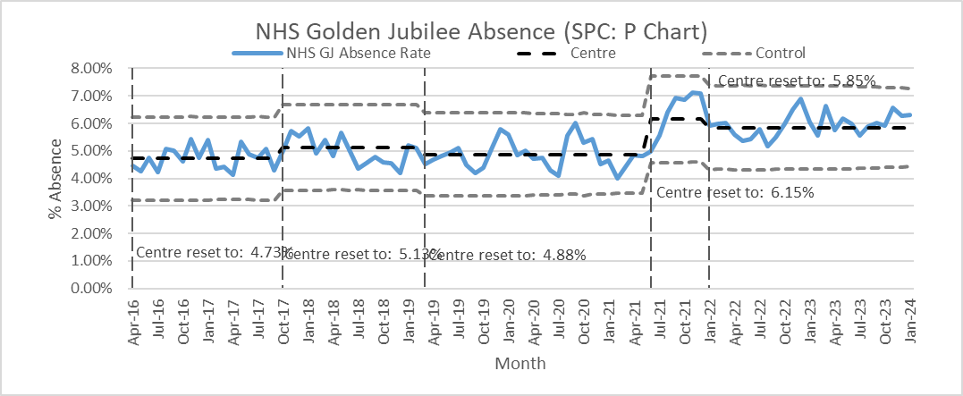

The rolling 12-month sickness absence rate for the Board was 5.4%. The 12-month breakdown for the Directorates was:
- Corporate: 4.4%;
- Golden Jubilee Conference Hotel: 3.1%;
- Heart, Lung and Diagnostic Services: 6.0%; and
- National Elective Services: 6.0%.

“Anxiety/stress/ depression/other psychiatric illnesses” was the highest cause of sickness absence in January, accounting for 21.4% of all sickness absence, 1.4% lower than December’s figure of 21.4%. It was the main cause of absence in three Directorates:
- Corporate: 21.0%;
- Golden Jubilee Conference Hotel: 44.1%;
- Heart, Lung and Diagnostic Services: 19.4%; and
- National Elective Services: 17.3%.

“Cold, cough, flu - influenza” was the second top cause of sickness absence overall in January, accounting for 18.9% of sickness absence hours.

Turnover
In January, turnover for NHS Golden Jubilee increased to 0.7%, up from 0.6% in December. This was due to 16 people leaving employment. The Directorate breakdown was as follows:
- Corporate: 0.7% (+0.1% on December);
- Golden Jubilee Conference Hotel: 0.0% (+/-0.0%);
- Heart, Lung and Diagnostic Services: 0.5% (+0.4%); and
- National Elective Services: 0.9% (-0.1%).

The rolling 12-month turnover rate for the Board was 9.2%. The 12-month breakdown for the Directorates was:
- Corporate: 9.5%;
- Golden Jubilee Conference Hotel: 10.2%;
- Heart, Lung and Diagnostic Services: 8.4%; and
- National Elective Services: 9.6%.

Agenda for Change appraisal
Within the twelve months to 31 January 2024, 58% of staff who come under the Agenda for Change terms and conditions completed their appraisal using TURAS, which is the same rate as the previous month. The Directorate breakdown is as follows:
- Corporate: 49% (-2% on December);
- Golden Jubilee Conference Hotel: 66% (+1%);
- Heart, Lung and Diagnostic Services: 59% (-1%); and
- National Elective Services: 58% (-6%).

Medical appraisal
The appraisal year for medical staff runs from 1 April to 31 March. As at 12 February 2024, 51 doctors out of 168 had completed their 2023/2024 appraisal, and one had an ARCP.

Medical job planning
In December 2023, we closed almost all medical job plans on the Allocate job planning system for 2023/2024, and started new job plans for the year starting 1 April 2024. As at 12 February 2024, 101 of the 131 job plans for 2024/2025 were sitting in discussion; 9 were awaiting the clinician’s sign off; 6 were awaiting first manager sign off; 13 were awaiting second manager sign off; and 2 had been signed off.

Staff Governance Performance Dashboard

Based on Statistical Process Control (SPC) methodology the following indicators are showing evidence of Special Cause Variation:
- Dignity at Work Investigations has reported above upper control limits.
- TURAS PDR has reported below lower control limits.

Section B: 3 Finance, Performance & Planning
Finance, Performance and Planning Performance Dashboard
Based on Statistical Process Control (SPC) methodology the following indicators are showing evidence of Special Cause Variation:
- Hospital Wide Bed Occupancy has reported above the below control limit.

Waiting Times & Productivity Dashboard
In January 3,836 SCI Gateway referrals were received, an increase of 754 compared to the December position. This is now reporting two outer third points.
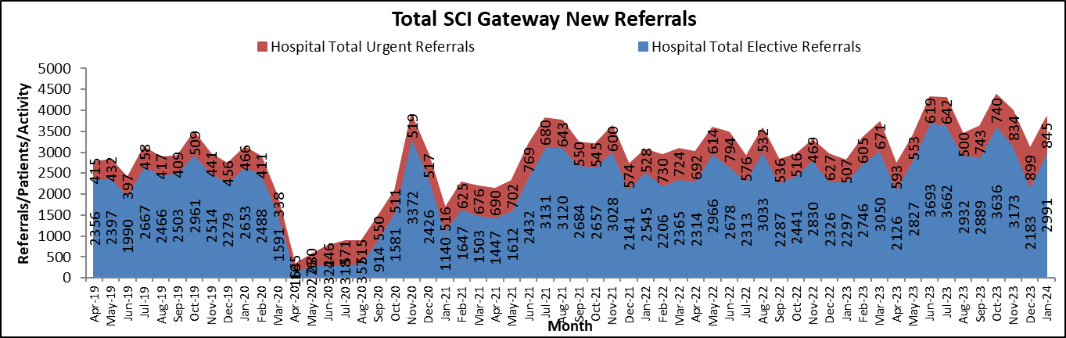
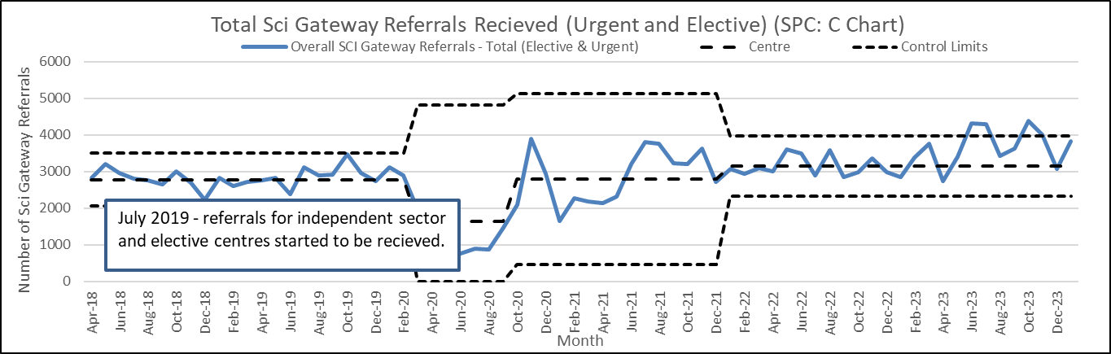
The number of Orthopaedic referrals received in January was 440 referrals, a decrease of 127 compared to December, reporting within control limits. Ophthalmology referrals has reported fifteen points near the centre line, showing stability in referrals received with 1237 received in January; an increase of 421 compared to the December position. There were 127 Cardiac Surgery referrals in January; an increase of 26 compared to the December position, reporting within control limits. There were 67 Thoracic Surgery referrals in January; an increase of four compared to December. Thoracic Surgery has reported Two Outer Third Points.
The number of patients on the outpatient waiting list in January was reported as 2,660, an increase of 335 from the December position. 2,094 (78%) of the patients on the outpatient waiting list are Ophthalmology patients. This reported above upper control limits.
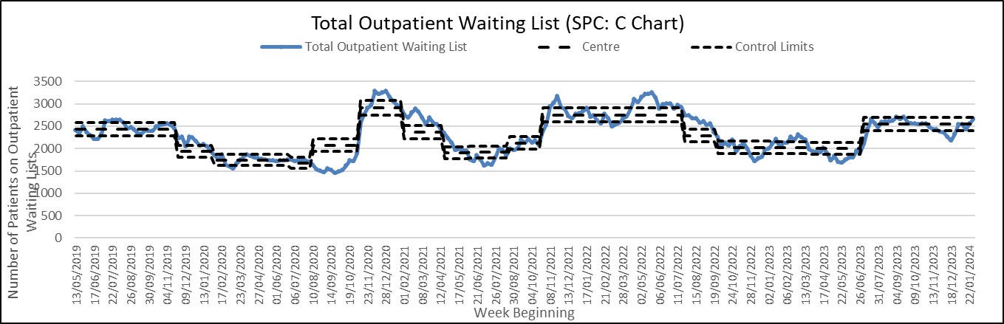
The overall total inpatient waiting list position decreased by 185 patients over the month of January to 5,054 The largest decrease was reported in the Ophthalmology waiting list, where the waiting list has decreased by 222 patients during January.
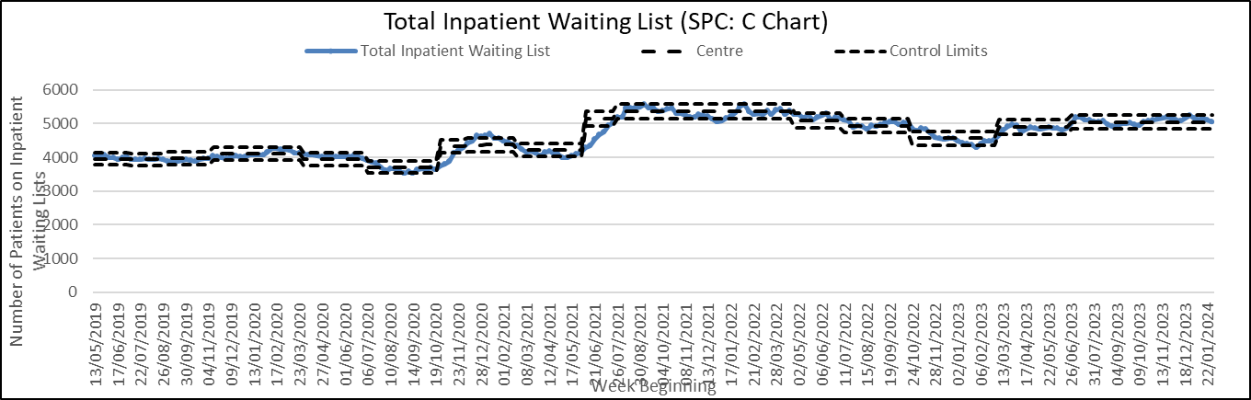
The number of available patients on waiting lists at month end who had waited between 12 and 26 weeks increased by 71, from 593 to 664 at the end of January. The number of patients waiting between 26 and 52 weeks increased by 26 patients during January with a month end position of 429. The number of patients waiting over 52 weeks increased by eight with 630 patients waiting over 52 weeks at end of January.
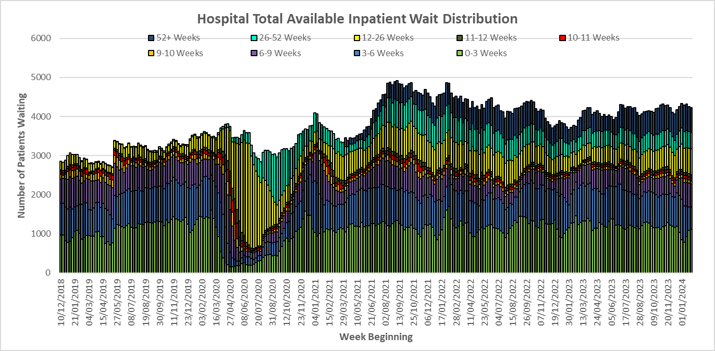
The number of patients who exceeded their 12-week treatment time guarantee in January was reported at 185. This is an increase of 13 from the December position of 189.
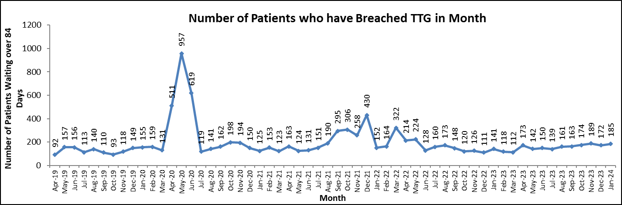
The hospital total cancellation rate for January was reported at 7.2% (182/2537) which is within control limits. Endoscopy had the largest number of cancellations (70/753, 9.3%), whilst General Surgery had the highest cancellation rate 13.3%, 21/158). The most common reason for cancellations were patient reasons with 79 cancellations.
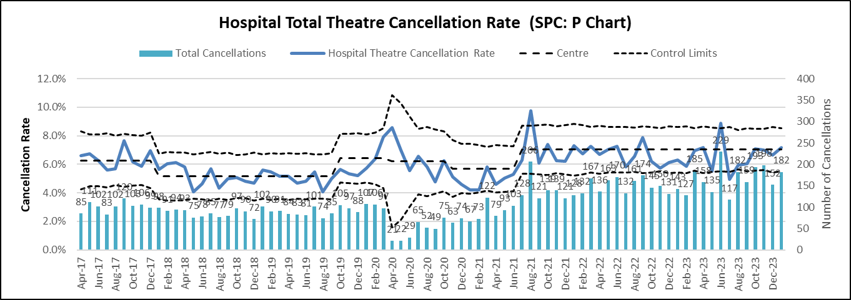
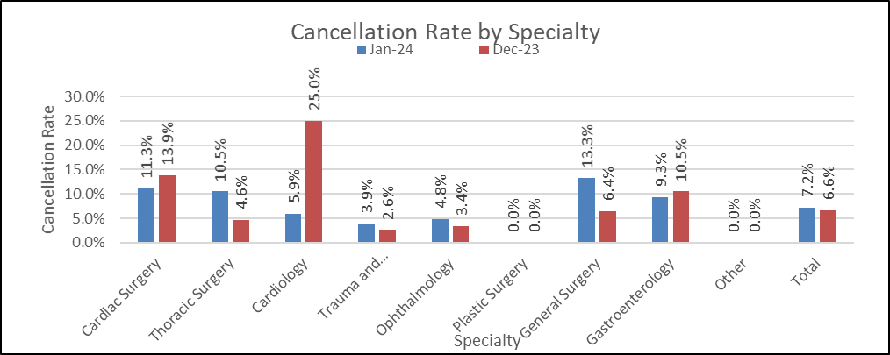
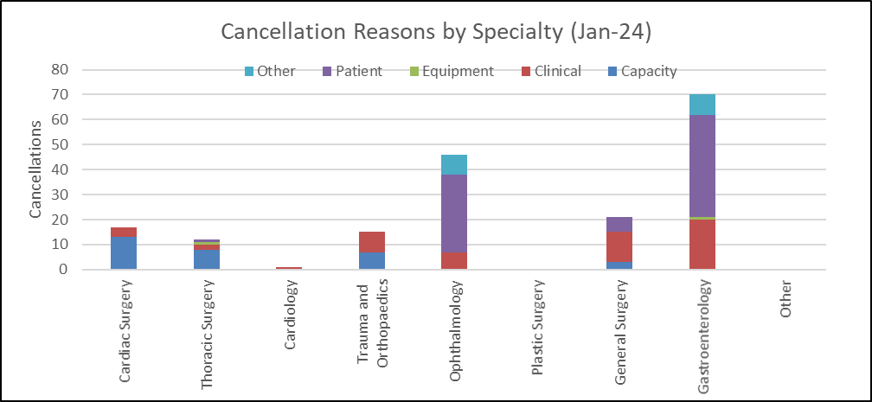
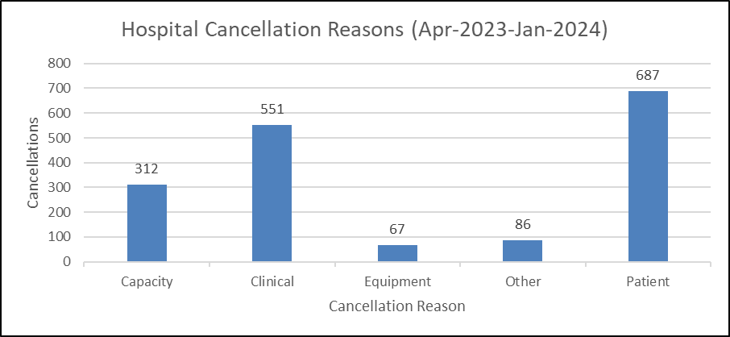
Corporate Departments Dashboard
The table below provides a breakdown of Corporate departments with regard to their sickness absence, appraisal and mandatory training.

Finance, Performance & Planning
National Comparators Table
The table below is intended to demonstrate Golden Jubilee National Hospital’s relative performance, compared to other organisations in Scotland, for indicators and Standards that are reported nationally on the NHS Discovery website.
The table provides:
- The latest time period available for comparison.
- Golden Jubilee National Hospital performance (local).
- Scotland’s performance for all submitting organisations.
- A rank showing Golden Jubilee National Hospital’s relative ranking compared to the number of organisations submitting data.
- Golden Jubilee’s ranking for the previously reported time period.
- A direction of travel indicator which shows whether Golden Jubilee National Hospital has risen, fallen or remained the same in terms of ranking and a colour indicator is provided to indicate into which quartile Golden Jubilee National Hospital would be categorised.

Since January’s IPR the following National Comparator indicators have been updated:
- One instance of SAB was recorded with a rate of 7.5 cases per 100,000 total occupied bed days, this was the second lowest rate of any NHS Scotland Board during Quarter 3 of 2023.
- One instance of CDI was recorded with a rate of 7.5 cases per 100,000 total occupied bed days, this was the third lowest of any NHS Scotland Board during Quarter 3 of 2023.
- Two instance of gram negative bacteremium with a rate of 15.1 cases per 100,000 total occupied bed days, this was the lowest of any NHS Scotland Board during Quarter 3 of 2023.
- The cancer waiting time position for all cancers was reported at 100% compliance for December 2023.
- 42.8% of patients on the Radiology waiting list had waited less than 6 weeks at the end of December with 471 patients over the 6 week threshold.
- In December NHS GJ had a cancellation rate of 6.5% (136/2101)
- In December the 4 Joint List rate was reported at 70%.




NHS GOLDEN JUBILEE
SUMMARY FINANCIAL REPORT
MONTH 10
AS AT 31 JANUARY 2024

FINANCIAL POSITION 31 January 2024 (MONTH 10)
EXECUTIVE SUMMARY
- 2023/2024 to 2025/26 FINANCIAL PLAN

The NHS Golden Jubilee Board in March 2023 approved a 3 year break-even Financial Plan for the period 2023/24 to 2025/26. The Month 10 forecast position is still assuming a continued break-even position, although the delivery of significant levels of savings in still required in each of the 3 years of the plan through a combination of recurring and non-recurring measures.

DELIVERY OF 2023/24 FINANCIAL PLAN

Current Risk Rating |  | Low

For 2023/24 a break-even outturn position requires the delivery of -£6.66m of in-year savings /budget reductions through a combination of recurring and non-recurring measures.

The Year to Date (YTD) core revenue position as at the end of January 2024 is a favourable variance of £780k This represents a favourable % variance of 0.4%.

Following the workstreams reviewing the revised SLA with HL&D NSD SLAs as well as confirmation of forecast performance across the Topslice SLAs, a significant update on both Pays and Non-pays across both Divisions has released recurring budgets to reflect the costs associated with this year’s ADP and SLA reviews.

The Month 10 position shows the impact of this re-alignment of both Pays and Non-pays, resulting in the improvement in the YTD position.

2023/2024 TO 2025/26 FINANCIAL PLAN

Current Risk Rating | Very High

March 2023 Financial Plan
2024/25 and 2025/26 also require the delivery of significant savings to achieve a break-even outturn position in both of the years.

March 2024 Financial Plan
A new 3 year draft financial plan (2024/25 to 2026/27) is currently being developed. Taking into account the significant levels of pressures across the Health System as a whole, there will be a requirement for a robust efficiency and savings plan to ensure delivery of a break-even position over the next 3 years.

The revised draft 3 year plan was submitted to Scottish Government on 29 January 2024 with the final draft requiring submission by 11 March 2024. The final March 2024 draft will be subject to ELT, Committee and ultimately Board approval.

- 2023/24 CORE INCOME POSITION

Current Risk Rating | Low

Income is £1.857m or 0.10% above the Financial Plan at Month 10.

- 2023/24 CORE EXPENDITURE POSITION

Core Expenditure is -£1.080m or -0.58% above the Financial Plan at Month 10.

PAY COSTS

Current Risk Rating | Medium

In overall terms, Pay costs at Month 10 are underspent by £692k or 0.55% below plan, following the release of funding related to the revised NSD SLAs within HL&D.

Further analysis is provided within the relevant section of the main report.

NON PAY COSTS

Current Risk Rating | Very High

In overall terms, Non Pay costs at Month 10 are overspent by -£1.771m equating to -2.95% above YTD budget across a number of Board expenditure categories. This position has been improved in Month 10 following the rebasing of SLAs across both HL&D and NES Divisions, to better reflect the baseline funding required to deliver this year’s associated ADP.

Further analysis is provided within the relevant section of the main report.

- 2023/24 EFFICIENCY REQUIREMENT

Current Risk Rating | Medium

There is a -£6.66m efficiency requirement within the Financial Plan to achieve the targeted break-even position for 2023/24.

FULL YEAR SAVINGS PLAN

Savings schemes identified to-date, as part of the Month 10 review, show that the efficiency target will be met in full by the year-end.

Forecast savings of £6.297m have been identified as at Month 10, leaving a remaining £0.369m still to be identified by the year end. £4.510m of this total has been identified non-recurrently, with c. £1.787m recurrently delivered.
This leaves an on-going recurring challenge of £4.9m which will be carried forward into next year’s financial planning assumptions.

- NON-CORE REVENUE POSITION

Current Risk Rating | Low

Non-Core position at Month 10 is anticipated to be break-even (expenditure matched by SG Income).

- CAPITAL INCOME AND EXPENDITURE

Current Risk Rating | Medium

Capital allocations of £4.270m have been confirmed by Scottish Government at Month 10 with ‘anticipated’ allocations expected of a further £10.042m which would result in an overall funded 2023/24 Capital Plan of £14.312m. This has been updated following the latest cost control meeting with the Board’s Phase 2 cost advisors, reducing the value of expected works carried out down significantly by the end of this financial year. The remaining balance of the Phase 2 works will be carried into the next financial year. The capital position will continue to be reviewed on a monthly basis and updated accordingly.

Section C: Glossary
