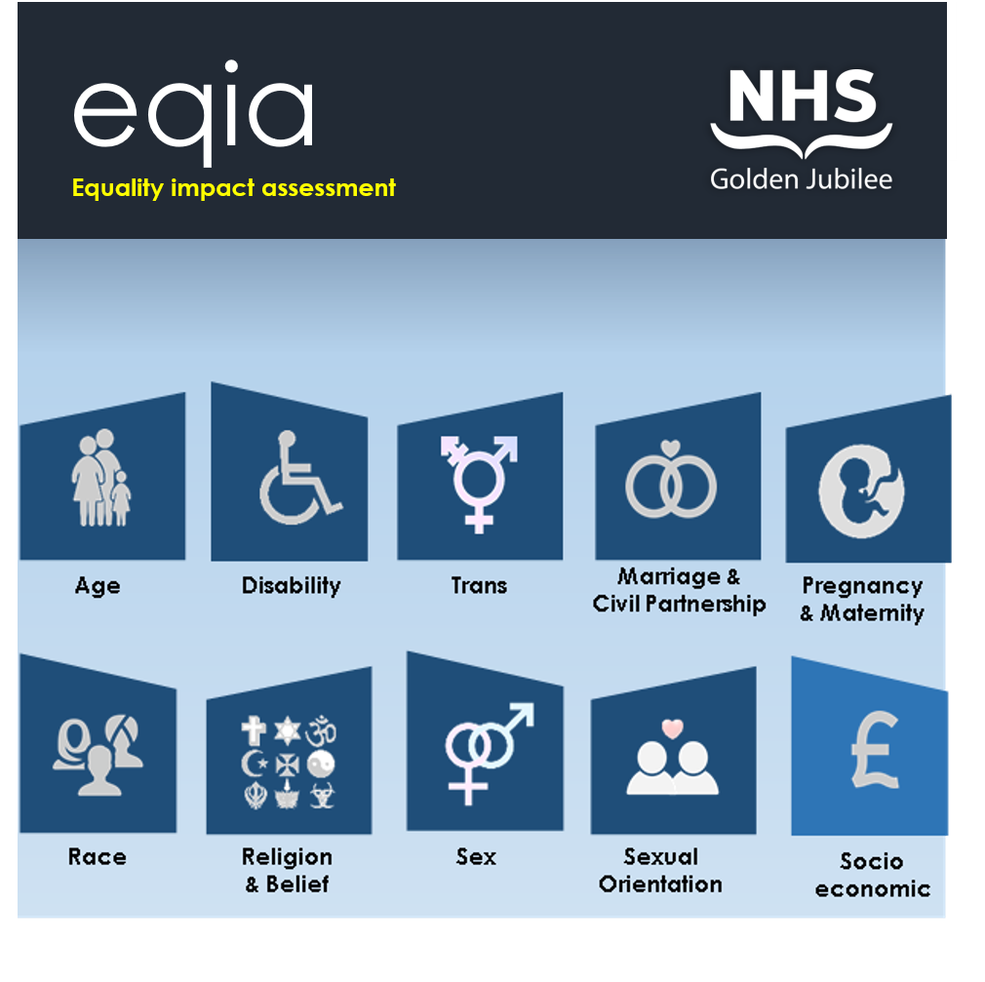

1. **EQIA details**

|  |  |
| --- | --- |
| **Name:**  (policy/ procedure/ practice/ function) | NHS Golden Jubilee Board Strategy 2025-30 |
| **Department:** | Quality, Performance, Planning and Programmes |
| **Lead Contact:** | Carole Anderson |
| **EQIA Assessor:** | Laura Morrison |
| **Date:** | 13/03/2025 |

**2. EQIA overview**

Use this section to provide details about the status **(new or existing)** of the policy/practice/procedure/function and provide an outline of the proposal including **aims**, **objectives** and **outcomes**.

Please note: All tables within this report are expandable.

|  |  |  |
| --- | --- | --- |
| **Status** | New | Existing |
| **Aims objectives & outcomes** | The aim of this new strategy is to ensure the Board has clear, focussed and well-developed strategic objectives to guide its strategic direction covering the period 2025-2030. | |

1. **Advancing Equality**

NHS Golden Jubilee has a legal requirement under the Public Sector Equality Duty to have due regard to the need to:

* Eliminate unlawful discrimination, harassment and victimisation and other conduct prohibited by the Act.
* Advance equality of opportunity between people who share a protected characteristic and those who do not.
* Foster good relations between people who share a protected characteristic and those who do not.

Provide details of how the work will impact **positively**, **negatively** or **neutrally** on people who share the characteristics below.

It will be helpful to consider any access issues, health inequalities or experiences of discrimination that might impact these groups within your area of work. It will also be helpful to think about human rights and whether these will be impacted for any group. Our rights are described in the [Human Rights Act](https://www.equalityhumanrights.com/en/human-rights/human-rights-act). Some groups are also protected by specific conventions, which are highlighted for your information in the relevant sections below.

There is no word count – you should include the information you think is required. Please ensure the information you use is evidence based (e.g. articles, public involvement, previous work). There is space at section 8 for you to record the evidence sources you use in your assessment.

|  |  |  |
| --- | --- | --- |
| Image result for family icon png | **Age** | Think about older people as well as children and young people, and their respective carers.  **United Nations Convention on the Rights of the Child (UNCRC)**  [Convention on the Rights of the Child](https://cypcs.org.uk/rights/uncrc/)  The UNCRC is a legally-binding international agreement setting out the civil, political, economic, social and cultural rights of every child, regardless of their race, religion or abilities.  If children are specifically affected, please provide a high level overview here and then go to **appendix A** to undertake a more detailed assessment using the **UNCRC checklist**. |
| Positive impact | | The NHS GJ Board Strategy identifies the need to accommodate an ageing population, and NHS GJ will be cognisant of this to ensure measures are in place to accommodate these needs through the delivery of our services.  Within our new set of equality outcomes 2025-2029 NHS GJ will provide dementia-friendly accommodation within the level 4 upgrade with scope to expand to existing wards in accordance with Design for Dementia Strategy.  NHS GJ predominately provides adult services with a small percentage of children within the SACCS patient group receiving treatment. A specific equality outcome has been identified to focus on making patient rooms more child friendly. |
| Negative impact | | No impacted identified |
| Neutral impact | | No impacted identified |
| noun_care_2152472 | **Care Experience** | Think about children and young people up to the age of 26 who have experience of being in care. This can include foster care/supported care, kinship care, residential care, or being looked after at home with the support of a supervision order.  NHS Golden Jubilee is named as a corporate parent under the [Children and Young People (Scotland) Act 2014](https://www.legislation.gov.uk/asp/2014/8/contents/enacted). You can find information and working examples of what this means for us in our [Corporate Parenting Plan.](http://nwtc-sharepoint/sites/huddle/Policies/Corporate%20Parenting%20Plan.docx) |
| Positive impact | | As a corporate parent NHS GJ has procedures in place to safeguard children’s wellbeing if mistreatment is suspected. |
| Negative impact | | No impacted identified |
| Neutral impact | | No impacted identified |
| Image result for wheelchair png | **Disability** | Think about people with sensory impairments, communication difficulties, learning disabilities, physical impairments, energy impairments, autism spectrum disorders, mental health conditions and Deaf users of British Sign Language. You might also consider unpaid carers here.  [Convention on the Rights of Person with Disabilities](https://www.un.org/development/desa/disabilities/convention-on-the-rights-of-persons-with-disabilities/convention-on-the-rights-of-persons-with-disabilities-2.html) |
| Positive impact | | Within the previous set of equality outcomes 2021-2025 NHS GJ have implemented a portfolio of measures to improve accessibility of onsite facilities for patients, customers and service users with a disability (including physical, sensory and neuro divergent conditions). Examples of this include installation of a changing places toilet and inclusive way finding within our surgical centre and eye centre.  Within our new set of equality outcomes 2025-2029 NHS GJ will continue to increase the accessibility of our campus. This includes a number of site upgrade works such as:   * A holistic care package for SACCS patients with a learning disability / additional needs. * Implementing an inclusive wayfinding directory within our main building. * Providing dementia-friendly accommodation within the level 4 upgrade with scope to expand to existing wards in accordance with Design for Dementia Strategy * Upgrading existing accessible W/C toilet fixtures and fittings within the main hospital building to bring in line with best practice guidance for accessibility. * Developing and delivering detailed digital access guides for all of our patient pathways by 2029. * Implementing a programme of inclusive design upgrade works across GJCH to enhance accessibility of disabled customers. * Introducing alternative format patient registration forms to help reduce health inequalities making information accessible for all. * Leading on a new accessible communication policy which will be rolled out as a once for Scotland approach. |
| Negative | | No impacted identified |
| Neutral impact | | No impacted identified |
| Image result for gender reassignment png | **Trans Status** | This is about trans / transgender people - anyone whose gender does not match the sex they were assigned at birth.  [Understanding the Transgender Community – Human Rights Campaign](https://www.hrc.org/resources/understanding-the-transgender-community) |
| Positive impact | | Introduction of self-contained gender-neutral sanitary facilities within our eye centre and surgical centre provide a non-gender space for all of our patients and customer service users. All of our patient’s rooms are sole occupancy with ensuite facilities.  NHS GJ are providing discreet change facilities within single sex change rooms as standard with the surgical centre, eye centre and within our main hospital building as part of ongoing refurbishment works. |
| Negative impact | | No impacted identified |
| Neutral impact | | No impacted identified |
| Image result for marriage icon png | **Marriage & Civil Partnership** | Are there any implications for people who are married or in a civil partnership?  [Marriage and civil partnership discrimination – Citizen’s Advice Bureau](https://www.citizensadvice.org.uk/law-and-courts/discrimination/protected-characteristics/marriage-and-civil-partnership-discrimination/) |
| Positive impact | | No impacted identified |
| Negative impact | | No impacted identified |
| Neutral impact | | No impacted identified |
| Related image | **Pregnancy & Maternity** | Think about people who are pregnant, breast-feeding or who recently gave birth.  [Convention on the Elimination of All Forms of Discrimination against Women](https://www.ohchr.org/en/professionalinterest/pages/cedaw.aspx) |
| Positive impact | | Within our new set of equality outcomes 2025-2029 NHS GJ will provide a dedicated onsite facility to enable female staff to express and store breast milk. |
| Negative impact | | No impacted identified |
| Neutral impact | | No impacted identified |
| Image result for race ethnicity icon png | **Race** | Think about people with non-white majority ethnicities. This includes gypsy/travellers.  [Convention on the Elimination of all forms of Racial Discrimination](https://www.ohchr.org/en/professionalinterest/pages/cerd.aspx) |
| Positive impact | | Within our new set of equality outcomes 2025-2029 NHS GJ will implement an anti-racism action plan to address racialized health inequalities and create a more equitable healthcare service. |
| Negative impact | | No impacted identified |
| Neutral impact | | No impacted identified |
| Image result for multi faith png | **Religion or Belief** | Think about people who follow particular religions. For example: Judaism, Islam, Sikhism, Christianity etc. Are there particular beliefs or practices that might be impacted?  [International standards on freedom of religion or belief](https://www.ohchr.org/en/issues/freedomreligion/pages/standards.aspx) |
| Positive impact | | Within our new set of equality outcomes 2025-2029 NHS GJ the Spiritual Care Centre will provide 24/7 access to enable people to express their spirituality. |
| Negative impact | | No impacted identified |
| Neutral impact | | No impacted identified |
| Image result for gender equality png | **Sex** | Think about any differences for women compared to men, or vice versa.  [Convention on the Elimination of all forms of Discrimination Against Women](https://www.ohchr.org/en/professionalinterest/pages/cedaw.aspx) |
| Positive impact | | Within our new set of equality outcomes 2025-2029 NHS GJ will implement a gender equality action plan to develop and deploy targeted measures. |
| Negative impact | | No impacted identified |
| Neutral impact | | No impacted identified |
| Image result for heart pngImage result for 9 icon png | **Sexual Orientation** | Think about people who are lesbian, gay or bi or who have another minority sexual orientation (e.g. are not heterosexual / straight).  [Combatting discrimination based on sexual orientation](https://www.ohchr.org/en/issues/discrimination/pages/lgbt.aspx) |
| Positive impact | | Within our new set of equality outcomes 2025-2029 NHS GJ will increase applications, on-boarding, quality of data and retention of people with protected characteristic with a focus on a specific characteristics including sexual orientation. |
| Negative impact | | No impacted identified |
| Neutral impact | | No impacted identified |
| Image result for british pound png | **Socio-economic** | Think about people living on low incomes and / or in deprived areas. If this is a strategic-level decision and the Fairer Scotland duty applies, you will need to give this characteristic detailed consideration. Otherwise, consider this as a cross-cutting issue(people who share a protected characteristic are more likely to experience poverty).  [The Fairer Scotland Duty Interim Guidance for Public Bodies](https://www.gov.scot/binaries/content/documents/govscot/publications/advice-and-guidance/2018/03/fairer-scotland-duty-interim-guidance-public-bodies/documents/00533417-pdf/00533417-pdf/govscot%3Adocument/00533417.pdf) |
| Positive impact | | Health inequalities is a key focus of our work moving forward and NHS GJ will align strategic objectives to the forthcoming Population Health Framework for Scotland by embedding relevant prevention-focused initiatives, creating the best possible equitable care pathways and leveraging our role as an anchor institution to address health inequalities and support local communities, contributing to Scotland’s broader public health goals. |
| Negative impact | | No impacted identified |
| Neutral impact | | No impacted identified |

1. **Overcoming negative impacts**

Where the policy/practice/procedure/function was identified to adversely affect (discriminate against) people who share a protected characteristic; provide details of how this impact will be eliminated, minimised or managed.

|  |  |  |  |
| --- | --- | --- | --- |
| **Protected Characteristic** | | **Actions** | **Person Responsible** |
| **All Characteristics** | | The NHS GJ Board Strategy has been designed to ensure it has a positive impact across the protected characteristics and any negative impacts have been eliminated or mitigated to the best of the Board’s ability. |  |
| Image result for family icon png | Age |  |  |
|  | Care Experience |  |  |
| Image result for wheelchair png | Disability |  |  |
| Image result for gender reassignment png | Trans Status |  |  |
| Image result for marriage icon png | Marriage/Civil Partnership |  |  |
| Related image | Pregnancy & Maternity |  |  |
| Image result for race ethnicity icon png | Race |  |  |
| Image result for multi faith png | Religion or Belief |  |  |
| Image result for gender equality png | Sex |  |  |
| Image result for heart png | Sexual Orientation |  |  |
| Image result for british pound png | Socio-economic |  |  |

1. **Impact rating**

Provide an impact rating based on the degree to which the policy/practice/procedure/function will impact people who share a protected characteristic.

**Impact Rating Key**

**Low**

There is **little or no evidence** that some people are (or could be) differently affected by the policy/practice/procedure/function.

**Medium**

There is **some evidence** that people are (or could be) differently affected by the policy/practice/procedure/function.

**High**

There is **substantial evidence** that people are (or could be) differently affected by the policy/procedure/function

|  |  |  |  |  |
| --- | --- | --- | --- | --- |
| **Protected Characteristic** | | **Low** | **Medium** | **High** |
| Image result for family icon png | Age | ✓ |  |  |
|  | Care Experience | ✓ |  |  |
| Image result for wheelchair png | Disability | ✓ |  |  |
| Image result for gender reassignment png | Trans Status | ✓ |  |  |
| Image result for marriage icon png | Marriage/Civil Partnership | ✓ |  |  |
| Related image | Pregnancy & Maternity | ✓ |  |  |
| Image result for race ethnicity icon png | Race | ✓ |  |  |
| Image result for multi faith png | Religion or Belief | ✓ |  |  |
| Image result for gender equality png | Sex | ✓ |  |  |
| Image result for heart pngImage result for 9 icon pngImage result for 9 icon png | Sexual Orientation | ✓ |  |  |
| Image result for british pound png | Socio-economic | ✓ |  |  |

1. **Stakeholder collaboration**

Provide details of stakeholder collaboration and consultation.

Refer to **Appendix** **B** for details of local and national charities and user groups which represent the Protected Characteristics defined by the Equality Act 2010.

|  |
| --- |
| **Name/job title or Meeting/Group** |
| 12 Internal workshops |
| 9 internal follow-up engagement sessions |
| Executive Leadership Team Away Day |
| 8 on-site engagement sessions |
| Consultation Survey – open to staff volunteers, patients, public and our partners |

1. **Monitor and review**

Regular reviews ensure that the policy, procedure or practice is kept up to date, and meets the requirements of current equality legislation.

|  |  |  |
| --- | --- | --- |
| **Scheduled Review** | **Assigned contact** | **Review Date** |
| Ewen McGregor | April 2027 |

Where a negative impact has been identified and remedial actions are being implemented, the policy owner should define a timescale for review.

|  |  |  |
| --- | --- | --- |
| **Identified**  **Issue** | **Assigned contact** | **Review Date** |
| N/A |  |  |
|  |  |  |

1. **Evidence and research**

Please detail all evidence and research utilised in order to support the rationale for this EQIA. (Include attachments where available).

[Equalities Evidence Finder](file://hcimax/Common/Equalities%20evidence%20finder)

|  |  |
| --- | --- |
| **Evidence & Research** | **Image result for attachment png** |
| Population Health Framework – key principles |  |
|  |  |

1. **EQIA sign off**

|  |  |  |
| --- | --- | --- |
|  |  | **EQIA’s with low impact ratings** |

If your EQIA demonstrates low impact ratings for each Protected Characteristic, then you are all set to go!

Please ensure that you email a copy of your EQIA to [equalities@gjnh.scot.nhs.uk](mailto:equalities@gjnh.scot.nhs.uk) to allow us to maintain a central database of assessments for auditing purposes.

|  |  |
| --- | --- |
| Image result for email png | [**equalities@gjnh.scot.nhs.uk**](mailto:equalities@gjnh.scot.nhs.uk) |

|  |  |  |
| --- | --- | --- |
|  |  | **EQIA’s with medium or high impact ratings** |

If your EQIA has identified any **medium** or **high impacts** for people who share a Protected Characteristic, you will need to share your assessment with the Equality and Inclusion Lead who will review and advise next steps.

|  |  |
| --- | --- |
| Person icon symbol sign 644845 Vector Art at Vecteezy | [**Rob**](mailto:equalities@gjnh.scot.nhs.uk) **White: Equality and Inclusion Lead** |
| Image result for email png | [**robert.white@gjnh.scot.nhs.uk**](mailto:equalities@gjnh.scot.nhs.uk) |
| Telephone - Cell Phone Icon Circle Png Transparent PNG - 1442x1442 - Free  Download on NicePNG | **5480** |

**Organisational governance process**

Next, you need to share the EQIA with the people you’re working with on your project, policy, process or practice.  Not least because you should be proud of your work, but also because you should communicate the results of your assessment to project boards, organisational leaders, key stakeholders and others in a timely way, so that they can make informed decisions about the change you’re making.

|  |  |
| --- | --- |
| **EQIA Assessor:** | Laura Morrison |
| **Sign-Off Date:** | 13/03/2025 |

**Appendix A**

UNCRC Checklist

**If your proposal does not affect children and young people do not complete this section.**

If your proposal affects children and young people, use the evidence you have collected to explain how your proposal could impact Children’s Rights. Not all UNCRC rights may apply to your proposal. If this is the case, simply say ‘Not relevant’ or ‘no known relevance’.

|  |  |  |  |
| --- | --- | --- | --- |
| **UNCRC Right** | **How will your work limit or restrict this right?** | **How will your work progress this right?** | **Are any groups of children particularly impacted?** |
| **3. Best interests of the child** |  | NHS GJ are implementing child friendly designs to ensure a smooth transition from paediatric to adult services within the SACCS service. |  |
| **4. Making rights real** |  | NHS GJ will implement child friendly feedback loops to enable the voice of the child to be heard. |  |
| **5. Family guidance as children develop** |  |  |  |
| **6. Life, survival and development** |  |  |  |
| **7. Name and nationality** |  |  |  |
| **8. Identity** |  |  |  |
| **9. Keeping families together** |  | NHS GJ will be procuring fold down beds to allow family members to stay with children while receiving care. |  |
| **10. Contact with parents across countries** |  | NHS GJ has systems in place to facilitate digital communication where family members are not co-located. |  |
| **11. Protection from kidnapping** |  | NHS GJ has an integrated security system in place including CCTV and a dedicated on-site security team. |  |
| **12. Respect for children’s views** |  | NHS GJ will implement child friendly feedback loops to enable the voice of the child to be heard and ensure child friendly communication. |  |
| **13. Sharing thoughts freely** |  | Please refer to response to question 12. |  |
| **14. Freedom of thought and religion** |  | NHS GJ has a Spiritual Care Centre accessible 24/7, the service has two chaplains providing cover 8am-8pm with on call cover also available. |  |
| **15. Freedom of association and peaceful assembly** |  |  |  |
| **16. Protection of privacy** |  | NH GJ adheres to information governance standards and ensures full compliance with data protection principles. |  |
| **17. Access to information** |  | The NHS GJ Marketing Communications and Stakeholder Relations team are developing an accessible Communication Strategy to ensure information is provided in an accessible format. |  |
| **18. Responsibility of parents** |  |  |  |
| **19. Protection from violence** |  | As a corporate parent, NHS GJ has procedures in place to safeguard children’s wellbeing. |  |
| **20. Children without families** |  | Please refer to response to question 19. |  |
| **21. Children who are adopted** |  | Please refer to response to question 19. |  |
| **22. Refugee children** |  | Please refer to response to question 19. |  |
| **23. Disabled children** |  | Please refer to response to disability within section 3. |  |
| **24. Enjoyment of the highest attainable standard of health** |  | NHS GJ is a leading person- centred health care provider. |  |
| **25. Review of a childs placement** |  |  |  |
| **26. Social and economic help** |  | Please refer to response to socio-economic within section 3. |  |
| **27. Food, clothing and safe home** |  |  |  |
| **28. Access to education** |  |  |  |
| **29. Aims of education.** |  |  |  |
| **30. Minority culture, language and religion** |  | NHS GJ has an in-house interpretation service and a Spiritual Care Centre. |  |
| **31. Rest, play, culture, arts** |  |  |  |
| **32. Protection from harmful work** |  | Please refer to response to question 19. |  |
| **33. Protection from harmful drugs** |  | Please refer to response to question 19. |  |
| **34. Protection from sexual abuse** |  | Please refer to response to question 19. |  |
| **35. Prevention from sale and trafficking** |  | Please refer to response to question 19. |  |
| **36. Protection from exploitation** |  | Please refer to response to question 19. |  |
| **37. Children in detention** |  | Please refer to response to question 19. |  |
| **38. Protection in war** |  |  |  |
| **39. Recovery and reintegration** |  |  |  |

**Appendix B**

Third sector organisations

|  |  |  |  |
| --- | --- | --- | --- |
| Image result for family icon png | Age | * Age UK | [www.ageuk.otg.uk](file:///E:/EQIA%20Review/www.ageuk.otg.uk) |

|  |  |  |  |
| --- | --- | --- | --- |
|  | Care Experience | * Become | https://www.becomecharity.org.uk/ |
| * CELCIS | [www.celcis.org](http://www.celcis.org) |
| * Who Cares? Scotland | www.whocaresscotland.org |
| * SCCYP | [www.sccyp.org.uk](http://www.sccyp.org.uk) |

|  |  |  |  |
| --- | --- | --- | --- |
| Image result for wheelchair png | Disability | * RNIB Scotland | [WWW.RNIB.ORG.UK](file:///E:/EQIA%20Review/WWW.RNIB.ORG.UK) |
| * Visibility | [WWW.VISIBILITY.ORG.UK](file:///E:/EQIA%20Review/WWW.VISIBILITY.ORG.UK) |
| * Action on Hearing Loss | [www.actiononhearingloss.org.uk](file:///E:/EQIA%20Review/www.actiononhearingloss.org.uk) |
| * Dementia UK | [www.dementiauk.org](file://nwtc-filesrv/users/whiter/EQIA%20Review/www.dementiauk.org) |
| * Alzheimer’s Society | [www.alzheimers.org.uk](file://nwtc-filesrv/users/whiter/EQIA%20Review/www.alzheimers.org.uk) |
| * Autism Alliance | [www.autism-alliance.org.uk](file://nwtc-filesrv/users/whiter/EQIA%20Review/www.autism-alliance.org.uk) |
| * Scottish Autism | [www.scottishautism.org](file:///E:/EQIA%20Review/www.scottishautism.org) |
| * Mind | [www.mind.org.uk](file:///E:/EQIA%20Review/www.mind.org.uk) |
| * Scope | [www.scope.org.uk](file:///E:/EQIA%20Review/www.scope.org.uk) |
| Image result for gender reassignment png | Trans Status | * Scottish Trans Alliance | [www.scottishtrans.org](file://nwtc-filesrv/users/whiter/EQIA%20Review/www.scottishtrans.org) |
| * Sparkie | [www.sparkie.org.uk](file:///E:/EQIA%20Review/www.sparkie.org.uk) |
| * Mermaids UK | [www.mermaidsuk.org.uk](file:///E:/EQIA%20Review/www.mermaidsuk.org.uk) |
| Image result for marriage icon png | Marriage/ Civil Partnership | * Equality Network | [www.equality-network.org](file:///E:/EQIA%20Review/www.equality-network.org) |
| Related image | Pregnancy & Maternity | * Maternity Action | [www.maternityaction.org.uk](file:///E:/EQIA%20Review/www.maternityaction.org.uk) |
| Image result for race ethnicity icon png | Race | * Race Equality Foundation | [www.raceequalityfoundation.org.uk](file:///E:/EQIA%20Review/www.raceequalityfoundation.org.uk) |
| * Ethnic Minority Foundation | [www.emfoundation.org.uk](file:///E:/EQIA%20Review/www.emfoundation.org.uk) |
| Image result for multi faith png | Religion or Belief | * Interfaith Scotland | [www.interfaithscotland.org](file:///E:/EQIA%20Review/www.interfaithscotland.org) |
| Image result for gender equality png | Sex | * Equality Now | [www.equalitynow.org](file:///E:/EQIA%20Review/www.equalitynow.org) |
| * Fawcett Society | [www.fawcettsociety.org.uk](file:///E:/EQIA%20Review/www.fawcettsociety.org.uk) |
| Image result for 9 icon pngImage result for heart pngImage result for 9 icon png | Sexual Orientation | * Stonewall Scotland | [www.stonewall.org.uk](file:///E:/EQIA%20Review/www.stonewall.org.uk) |
| * West Dunbartonshire LGBT Network | [www.lgbtwestdunbartonshire.com](file:///E:/EQIA%20Review/www.lgbtwestdunbartonshire.com) |
| * LGBT Youth Scotland | [www.lgbtyouth.org.uk](file:///E:/EQIA%20Review/www.lgbtyouth.org.uk) |
| Image result for british pound png | Socio-economic | * The Poverty Alliance | [www.povertyalliance.org](file:///E:/EQIA%20Review/www.povertyalliance.org) |
| * Citizens Advice | [www.citizensadvice.org.uk](file:///C:/Users/pearlstoneb/AppData/Local/Microsoft/Windows/INetCache/Content.Outlook/K6NYNGYS/www.citizensadvice.org.uk) |