Healthcare Associated Infection Report
End of year HAIRT-March 2025
Section 1 – Board Wide Issues
Section 1 of the HAIRT covers Board wide infection prevention and control activity and actions. For reports on individual departments, please refer to the ‘Healthcare Associated Infection Report Cards’ in Section 2.

Key Healthcare Associated Infection Headlines

- Staphylococcus aureus Bacteraemia (SAB) 2024-2025
9 cases in total /15.64 per 100,000 total occupied bed days.
This rate is above the local trajectory of 11.22 per 100,000 total occupied bed days (by n=3 cases), however below national quarterly rates ranging between 17.3 - 20.2 per 100,000 total occupied bed days.
This local rate is static from the previous rolling 23/24 target rate of 15.34 per 100,000 total occupied bed days.

SAB Investigation Tool proforma was updated 24/2 supporting process around multiprofessional agreement of source of SAB.

- Clostridioides difficile infection (CDI) 2024-2025
2 cases in total / 3.48 per 100,000 total occupied bed days.
This rate is above the local trajectory of 1.9 per 100,000 total occupied bed days (by n=1 case), but below national quarterly rates ranging 17-18.4 per 100,000 total occupied bed days.
It should be noted the local rate is reduced from the previous rolling 23/24 target rate of 5.75 per 100,000 total occupied bed days.

- Gram Negative/E.coli Bacteraemia (ECB) 2024-2025
4 cases in total / 6.95 per 100,000 total occupied bed days.
This rate is below the local trajectory of 15.5 per 100,000 total occupied bed days, and below national quarterly rates ranging between 36.9 - 39.4 per 100,000 total occupied bed days.
It should be noted the local rate is reduced from the previous rolling 23/24 target rate of 9.59 per 100,000 total occupied bed days.

- Hand Hygiene- Overall compliance score for March is 99%. Performance over 24/25 is described within.

- Cleaning and the Healthcare Environment -Facilities Management Tool
March Housekeeping Compliance: 98.39%. Estates Compliance: 98.17%
Both compliance rates are above national trajectories. Performance over 24/25 is described within.

- Orthopaedic Surgical Site Surveillance-
THR/TKR SSI rates have remained within control limits throughout 24/25.
Overall THR SSI rate 0.3%/Overall TKR SSI rate 0.08%

- Cardiac Surgical Site Surveillance-
CABG & Valve +/- CABG SSI rates have remained within control limits throughout 24/25.
Overall CABG SSI rate 2.2%/Overall Valve +/- CABG SSI 2.6%

2024/2025 HCAI Key Activity Overview
The Prevention and Control of Infection Planned programme contains the specifics of PCIT HCAI activity and tracks its delivery. Of the 15 key programme objectives within, all are green status. In addition to key surveillance data described in this HAIRT, below is a summary of other key activity.

Built Environment /Hospital Expansion
Phase 2 Surgical Centre officially opened August 2024.
This project from design to handover has provided a once in a career opportunity for the team to be involved in a project of this scale. The expert skill set of the team has expanded and developed throughout the project and has proven to be an invaluable development opportunity for the team, as has learning from the project shared with NHS ASSURE and counterparts in other Boards.

To support the planning around operational delivery and handover, there had also been a marked increase in all PCI team activity in various delivery and commissioning groups, working closely with operational colleagues. Additional Work Task Order (WTO) projects to support hospital expansion have been simultaneous during this time and will continue in 25/26.

Non expansion related HAI SCRIBE activity has also continued and increased by 54% from 23/24. There were 203 SCRIBES in 23/24 and 312 in 24/25. This work is linked to-
- Reactive estates issues/ maintenance issues e.g. water ingress
- Planned maintenance/ upgrades
- WTO 6- Lift refurb
- Cardiac CT scanner
- NHS Academy Skills and Simulation Centre
- Theatre changing refurbishment
- LED lighting all levels
- Galley refurbishments

HCAI incidents
There are several processes of risk assessment for HCAI related incidents from
PAG (Problem Assessment Group) to Incident Management and escalation to ARHAI and SG policy unit via the HIORT. In this time period seven PAGs were initiated, three of which were related to national /other Board issues. Other than onward reporting for information, the remaining four PAGs did not require ARHAI support.

MRSA screening
Following a review MRSA screening outputs and consideration of benefits of additional screening currently provided at NHS Golden Jubilee, 7 day MRSA will cease, however will continue in critical care, NSD, NSD2 and long term orthopaedics in 2 West.
Workforce
In June, the Associate CNO from Scottish Government met with the Associate Director Prevention and Control of Infection, the Head of Nursing Prevention and Control of Infection
and the Medical Director to discuss progress with local HAI Strategy and workforce. Progress to date and planned direction of travel at that time received positive feedback.

In October, HCAI AMR/Policy Unit held an engagement event in conjunction with HAI Executive leads and Board Prevention and Control of Infection leads. NHS GJ were invited to present and share learning from Phase1 and Phase 2 expansion.
This was well received and prompted several further discussions from other Boards to share our lessons learned.

National influencing factors
During 2024/25, national priorities /publications have also influenced the work of the PCIT and NHS GJ, these include:
- IPC Workforce Strategy 2022-2024
- Green Theatres Programme
- Mpox- Preparedness planning September 24 until March 25 following declassification of Mpox as a HCID
- Director’s Letter DL (2024) 29 - PUBLICATION OF NEW DELIVERABLES FOR THE SECOND PHASE OF THE ‘HEALTHCARE ASSOCIATED INFECTION STRATEGY 2023-2025’ was issued 21/11/24. The vast majority of deliverables within this DL remain with ARHAI and Scottish Government, the output/impact of these on local Boards will be shared when known
- Chapter 4 NIPCM- Collaboration with Estates colleagues to review Chapter 4 NIPCM and gap analysis development
- The PCIT are working closely with national groups to develop outputs to inform local Board delivery, the most recent being the ongoing review of Transmission Based Precautions (TBPs).

Horizon Scanning
- Director’s letter (2025) 05 was published on 27th March 2025 advising that following an objective review by ARHAI and consideration of their recommendations by Cabinet Secretary for Health & Social Care, the trajectory for HAI standards would be based on the 2023/24 baseline.
 | 2023/2024 case numbers | Based on 23/24 data/Rate per 100 ,000 bed days
CDI | 3 | 5.75
ECB | 6 | 11.5
SAB | 8 | 15.34
- The national Surveillance Programme in Scotland is under review and recommendations due to be presented to the Scottish Government by November 2025 and will consider new standards baseline for 2026.
- FMT Review – the system, implemented in 2006, has had several updates to the framework however never a full review. A project team has been established by NSS and will highlight best practices, faults and recommend a way forward. NHSGJ are represented on the SLWG, with other key stakeholders across Scotland Territorial and Special Health Boards. Work will progress over 2025/26.

Staphylococcus aureus (including MRSA)
Staphylococcus aureus is an organism which is responsible for a large number of healthcare associated infections, although it can also cause infections in people who have not had any recent contact with the healthcare system. The most common form of this is Meticillin Sensitive Staphylococcus aureus (MSSA), but the more well-known is MRSA (Meticillin Resistant Staphylococcus aureus), which is a specific type of the organism which is resistant to certain antibiotics and is therefore more difficult to treat.
NHS Boards carry out surveillance of Staphylococcus aureus blood stream infections, known as bacteraemias. These are a serious form of infection and there is a national target to reduce them.
More information can be found at: Staphylococcus aureus bacteraemia | National Services Scotland (nhs.scot)

NHS GJ approach to SAB prevention and reduction
It is accepted within ARHAI that care must be taken in making comparisons with other Boards’ SAB data because of the specialist patient population within NHS GJ. All SAB isolates identified within the laboratory are subject to case investigation to determine future learning and quality improvement.

Small numbers of cases can quickly change our targeted approach to SAB reduction.

Broad HCAI initiatives which influence our SAB rate include-
- Hand Hygiene compliance monitoring
- MRSA screening at pre-assessment clinics and admission
- Compliance with National Cleaning Standards Specifications
- Audit of the environment and practices via Prevention and Control of Infection Annual Reviews, monthly SCN led Standard Infection Control Precautions audit and CNM Peer Review monitoring
- Participation in National Enhanced SAB surveillance- gaining further intelligence on the epidemiology of SAB locally and nationally.

SSI Related SAB
- MSSA screening for cardiac surgery and subsequent treatment pre and
post op as a risk reduction approach
- Surgical Site Infection Surveillance in collaboration with ARHAI to allow rapid identification of increasing and decreasing trends of SSI
- Orthopaedic Prosthetic Joint Infection Audit Group scoping introduction of MSSA decolonisation pre operatively, group currently paused.

Device Related SAB
- Implementation of PVC, CVC, PICC and IABP bundles; assessment of compliance locally aids targeting of interventions accordingly.

NHS GJ SAB HCAI Standards /AOP Trajectories- Rolling Target
NHS Boards are expected to achieve a reduction of 10% in the national rate of healthcare associated SAB from 2019 to 2023, with 2018/19 used as the baseline for the SAB reduction target this year. The percentage reductions will be measured against individual NHS Scotland Boards’ current levels, rather than taking a “best in class” approach as previous. Targets currently under national review with possible interim targets being reviewed by Scottish Government Policy Unit.
For NHS GJ this target is 11.22 per 100,000 TOBD. This remains a challenging target given NHS GJ existing low SAB rate and high risk patient population.
The data above reflects NHS GJ SAB isolates beyond 48hrs of admission.

Sources of SAB
The Prevention and Control of Infection Team work closely with the clinical teams, CG and clinical educators to gain insight into the sources of SAB acquisition and associated learning. Each SAB is subject to an enhanced surveillance process involving the PCIT, SCN and responsible consultant to determine any learning from the source of the SAB. Thereafter the Enhanced SAB surveillance reports are submitted to the relevant service clinical governance group to share potential learning and note actions required.
2 East
May 24- Unknown & PVC
June 24- Unknown
Sept 24- PVC
Jan 25- Infected hip
3 West
Sept 24-Respiratory
Jan 25- PVC
3East
April 24- Unknown
NSD 2
April 24- Vascath

MRSA Screening Compliance
MRSA screening promotes early identification of patients colonised or infected with MRSA. This facilitates early implementation of decolonisation / treatment with the aim of reducing the reservoir of MRSA and therefore the risk of transmission to other vulnerable patients. Screening must be completed at pre assessment where applicable, and on admission into NHS GJ.

Within NHS GJ MRSA screening must be completed for all elective admissions within high impact specialities e.g. ORTHOPAEDIC /CARDIAC/CARDIOTHORACIC/CARDIOLOGY and all overnight stay patients. Thereafter patients whose length of stay is 10 days or more are subject to additional screening on:
- Day 10
- And each 7 days thereafter

Day 10 screen was identified as the initial screen date as it captures patient stay beyond routine pathways. Compliance is monitored via reviewing a sample of eligible patients against submitted MRSA screens. SCNs are informed of results at the time of audit and informed an action plan is required to improve compliance should be submitted.

Clostridioides difficile infection (previously known as Clostridium difficile)
Clostridioides difficile is an organism which is responsible for a large number of healthcare associated infections, although it can also cause infections in people who have not had any recent contact with the healthcare system. NHS Boards carry out surveillance of Clostridioides difficile infections (CDI), and there is a national target to reduce these.
More information on Clostridioides difficile infections can be found at: Clostridioides difficile infection | National Services Scotland (nhs.scot)

NHS GJ approach to CDI prevention and reduction
Our numbers of CDI cases are low in comparison with other Boards, which is likely to relate to our specialist patient population.

Actions to reduce CDI-
- Ongoing alert organism surveillance and close monitoring of the severity of cases by the PCIT.
- Unit specific reporting and triggers.
- Implementation of ARHAI Severe Case Investigation Tool if the case definition is met.
- Typing of isolates when two or more cases occur within 30 days in one unit.

NHS GJ CDI HCAI Standards/ AOP Trajectories Rolling Target

Reduction of 10% in the national rate of healthcare associated CDI from 2019 to 2023, with 2018/19 used as the baseline for the CDI reduction target. The percentage reductions will be measured against individual NHS Scotland Boards’ current levels, rather than taking a” best in class” approach as previously. For NHS GJ this target is 1.9 per 100,000 TOBD.
This remains a challenging target given NHS GJ exceptionally low CDI rates, small numbers of cases will influence the achievement of this target. Targets currently under national review with possible interim targets to follow.

Gram Negative/E.coli Bacteraemia
Escherichia coli (E. coli) is a bacterium that forms part of the normal gut flora that helps human digestion. Although most types of E. coli live harmlessly in your gut, some types can cause illness. E. coli bacteraemias can be as a result of an infection such as:
•urinary tract
•surgery
•inappropriate use of medical devices

E. coli is currently the most common cause of bacteraemia in Scotland. As a result, its reduction has been added as a new HAI Standard target. More information can be found at: HPS Website - Protocol for National Enhanced Surveillance of Bacteraemia (scot.nhs.uk)

NHS GJ ECB HCAI Standards/ AOP Trajectories
In recognition of Boards difficulty in achieving the previous target, DL 2023 06 requests Board to achieve a reduction of 25% in healthcare associated E. coli bacteraemia by 2023/24 year end.
For NHS GJ, this 25% reduction is target based on 22/23 data and is 15.5 per 100,000 TOBD.
All ECB isolates identified within the laboratory are subject to case investigation to determine future learning and quality improvement.
Targets currently under national review with possible interim targets to follow.

Hand Hygiene
NHS GJ approach to Hand Hygiene

The hand hygiene report for March shows an overall compliance of 99%.

During 24/25 the methodology of hand hygiene compliance monitoring changed. The report now incorporates all reporting areas’ data as opposed to a random selection of 15 areas (as per historical Hand Hygiene Campaign methodology) and as such is a better predictor of compliance.

This data is also generated automatically via Sharepoint and available for all staff to access.

Overall compliance has remained above 95% throughout 24/25.

Good hand hygiene by staff, patients and visitors is a key way to prevent the spread of infections. More information on the importance of good hand hygiene can be found at: http://www.nipcm.hps.scot.nhs.uk
NHS Boards monitor hand hygiene and ensure a zero tolerance approach to non-compliance.

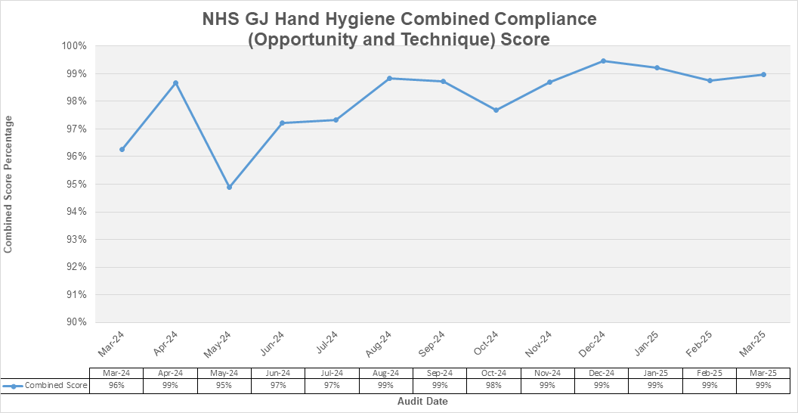

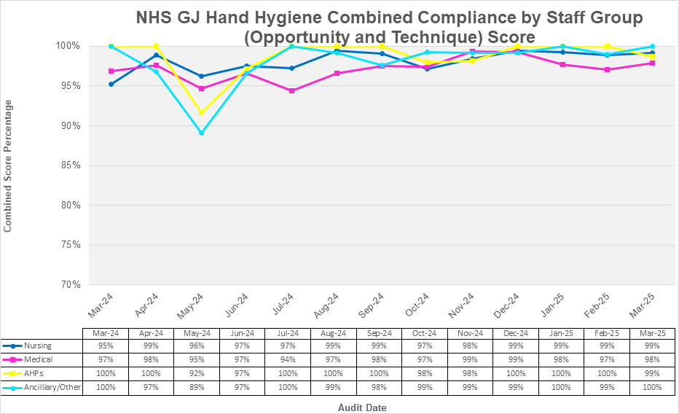

Hand Hygiene - Compliance by Area
Compliance scores by area are highlighted in the tables below
 | Area not in use
#DIV/0! | 20 Observations not undertaken/recorded
 | >95%
 | 80-94%
 | <80%

March 2025- Non Compliances

2 East Cardiology - 3 instances of staff not taking the opportunity to perform hand hygiene.

Ortho 2 West - 2 instances where staff did not take the opportunity to perform hand hygiene. 1 instance where staff member did not use the correct product for hand hygiene.

Cleaning and Maintaining the Healthcare Environment

Additional areas in hospital expansion await transfer to supplier domain from NSS server to allow these new areas to be integrated into the FMT process. Housekeeping services will continue to conduct observational inspection audits, reporting exceptions until issue resolved.

National Cleaning Standards - A national review of the FMT is planned to commence in Spring 2025 with the Project Initiation Document currently out for comment – still awaiting update.

Housekeeping and Portering Services recruitment continues. Management supporting the corporate services review. Expansion support still ongoing.

Housekeeping FMT Audit Results

Enlarged image available at the end of HAIRT

Healthcare Associated Infection Reporting Template (HAIRT)
Section 2 – Healthcare Associated Infection Report Cards
The following section is a series of ‘Report Cards’ that provide information, for each acute hospital and key community hospitals in the Board, on the number of cases of Staphylococcus aureus blood stream infections (also broken down into MSSA and MRSA) and Clostridioides difficile infections, as well as hand hygiene and cleaning compliance. In addition, there is a single report card which covers all community hospitals [which do not have individual cards], and a report which covers infections identified as having been contracted from outwith hospital. The information in the report cards is provisional local data, and may differ from the national surveillance reports carried out by ARHAI. The national reports are official statistics which undergo rigorous validation, which means final national figures may differ from those reported here. However, these reports aim to provide more detailed and up to date information on HAI activities at local level than is possible to provide through the national statistics.

Understanding the Report Cards – Infection Case Numbers
Clostridioides difficile infections (CDI) and Staphylococcus aureus bacteraemia (SAB) cases are presented for each hospital, broken down by month. Staphylococcus aureus bacteraemia (SAB) cases are further broken down into Meticillin Sensitive Staphylococcus aureus (MSSA) and Meticillin Resistant Staphylococcus aureus (MRSA).

For each hospital the total number of cases for each month are those which have been reported as positive from a laboratory report on samples taken more than 48 hours after admission. For the purposes of these reports, positive samples taken from patients within 48 hours of admission will be considered to be confirmation that the infection was contracted prior to hospital admission and will be shown in the “out of hospital” report card.

Targets
There are national annual operating plans associated with reductions in HCAI. More information on these can be found on the Scottish Government website.

Understanding the Report Cards – Hand Hygiene Compliance
Hospitals carry out regular audits of how well their staff are complying with hand hygiene. Each hospital report card presents the combined percentage of hand hygiene compliance with both opportunity taken and technique used broken down by staff group.

Understanding the Report Cards – Cleaning Compliance
Hospitals strive to keep the care environment as clean as possible. This is monitored through cleaning and estates compliance audits. More information on how hospitals carry out these audits can be found here:
Facilities Monitoring Report | National Services Scotland (nhs.scot)

NHS BOARD REPORT CARD

Staphylococcus aureus bacteraemia monthly case numbers
 | Apr  24 | May 24 | Jun  24 | Jul  24 | Aug 24 | Sept 24 | Oct 24 | Nov 24 | Dec  24 | Jan 25 | Feb  25 | Mar  25
MRSA | 0 | 0 | 1 | 0 | 0 | 0 | 0 | 0 | 0 | 0 | 0 | 0
MSSA | 2 | 1 | 1 | 0 | 0 | 2 | 0 | 0 | 0 | 2 | 0 | 0
Total SABS | 2 | 1 | 2 | 0 | 0 | 2 | 0 | 0 | 0 | 2 | 0 | 0

Clostridioides difficile infection monthly case numbers
 | Apr  24 | May 24 | Jun  24 | Jul  24 | Aug 24 | Sept 24 | Oct 24 | Nov 24 | Dec  24 | Jan 25 | Feb  25 | Mar  25
Ages15-64 | 0 | 0 | 0 | 0 | 0 | 0 | 0 | 0 | 0 | 0 | 0 | 0
Ages 65+ | 1 | 0 | 1 | 0 | 0 | 0 | 0 | 0 | 0 | 0 | 0 | 0
Ages 15 + | 0 | 0 | 0 | 0 | 0 | 0 | 0 | 0 | 0 | 0 | 0 | 0

E.Coli bacteraemia monthly case numbers

 | Apr  24 | May 24 | Jun 24 | Jul  24 | Aug 24 | Sept 24 | Oct 24 | Nov 24 | Dec  24 | Jan 25 | Feb  25 | Mar  25
ECB | 1 | 1 | 1 | 0 | 0 | 0 | 0 | 0 | 0 | 0 | 0 | 1

Hand Hygiene Monitoring Compliance (%)
 | Apr  24 | May 24* | Jun  24 | Jul  24* | Aug 24 | Sept 24 | Oct 24 | Nov 24 | Dec  24 | Jan 25 | Feb  25 | Mar  25
Nurse |  | 99 |  | 99 |  | 99 | 97 | 98 | 99 | 99 | 99 | 99
Medical |  | 100 |  | 100 |  | 98 | 97 | 99 | 99 | 98 | 97 | 98
AHP |  | 100 |  | 100 |  | 100 | 98 | 98 | 100 | 100 | 100 | 99
Ancillary/Other |  | 100 |  | 100 |  | 98 | 99 | 99 | 99 | 100 | 99 | 100
Board Total |  | 99.6 |  | 99 |  | 99 | 98 | 99 | 99 | 99 | 99 | 99
*Undertaken using previous methodology
Cleaning Compliance (%)
 | Apr  24 | May 24 | Jun  24 | Jul  24 | Aug 24 | Sept 24 | Oct 24 | Nov 24 | Dec 24 | Jan 25 | Feb  25 | Mar  25
Board Total | 98.21 | 98.8 | 97.18 | 98.6 | 98.7 | 98.42 | 98.25 | 98.85 | 98.23 | 98.64 | 98.25 | 98.39

Estates Monitoring Compliance (%)
 | Apr  24 | May 24 | Jun  24 | Jul  24 | Aug  24 | Sept 24 | Oct  24 | Nov  24 | Dec  24 | Jan 25 | Feb  25 | Mar  25
Board Total | 96.37 | 97.87 | 95.18 | 98.8 | 97.38 | 98.95 | 92.47 | 97.55 | 96.3 | 98.54 | 92.61 | 98.17

Surgical Site Infection Surveillance- Orthopaedic Local data
Hip Arthroplasty SSI
Number of Procedures | Month | Type of SSI | Status
157 | Apr 24 | 1 Superficial | Confirmed
170 | May 24 | 2 Superficial | Confirmed
156 | June 24 | 1 Superficial | Confirmed
164 | July 24 | 0 | Confirmed
153 | Aug 24 | 0 | Confirmed
119 | Sept 24 | 0 | Confirmed
216 | Oct 24 | 0 | Confirmed
188 | Nov 24 | 0 | Confirmed
150 | Dec 24 | 0 | Confirmed
169 | Jan 25 | 1 Deep Infection | Confirmed
148 | Feb 25 | 0 | Confirmed
220 | Mar 25 | 1 Deep Infection | Unconfirmed
Annual Overall SSI rate =0.3

*A surgical site infection is defined as a superficial, deep or organ space infection occurring within 30 days of operation. Definitions of superficial, deep and organ space are defined in Health Protection Scotland Surgical Site Infection Surveillance Protocol.

Knee Arthroplasty SSI
Number of Procedures | Month | Type of SSI | Status
173 | Apr 24 | 0 | Confirmed
167 | May 24 | 0 | Confirmed
149 | June 24 | 0 | Confirmed
198 | July 24 | 0 | Confirmed
220 | Aug 24 | 0 | Confirmed
127 | Sept 24 | 1Superficial | Confirmed
238 | Oct 24 | 0 | Confirmed
232 | Nov 24 | 1Superficial | Confirmed
238 | Dec 24 | 0 | Confirmed
273 | Jan 25 | 0 | Confirmed
212 | Feb 25 | 0 | Confirmed
231 | Mar 25 | 0 | Unconfirmed
Annual Overall SSI rate =0.08

*A surgical site infection is defined as a superficial, deep or organ space infection occurring within 30 days of operation. Definitions of superficial, deep and organ space are defined in Health Protection Scotland Surgical Site Infection Surveillance Protocol.

Surgical Site Infection Surveillance- CABG Local data
CABG SURGERY SSI
Number of Procedures |  | Month |  | Type of SSI |  | Status
 | 51 |  | Apr 24 |  | 2 -1 Superficial/1 Deep |  | Confirmed
 | 53 |  | May 24 |  | 2 -Superficial |  | Confirmed
 | 37 |  | June 24 |  | 0 |  | Confirmed
 | 62 |  | July 24 |  | 2- Superficial Sternum |  | Confirmed
 | 40 |  | Aug 24 |  | 0 |  | Confirmed
 | 43 |  | Sept 24 |  | 1-Superficial Sternum |  | Confirmed
 | 54 |  | Oct 24 |  | 0 |  | Confirmed
 | 45 |  | Nov 24 |  | 0 |  | Confirmed
 | 38 |  | Dec 24 |  | 1-Superficial Sternum |  | Confirmed
 | 48 |  | Jan 25 |  | 1 Superficial Sternum/1 Superficial Sternum & leg |  | Confirmed
 | 41 |  | Feb 25 |  | 2 Superficial Sternum |  | Confirmed
 | 36 |  | Mar 25 |  | 0 |  | Unconfirmed
 | Annual Overall SSI rate =2.2
Surgical Site Infection Surveillance- Valve Replacement +/- CABG Local data
Valve Replacement +/- CABG SSI
Number of Procedures | Month | Type of SSI | Status
31 | Apr 24 | 0 | Confirmed
30 | May 24 | 1 Superficial Sternum | Confirmed
35 | June 24 | 1 Superficial Sternum | Confirmed
34 | July 24 | 0 | Confirmed
43 | Aug 24 | 1 | Confirmed
44 | Sept 24 | 3- 2 Superficial /1 Deep sternum | Confirmed
43 | Oct 24 | 1 Superficial Sternum | Confirmed
41 | Nov 24 | 1 Superficial Sternum | Confirmed
33 | Dec 24 | 1 Superficial Sternum | Confirmed
31 | Jan 25 | 1 Superficial Sternum | Confirmed
25 | Feb 25 | 0 | Confirmed
30 | Mar 25 | 1 Superficial Sternum | Unconfirmed
Annual Overall SSI rate =2.6

HAIRT Table of Abbreviations
AHP | Allied Health Professional
ARHAI | Antimicrobial Resistance and Healthcare Associated Infection
AOP | Annual Operating Plan
CABG | Coronary Artery Bypass Graft
CG | Clinical Governance
CGC | Clinical Governance Committee
CCU | Coronary Care Unit
CDI/C.difficile | Clostridioides difficile infection
CMO | Chief Medical Officer
CNM | Clinical Nurse Manager
CNO | Chief Nursing Officer
CPE | Carbapenamase-producing enterobacteriacaea
CVC | Central Venous Catheter
DMT | Domestic Monitoring Tool
DSEG | Domestic Services Expert Group
ECB | Escherichia coli bacteraemia
EDU | Endoscopy Decontamination Unit
FMT | Facilities Monitoring Tool
GI | Gastro Intestinal
GJNH | Golden Jubilee National Hospital
GS | General Surgery
HAIRT | Healthcare Associated Infection Report Template
HCAI | Healthcare Associated Infection
HDU | High Dependency Unit
HH | Hand Hygiene
HIIAT | Healthcare Infection Incident Assessment Tool
HLD | Heart and Lung Division
HA MRSA | Hospital Acquired Meticillin Resistant Staphylococcus aureus
HEAT | Health Improvement, Efficiency, Access to treatment, and Treatment
HEI | Healthcare Environment Inspection
HFS | Healthcare Facilities Scotland
HH | Hand Hygiene
HIS | Healthcare Improvement Scotland
HPS | Health Protection Scotland
IABP | Intra-aortic balloon pump
IC | Infection Control
IMT | Incident Management Team
MRSA | Meticillin Resistant Staphylococcus aureus
MSSA | Meticillin Sensitive Staphylococcus aureus
NA | Not Applicable
NCSS | National Cleaning Standards Specification
NHSGJ | NHS Golden Jubilee
NIPCM | National Infection Prevention Control Manual
NSD | National Services Division
NSS | National Services Scotland
OER | Orthopaedic Enhanced Recovery
PAG | Problem Assessment Group
PCIC | Prevention & Control of Infection Committee
PCIN | Prevention & Control of Infection Nurses
PCIT | Prevention & Control of Infection Team
PCIAR | Prevention and Control of Infection Annual Review
PICC | Peripherally Inserted Central Catheter
PVC | Peripheral Venous Cannula
SAB | Staphylococcus aureus bacteraemia
SAU | Surgical Admissions Unit
SBAR | Situation Background Assessment Recommendations
SCN | Senior Charge Nurse
SCRIBE | Systems for Control Risk in the Built Environment
SG | Scottish Government
SGHD | Scottish Government Health Department
SICP | Standard Infection Control Precautions
SLWG | Short Life Working Group
SPSP | Scottish Patient Safety Programme
SSI | Surgical Site Infection
TBP | Transmission Based Precautions
THR | Total Hip Replacement
TKR | Total Knee Replacement
TOBD | Total Occupied Bed Days
VIP | Visual Infusion Phlebitis
WTO | Work Task Order

