**Duty of Candour Annual Report**

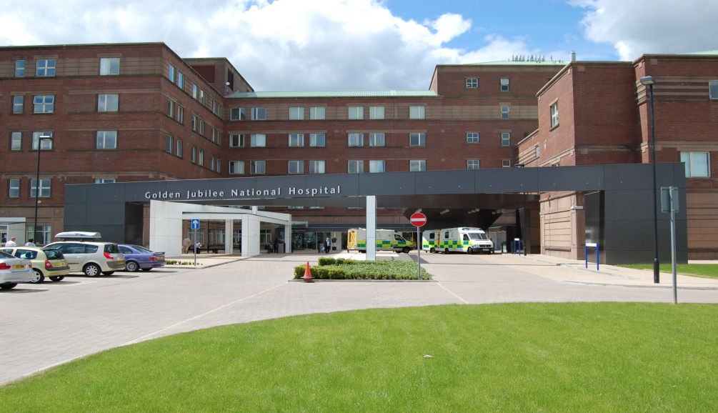

**2024 - 2025**

### **Meeting:** Clinical Governance Risk Management Group

### **Meeting date:** 20 May 2025

### **Title:** Duty of Candour Annual Report

### **Responsible Executive/Non-Executive:** Mark MacGregor, Executive Medical Director

### **Report Author:** Kevin McMahon, Head of Risk and Clinical Governance

**Contents**

1 Purpose 3

2 Report summary 3

2.1 Situation 3

2.2 Background 3

2.3 Assessment 3

2.4 Recommendation 5

3 List of appendices 5

Introduction 6

About Golden Jubilee National Hospital 6

Our Policies and Procedures 6

Duty of Candour Activity 2023-2024 7

DoC Events 8

Learning 9

Conclusion 9

Appendix 1 – DoC Criteria 10

Appendix 2 – Events that triggered DoC \*\***NOT** for external publication** 11

## 

## **1 Purpose**

### This is presented to the group for:

### Approval

### This report relates to a:

* Government policy/directive

### This aligns to the following NHS Scotland quality ambition(s):

* Safe
* Effective
* Person Centred

**This aligns to the following NHSGJ Corporate Objectives:**

* High Performing Organisation – Establishing the conditions for success to enable excellent outcomes and experience for patients and staff

## **2 Report summary**

## **2.1** **Situation**

This paper presents the Duty of Candour Annual Report for NHS Golden Jubilee as a requirement of the Duty of Candour legislation.

## **2.2 Background**

All health and social care services in Scotland have a Duty of Candour (DoC). This is a legal requirement which means that when unintended or unexpected events happen that result in death or harm as defined in the Act, the people affected understand what has happened, receive an apology, and that organisations learn how to improve for the future.

An important part of this duty is that we provide an annual report about how the DoC is implemented in our services. This report describes how we have operated the DoC during the time between 1 April 2024 and 31 March 2025.

## **2.3 Assessment**

Appendix 1 contains the Duty of Candour Annual Report 2024 – 2025.

### 2.3.1 Quality/ Patient Care

The Clinical Governance team work closely with Division Management Teams to constantly review ways of improving the process for reviewing Significant Adverse Events (SAER) to ensure the best possible quality of review and best possible outcome for the patient/family involved.

### 2.3.2 Workforce

The significant adverse event process and Duty of Candour undoubtedly presents challenges in various forms to the workforce both from a psychological and capacity perspective. The organisation is reinforcing support mechanisms for those involved whilst ensuring that learning is the focus of the outcome of the reviews.

### 2.3.3 Financial

There is a potential for financial impact to the organisation in relation to claims as a result of adverse events which trigger the Duty of Candour.

### 2.3.4 Risk Assessment/ Management

Significant adverse event reviews are managed on a case by case basis and risk assessment is supported where required, this is further embedded within action plans if appropriate.

### 2.3.5 Equality and Diversity, including health inequalities An impact assessment has not been completed as this paper provides a report following an analysis of data.

### 2.3.6 Other impacts

Potential for reputational impact due to the nature and content of the report.

### Communication, involvement, engagement and consultation

The Board has carried out its duties to involve and engage external stakeholders where appropriate:

* Service Clinical Governance Meetings throughout the year (as SAERs are completed)
* Division Management Team Meetings throughout the year (as SAERs are completed)
* Clinical Governance Risk Management Groups (for final approval of SAER reports)
* Regular reporting to the Clinical Governance Committee on SAERs.

### Route to the Meeting

This has been previously considered by the following groups as part of its development. The groups have either supported the content, or their feedback has informed the development of the content presented in this report.

* Service Clinical Governance Meetings throughout the year (as SAERs are completed)
* Division Management Team Meetings throughout the year (as SAERs are completed)
* Clinical Governance Risk Management Groups (for final approval of SAER reports)

### 2.4 Recommendation

* Approval

### 3 List of appendices

The following appendices are included with this report:

* Appendix No 1, Duty of Candour Criteria
* Appendix No 2, Duty of Candour Detail Report with Status (**Not** for publication)

**Duty of Candour Report**

### Introduction

All health and social care services in Scotland have a Duty of Candour (DoC). This is a legal requirement, which means that when unintended or unexpected events happen that result in death or harm as defined in the Act, the people affected understand what has happened, receive an apology, and that organisations learn how to improve for the future.

An important part of this duty is that we provide an annual report about how the DoC is implemented in our services. This report describes how we have operated the DoC during the time between 1 April 2024 and 31 March 2025.

### About Golden Jubilee National Hospital

NHS Golden Jubilee has always aimed to ensure that we support the delivery of NHS Scotland’s national health priorities. Our focus since our establishment has been to meet NHS Board demands and deliver equity of access to high quality healthcare for as many patients as possible so that they benefit from our clinical expertise and excellent facilities.

### Our Policies and Procedures

Adverse Events are reported, and reviewed on the Datix system. The procedure for reviewing each level of incident is set out in the Adverse Events Management policy. The Adverse Events Management policy and supporting tools/ guidance reflect the DoC requirements.

The decision on DoC is built into the Significant Adverse Event Review (SAER) process.

All severity 4 and 5 adverse events are automatic escalations, as **potential** SAER. Legislation requires that a **clinical** person must make the final decision on Duty of Candour.

The Clinical Governance Lead and/ or Clinical Nurse Manager, depending on the type of event, complete the Initial Assessment Tool (IAT) that supports the review of SAERs. This includes a specific question relating to the Duty of Candour status. The completed assessment and recommendation of Duty of Candour is then agreed/ approved by the Division Management Team (DMT), which includes an Associate Nurse and Medical Director.

Any IATs that do not progress for review, are presented and discussed at the Service’s Clinical Governance Forum, with multi-disciplinary representation to ensure learning is captured. This offers further opportunity for any challenge on the level of review and DoC status.

Each adverse event is reviewed, with a focus on learning/ potential learning from what has happened, regardless of the level of harm. On completion of an adverse event review actions are identified, and these are monitored through the Clinical Governance Service Meetings to completion via the Clinical Governance reporting framework.

All staff receive training regarding adverse event reporting and the implementation of DoC via the corporate induction e-learning package. Training is provided to those responsible for reviewing incidents on Datix and a supporting toolkit is available to staff who could potentially take part in a Significant Adverse Event investigation; this will take the form of blended learning, utilising webinars, MS Teams sessions and in-person training where possible.

We know that being involved in a significant adverse event can be difficult for staff as well as those affected by the event. We have support available to staff in the form of the formal line management structure.

In addition to this we have the Spiritual Care Lead and the Occupational Health team who are available to provide staff support in different forms following significant adverse events, where required.

NHS Golden Jubilee staff also benefit from access to the TimeforTalking Employee Assistance Programme. This service works alongside the current range of health and wellbeing support available through NHS Golden Jubilee, both internally and externally and is available via telephone, online or face-to-face counselling for staff.

Further to this, patients/families are offered the support of our Spiritual Care Lead and clinicians where required.

### Duty of Candour Activity 2024-2025

During the reporting period, 21 events triggered the organisational Duty of Candour; **table 1** below shows the breakdown of these in relation to the outcome of the event, specific detail regarding the events is documented in **appendix 2**.

Regardless of DoC status, when significant adverse event reviews are commissioned, the appropriate team makes contact with patients and/ or families to advise of an event and the investigation process.

**Table 1: Duty of Candour Rationale**

|  |  |
| --- | --- |
| **Nature of unexpected or unintended incident where Duty of Candour applies** | **Number** |
| A person died | 4 |
| A person suffered permanent lessening of bodily, sensory, motor, physiologic or intellectual functions | 0 |
| Harm which is not severe harm but results or could have resulted in: | |
| An increase in the person’s treatment | 14 |
| Changes to the structure of the person’s body | 1 |
| The shortening of the life expectancy of the person | 0 |
| An impairment of the sensory, motor or intellectual functions of the person which has lasted, or is likely to last, for a continuous period of at least 28 days | 0 |
| The person experiencing pain or psychological harm which has been, or is likely to be, experienced by the person for a continuous period of at least 28 days. | 0 |
| The person required treatment by a registered health professional in order to prevent: | |
| The person dying | 1 |
| An injury to the person which, if left untreated, would lead to one or more of the outcomes mentioned above. | 1 |
| **Total** | **21** |

### Events

Of the 21 events that triggered the DoC, 5 remain open at the time of reporting [06/05/2025]; these reviews are projected to breach timeframes. However, effective communication will continue with those involved in the process.

In all DoC cases, relevant parties are advised if a SAER is taking place. With all closed DoC events, a copy of the final report is provided, with an offer made to meet to discuss the content of the report with the patient/ family. In all cases, an offer to meet with senior staff was made. However, despite this offer, patients and families sometimes do not take the opportunity to meet. In some instances, it was clear the relevant person was reassured by the comprehensive review undertaken and of the detailed findings of the final Significant Adverse Event Review report. Communication with patients and families is a primary focus of our management of Duty of Candour with efforts made to ensure a positive experience of inclusive engagement throughout the process. In all cases, patients and families have been reassured by the review of patient care.

Timescales for conducting and concluding SAERs has remained a challenge due to a number of factors and this has had an impact on the 90-day timescale for completion of DoC review. No events reported during the reporting period have met the DoC process requirements including meeting the 90-day timescale for completion of the review process**.** It is acknowledged that meeting the timescales for DoC has been challenging during this period. The Clinical Governance team work closely with the Divisional Management Teams to improve compliance with timeframes and will monitor this throughout the year making necessary amendments where indicated.

### Learning

Further to the review of the events that triggered the DoC, several learning points have been identified. Key highlights from the learning that was **completed** includes:

* Knowledge of the safe medication administration guidelines and policies has been highlighted for refresher training with all teams.
* Staff to have a documentation pause when a patient is being transferred between wards.
* Inpatient falls section of Falls Bundle will be completed to ensure information can be crosschecked with falls bundle assessment and care plans.
* The importance of documenting doses ‘not given’ was communicated to all staff.

Some of the learning outstanding **to be actioned/ implemented** includes:

* Increase Staff awareness by way of further education on the Safe Use of Bedrails Guideline / Risk Assessment and requirement to document patient conversation and verbal consent to use.
* Departmental education to review the diagnostic spectra of aortic valve disease with particular focus of low flow, low gradient aortic valve disease especially in the setting of multi-valve disease.
* All Thoracic patients to have an eForm to ensure effective patient care is established.
* Cardiac Physiology to review process to communicate urgent and unexpected findings to referrers.

The implementation of learning and actions from SAER’s has also been a challenge and the Clinical Governance team have been working closely with the Divisional Management Teams and services to support the timely progress of action points.

### Conclusion

This is the seventh year of the DoC being in operation. The organisation continues to learn and refine processes to ensure adherence to the DoC process.

This report will be cascaded via the Clinical Governance reporting structure for internal information and published on our public website as per the DoC legislation. The Scottish Government are aware of the publication of this report and we acknowledge that they may, for the purposes of compliance with the DoC provision, request information regarding the content of this report.

# Appendix 1 – DoC Criteria

**Incident which activates the duty:**

The DoC procedure must be carried out by the responsible person as soon as practicable after becoming aware that an individual who has received a health, social care or social work service has been the subject of an unintended or unexpected incident, and in the reasonable opinion of a registered health professional has resulted in or could result in:

* death of the person
* a permanent lessening of bodily, sensory, motor, physiologic or intellectual functions
* an increase in the person’s treatment
* changes to the structure of the person’s body
* the shortening of the life expectancy of the person
* an impairment of the sensory, motor or intellectual functions of the person which has lasted, or is likely to last, for a continuous period of at least 28 days
* the person experiencing pain or psychological harm which has been, or is likely to be, experienced by the person for a continuous period of at least 28 days
* the person requiring treatment by a registered health professional in order to prevent –
  + the death of the person, or
  + any injury to the person which, if left untreated, would lead to one or more of the outcomes mentioned above.

# Appendix 2 – Events that triggered DoC **NOT for external publication**

| Division | Ref | Opened date | SAER Short Title | Outcome code | Duty of Candour Rationale | Severity | Closed/ Open |
| --- | --- | --- | --- | --- | --- | --- | --- |
| Heart, Lung and Diagnostic Services | DW-11410 | 10/04/2024 | OOHCA - patient discharged home without ICD | IAT completed - Not for SAER | Increase in patients treatment | Moderate | Closed 20/05/2024 |
| Heart, Lung and Diagnostic Services | DW-11743 | 13/06/2024 | Medication error - 2 East Cardiology | IAT completed - Not for SAER | Increase in patients treatment | Moderate | Closed 17/09/2024 |
| Heart, Lung and Diagnostic Services | DW-12171 | 13/09/2024 | Cardiology guide-catheter patient | IAT completed - Not for SAER | Increase in patients treatment | Minor | Closed 17/09/2024 |
| Heart, Lung and Diagnostic Services | DW-11821 | 28/06/2024 | 3 East fall with harm to head & elbow | IAT completed - Not for SAER | Increase in patients treatment | Minor | Closed 15/10/2024 |
| Heart, Lung and Diagnostic Services | DW-11801 | 25/06/2024 | Coronary perforation leading to death | IAT completed - Not for SAER | The patient died | Major | Closed 22/10/2024 |
| Heart, Lung and Diagnostic Services | DW-12079 | 28/08/2024 | Cardiology pt transfer from IRH | IAT completed - Not for SAER | Increase in patients treatment | Moderate | Closed 21/11/2024 |
| National Elective Services | DW-12103 | 02/09/2024 | Patient Fall - 2 West | IAT completed - Not for SAER | Increase in patients treatment | Moderate | Closed 25/11/2024 |
| Heart, Lung and Diagnostic Services | DW-11982 | 07/08/2024 | Robotic right upper lobectomy-stapled silicon sloop | IAT completed - Not for SAER | Increase in patients treatment | Minor | Closed 28/11/2024 |
| National Elective Services | DW-12526 | 03/12/2024 | Unsterile item used in Ortho Theatre | IAT completed - Not for SAER | Increase in patients treatment | Moderate | Closed 15/01/2025 |
| National Elective Services | DW-12282 | 14/10/2024 | Patient fall - 2 West Pelvis Fracture | IAT completed - Not for SAER | Increase in patients treatment | Major | Closed 17/01/2025 |
| Heart, Lung and Diagnostic Services | DW-12553 | 06/12/2024 | Medication Errors - 2 East | IAT completed - Not for SAER | Increase in patients treatment | Moderate | Closed 21/01/2025 |
| Heart, Lung and Diagnostic Services | DW-12554 | 06/12/2024 | Medication Errors - 2 East | IAT completed - Not for SAER | Treatment or intervention to prevent injury | Moderate | Closed 21/01/2025 |
| Heart, Lung and Diagnostic Services | DW-12321 | 22/10/2024 | Cardiology patient missed diagnosis | IAT completed - Not for SAER | The patient died | Major | Closed 21/01/2025 |
| Heart, Lung and Diagnostic Services | DW-12063 | 23/08/2024 | TAVI patient fall (death) | IAT completed - Not for SAER | The patient died | Major | Closed 25/03/2025 |
| Heart, Lung and Diagnostic Services | DW-12530 | 03/12/2024 | Cath lab complication requiring emergency surgery | IAT completed - Not for SAER | Treatment or intervention to prevent patient death | Moderate | Closed 25/03/2025 |
| Heart, Lung and Diagnostic Services | DW-12689 | 08/01/2025 | Thoracic patient echo findings not reported | IAT completed - Not for SAER | Increase in patients treatment | Moderate | Closed 08/04/2025 |
| Heart, Lung and Diagnostic Services | DW-12157 | 13/09/2024 | Thoracic retained guidewire | 3 | Changes to the patients body structure | Moderate | Open |
| Heart, Lung and Diagnostic Services | DW-12075 | 27/08/2024 | Transplant patient death Jul 2024 | 3 | The patient died | Major | Open |
| Heart, Lung and Diagnostic Services | DW-11870 | 09/07/2024 | Sternal plating set missing | 3 | Increase in patients treatment | Minor | Open |
| National Elective Services | DW-12177 | 16/09/2024 | Medication error (mycophenolate) - 2 West | 3 | Increase in patients treatment | Major | Open |
| Heart, Lung and Diagnostic Services | DW-12193 | 19/09/2024 | Heart declined due to staffing levels | 1 | Increase in patients treatment | Moderate | Open |