

Whistleblowing Performance Report

-----------------------

Quarter 1 – April to June 2025

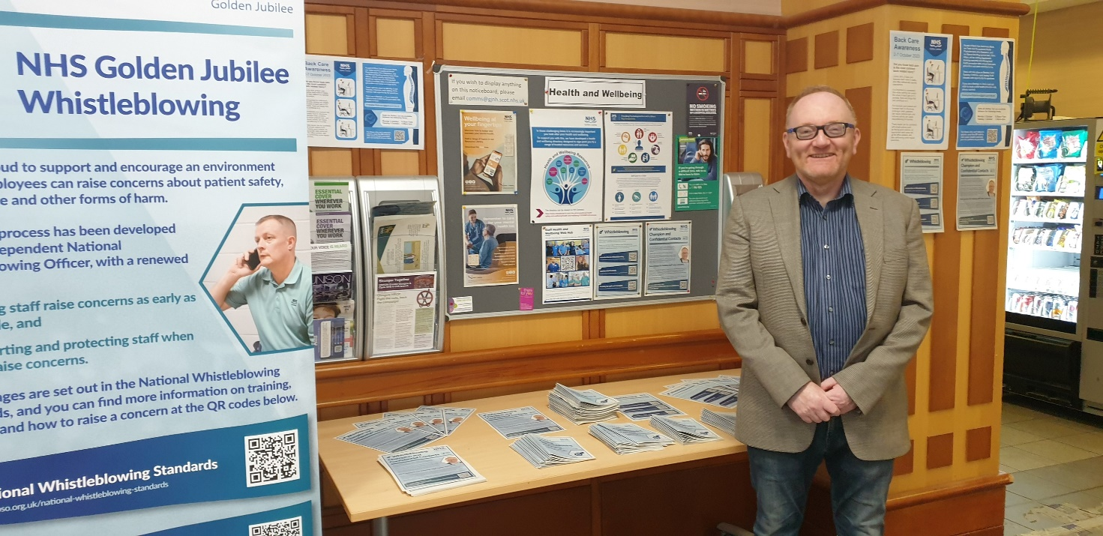

Photo: C Blackburn, Non-Executive Whistleblowing Champion – Taken during Speak Up Week 2024

July 2025 – Quarter 1

# **Contents**

**Contents** 2

**1.0 Context** 3

**2.0 Areas covered by the Report** 4

**3.0 Quarter 1 Performance** 4

**3.0 Key Performance Indicators** 5

**4.0 Learning, changes or improvements to services** 6

**5.0 Level of staff perception, awareness and training** 6

**6.0 Speak Up Week 2025** 7

**7.0 Whistleblowing Oversight Group** 7

**8.0 Reporting** 8

**9.0 Conclusion** 8

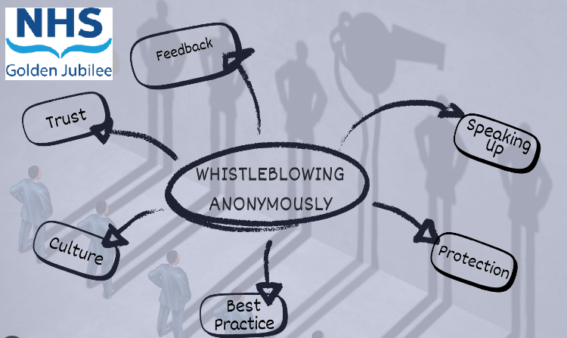

# **1.0 Context**

The National Whistleblowing Standards (the Standards) set out how all NHS service providers in Scotland must handle concerns that have been raised with them about risks to patient safety and effective service delivery. They apply to all services provided by or on behalf of NHS Scotland and must be accessible to all those working in these services, whether they are directly employed by the NHS or a contracted organisation. This includes students, trainees, volunteers and ex-employees for up to six months.

“Whistleblowing” is defined as: *“…when a person who delivers services or used to deliver services on behalf of a health service body, family health service provider or independent provider (as defined in section 23 of the Scottish Public Services Ombudsman Act 2002) raises a concern that relates to speaking up, in the public interest, about an NHS service, where an act or omission has created, or may create, a risk of harm or wrong doing.”*

This report will demonstrate our performance in the national key indicators as required by the Independent National Whistleblowing Officer (INWO) and includes key areas of Whistleblowing handling, as well as highlighting outcomes and providing more detail on any Whistleblowing themes. Over time, this approach will illustrate trends in and more importantly, allow us to evidence necessary improvement and learning in response to the trends and themes demonstrated.

The Standards specify high level principles plus a detailed process for investigating concerns which all NHS organisations in Scotland must follow. NHS Health Boards have particular responsibilities regarding the implementation of the Standards:

• ensuring that their own whistleblowing procedures and governance arrangements are fully compliant with the Standards.

• ensuring there are systems in place for primary care providers in their area to report performance data on handling concerns.

• working with higher education institutions and voluntary organisations to ensure that anyone working to deliver NHS Scotland services (including students, trainees and volunteers) has access to the Standards and knows how to use them to raise concerns

Whistleblowing remains an important process for staff, students and volunteers to enable them to speak up about any concerns they may have in the organisation with respect to quality and safety in patient care. The information in this report has no direct impact on patient care, except in those circumstances when the whistleblowing process is used to highlight patient safety concerns or other quality matters in the organisation. Any recommendations or actions that come out of future whistleblowing cases will help to improve quality of NHS Golden Jubilee’s services and patient care.

This report provides the performance update for Quarter 1 for 2025/26.

# **2.0 Areas covered by the Report**

The national Whistleblowing Standards (the Standards) set out how all NHS Service providers in Scotland must handle concerns that have been raised with them about risk to patient safety and effective service delivery.

Under the terms of the Standards, the quarterly performance report must contain information on the following indicators:

1. Total number of concerns received.

2. Concerns closed at stage 1 and stage 2 of the whistleblowing procedure as a percentage of all concerns closed.

3. Concerns upheld, partially upheld and not upheld at each stage of the whistleblowing procedure as a percentage of all concerns closed in full at each stage.

4. The average time in working days for a full response to concerns at each stage of the whistleblowing procedure.

5. The number and percentage of concerns at each stage which were closed in full within the set timescales of 5 and 20 working days.

6. The number of concerns at stage 1 where an extension was authorised as a percentage of all concerns at stage 1.

7. The number of concerns at stage 2 where an extension was authorised as a percentage of all concerns at stage 2.

NHS Golden Jubilee’s approach to the implementation of the standards was key to ensuring that staff feel safe, supported and have confidence in the fairness of the processes should they feel they need to raise concerns.

In NHS Golden Jubilee the agreed governance route for reporting on whistleblowing is to Clinical Governance Committee with any staff concerns being shared with Staff Governance and Person Centred Committee and then onward to the Board.

# **3.0 Quarter 1 Performance**

This section of the report provides a summary of activities, actions and responses undertaken in support of the whistleblowing agenda. During 2025-26, the organisation will continue to promote the Standards, encourage staff to raise concerns in the public interest and respond appropriately to any whistleblowing issues raised.

In his role as Whistleblowing Champion, Callum Blackburn, Non-Executive Director, is Chair of the Whistleblowing Oversight Group that meets to discuss and progress the whistleblowing agenda.

Between 1 April 2025 to 30 June 2025, NHS Golden Jubilee received no whistleblowing concerns.

# **3.0 Key Performance Indicators**

This section outlines the Key Performance Indicators.

**Indicator 1 - Total number of concerns, and concerns by Stage**

During Quarter 1, April to June 2025, no Whistleblowing Concerns were received.

**Indicator 2 – Concerns closed at Stage 1 and Stage 2 of the whistleblowing procedure as a percentage of all concerns closed.**

To date there has been one Whistleblowing Concern received, during 2022/23 that was concerned with the adequacy of arrangements within NHS Golden Jubilee for the provision of First-Aid to employees, patients and visitors. The lessons learned are continually being reviewed.

**Indicator 3 - Concerns upheld, partially upheld and not upheld at each stage of the whistleblowing procedure as a percentage of all concerns closed in full at each stage.**

The definition of a stage 1 concern - Early resolution is for simple and straightforward concerns that involve little or no investigation and can be handled by providing an explanation or taking limited action, within 5 working days.

No stage 1 concerns were received in Q1 this year.

The definition of a stage 2 concern – are concerns which tend to be serious or complex and need a detailed examination before the organisation can provide a response within 20 working days.

No stage 2 concerns were received in Q1 this year.

**Indicator 4 - The average time in working days for a full response to concerns at each stage of the whistleblowing procedure.**

No Whistleblowing Concerns were raised during Quarter 1 this year.

**Indicator 5 - The number and percentage of concerns at each stage which were closed in full within the set timescales of 5 and 20 working days.**

No Whistleblowing Concerns were raised during Quarter 1 this year.

**Indicator 6 - The number of concerns at stage 1 where an extension was authorised as a percentage of all concerns at stage 1.**

No Whistleblowing Concerns were raised during Quarter 1 this year.

**Indicator 7 - The number of concerns at stage 2 where an extension was authorised as a percentage of all concerns at stage 2.**

No Whistleblowing Concerns were raised during Quarter 1 this year.

# **4.0 Learning, changes or improvements to services**

Learning, changes or improvements to services can be limited by the need to maintain confidentiality of individual Whistleblowers.

Work continues to improve our processes and means by which individuals can raise concerns and Whistleblowing aligns to the culture work within our programmed OD activity. In Quarter 2 we will continue to raise awareness through the Speak Up Week, especially around the importance of Speaking Up and ensuring there are numerous routes to support this.

Our Kindness Matters programme has created over 50+ Culture Champions and part of their remit will be to encourage staff to speak up.

# **5.0 Level of staff perception, awareness and training**

It is difficult to quantify staff perceptions. However we continue to promote the Senior Managers and staff training and will continue to monitor uptake, effectiveness and appropriateness as required.

Our Communications Team will continue to promote raising awareness and further actions in relation to this topic and is discussed later in the report.

Our Whistleblowing Champion meets with the Confidential Contacts on a periodic basis to ensure any Whistleblowing Concerns are signposted as a support to staff.

It is recognised that this is a learning process and that processes and communications may require to be changed or developed as feedback from updated Whistleblowing processes is received.

The current levels of Training for staff are shown as:

|  |  |  |
| --- | --- | --- |
| **Short Resource Hierarchy - Resource Name** | **Learning Status - Status** | **Learners** |
| Whistleblowing : an overview 2024/25 | Completed | 513 |
| Whistleblowing : for staff | Completed | 16 |
| Whistleblowing : for line/senior managers | Completed | 0 |

This table will be updated each quarter as staff continuously undertaking the learning.

# **6.0 Speak Up Week 2025**

NHS Golden Jubilee will participate in the National Speak Up Week held week of 29 September to 3 October 2025 with the theme ‘Listen, Act, Build Trust’.  The theme aims to build on previous years' feedback and focus on the importance of listening to concerns, taking action and fostering trust within organisations. The proposed timetable is as follows:

**Monday: Launch**

A live interview on this year’s theme with the Independent National Whistleblowing Officer and a health board executive.

**Tuesday: Listening to Concerns**

A live panel discussion on the inclusion of seldom heard groups.

**Wednesday: Acting on Feedback**

A live panel discussion with experts on the importance of communication and following up after a concern has been raised.

**Thursday: The Benefits of Building Trust**

A live webinar highlighting organisations who have taken positive steps towards creating a healthy speak up culture.

**Friday: Round Up**

Practical guidance session for people on the next steps.

NHS Golden Jubilee are promoting wellbeing and care by continuing to adopt a kinder, more inclusive culture across the organisation called ‘Kindness Matters’. As part of our Speak Up Week, we will want to ensure that everyone feels valued and supported.

# **7.0 Whistleblowing Oversight Group**

The Whistleblowing Oversight Group (‘the Group’) was established in September 2024 to provide assurance to the Clinical Governance Committee, Staff Governance and Person Centred Committee and NHS GJ Board that Whistleblowing Concerns are being discharged in relation to the National Whistleblowing Standards and Once for Scotland Policies. A Terms of Reference had also been established.

The Group are responsible for the oversight of all Whistleblowing arrangements within NHS Golden Jubilee and will ensure that guidance and processes are in place to deliver the requirements of the National Whistleblowing Standards. The Group meet on a quarterly basis and the Chair is the Non-Executive Whistleblowing Champion.

The Group support, oversee and enable the appropriate quarterly and annual reporting to the Clinical Governance Committee and also share the report for noting with the Staff Governance and Person Centred and NHS GJ Board.

One of the main functions of the Group is to support, oversee and plan for the ‘Speak Up’ weeks that are held each year, to ensure these are meaningful, manageable and memorable.

# **8.0 Reporting**

The reporting of any concerns raised through Whistleblowing is reported through Executive Leadership Team, Partnership Forum, Clinical Governance Committee, Staff Governance and Person-Centred Committee and the Board.

All Whistleblowing concerns would be recorded locally via the Datix system and would be updated as and when the case was investigated and concluded.

All relevant Committees receive quarterly updates on any concerns raised which are then finally discussed at Board.

# **9.0 Conclusion**

It is recognised that this is a learning process and that processes may require to be changed or developed as feedback from updated Whistleblowing processes is received.

In line with the National Whistleblowing Standards, we reiterate our commitment to dealing responsibly, openly and professionally regarding any whistleblowing concern we may receive.

This quarterly report will form part of our Annual Report 2025/26 as we continually raise the profile of Whistleblowing and our commitment to support everyone to ‘speak up’ at the earliest opportunity.