# Blue text on a black background AI-generated content may be incorrect. NHS Golden Jubilee

### **Meeting:** **NHS Golden Jubilee Board**

### **Meeting date: 28 August 2025**

### **Title: Health and Safety Report - Quarter 1**

### **Responsible Executive/Non-Executive: Jonny Gamble, Executive Director of Finance**

### **Report Author: David Wilson, Head of Health and Safety)**

## Purpose

### This is presented to NHS Golden Jubilee Board for:

* Awareness
* Decision

### This report relates to a:

* Legal Requirement
* Local Policy

### This aligns to the following NHS Scotland quality ambition(s):

* Safe
* Effective
* Person Centred

**This aligns to the following NHSGJ Corporate Objectives:**

* Leadership, Strategy & Risk

## 2 Report summary

## 2.1 Situation

Reports are provided on a quarterly basis to Health and Safety Forums, Health and Safety Committee and Staff Governance and Person Centred Committee which relate to Health and Safety activity across NHS Golden Jubilee. This report summarises Health and Safety activity for Quarter 1 for 2025/26.

## Background

The Health and Safety at Work etc. Act 1974 is the primary legislation covering health and safety in the UK. Sections 2 (6) and 2 (7) of this Act requires employers to formally consult their employees on matters that affect their health and safety. NHS Golden Jubilee has decided that the most effective way to discharge these requirements is through the formation of Divisional Health and Safety Forums and Health and Safety Committee.

The main purpose of the Health and Safety Committee is to foster a culture whereby the promotion of the health and safety of employees, patients, visitors, contractors and suppliers becomes an integral part of our organisation’s activities.

The Committee Terms of Reference sets out a number of aims and these are summarised below:

* To encourage safe working practices and safeguards for all staff and others in line with health and safety legislation.
* To promote safety consciousness within staff at every level in order to effect a reduction in the level of accidents.
* To promote appropriate courses of training in health and safety for all staff.
* To consider concerns expressed by management and staff in relation to health and safety matters.
* To agree a program of workplace inspections, receive reports and make recommendations on action required.
* To monitor progress against health and safety action plan.

## 2.3 Assessment

Appendix 1 contains the Health and Safety Quarter One Report for 2025/2026.

### 2.3.1 Quality/ Patient Care

Ensuring we deliver safe patient care.

### 2.3.2 Workforce

Ensures we provide staff a safe working environment in accordance with NHS Staff Governance Standards.

### 2.3.3 Financial

In accordance with SFIs and existing resources.

### 2.3.4 Risk Assessment/Management

Any key risks are highlighted within Appendix 1. New and emerging risks will remain as standard agenda item at Health and Safety Committee meetings in order to provide a focused attention on risk management.

### 2.3.5 Equality and Diversity, including health inequalities

Not applicable (N/A). Any policies that are reviewed or developed as noted in this quarterly report will be subject to equality impact assessment where identified as being required.

### 2.3.6 Climate Emergency and Sustainability

This paper supports NHS GJ Net Zero target and aspirations to reduce energy and carbon year on year.

### Communication, involvement, engagement and consultation

The Board has carried out its duties to involve and engage external stakeholders where appropriate. The purpose of this report is a means for communication, engagement and consultation.

### Route to the Meeting

This has been previously considered by the following groups as part of its development. The have either supported the content, or their feedback has informed the development of the content presented in this report:

* Corporate Health and Safety Forum, 23 June 2025
* Clinical Health and Safety Forum, 24 June 2025
* Health and Safety Committee, 15 July 2025
* Staff Governance and Person Centred Committee, 12 August 2025

## Recommendation

The Board are asked to approve the Health and Safety Quarter 1 Report for 2025/26.

## List of appendices

The following appendices are included with this report:

* Appendix 1 - Health and Safety Q1 Report for 2025/2026.
* Appendix 2 – Adverse Event Listing Reports

**APPENDIX 1**

**HEALTH & SAFETY COMMITTEE QUARTERLY REPORT**

**Q1 2025/26 (1st April – 9th June 2025)**

**Section 1: We said, we did**

|  |  |
| --- | --- |
| **What we said we would do** | **What we did** |
| Develop and publish monthly matters covering Stress Awareness; Control of Substances Hazardous to Health (COSHH); and Terrorism (Protection of Premises) Act 2025. | Developed and published Monthly matters articles on Stress Awareness; COSHH; and Terrorism (Protection of Premises) Act 2025. |
| Review the following policies: Control of Noise at Work; Sharps Safety Devices; Reducing the Risks Associated with falls from Height & Windows Policy | Reviewed the following policies and have submitted to Forums for initial review prior to elevation to Health and Safety Committee. |
| Launch awareness campaign to support Stress Awareness Month for April 2025. | Launched month long awareness raising campaign focusing on Stress in the Workplace in collaboration with key teams within GJ. |
| Prepare a position paper on our preparedness for the Terrorism (protection of Premises) Act 2025 | Paper on Terrorism (protection of premises) Act 2025 submitted to Forums and onward to Health and Safety Committee. |
| Focus on sharps injury prevention and improved investigation of sharps datix investigations. | Within investigation questions within datix, additional questions have now been mandated. The questions are:   * Did the device have a safety mechanism to protect from sharps injury * Do you have an opinion that any other engineering, administrative or workplace control could have prevented the injury?   The datix cannot be approved until these questions have been answered. This will encourage improved investigations into root causes of sharps events. |
| Start the health and safety annual audit programme. | Health and safety audit programme bookable slots advertised from 5th June. Slots available from 30th June onwards. |

**Section 2: What we’ll do next**

|  |
| --- |
| Develop and publish monthly matters articles on:   * Sharps Injury Prevention (July); * Violence and Aggression (August); * Skin Health (September) |
| Review the following policies:   * Smoking & Vaping; * Personal Protective Equipment (PPE); * First Aid at Work. |
| Provide update report on V&A SLWG progress |
| Provide early feedback on progress with H&S Audit programme |
| Launch Sharps Awareness Month for August 2025 |

**Section 3: Adverse Event Reporting**

**This section provides an overview of health and safety related adverse incidents in Q1 25/26.**

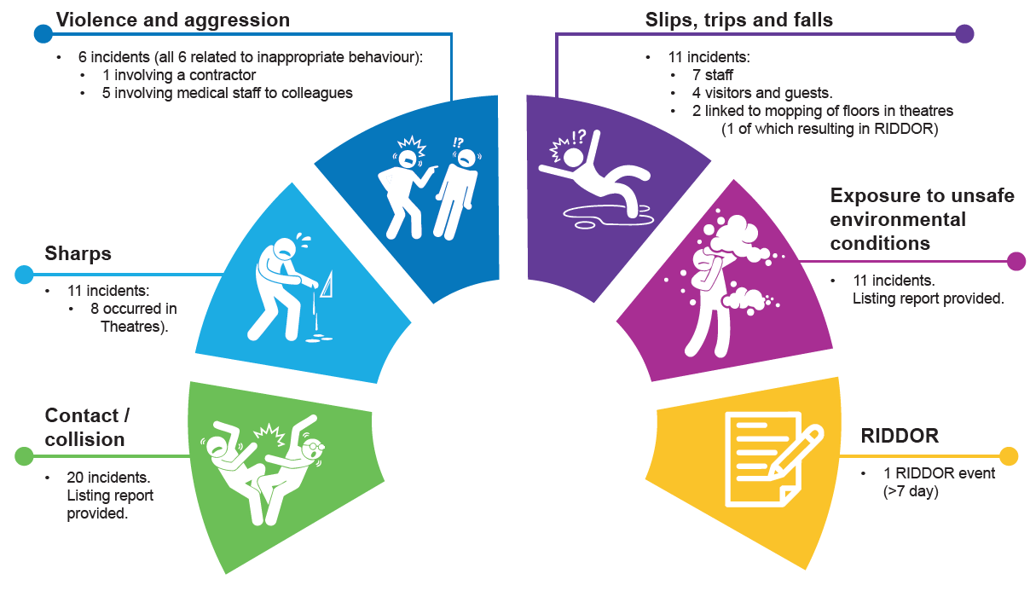

These top 5 sub categories have been consistent in comparison to previous quarter as shown in the bar chart below, although a spike is evident in collision/contact incidents. Upon review, there does not appear to be any contributory factor in the spike in collision/contact incidents. There are a number of unconnected incidents which are shown in the full listing report within appendix 2.

Within the category of Exposure to Unsafe Environmental Conditions’ there is a variety of different types of events. The detail of this is shown in the listing report in appendix 2.

From the incidents that have been risk rated on datix, the vast majority are either minor or less. The moderate rated incidents are shown in the listing report below.

32% negligible (23)

61% minor (44)

7% moderate (5)

Details of the 5 moderate risk rated events are shown in appendix 2.

**Appendix 2: Adverse Incidents Listing Report**:

Listing report for ‘contact/collision’ incidents:

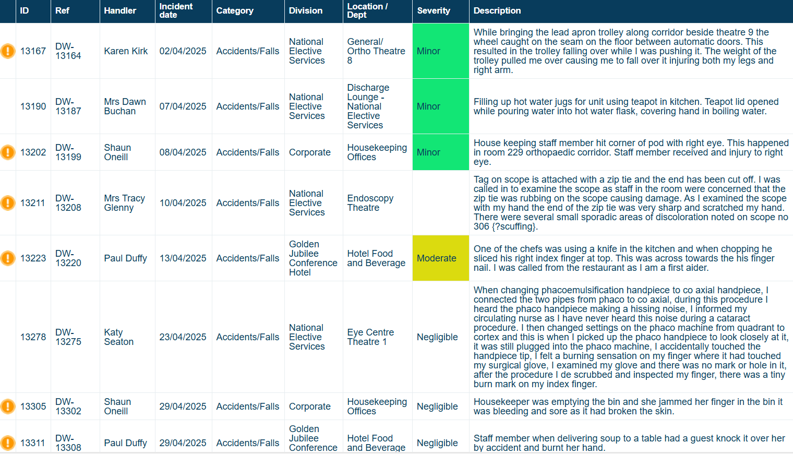

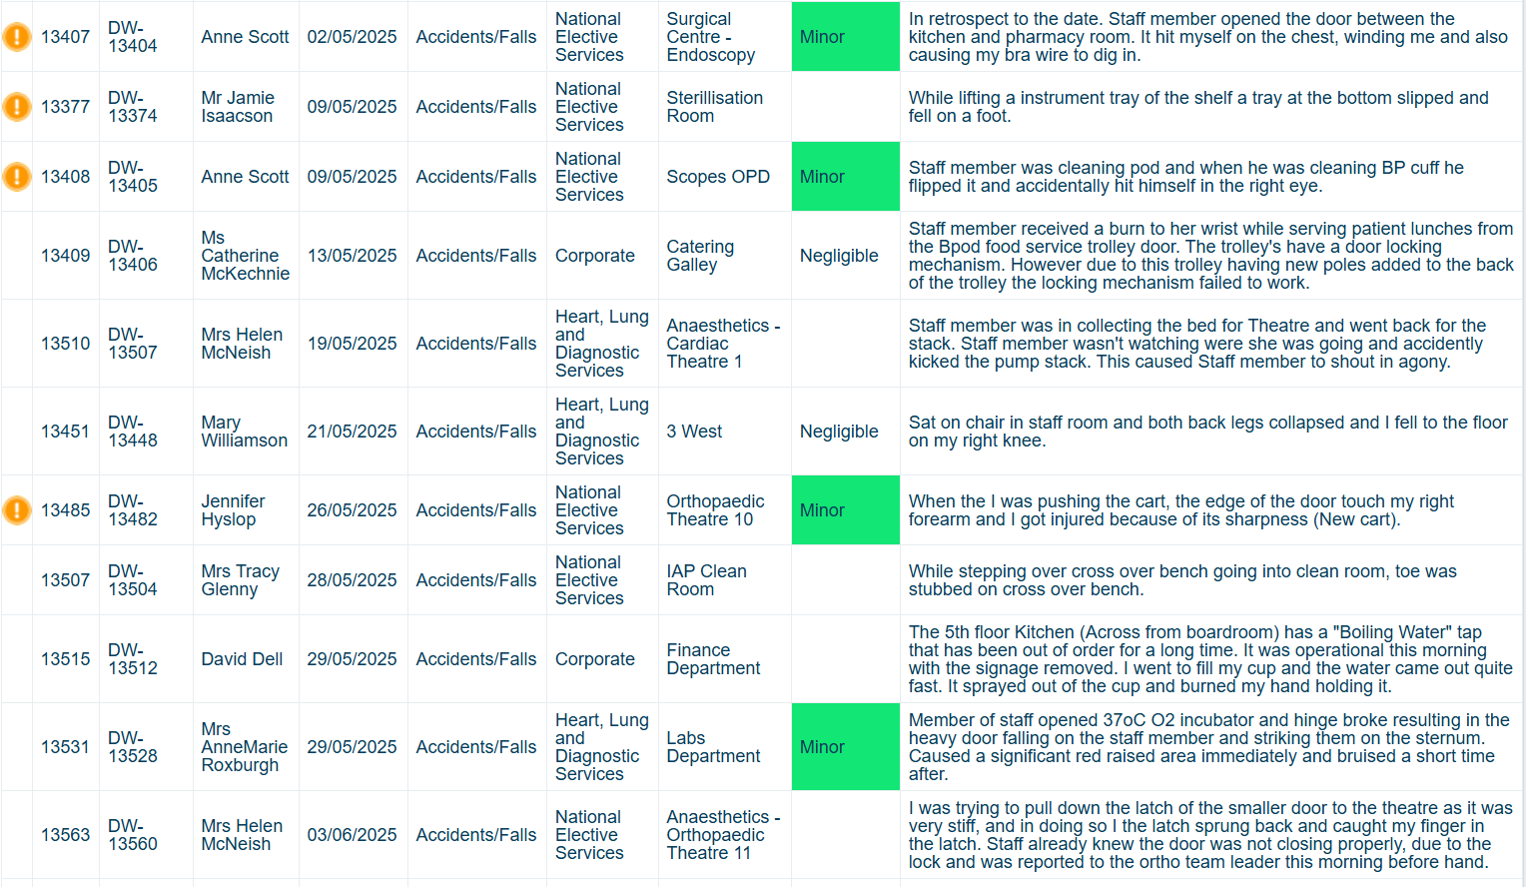

Listing Report for ‘Exposure to Unsafe Environmental Conditions’:

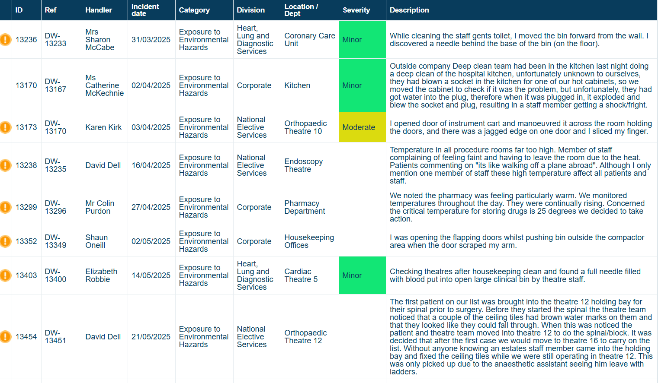

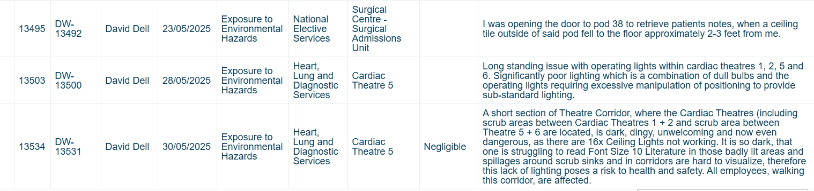

Listing Report for moderate risk rated events:

