Healthcare Associated Infection Report
September 2025
Section 1 – Board Wide Issues
Section 1 of the HAIRT covers Board wide infection prevention and control activity and actions. For reports on individual departments, please refer to the ‘Healthcare Associated Infection Report Cards’ in Section 2.

Key Healthcare Associated Infection Headlines
- Staphylococcus aureus Bacteraemia (SAB)
Nil to report.

- Clostridioides difficile infection (CDI)
One case to report.
7 cases of CDI to date since April. As a result the Scottish Government HAI target has been breached (n=3) for 25/26. This is a very a challenging target given NHS GJ exceptionally low CDI rates, small numbers of cases influence the achievement of this target.

Known patient risk factors have been identified, no commonalities or patient to patient transmission noted. Ribotyping (where available) have been commonly circulating strains within NHS Scotland.

- Gram Negative/E.coli Bacteraemia (ECB)
One ECB to report, source ECMO site.

- Hand Hygiene- Overall compliance score for September 95.3%

Not taking the opportunity to perform hand hygiene as opposed to incorrect technique continues to be the largest non-compliance.

In September, Comms colleagues shared hand hygiene messaging in News Digest “Clean hands-safe care starts with you”, related screen saver messaging to follow up awaited.

July/August reduction in medical staff compliance and area specifics has been escalated to Exec Medical Director and Associate Medical Director colleagues. Medical staff compliance improved from Jul/Aug to 90.4% and will continue to monitor for sustained improvement.

- Cleaning and the Healthcare Environment -Facilities Management Tool
Housekeeping Compliance: 97.98% Estates Compliance: 97.93%

- Orthopaedic Surgical Site Surveillance-
0 THR SSI to report/0 TKR SSI report.

- Cardiac Surgical Site Surveillance
1 Superficial CABG SSI to report/1 Superficial Cardiac SSI to report.

2 September 2025 NHS Safe Delivery of Care Acute Inspection - Unannounced follow up visit very positive, no subsequent environmental/infection control actions raised. The report and action plan will be published on HIS website on Wednesday 5 November 2025 (currently embargoed).

Other HAI activity overview
DL (2025) 20
A unified PPE ensemble for the assessment and care of an individual with a suspected or confirmed High Consequence Infectious Disease has now been adopted by all four nations. NHS Scotland Boards are asked to transition to the new ensemble by 26th August 2026. Discussion via Resilience Group has commenced.

Staphylococcus aureus (including MRSA)
Staphylococcus aureus is an organism which is responsible for a large number of healthcare associated infections, although it can also cause infections in people who have not had any recent contact with the healthcare system. The most common form of this is Meticillin Sensitive Staphylococcus aureus (MSSA), but the more well-known is MRSA (Meticillin Resistant Staphylococcus aureus), which is a specific type of the organism which is resistant to certain antibiotics and is therefore more difficult to treat.
NHS Boards carry out surveillance of Staphylococcus aureus blood stream infections, known as bacteraemias. These are a serious form of infection and there is a national target to reduce them.
More information can be found at: Staphylococcus aureus bacteraemia | National Services Scotland (nhs.scot)

NHS GJ approach to SAB prevention and reduction
It is accepted within ARHAI that care must be taken in making comparisons with other Boards’ SAB data because of the specialist patient population within NHS GJ. All SAB isolates identified within the laboratory are subject to case investigation to determine future learning and quality improvement.

Small numbers of cases can quickly change our targeted approach to SAB reduction.

Broad HCAI initiatives which influence our SAB rate include-
- Hand Hygiene compliance monitoring
- MRSA screening at pre-assessment clinics and admission
- Compliance with National Cleaning Standards Specifications
- Audit of the environment and practices via Prevention and Control of Infection Annual Reviews, monthly SCN led Standard Infection Control Precautions audit and CNM Peer Review monitoring
- Participation in National Enhanced SAB surveillance- gaining further intelligence on the epidemiology of SAB locally and nationally.

SSI Related SAB
- MSSA screening for cardiac surgery and subsequent treatment pre and
post op as a risk reduction approach
- Surgical Site Infection Surveillance in collaboration with ARHAI to allow rapid identification of increasing and decreasing trends of SSI
- Orthopaedic Prosthetic Joint Infection Audit Group scoping introduction of MSSA decolonisation pre operatively.

Device Related SAB
- Implementation of PVC, CVC, PICC and IABP bundles; assessment of compliance locally aids targeting of interventions accordingly.

NHS GJ SAB HCAI Standards /AOP Trajectories- Rolling Target
Director’s letter (2025) 05 advises Boards that the trajectory for HAI standards is based on 23/24 baseline.
For NHS GJ, this target is 15.34 per 100,000 TOBD. This remains a challenging target given NHS GJ existing low SAB rate and high risk patient population.
The data above reflects NHS GJ SAB isolates beyond 48hrs of admission.

Sources of SAB
The Prevention and Control of Infection Team work closely with the clinical teams, CG and clinical educators to gain insight into the sources of SAB acquisition and associated learning. Each SAB is subject to an enhanced surveillance process involving the PCIT, SCN and responsible consultant to determine any learning from the source of the SAB. Thereafter the Enhanced SAB surveillance reports are submitted to the relevant service clinical governance group to share potential learning and note actions required.

3 East
Jun 25- Unknown
Aug 25- PVC
2 West Ortho
Jan 25- Hip
3 West
Jan 25- PVC

MRSA Screening Compliance
MRSA screening promotes early identification of patients colonised or infected with MRSA. This facilitates early implementation of decolonisation / treatment with the aim of reducing the reservoir of MRSA and therefore the risk of transmission to other vulnerable patients. Screening must be completed at pre assessment where applicable, and on admission into NHS GJ.

Within NHS GJ MRSA screening must be completed for all elective admissions within high impact specialities e.g. ORTHOPAEDIC /CARDIAC/CARDIOTHORACIC/CARDIOLOGY and all overnight stay patients. Thereafter patients whose length of stay is 10 days or more are subject to additional screening on:
- Day 10
- Weekly thereafter in high risk settings i.e. NSD 1&2/ Critical Care/Long stay orthopaedics 2W.

Day 10 screen was identified as the initial screen date as it captures patient stay beyond routine pathways. Compliance is monitored via reviewing a sample of eligible patients against submitted MRSA screens. SCNs are informed of results at the time of audit and informed an action plan is required to improve compliance should be submitted.
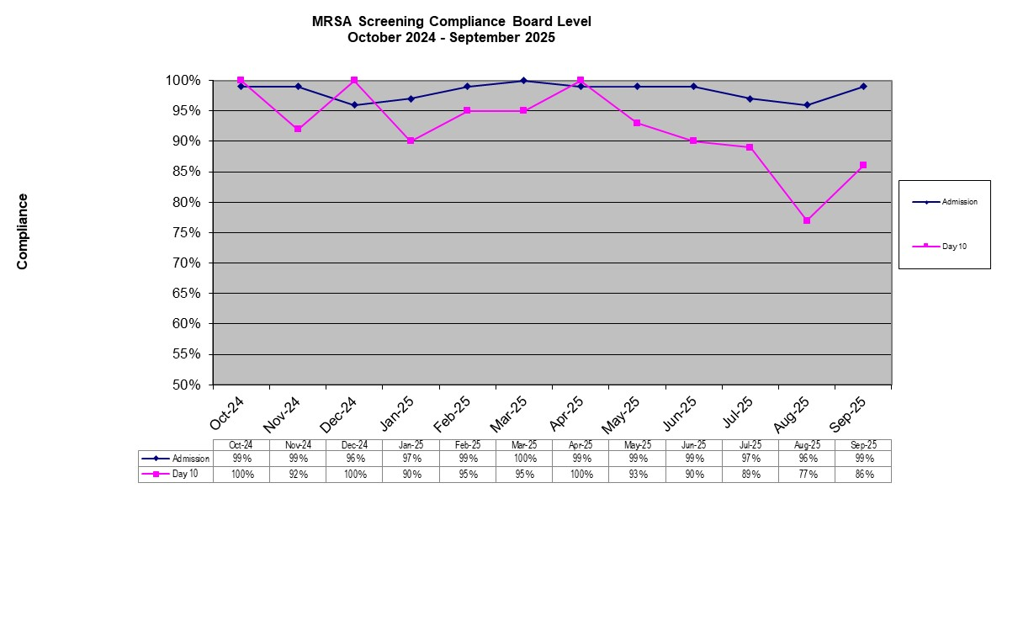

Sept 25- of the non-compliances noted, in 75% samples were not taken.
Clostridioides difficile infection (previously known as Clostridium difficile)
Clostridioides difficile is an organism which is responsible for a large number of healthcare associated infections, although it can also cause infections in people who have not had any recent contact with the healthcare system. NHS Boards carry out surveillance of Clostridioides difficile infections (CDI), and there is a national target to reduce these.
More information on Clostridioides difficile infections can be found at: Clostridioides difficile infection | National Services Scotland (nhs.scot)

NHS GJ approach to CDI prevention and reduction
Our numbers of CDI cases are low in comparison with other Boards, which is likely to relate to our specialist patient population.

Actions to reduce CDI -
- Ongoing alert organism surveillance and close monitoring of the severity of cases by the PCIT.
- Unit specific reporting and triggers.
- Implementation of ARHAI Severe Case Investigation Tool if the case definition is met.
- Typing of isolates when two or more cases occur within 30 days in one unit.

NHS GJ CDI HCAI Standards/ AOP Trajectories Rolling Target

Director’s letter (2025) 05 advises Boards that the trajectory for HAI standards is based on 23/24 baseline.
For NHS GJ, this target is 5.75 per 100,000 TOBD.
This remains a challenging target given NHS GJ exceptionally low CDI rates, small numbers of cases will influence the achievement of this target.

7 cases of CDI have been noted to date since April, as a result the Scottish Government HAI target has breached (n=3) for 25/26.This is a very a challenging target given NHS GJ exceptionally low CDI rates, small numbers of cases influence the achievement of this target.

Local surveillance indicates, known patient risk factors were identified, no commonalities or patient to patient transmission noted. Ribotyping (where available) have been commonly circulating strains within NHS Scotland. Context of NHS GJ rates against remainder of NHS Scotland is provided below.

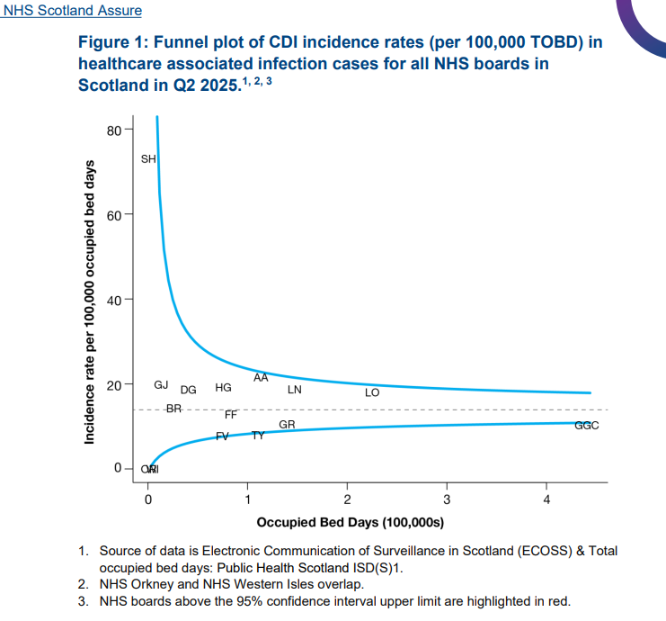

HAI Quarterly Report Q2 2025 - Full Report

Gram Negative/E.coli Bacteraemia
Escherichia coli (E. coli) is a bacterium that forms part of the normal gut flora that helps human digestion. Although most types of E. coli live harmlessly in your gut, some types can cause illness. E. coli bacteraemias can be as a result of an infection such as:
•urinary tract
•surgery
•inappropriate use of medical devices

E. coli is currently the most common cause of bacteraemia in Scotland. As a result, its reduction has been added as a new HAI Standard target. More information can be found at: HPS Website - Protocol for National Enhanced Surveillance of Bacteraemia (scot.nhs.uk)

NHS GJ ECB HCAI Standards/ AOP Trajectories
Director’s letter (2025) 05 advises Boards that the trajectory for HAI standards is based on 23/24 baseline.
For NHS GJ, this is 11.5 per 100,000 TOBD.
All ECB isolates identified within the laboratory are subject to case investigation to determine future learning and quality improvement.

Hand Hygiene
NHS GJ approach to Hand Hygiene
This report utilises data from all clinical areas submitted via Sharepoint by the 7th of each month. Division and Board wide data is available for staff to access via Sharepoint.

The hand hygiene report for September shows an overall compliance of 95.3%.

Not taking the opportunity to perform hand hygiene as opposed to incorrect technique continues to be the largest non compliance.

Good hand hygiene by staff, patients and visitors is a key way to prevent the spread of infections. More information on the importance of good hand hygiene can be found at: http://www.nipcm.hps.scot.nhs.uk
NHS Boards monitor hand hygiene and ensure a zero tolerance approach to non-compliance.

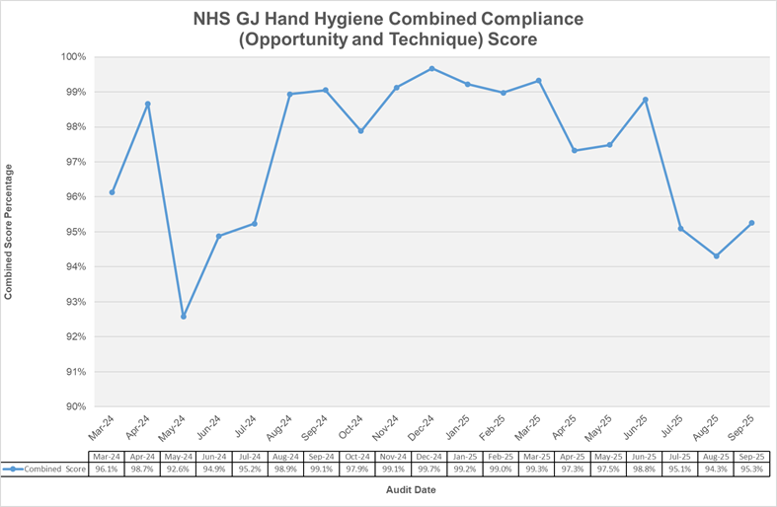

Please note - Previous months data may differ from data reported in previous HAIRT submissions. This is due to areas submitting data after the cut-off date of the 7th of each month.
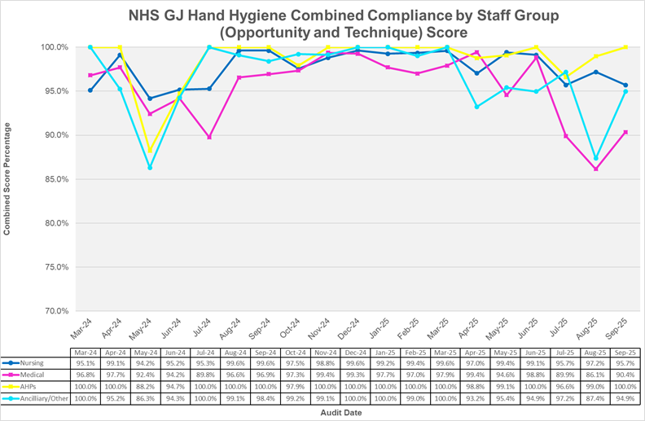

*NB Th 11 &16 not in use

NOT20 | 20 Observations not undertaken/recorded | PCIT alerts areas where this is noted
 | >95%
 | 80-94%
 | <80%

Locations with compliance of less than 90%

Location | Non-compliance-  Did not take opportunity | Non-compliance- Inadequate technique
CCU | Before touching a patient  Medic, Nurse  After touching patient surroundings  Nurse, Medic
2 West General | Before touching a patient  Medic  After touching patient surroundings  Other (Radiographer)
ICU 2 | Before touching a patient  Medic  After touching a patient  Nurse  After touching patient surroundings  x2 Nurse | Before touching a patient  x2 Medic  After touching patient surroundings  Medic, Nurse
2 East | Before touching a patient  Medic, x2 Nurse  After touching patient surroundings  Nurse  After body fluid exposure  Nurse
PACU |  | After touching patient surroundings  Nurse  After touching a patient  Other
Th 3 | After touching patient surroundings  Other  Before touching a patient  Medic
Th 4 | Before touching a patient  Nurse  After touching patient surroundings  x3 Nurse | After touching patient surroundings  Nurse
Th 9 | After touching patient surroundings  Medic | After body fluid exposure  Nurse
Th 12 | After touching a patient  Nurse  After touching patient surroundings  Other
Th 14 | Before clean/aseptic procedure  Medic  After touching patient surroundings  Medic
Th 42 | After touching a patient  Medic  Before touching a patient  Medic

Cleaning and Maintaining the Healthcare Environment
The external migration for FMT is ongoing through national SLWG, representation from NHS GJ includes Housekeeping, Estates and E Health, progress reports will be received by the Domestic Services Expert Group.

National Cleaning Services Specifications have been reviewed and released. Updates at key Nursing Governance groups ongoing.

Housekeeping FMT Audit Results
Enlarged image available at the end of HAIRT

Healthcare Associated Infection Reporting Template (HAIRT)
Section 2 – Healthcare Associated Infection Report Cards

The following section is a series of ‘Report Cards’ that provide information, for each acute hospital and key community hospitals in the Board, on the number of cases of Staphylococcus aureus blood stream infections (also broken down into MSSA and MRSA) and Clostridioides difficile infections, as well as hand hygiene and cleaning compliance. In addition, there is a single report card which covers all community hospitals [which do not have individual cards], and a report which covers infections identified as having been contracted from outwith hospital. The information in the report cards is provisional local data, and may differ from the national surveillance reports carried out by ARHAI. The national reports are official statistics which undergo rigorous validation, which means final national figures may differ from those reported here. However, these reports aim to provide more detailed and up to date information on HAI activities at local level than is possible to provide through the national statistics.

Understanding the Report Cards – Infection Case Numbers
Clostridioides difficile infections (CDI) and Staphylococcus aureus bacteraemia (SAB) cases are presented for each hospital, broken down by month. Staphylococcus aureus bacteraemia (SAB) cases are further broken down into Meticillin Sensitive Staphylococcus aureus (MSSA) and Meticillin Resistant Staphylococcus aureus (MRSA).

For each hospital the total number of cases for each month are those which have been reported as positive from a laboratory report on samples taken more than 48 hours after admission. For the purposes of these reports, positive samples taken from patients within 48 hours of admission will be considered to be confirmation that the infection was contracted prior to hospital admission and will be shown in the “out of hospital” report card.

Targets
There are national annual operating plans associated with reductions in HCAI. More information on these can be found on the Scottish Government website.

Understanding the Report Cards – Hand Hygiene Compliance
Hospitals carry out regular audits of how well their staff are complying with hand hygiene. Each hospital report card presents the combined percentage of hand hygiene compliance with both opportunity taken and technique used broken down by staff group.

Understanding the Report Cards – Cleaning Compliance
Hospitals strive to keep the care environment as clean as possible. This is monitored through cleaning and estates compliance audits. More information on how hospitals carry out these audits can be found here:
Facilities Monitoring Report | National Services Scotland (nhs.scot)

NHS BOARD REPORT CARD

Staphylococcus aureus bacteraemia monthly case numbers
 | Oct 24 | Nov 24 | Dec  24 | Jan 25 | Feb  25 | Mar  25 | Apr  25 | May 25 | Jun 25 | Jul  25 | Aug  25 | Sept  25
MRSA | 0 | 0 | 0 | 0 | 0 | 0 | 0 | 0 | 0 | 0 | 1 | 0
MSSA | 0 | 0 | 0 | 2 | 0 | 0 | 0 | 0 | 1 | 0 | 0 | 0
Total SABS | 0 | 0 | 0 | 2 | 0 | 0 | 0 | 0 | 1 | 0 | 1 | 0

Clostridioides difficile infection monthly case numbers
 | Oct 24 | Nov 24 | Dec  24 | Jan 25 | Feb  25 | Mar  25 | Apr  25 | May 25 | Jun 25 | Jul  25 | Aug  25 | Sept  25
Ages15-64 | 0 | 0 | 0 | 0 | 0 | 0 | 0 | 0 | 0 | 1 | 0 | 0
Ages 65+ | 0 | 0 | 0 | 0 | 0 | 0 | 0 | 1 | 2 | 2 | 0 | 1
Ages 15 + | 0 | 0 | 0 | 0 | 0 | 0 | 0 | 0 | 0 | 0 | 0 | 0

E.Coli bacteraemia monthly case numbers

 | Oct 24 | Nov 24 | Dec  24 | Jan 25 | Feb  25 | Mar  25 | Apr  25 | May 25 | Jun 25 | Jul  25 | Aug  25 | Sept  25
ECB | 0 | 0 | 0 | 0 | 0 | 1 | 2 | 0 | 0 | 0 | 1 | 1

Hand Hygiene Monitoring Compliance (%) (as reported at 7th of each month)
 | Oct 24 | Nov 24 | Dec  24 | Jan 25 | Feb  25 | Mar  25 | Apr  25 | May 25 | Jun 25 | Jul  25 | Aug  25 | Sept  25
Nurse | 97 | 98 | 99 | 99 | 99 | 99 | 97 | 99 | 96 | 95.7 | 97.1 | 95.7
Medical | 97 | 99 | 99 | 98 | 97 | 98 | 99 | 94 | 99 | 89.9 | 84.9 | 90.4
AHP | 98 | 98 | 100 | 100 | 100 | 99 | 99 | 99 | 100 | 96.6 | 98.9 | 100
Ancillary/Other | 99 | 99 | 99 | 100 | 99 | 100 | 93 | 95 | 89 | 97.2 | 85.7 | 94.9
Board Total | 98 | 99 | 99 | 99 | 99 | 99 | 97 | 97 | 96.5 | 95.1 | 93.9 | 95.3

Cleaning Compliance (%)
 | Oct 24 | Nov 24 | Dec 24 | Jan 25 | Feb  25 | Mar  25 | Apr  25 | May 25 | Jun 25 | Jul  25 | Aug  25 | Sept  25
Board Total | 98.25 | 98.85 | 98.23 | 98.64 | 98.25 | 98.39 | 98.49 | 98.11 | 97.09 | 97.99 | 97.62 | 97.98

Estates Monitoring Compliance (%)
 | Oct  24 | Nov  24 | Dec  24 | Jan 25 | Feb  25 | Mar  25 | Apr  25 | May 25 | Jun 25 | Jul  25 | Aug  25 | Sept  25
Board Total | 92.47 | 97.55 | 96.3 | 98.54 | 92.61 | 98.17 | 97.5 | 91.91 | 97.74 | 98.09 | 93.94 | 97.93

Surgical Site Infection Surveillance- Orthopaedic Local data
Knee Arthroplasty SSI
Number of Procedures | Month | Type of SSI | Status
238 | Oct 24 | 0 | Confirmed
232 | Nov 24 | 1Superficial | Confirmed
238 | Dec 24 | 0 | Confirmed
273 | Jan 25 | 0 | Confirmed
212 | Feb 25 | 0 | Confirmed
231 | Mar 25 | 0 | Confirmed
232 | Apr 25 | 0 | Confirmed
274 | May 25 | 0 | Confirmed
249 | June 25 | 0 | Confirmed
291 | July 25 | 0 | Confirmed
284 | Aug 25 | 0 | Confirmed
308 | Sept 25 | 0 | Unconfirmed
*A surgical site infection is defined as a superficial, deep or organ space infection occurring within 30 days of operation. Definitions of superficial, deep and organ space are defined in Health Protection Scotland Surgical Site Infection Surveillance Protocol.
Hip Arthroplasty SSI
Number of Procedures | Month | Type of SSI | Status
216 | Oct 24 | 0 | Confirmed
188 | Nov 24 | 0 | Confirmed
150 | Dec 24 | 0 | Confirmed
169 | Jan 25 | 1 Deep Infection | Confirmed
148 | Feb 25 | 0 | Confirmed
220 | Mar 25 | 1 Deep Infection | Confirmed
185 | Apr 25 | 0 | Confirmed
235 | May 25 | 3- 2 Deep/1 Superficial | Confirmed
190 | June 25 | 1-Organ Space | Confirmed
204 | July 25 | 0 | Confirmed
190 | Aug 25 | 0 | Confirmed
163 | Sept 25 | 0 | Unconfirmed

*A surgical site infection is defined as a superficial, deep or organ space infection occurring within 30 days of operation. Definitions of superficial, deep and organ space are defined in Health Protection Scotland Surgical Site Infection Surveillance Protocol.
Surgical Site Infection Surveillance- CABG Local data
CABG SURGERY SSI
Number of Procedures |  | Month |  | Type of SSI |  | Status
 | 54 |  | Oct 24 |  | 0 |  | Confirmed
 | 45 |  | Nov 24 |  | 0 |  | Confirmed
 | 38 |  | Dec 24 |  | 1-Superficial Sternum |  | Confirmed
 | 48 |  | Jan 25 |  | 2-1 Superficial Sternum/1 Superficial Sternum & leg |  | Confirmed
 | 41 |  | Feb 25 |  | 2 Superficial Sternum |  | Confirmed
 | 36 |  | Mar 25 |  | 0 |  | Confirmed
 | 42 |  | Apr 25 |  | 4- 2 Superficial Sternum/1 organ space/1 deep leg |  | Confirmed
 | 41 |  | May 25 |  | 0 |  | Confirmed
 | 46 |  | June 25 |  | 0 |  | Confirmed
 | 48 |  | July 25 |  | 0 |  | Confirmed
 | 53 |  | Aug 25 |  | 0 |  | Confirmed
 | 57 |  | Sept 25 |  | 1 Superficial Sternum |  | Unconfirmed

Surgical Site Infection Surveillance- Valve Replacement +/- CABG Local data
Valve Replacement +/- CABG SSI
Number of Procedures | Month | Type of SSI | Status
43 | Oct 24 | 1 Superficial Sternum | Confirmed
41 | Nov 24 | 1 Superficial Sternum | Confirmed
33 | Dec 24 | 1 Superficial Sternum | Confirmed
31 | Jan 25 | 1 Superficial Sternum | Confirmed
25 | Feb 25 | 0 | Confirmed
30 | Mar 25 | 1 Superficial Sternum | Confirmed
32 | Apr 25 | 2 Superficial Sternum | Confirmed
32 | May 25 | 1 Superficial Groin | Confirmed
33 | June 25 | 0 | Confirmed
35 | July 25 | 2 Superficial Sternum | Confirmed
35 | Aug 25 | 2- 1 Superficial Sternum/1 Organ Space Sternum | Confirmed
35 | Sept 25 | 1 Superficial Sternum | Unconfirmed

HAIRT Table of Abbreviations
AHP | Allied Health Professional
ARHAI | Antimicrobial Resistance and Healthcare Associated Infection
AOP | Annual Operating Plan
CABG | Coronary Artery Bypass Graft
CG | Clinical Governance
CGC | Clinical Governance Committee
CCU | Coronary Care Unit
CDI/C.difficile | Clostridioides difficile infection
CMO | Chief Medical Officer
CNM | Clinical Nurse Manager
CNO | Chief Nursing Officer
CPE | Carbapenamase-producing enterobacteriacaea
CVC | Central Venous Catheter
DMT | Domestic Monitoring Tool
DSEG | Domestic Services Expert Group
ECB | Escherichia coli bacteraemia
EDU | Endoscopy Decontamination Unit
FMT | Facilities Monitoring Tool
GI | Gastro Intestinal
GJNH | Golden Jubilee National Hospital
GS | General Surgery
HAIRT | Healthcare Associated Infection Report Template
HCAI | Healthcare Associated Infection
HCID | High Consequence Infectious Disease
HDU | High Dependency Unit
HH | Hand Hygiene
HIIAT | Healthcare Infection Incident Assessment Tool
HLD | Heart and Lung Division
HA MRSA | Hospital Acquired Meticillin Resistant Staphylococcus aureus
HEAT | Health Improvement, Efficiency, Access to treatment, and Treatment
HEI | Healthcare Environment Inspection
HFS | Healthcare Facilities Scotland
HH | Hand Hygiene
HIS | Healthcare Improvement Scotland
HPS | Health Protection Scotland
IABP | Intra-aortic balloon pump
IC | Infection Control
IMT | Incident Management Team
MRSA | Meticillin Resistant Staphylococcus aureus
MSSA | Meticillin Sensitive Staphylococcus aureus
NA | Not Applicable
NCSS | National Cleaning Standards Specification
NHSGJ | NHS Golden Jubilee
NIPCM | National Infection Prevention Control Manual
NSD | National Services Division
NSS | National Services Scotland
OER | Orthopaedic Enhanced Recovery
PAG | Problem Assessment Group
PCIC | Prevention & Control of Infection Committee
PCIN | Prevention & Control of Infection Nurses
PCIT | Prevention & Control of Infection Team
PCIAR | Prevention and Control of Infection Annual Review
PICC | Peripherally Inserted Central Catheter
PVC | Peripheral Venous Cannula
SAB | Staphylococcus aureus bacteraemia
SAU | Surgical Admissions Unit
SBAR | Situation Background Assessment Recommendations
SCN | Senior Charge Nurse
SCRIBE | Systems for Control Risk in the Built Environment
SG | Scottish Government
SGHD | Scottish Government Health Department
SICP | Standard Infection Control Precautions
SLWG | Short Life Working Group
SPSP | Scottish Patient Safety Programme
SSI | Surgical Site Infection
TBP | Transmission Based Precautions
THR | Total Hip Replacement
TKR | Total Knee Replacement
TOBD | Total Occupied Bed Days
VIP | Visual Infusion Phlebitis
WTO | Work Task Order

