
NHS Golden Jubilee

Meeting: NHS Golden Jubilee Board

Meeting date: 27 November 2025

Title: Health and Safety Report - Quarter 2 (25/26)

Responsible Executive/Non-Executive: Jonny Gamble (Executive Director of Finance)

Report Author: David Wilson (Head of Health and Safety)

Purpose

This is presented to NHS GJ Board for:
- Approval

This report relates to a:
- Legal Requirement
- Local Policy

This aligns to the following NHS Scotland quality ambition(s):
- Safe
- Effective
- Person Centred

This aligns to the following NHSGJ Corporate Objectives:
- Leadership, Strategy & Risk

2 Report summary

2.1 Situation

Reports are provided on a quarterly basis to Health & Safety Forums, Health & Safety Committee and Staff Governance & Person Centred Committee which relate to Health and Safety Activity across NHS Golden Jubilee. This report summarises Health and Safety activity for Quarter 2 2025/26.

Background

The Health and Safety at Work etc. Act 1974 is the primary legislation covering health and safety in the UK. Sections 2 (6) and 2 (7) of this Act requires employers to formally consult their employees on matters that affect their health and safety. NHS Golden Jubilee has decided that the most effective way to discharge these requirements will be through the formation of Divisional Health & Safety Forums and Health & Safety Committee.
The main purpose of the committee is to foster a culture whereby the promotion of the health and safety of employees, patients, visitors, contractors and suppliers becomes an integral part of our organisation’s activities.

The committee terms of reference sets out a number of aims and these are summarised below:
- To encourage safe working practices and safeguards for all staff and others in line with health and safety legislation.
- To promote safety consciousness within staff at every level in order to effect a reduction in the level of accidents.
- To promote appropriate courses of training in health and safety for all staff.
- To consider concerns expressed by management and staff in relation to health and safety matters.
- To agree a program of workplace inspections, receive reports and make recommendations on action required.
- To monitor progress against health and safety action plan.

2.3 Assessment
Appendix 1 contains Health & Safety Quarterly Report for Q2. 25/26

2.3.1 Quality/ Patient Care
Ensuring we deliver safe patient care.

2.3.2 Workforce
Ensures we provide staff a safe working environment in accordance with NHS Staff Governance Standards.

2.3.3 Financial
In accordance with SFIs and existing resources.

2.3.4 Risk Assessment/Management
Any key risks are highlighted within Appendix 1. New and emerging risks will remain as standard agenda item at Health and Safety Committee meetings in order to provide a focused attention on risk management.

2.3.5 Equality and Diversity, including health inequalities
Not applicable (N/A). Any policies that are reviewed or developed as noted in this quarterly report will be subject to equality impact assessment where identified as being required.

2.3.6 Other impacts
N/A.

Communication, involvement, engagement and consultation
The Board has carried out its duties to involve and engage external stakeholders where appropriate. The purpose of this report is a means for communication, engagement and consultation.

Route to the Meeting
N/A –as above (2.3.7) this update is for information sharing and provides a platform for further discussion at the Forum and Committee meetings.

2.4 Recommendation

- Decision – For Members’ approval.

List of appendices
The following appendices are included with this report:
- Appendix No 1, Health and Safety Quarterly Report Q2 25/26.


APPENDIX 1
HEALTH & SAFETY COMMITTEE QUARTERLY REPORT
Q2 2025/26 (1st July – 24 September 2025)
Section 1: We said, we did
What we said we would do | What we did
Develop and publish monthly matters articles on:  - Sharps Injury Prevention (July);  - Violence and Aggression (August);  - Skin Health (September) | Published monthly matters articles on:  - Sharps Injury Prevention (July);  - Violence and Aggression (August);  - Fire Safety (to support Policy review)  - Skin Health moved to October (September)
Review the following policies:  - Smoking & Vaping;  - Personal Protective Equipment (PPE);  - First Aid at Work. | Reviewed each of these policies which are tabled for Q2 H&S meetings for approval prior to upload to share point.  In addition, we have also taken the opportunity to review the following at this time:  - Permit to Work Policy  - Stress in the Workplace (interim review whilst awaiting release of OfS Managing Health at Work 2026)
Provide update report on V&A SLWG progress | Paper provided for presentation at October Q2 H&S meetings.
Provide early feedback on progress with H&S Audit programme | Paper provided for presentation at October Q2 H&S meetings.
Launch Sharps Awareness Month for August 2025 | Sharps Safety Sessions delivered with over 70 attendees mainly from Nursing. No attendance from Medical teams.
Provide drop in sessions for staff to support the recent review of the Fire Safety Policy | Sessions delivered 16th and 22nd September 2025. Attendance from a range of departments.
Section 2: What we’ll do next
Develop and publish monthly matters articles on:
- Skin Health (October) – In line with Responsible Person training for Skin Health
- Focus on Risk Assessment (November); To Provide support and awareness to address deficiencies identified via early rounds of H&S Audits.
- Manual Handling (November); To support roll out of Training Needs Analysis
- Driving at Work (December) – Linked to adverse weather
- Christmas Safety extra edition (December)
Review the following policies:
- Confined Spaces Policy
- Lifting Operations/Lifting Equipment (LOLER) Policy
- Procurement and Use of Portable Electrical Appliances Policy
- Work at Height Policy
Develop Violence & Aggression share point site within the H&S landing page (November 2025). This will support the work being undertaken via the V&A SLWG.
Develop proposal for the delivery of enhanced V&A training (beyond e-learning provision)

International Stress Awareness week – November 3rd 2025. We will take the opportunity to build on the positive engagement around Stress Awareness from April 2025 with a similar approach involving collaboration with key stakeholders.

Focus on Risk Assessment (November 2025). Required to support departments to improve on knowledge, understanding and application of work activity risk assessments as this has been identified as an area for improvement via the first round of H&S Audit Programme.

H&S Engagement Survey (January 2026). This will provide useful information on how well we are communicating with intended recipients with the aim of acting on feedback to make improvements where required. This will be supported by a communications ‘spotlight’ on the H&S Service.

Section 3: Adverse Event Reporting
This section provides an overview of health and safety related adverse incidents in Q2 25/26.

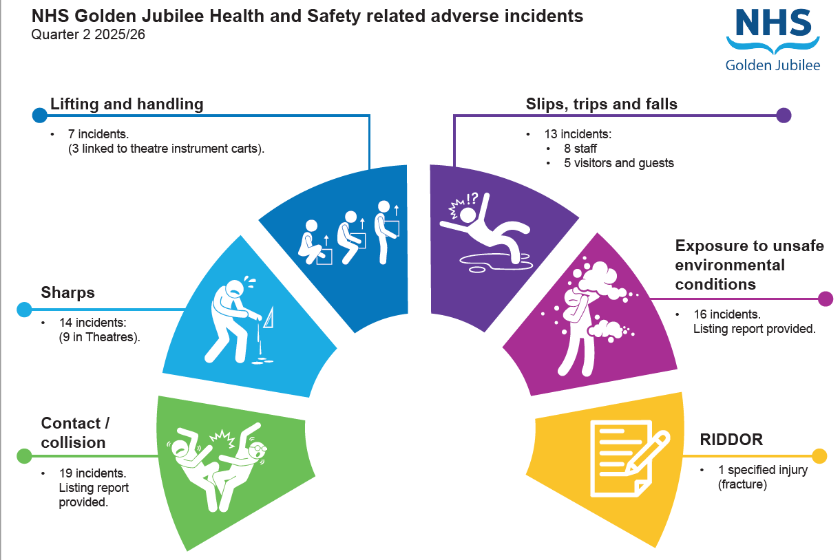

These top 5 sub categories have been reasonably consistent in comparison to previous quarter, with similar numbers for each of the top 5 sub categories. This quarter has seen ‘violence and aggression’ drop out of the top 5 and replaced with Lifting/Manual handling’. As there are a wide variety of incident types within the ‘contact/collision; and ‘unsafe environmental conditions’, the full listing reports for each of these sub categories is presented in appendix 2 and 3. An additional listing report has also been provided for ‘Sharps’ within appendix 4.

From the incidents that have been risk rated on datix, the vast majority are either minor or less. The moderate rated incidents are shown in the listing report below.

35% negligible
77% minor
8% moderate
Overview of the moderate risk rated events:

- Staff member burnt hand from heating soup in microwave (research)
- Contractor working on flooring, cut wrist (estates)
- Staff member blood splash in eye, Cath lab 1
- Fire on external grounds of hotel (grass area)
- Hotel staff member tripped and fell leading to over 7 day (possible RIDDOR, TBC)
- Staff member cut finger on sharp edge of theatre cart.
- 4 x V&A related. 1 x Arthroplasty verbally (passive aggressive) patient to staff; 1 x car park visitor towards contractor (physical); 1 x car park visitor to staff member (verbal); 1 x HDU patient to staff (physical)

Appendix 2: Listing report for ‘contact/collision’ incidents:

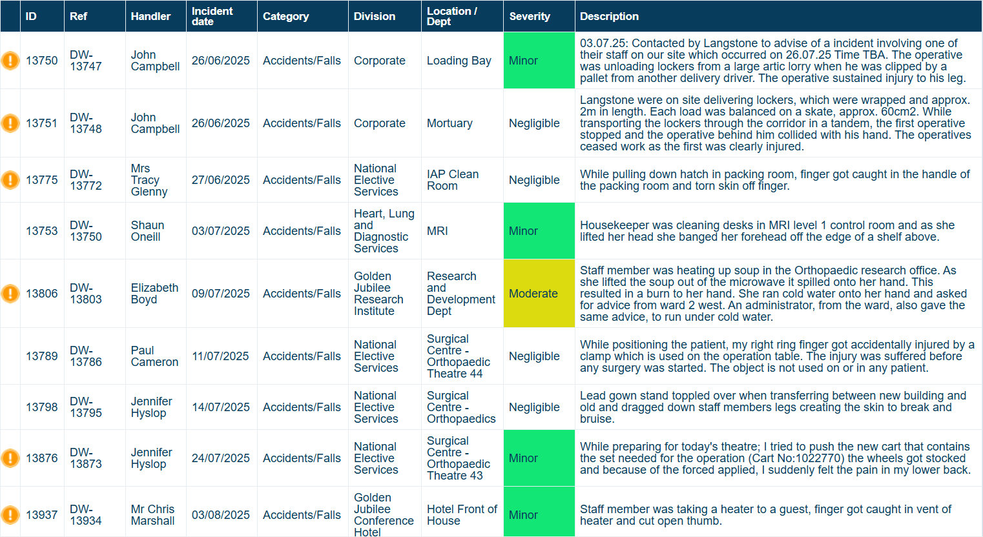
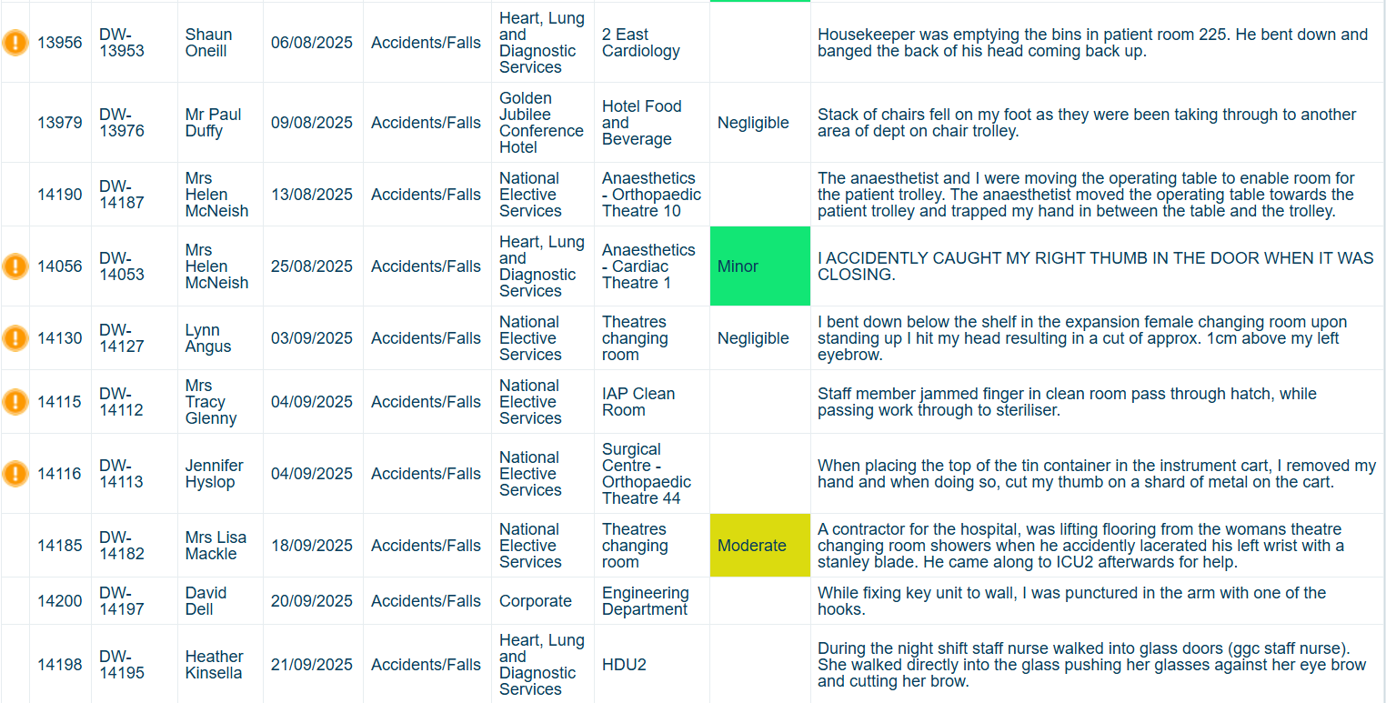

Appendix 3: Listing Report for ‘Exposure to Unsafe Environmental Conditions’
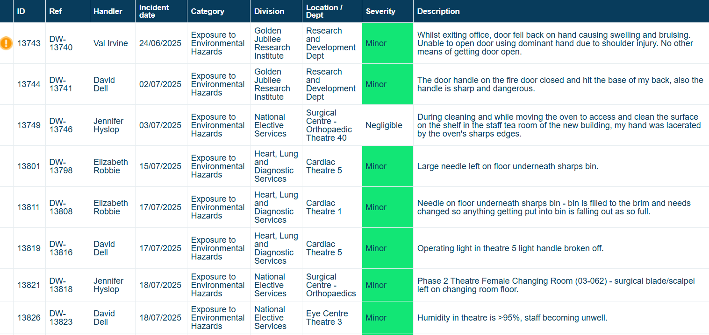
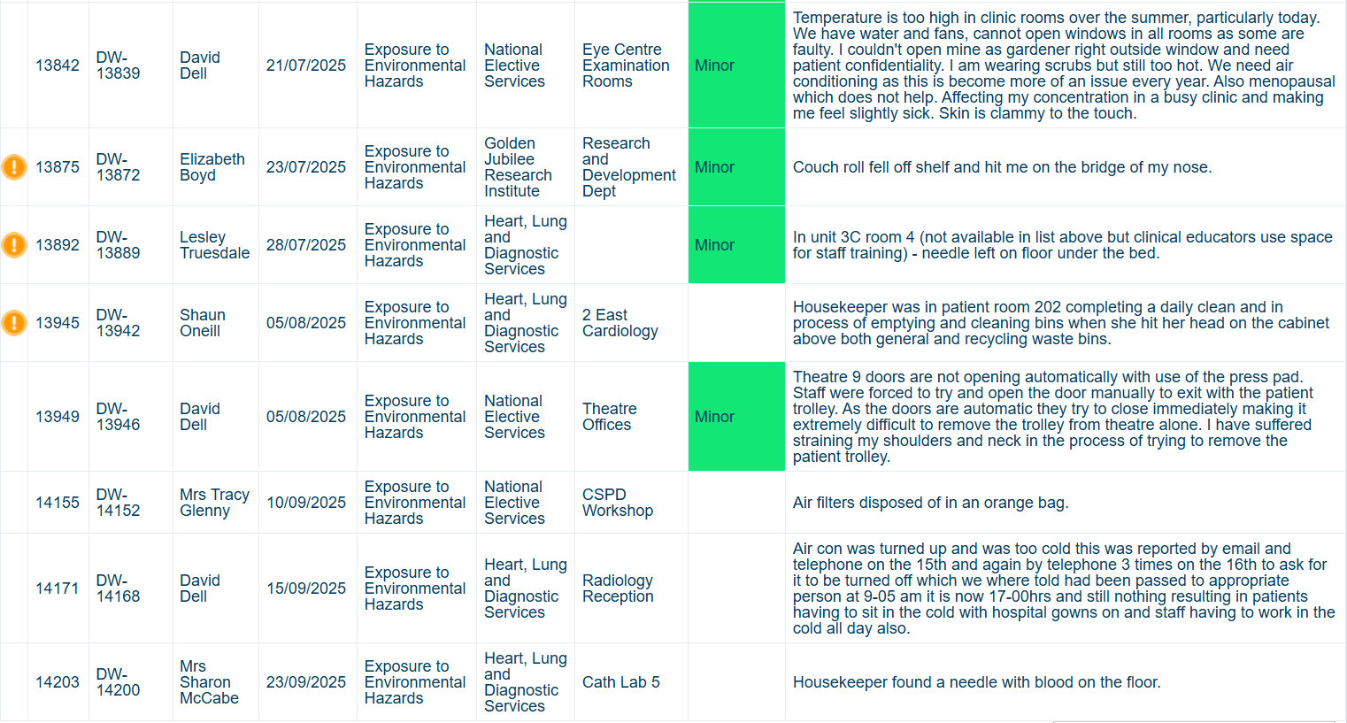

Appendix 3: Sharps Listing Report

