Board Meeting: | 14 February 2019 | 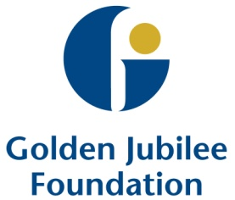
Subject: | Updated Terms of Reference for Audit and Risk Committee
Recommendation: | Board members are asked to:  Discuss and Note  Discuss and Approve X  Note for Information only

1 Background

The Audit and Risk Committee previously reviewed the new Audit and Assurance Handbook and agreed that, whilst they mirrored the key elements of the previous guidelines, further work was required to update them in line with the new guidelines.

As a result, the Audit and Risk Committee Terms of Reference have now been updated, with all changes highlighted in the attached.

2 Update to Terms of Reference

The Terms of Reference for the Audit and Risk Committee have been amended as follows:

- Inclusion of new Members;
- Removal of dates of membership;
- Amending Quorum to three members to reflect that four members are in place;
- Replacement of the NHS Audit Committee Handbook with the new Audit and Assurance Committee Handbook guidelines; and
- Inclusion of requirement for all members to sign a formal declaration to state that they acknowledge their governance responsibility as committee members.

The Audit and Risk Committee approved their updated Terms of Reference were at the meeting on 5 February 2019. These are now presented to the Board for formal approval.

3 Conclusion/Recommendation

Board members are asked to approve the new Audit and Risk Committee Terms of Reference.

Julie Carter
Director of Finance
6 February 2019

(Lily Bryson, Assistant Director of Finance – Governance and Financial Accounting)

