Board Meeting: | 9 May 2019 | 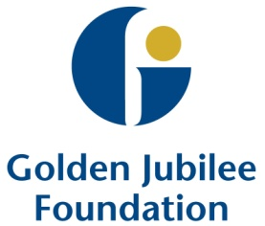
Subject: | Golden Jubilee Foundation Phase one expansion
Recommendation: | Board members are asked to:  Discuss and Note  Discuss and Approve  Note for Information only

1 Background
This paper provides an overview of progress to date with regards Phase one of the hospital expansion programme.

The format of the paper was agreed by the Programme Board as the standard monthly reporting template.

2 Proposals

The paper:
- provides a programme update
- provides a commercial summary;
- provides an update on the design status;
- provides an update on the statuary approval status;
- provides an update on works on site
- provides an update on the progress of the work stream groups;
- provides an update on community benefits;
- provides a summary of the key risks and mitigation;
- provides a summary of the programme budget;
- provides a summary of issues affecting the programme;
- provides an update on communication and stakeholder engagement;
- sets out key tasks going forward

6 Conclusion/Recommendation
The Board is asked to acknowledge the overall progress to date made with Phase one of the hospital expansion programme.

Jann Gardner
Chief Executive
26 April 2019

(John M Scott, Programme Director)

