Board Meeting: | 9 May 2019 | 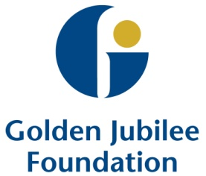
Subject: | Draft Equality Mainstreaming Report
Recommendation: | Board members are asked to:  Discuss and Note  Discuss and Approve  Note for Information only

1 Background
Our Equalities Mainstreaming Report for 2016-2018 highlights how we have met the requirements of the Scottish Public Sector Equality Duty. It shows how we have embedded participation and equalities into our services, functions and policies, provides information on our protected characteristics and gender pay, and demonstrates our progress in implementing our equality outcomes.
Since our last report, we have continued to take large steps to improve awareness of our responsibilities and to support all staff in achieving these.

2 Consultation

Our mainstreaming report is presented as a combination of highlight reports and case studies. The Equalities group and key colleagues within the HR Dept have all contributed to the development of this report.

3 Conclusion/Recommendation

Board members are asked to discuss and approve the content of this report.

Gareth Adkins
Director of Quality, Innovation & People
29 April 2019

Author: Andy Gillies
Spiritual Care & Diversity Lead

