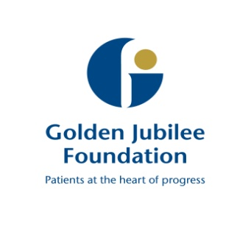

Board Meeting: 16 April 2019

Subject: Clinical Governance Committee Update

Recommendation: Board members are asked to note discussions from the meeting 16 April 2019
___________________________________________________

1 Background

The following key points were agreed at the meeting and have been split into the three high level quality ambitions of person centred, safe, and effective.

Person Centred
Mutually beneficial partnerships between patients, their families and those delivering healthcare services which respect individual needs and values and which demonstrate compassion, continuity, clear communication and shared decision-making.
- The six-monthly Claims Report was received. Triangulation with divisional reports was noted.

- The HIS Quality of Care Team observed the Committee meeting and gave verbal feedback.

Safe
There will be no avoidable injury or harm to people from healthcare they receive, and an appropriate, clean and safe environment will be provided for the delivery of healthcare services at all times.
- The two divisional reports were received and discussed in detail. The new section updating on wider CG activity welcomed by the Committee.

- Reports on 2 closed significant events were received and discussed.

- Safety and Cleanliness: The response to an unannounced inspection of a local hospital was reviewed. Requirements which were not completely met related to areas of limited relevance to GJNH.

Effective
The most appropriate treatments, interventions, support and services will be provided at the right time to everyone who will benefit, and wasteful or harmful variation will be eradicated.
- The January HAIRT data was received and discussed. The continuing attention to Staphylococcus Aureus Bacteraemia and Surgical Site Infections was discussed in detail. National comparison through the National Cardiac Benchmarking Collaborative (NCBC) was being sought and novel approaches for improvement had been identified there.
- The Clinical Governance Annual Report was received and approved subject to minor modifications.

The next meeting is scheduled for 16 July 2019 at 10am, Level 5 Boardroom

Mark MacGregor
Chair, Clinical Governance Committee
16 April 2019

