Board Meeting: | 9 May 2019
Subject: | Board Performance Report
Recommendation: | Board members are asked to:  Discuss and Note X  Discuss and Approve  Note for Information only

__________________________________________________________________

- Introduction

The Board is asked to discuss the content of the performance report covering matters discussed at the April 2019 meeting of the Performance and Planning Committee.

- Board Exception Report – Key Performance Indicators (KPIs)
- Effective KPIs
- Person-centred KPIs
- Safe KPIs

- Divisional Exception Reports
(a) Surgical Services
(b) Regional and National Medicine

- Waiting lists – Cardiac Surgery, Thoracic Surgery and Cardiology.

- Corporate Balanced Scorecard (Appendix 1)

2 Recommendation
Board members are asked to note the update for the current reporting period.

Jann Gardner
Chief Executive
26 April 2019

(Carole Anderson, Head of Strategy and Performance)

Board Exception Report
Improved performance
Same performance
Worse performance

Effective Board Performance update – May 2019
KPI | Details |  |  |  | Tolerance |  |  | Dec 2018 |  |  | Jan 2019 |  |  |  | Feb 2019 |  |  | Target |  |  | On Track
Elective Acute Ward Bed Occupancy | Combined occupancy position for NSD, 2 East, 2 West, 3 East, 3 West |  |  |  | >90.1% = Red  86-90%= Green  78-85.9% = Amber  <77.9% = Blue |  |  | 80.3% |  |  | 77.4% |  |  |  | 79.4% |  |  | 86-90%
Interventional Cardiology Wards Bed Occupancy | Combined occupancy position for 2C, 2D and CCU |  |  |  | 87.4%- 100% = R  81% -87.3% = G  77%-80.9%= A  <76.9% = B |  |  | 86.8% |  |  | 86.0% |  |  |  | 85.1% |  |  | 81-87.3%
Critical Care Wards Bed Occupancy | Combined occupancy position for ICU1, ICU2, HDU2, HDU3 |  |  |  | ≥ 84.8% = R  73 – 84.7% = G  63.4 – 72.9% = A  ≤ 63.3% = B |  |  | 72.5% |  |  | 68.6% |  |  |  | 74.8% |  |  | 70-90%
Analysis
Overall bed occupancy in the elective acute wards increased by 2% in February compared to January. Wards 2 East, 2 West, 3 East, 3 West and the NSD ward all reported increased occupancy levels. Ward 3 West reported a very small reduction of 0.1% in occupancy. Ward 2 East reported a 7.8% increase in occupancy which resulted in the ward’s highest occupancy level since August 2018.
Bed occupancy in Cardiology reduced slightly in February compared to January. Ward 2C’s occupancy levels remained stable whilst 2D reported a 12% increase in occupancy and CCU reported a decrease of almost 10%.
Overall bed occupancy within the critical care units increased by over 6% in February. ICU1 reported a 1.4% decrease in occupancy whilst ICU2, HDU2 and HDU3 reported increases, withHDU2 reporting an increase of 10%.

KPI |  | Details |  |  | Tolerance |  | Jan 2019 |  |  | Feb 2019 |  |  |  | Mar 2019 |  |  | Target |  |  |  |  | On Track
Cardiac Surgery Cancellation Rate |  | Percentage of Cardiac Surgery patients cancelled on day of procedure |  |  | Achieved = G  Not Achieved = R |  | 14.1% |  |  | 18.9% |  |  |  | 10.8% |  |  | Incremental reduction from baseline position of 16% to 8% by March 2019
Plastic Surgery Cancellation Rate |  | Percentage of Plastic Surgery patients cancelled on day of procedure |  |  | Achieved = G  Not Achieved = R |  | 8.9% |  |  | 4.6% |  |  |  | 4.2% |  |  | Incremental reduction from baseline position of 5% to 3% by March 2019
General Surgery Cancellation Rate |  | Percentage of General Surgery patients cancelled on day of procedure |  |  | Achieved = G  Not Achieved = R |  | 6.0% |  |  | 14.8% |  |  |  | 9.6% |  |  | Incremental reduction from baseline position of 9% to 5% by March 2019
Ophthalmology Cancellation Rate |  | Percentage of Ophthalmology patients cancelled on day of procedure |  |  | Achieved = G  Not Achieved = R |  | 2.9% |  |  | 3.1% |  |  |  | 3.5% |  |  | Monthly 3% cancellation rate
Orthopaedic Cancellation Rate |  | Percentage of Orthopaedic patients cancelled on day of procedure |  |  | Achieved = G  Not Achieved = R |  | 3.2% |  |  | 3.5% |  |  |  | 3.2% |  |  | Monthly 3% cancellation rate
Endoscopy Cancellation Rate |  | Percentage of Endoscopy patients cancelled on day of procedure |  |  | Achieved = G  Not Achieved = R |  | 8.4% |  |  | 5.4% |  |  |  | 6.0% |  |  | Incremental reduction from baseline position of 9% to 5% by March 2019
Thoracic Surgery Cancellation Rate |  | Percentage of Thoracic Surgery patients cancelled on day of procedure |  |  | Achieved = G  Not Achieved = R |  | 13.7% |  |  | 5.2% |  |  |  | 8.6% |  |  | Incremental reduction from baseline position of 9% to 5% by March 2019
Cardiology Cancellation Rate |  | Percentage of Cardiology patients cancelled on day of procedure |  |  | Achieved = G  Not Achieved = R |  | 4.1% |  |  | 0% |  |  |  | 9.5% |  |  | Incremental reduction from baseline position of 5.5% to 3% by March 2019
Analysis
There has been an overall improvement in theatre cancellation rates for 2018/19 compared to 2017/18; and all specialties apart from general surgery and plastic surgery have reported an improved cancellation rate for 2018/19.
However during March none of the clinical specialties were able to achieve their cancellation rate target.
Cardiac surgery reported 15 cancellations during March, 12 fewer than reported in February. Five of the cardiac surgery cancellations were due to priority cases or emergencies, three cancellations were due to a lack of operating time. There were two plastic surgery cancellations, both due to the patient failing to attend. Ten general surgery patients were cancelled in March, an improvement of two on the twelve reported in February, with the most common cancellation reason being due to the patient not attending. Ophthalmology failed to achieve their 3% cancellation target for only the third time during 2018/19 in March. The patient not being fit for their procedure was the primary ophthalmology cancellation reason. Orthopaedics has either achieved or been within 0.5% of their 3% cancellation target on nine occasions during 2018/19. Twelve endoscopy patients were cancelled in March, one third of the cancellations were due to patients attendance for appointments. Thoracic surgery has only exceeded their improvement target on two occasions during 2018/19 (January and March). During March the most common cancellation reason for thoracic patients was a lack of operating time. There were four cardiology cancellations in March, which amounted to 9.5% of cardiology theatre activity.

KPI |  |  | Details |  | Tolerance |  |  | Dec 2018 |  |  |  | Jan 2019 |  |  | Feb 2019 |  |  | Target |  |  | On Track
Treatment Time Guarantee (TTG) |  |  | Percentage of patients admitted within 12 weeks |  | 100% = Green  95-99.9% = Amber  ≤94.9% = Red |  |  | 87.5% |  |  |  | 87.0% |  |  | 90.7% |  |  | 0
Analysis
In February 1,305 (90.7%) patients were treated within 12 weeks and 134 patients received their treatment over the 12 week TTG. The patients treated beyond their 12 week guarantee date were comprised of 60 coronary, 37 electrophysiology, 10 device, five lead extraction and 22 cardiac surgery patients.

KPI |  |  |  | Details |  | Dec 2018 |  |  | Jan 2019 |  |  |  | Feb 2019 |  |  | Mar 2019 |  |  | Target | On Track
Cardiac Surgery Day of Surgery Admission Rate |  |  |  | Target for 15% of Cardiac Surgery major procedure admissions to be DoSA by March 2019 |  | 8.3% |  |  | 8.9% |  |  |  | 13.2% |  |  | 15.9% |  |  | 15% by March 2019
Orthopaedic Day of Surgery Admission Rate (Primary Joint Replacement) |  |  |  | Target for 70% of Orthopaedic Primary Joint Replacement admissions to be DoSA, rising to 75% from October 2018. |  | 53.0% |  |  | 65.3% |  |  |  | - |  |  | - |  |  | 75% from October 2018
Thoracic Surgery Day of Surgery Admission Rate |  |  |  | Target for 44% of Thoracic Surgery admissions to be DoSA by March 2019 |  | - |  |  | - |  |  |  | - |  |  | - |  |  | 44% by March 2019
Analysis
Cardiac surgery achieved the 15% DoSA target for March 2019. Thirteen cardiac surgery patients were admitted as DoSA in March giving a 15.9% DoSA rate. This is the largest number of DoSA admissions and the highest DoSA rate achieved within cardiac surgery.
There were 179 Orthopaedic DoSA admissions in January, returning a rate of 65.3%. This is an increase of over 10% compared to December.
The calculation of DoSA rates is currently reliant on coded data. A significant number of uncoded episodes for Thoracic Surgery mean that updated DoSA figures are not currently available. An updated method for calculating the DoSA rate has been developed which is not reliant on coded data, these figures will be reported for 2019/20.

Safe Board Performance update – May 2019
Due to the quarterly reporting of safe key performance indicators there is no update at this time.

Person Centred Board Performance update – May 2019
KPI |  |  | Details | Tolerance |  |  |  | Dec 2018 |  |  |  | Jan 2019 |  |  |  | Feb 2019 |  |  |  |  | Target | On Track
Stage Two complaints responded to within 20 days. |  |  | Measured as a percentage of complaints received. | >75% = Green  75% - 60% = Amber  <60% = Red |  |  |  | 100% |  |  |  | 40% |  |  |  | 60% |  |  |  |  | >75%
Analysis
During January there were eleven complaints, six Stage One and five Stage Two. Two of the five Stage Two complaints were responded to within 20 days.
During February there were six complaints, one Stage One and five Stage Two. Three of the five Stage Two complaints were responded to within 20 days.
The complaints which were not responded to within the target 20 days were the due to the complex nature of the complaints. For some of the complaints, the response required information to be provided from other NHS Boards, which slowed the ability to respond during the 20 day timescale.
During January and February all of the Stage One complaints were responded to within the five day target.

KPI | Details |  |  |  | Tolerance |  |  |  | Nov 2018 |  |  |  | Dec 2018 |  |  |  | Jan 2019 |  |  | Target |  | On Track
Sickness Absence | Percentage hours lost due to staff sickness absence as reported via SWISS |  |  |  | Achieved = Green  Not achieved = Red |  |  |  | 4.66% |  |  |  | 4.88% |  |  |  | 5.20% |  |  | ≤4%
Analysis
The sickness absence rate for January was reported at 5.20%. Long term sickness absence was 1.79% with short term 3.41%. The overall sickness absence rate for the 22 NHS Scotland Boards was 6.08% for January.
KPI | Details |  |  |  |  | Tolerance |  |  |  | Oct 2018 |  |  |  | Dec 2018 |  |  |  | Mar 2019 |  |  | Target | On Track
Job Planning Surgical Specialties: Consultants | Current, signed off job plans on eJP system as a percentage of headcount |  |  |  |  | Achieved = Green Not achieved = Red |  |  |  | 61.3% |  |  |  | 72.1% |  |  |  | 68.2% |  |  | Oct 18: 50%  Dec 18: 75%  Mar 19: 100%
Job Planning Surgical Specialties: SAS Doctors | Current, signed off job plans on eJP system as a percentage of headcount |  |  |  |  | Achieved = Green Not achieved = Red |  |  |  | 83.3% |  |  |  | 71.4% |  |  |  | 55.6% |  |  | Oct 18: 50%  Dec 18: 75%  Mar 19: 100%
Job Planning Regional and National Medicine: Consultants | Current, signed off job plans on eJP system as a percentage of headcount |  |  |  |  | Achieved = Green Not achieved = Red |  |  |  | 69.2% |  |  |  | 69.2% |  |  |  | 50.0% |  |  | Oct 18: 50%  Dec 18: 75%  Mar 19: 100%
As of 31 March 2019, 59 out of 93 (63.4%) of job plans had been signed off. In Surgical Specialties 45 out of 66 (68.2%) of consultants and five out of nine (55.6%) SAS doctors had a signed off job plan. Nine of the 18 (50%) Regional and National Medicine consultants had a signed off job plan.
There has been a deterioration in the percentage of signed off job plans since the last reporting period, this is due to the increase in Surgical SAS doctors and numbers of employed consultants across both divisions.
The Committee considered in detail the current Consultant job planning process, with particular reference to the process currently ongoing for the award of discretionary points. As a result of the discussion it was agreed that the Director of Quality, Innovation and People and the Medical Director would collaborate to submit a paper outlining the current position and provide recommendations to the Executive team and the Person Centred Committee on the future approach that will ensure discretionary points applications are dependant on the existence of a current, signed-off job plan.
KPI |  | Details |  |  |  |  | Tolerance |  |  |  | Jul 2018 |  |  |  | Nov 2018 |  |  |  | Mar 2019 |  | Target | On Track
Medical Appraisals of relevant doctors in 2018/19 |  | Completed appraisal interview and Form 4 |  |  |  |  | Achieved = Green Not achieved = Red |  |  |  | 1.5% |  |  |  | 17.7% |  |  |  | 62.8% |  | July 18 - 30%  Nov 18 - 60%  Mar 19 - 100%
The Golden Jubilee Foundation has responsibility for the appraisal of 129 doctors. As of 31 March, 81 had completed their appraisal and Form 4. Five had completed there appraisal interview but not the Form 4. A further 39 were at various stages within the appraisal process. One doctor was on maternity leave and three had not started the appraisal process.

Surgical Services Division Performance Board Performance Update – May 2019

ISSUE | ACTION | RESPONSIBLE LEAD | TIMESCALE
Critical Care | There has been an overall increase in critical care bed occupancy during both February and March. Orthopaedic critical care bed use increased from five days in January to 27 in February and lowered slightly to 25 in March. The number of cardiology bed days in ICU2 also rose sharply from 90 days in January to 167 in February. This increase in unplanned activity impacted theatre on two occasions with elective procedures being cancelled. | Lynn Graham | Ongoing
Wards | There have been significant periods of high occupancy within 3 East over recent months with upper tolerance levels exceeded in a number of occasions. All patients have been safely allocated beds, even during times of high demand. Whilst elements of this are surgically driven there are also significant but varying requirements for cardiology patients. Cardiology usage of beds within 3 East has increased significantly within the financial year 18/19. This has affected operational delivery on a regular basis as surgical patients are boarded to other clinical areas and has on occasion affected patients being discharged from critical care. | Lynn Graham | Ongoing
Cardiac Surgery | Cardiac surgery activity remains under extreme pressure as the demands on the service continue to grow in a sustained manner. Overall activity within 2018/19 was 7% higher than in 2017/18, with the service achieving close to 1400 major cardiac cases this year.  Increased referral numbers, stable conversion rates above 70% and a growth in complex and clinically urgent patients presents significant operational challenges. There is a growing mismatch between the natural fluctuations in activity demand and the capacity available, with the previous ability to flex up using other specialities sessions no longer possible.  The current constraints of the theatre model, and bed challenges across critical care and the surgical wards has meant that although the clinical teams worked extremely hard to deliver this year’s activity the service has struggled to keep up with meeting demand and the 12 week treatment time guarantee whist aiming to ensure that clinically appropriate timescales are met for patients. In February 22 patients were treated over the TTG and in March 20 patient were treated outwith 12 weeks.  There are now an increasing number of patients waiting over nine weeks for cardiac surgery and it is predicted that a number of these will not be able to be treated within 12 weeks in order to meet clinical demand. Recovery planning of additional theatre sessions by extending the days plus running some weekend additional lists without recurring staff resource has proven very challenging to implement.  The Committee were presented with a paper detailing the challenges faced within cardiac surgery and the improvements which had been made within the service. There is an unmet demand for cardiac surgery which the service is unable to accommodate despite best efforts. The long term strategy of extending the theatre day for cardiac surgery has been agreed within the Board with funding options currently being explored. In the interim a request was made for additional funding to support the opening of a cardiac theatre on a Friday which is currently unfunded. The Chief Executive has requested a summary briefing paper outlining the requirements to deliver the increase in activity. The Committee was supportive of all endeavours to identify ways to fund this gap until extended theatre days can be initiated.  The surgical bed pressures across both wards and critical care have remained a challenge over recent months. The main area of pressure in February was within critical care although this eased in March. However bed pressures overall did not disappear and the higher level of acute patients, at this point largely within the ward environment, driven both by the increased emergency and urgent activity and the complexity of some of our elective population continued to cause some difficulties throughout this period.  Despite the significant operational challenges there has been a considerable amount of improvement work within cardiac service supported by the Performance and Planning team. Some of the key achievements include the service achieving 15% DoSA (Day of Surgery Admission) rates within 2018/19 and undertaking urgent surgery for 55% of clinically ready patients within seven days. The patient flow scheduling/ admin project has worked with clinical teams to embed electronic out coming for the nursing team within outpatients and the consultant electronic vetting of outpatients commenced in December. These projects are key to ensuring that a ‘paper-lite’ approach is being taken to this early stage of the cardiac pathway and is preparing the clinical teams for the introduction of EPR (Electronic Patient Records). The establishment of various groups to review and maintain the quality improvement focus within cardiac surgery across various disciplines have now become routine within the service.  Plans are underway for some of the further developments in 2019/20 including plans being developed to commence Surgical TAVI once agreed by the national planning team, and the introduction of pharmacy presence within the pre-assessment clinic by May 2019.  Anaesthetic assessment continues to be a central feature of the cardiac outpatient model, with the addition of another Consultant Anaesthetist enhancing this service. Assessment levels however dropped in February and March largely due to some significant consultant absence.  A new protocol has been agreed to minimise patient’s attendance at hospital for repeat pre-operative assessments through virtual screening or telephone consultations. This is due to commence within April 2019 for a select group of suitable patients and will reduce visits and better utilise pre-operative assessment slots. | Lynn Graham | Ongoing
Thoracic | As of 9 April 2019 the service had successfully treated 79 patients with a planned Robotic Assisted Thoracic Surgery (RATS). As the expertise within the thoracic surgeon group builds, the benefits of the minimally invasive approach are beginning to be realised. Early ward based data shows that 57% of patients having a robotic procedure returned to the ward directly following their procedure.  A visit to Oxford was undertaken in April to review their enhanced monitoring beds for thoracic patients. The visit generated learning and opportunities which will form the basis of an improvement plan which is now under development. One area being reviewed is the thoracic outpatient model with the aim of taking advantage of potential opportunities for pre-operative assessment and patient optimisation within this patient group.  Consultant absence proved challenging within the thoracic service in February due to unplanned staff sickness which impacted on cancellations and theatre activity. Some waits for patients were increased, however in February and March all patients were treated within the 12 week treatment time guarantee (non cancer patients) and all cancer patients have been treated within the 31 day pathway. | Lynn Graham | Ongoing
Orthopaedics | The DoSA rate for December dropped to 53% and increased during January to 66%. Multiple challenges to day of surgery admission have been identified with a number of change ideas prioritised in order of potential scope for improvement and impact.  New length of stay trajectories, for primary hip and knee replacement patients, have been established and will be used to evaluate performance during 2019. It is anticipated achievement will be a gradual process throughout the year, however during February performance continued to exceed the trajectories set in 2018. During this period 35% of patients undergoing primary total hip replacement were discharged on post-operative day one.  Additional resources have been allocated to the Enhanced Recovery after Surgery (ERAS) orthopaedic work stream for one year. This has provided capacity to re-energise the CALEDonian programme and review patient flow.  Pre-operative anaemia clinics started in cardiac and orthopaedic outpatients on 1 April 2019.  A successful bid to the Strategic Projects Group has allowed two Band 4 Assistant Practitioners to be recruited to support the redesign of orthopaedic pre-operative assessment. | Christine Divers | Ongoing
Ophthalmology | Patients continue to be recruited from outpatients to replace on the day theatre cancellations. This has resulted in around 40% to 50% of on the day theatre cancellations being replaced. This is receiving positive patient feedback and ensuring that theatre time is maximised.  Recruitment has started for the expansion with a Clinical Educator in post from 1 April 2019. | Lynn Graham | Ongoing

Regional and National Medicine Division Performance Board Performance Update – May 2019

ISSUE | ACTION | RESPONSIBLE LEAD | TIMESCALE
Scottish National Advanced Heart Failure Service (SNAHFS) Transplant Update | During 2018/19 nine transplants were carried out. As at 31 March 2019 there were 21 patients on the transplant waiting list. These include one super urgent patient.  The number of transplants carried out was lower than planned, however this would be within expected natural variation. | Lynne Ayton | Ongoing
Scottish Adult Congenital Cardiac Service (SACCS) | As at 31 March 2019 there were 1687 patients on the return waiting list, an increase of 30 compared to February. 548 patients had a recall date before 31 March 2019, and of these patients, 437 currently have no appointment date. This is a slight improvement on the previous month.  Measures have been put in place to address the shortfall but to date these are having minimal impact. Further work is progressing to carry out a full demand and capacity analysis.  An Adult Congenital Heart Disease (ACHD) Peer Review is planned for July; it will be an opportunity to discover how these services compare around the UK. | Lynne Ayton | Ongoing
Interventional Cardiology | The mobile cath lab increased coronary activity significantly, delivering the planned 400 procedures during the three months it was on site.  The number of coronary patients waiting over 12 week reduced by approximately 50% during February and March. With 117 patients waiting over 12 weeks in January, 60 in February and 33 in March. These figures are higher than those on the corporate balance scorecard as they include patients who are taking part in research projects who are not formally reported.  It remains challenging to significantly increase the capacity in electrophysiology (EP) due to small staffing teams and recruitment challenges. Options are being explored for additional non recurrent funding to support a second mobile cath lab with EP functionality from June 2019.  A short life working group has been established to progress the planning for the second mobile unit which would deliver an additional three EP days and two coronary days per week. This additional coronary capacity would provide sufficient capacity to maintain waiting times below 12 weeks. If the funding for the mobile unit is not approved it is projected that coronary waiting times will increase and exceed 12 weeks from June.  A business case for the fifth cath lab and associated infrastructure is to be presented to the June meeting of the Board. | Lynne Ayton | Ongoing
Transcatheter aortic valve implantation (TAVI) | As of 31 March 2018, 85 patients had been successfully treated with excellent outcomes. Activity is was in line with the plan of carrying out 84 procedures during the first year.  The activity for 2019/20 has yet to be agreed. | Lynne Ayton | Ongoing
Scottish Pulmonary Vascular Unit (SPVU) | Two outreach clinics for review patients in NHS Lothian have now taken place with positive patient feedback.  The increase in outreach clinics, in conjunction with the consultant appointment has enabled the service to increase clinic capacity and improve access for patients at the same time as reducing the regular WLI clinics.  There has been a significant improvement in waiting times over the last 12 months with a reduction in the time new patients are waiting for their first appointment.  The numbers of patients waiting for inpatient / diagnostic procedures have also decreased. As of 13 March 2019 there were 15 patients on the waiting list, compared to a peak of over 40 during the summer of 2018. | Lynne Ayton | Ongoing
Cardiac Physiology | As a result of ongoing vacancies, staffing core activity continues to be augmented with locum cover. Overtime, extended shifts and bank staff are being used to assist with additional activity to meet waiting times targets. | Lynne Ayton | Ongoing
Radiology | Radiology waiting times activity remains ahead of target despite some workforce challenges.  The second CT scanner is fully operational, two weeks ahead of schedule, necessitating the creation of a temporary recovery space until the new permanent one is completed. The technical applications issue, which led to some “down” time has been resolved by the supplier.  Following the approval of the scheduled replacement of the primary MRI scanner , the project is now moving forward to implementation, with work commencing in April. | Lynne Ayton | Ongoing

Cardiac Surgery Inpatient Waiting List
This is a snapshot of the cardiac surgery inpatient waiting list as at 4 April 2019 with a total of 335 patients waiting for surgery. Approximately 83% of the total waiting list are patients that are on the available waiting list (277 patients) and 17% (58 patients) were unavailable.

Figure 2: As a percentage of the total waiting list, the number of unavailable patients was 14% (46 patients) were for medical reason and 3.5% (12) were patients advised unavailability.

Figure 1 | Figure 2
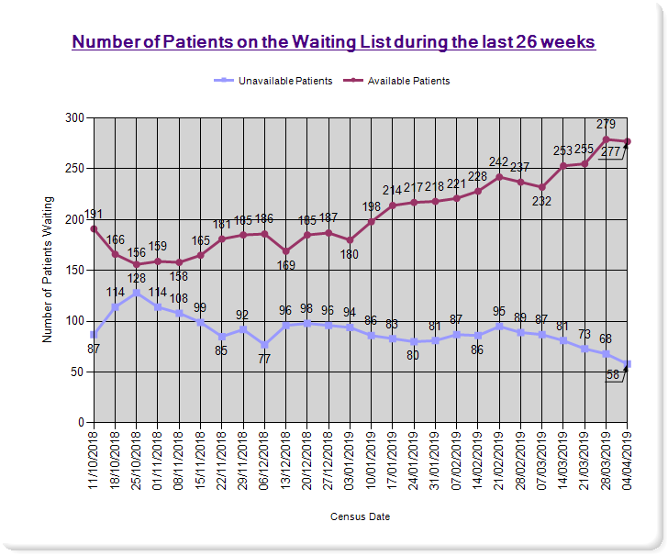 | 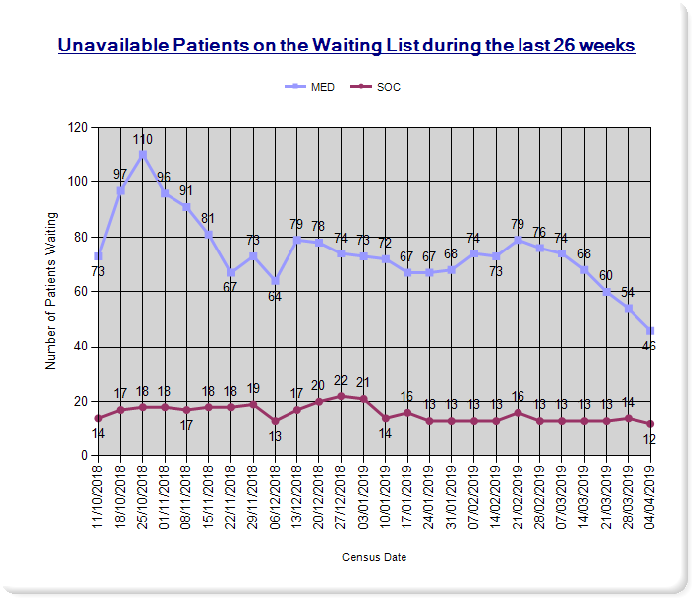

Thoracic Surgery Inpatient Waiting List

As of 4 April 2019 there were 89 patients (Figure 4) on the Thoracic Surgery Inpatient waiting list.

The distribution of patients is 83% (74 patients) on the available waiting list and 17% (15 patients) were on the unavailable list.

Figure 5: As a percentage of the total waiting list there were 5 patients (6%) medically unavailable patients and 10 patients (11%) advised that they were unavailable.

Figure 4 | Figure 5
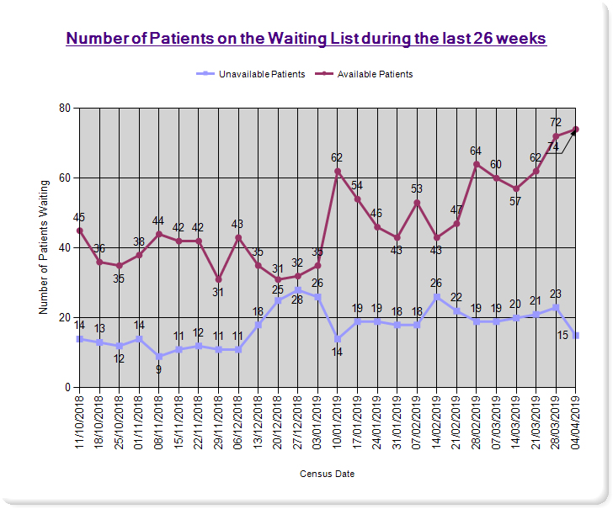 | 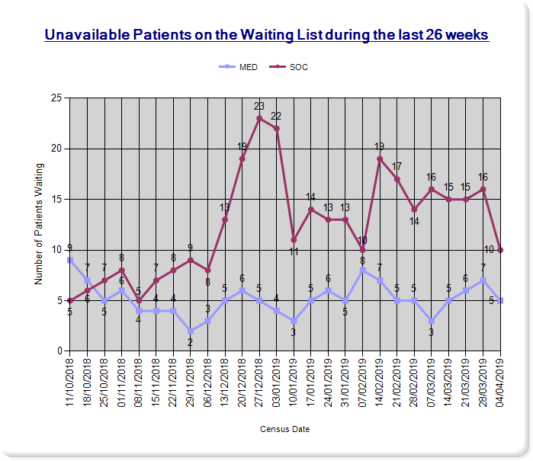
Cardiology Inpatient Waiting List
Figure 6 illustrates the number of cardiology patients on the waiting list during the last 26 weeks. On 18 April 2019 a total of 891 patients were on the cardiology waiting list with around 95% (847) patients on the available list. In addition to this, 5% (44) of patients were unavailable. The number of people on the cardiology inpatient waiting list has decreased by 5% on the previous reporting period (down from 937 patients).

Figure 6
