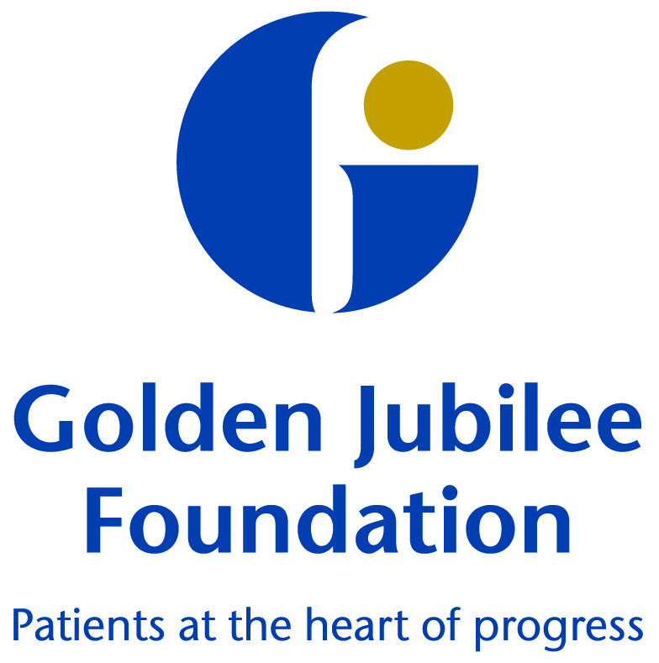
Board Meeting Agenda

Thursday 9 May 2019, 10am
Level 5 Boardroom, Golden Jubilee National Hospital

Item |  | Details | Lead
1 | Verbal | Chair’s Introductory Remarks | Susan Douglas-Scott CBE
2 | Verbal | Apologies | Susan Douglas-Scott CBE
3 | Verbal | Declarations of Interest | All
4 |  | Updates from last meeting
4.1 | Paper | Unapproved Minutes (for Board Members only) | Susan Douglas-Scott CBE/All
4.2 | Paper | Actions (for Board Members only) | Susan Douglas-Scott CBE/ All
4.3 | Verbal | Matters Arising | All
5 |  | Person Centred
5.1 | Paper | Hospital Expansion Phase One Update | Jann Gardner/June Rogers
5.2 | Paper | Hospital Expansion Phase Two Update | Jann Gardner/June Rogers
5.3 | Paper | Health Promoting Health Service (HPHS) Self Assessment and Action Plan | Anne Marie Cavanagh
5.4 | Paper | Equalities Mainstreaming Report | Gareth Adkins
5.5 | Paper | Person Centred Committee minutes: 29 January 2019 | Kay Harriman
5.6 | Paper | Person Centred Committee update: 17 April 2019 | Kay Harriman
6 |  | Safe
6.1 | Paper | Healthcare Associated Infection Report (HAIRT) | Anne Marie Cavanagh
6.2 | Paper | Clinical Governance Committee minutes: 29 January 2019 | Mark McGregor
6.3 | Paper | Clinical Governance Committee update: 16 April 2019 | Mark McGregor
7 |  | Effective
7.1 | Paper | Performance Update | Jann Gardner
7.2 | Paper | Business Update | June Rogers
7.3 | Paper | Finance Update | Julie Carter
7.4 | Paper | Audit and Risk Committee minutes: 5 February 2019 | Karen Kelly
7.5 | Paper | Audit and Risk Committee update: 16 April 2019 | Karen Kelly
7.6 | Paper | Endowments Sub Committee update: 16 April 2019 | Phil Cox
7.7 | Paper | New Board dates and process | Jann Gardner
8 |  | AOCB
9 | Verbal | Date and Time of Next Meeting:  Thursday 20 June 2019, 10am | Susan Douglas-Scott CBE

