Standard Business Case

Redevelopment of existing space to support delivery of the Cardiology Strategy and associated accommodation

Version One

Contents

1. Executive Summary 3
2. Background 3
3. Key points 3
4. Objectives 3
5. Consideration of Key Drivers 3
6. Shortlist of Options 3
7. Cath Lab 5 Estates – Risk and Benefits Appraisal 3
7.1. Workshop attendees 3
7.2. Options 3
7.3. Assessment of benefit criteria 3
7.4. Results of the benefits scoring exercise 3
7.5. Assessment of Risks 3
7.6. Conclusion from the assessment of benefits and risks 3
8. Financial Appraisal 3
8.1. Overview 3
8.2. Key financial assumptions 3
8.3. The scope of financial analysis 3
8.4. Costing methodology 3
8.5. Capital costs 3
8.5.1Capital Costing Summary 3
8.6. Depreciation 3
8.7. Recurring core revenue cost analysis 3
8.8. Funding for recurring revenue 3
8.9. Expenditure profile 3
8.10.Affordability 3
9. Economic appraisal 3
9.1. Overview 3
9.2. Options appraisal 3
9.3. Preferred option from the financial and economic appraisal 3
10. Preferred Option 3
11. Implementation Plan 3
12. Project Programme and Timescales 3
13. Risk Management Strategy 3
Appendix One – Schematic 3
Appendix Two: Indicative Programme 3
Appendix Three: Benefits Assessment Scoring 3
Appendix Four: Risk Assessment Scoring 3

Executive Summary

The Golden Jubilee Foundation (GJF) is the brand name for the NHS National Waiting Times Centre, which encompasses the:

- - Golden Jubilee National Hospital (GJNH);
- - Golden Jubilee Research Institute;
- - Golden Jubilee Innovation Centre; and
- - Golden Jubilee Conference Hotel.

The Golden Jubilee Foundation is unique within the NHS. A national institution, independently run by its own NHS Board, the Golden Jubilee Foundation is helping to re-define the concept of the public hospital, with a vision of “Leading Quality, Research and Innovation” for NHSScotland.

Set in a modern, purpose built environment the facility combines a top quality hospital with hotel, and conference facilities and centres for research, clinical skills and innovation. This integrated approach, with a focus on continuous learning and strong links to academia and industry, creates a crucible for innovation and a vibrant network for the spread of learning and best practice.

Our patient-led approach to healthcare encourages an ethos that is open, questioning and participative; everyone is encouraged to speak out and be actively involved in the quest for continuous improvement and innovation.

The following business case has been developed to support the ongoing review of the Board Estates Strategy and to ensure maximum use of space. The key drivers of this are as follows:

- Continued demand by Scottish Government to increase the available clinical capacity within the hospital
- An ongoing requirement to ensure the maximum and efficient use of space within the Board property targeting specifically unused clinical space
- A requirement to meet the need of immediate diagnostic activity pressures as identified by Scottish Government
- Funding made available within the Board’s capital plan to support a fifth Cardiac Catheter lab
- A requirement to redesign space to a modern fit for purpose facility

The business case will address drivers through an assessment of options on how this can be most efficiently and effectively be delivered through an evaluation of costs, risks and benefits.

The Scottish Government has identified an immediate requirement for additional Cardiac Catheter lab capacity. This will support Health Boards throughout Scotland in the management of their Cardiac Catheter lab waiting times guarantees.

Year on year we have experienced an increasing demand for access to diagnostic imaging capacity at GJNH. Requests for Cardiac Catheter lab activity have significantly exceeded our capacity for a number of years. Additionally, there has been a continued demand by Scottish Government to expand the services we provide

Despite commissioning a mobile Cardiac Catheter lab, we continue to be unable to meet the demands of referring Boards. Consequently, we are unable to fully support Boards in meeting their challenging waiting time guarantees. In order to address this situation, the Scottish Government has made funding available to support the purchase and installation a fifth Cardiac Catheter lab within the Golden Jubilee Hospital

Background

Interventional cardiology includes coronary intervention including optimal reperfusion service (ORS) and the elective diagnostic and treatment service, structural heart interventions, electrophysiology and devices. Interventional cardiology also comprises the national services; SPVU admits patients for comprehensive assessment which includes right heart catheterisation carried out in the cath lab, and the adult congenital service carries out diagnostic and catheter based treatments within the cath lab.

The Strategy described the current service and the predicted requirements for change over the next five years. The drivers for change are clear; there is a relentless burden of cardiovascular disease in Scotland, and in particular the West of Scotland. Having reacted innovatively (through advances in clinical care and world-class research) to the problem we face, we are in a unique position to drive future improvement and meet the changing therapeutic landscape of cardiovascular disease and the expectations of our patients.

There are currently significant capacity pressures within interventional cardiology resulting in long waiting times for patients due to various factors including increasing complexity and changing presentation of coronary disease.

Within coronary intervention, there has been an incremental shift from elective stable to urgent elective procedures, this has been experienced in GJNH, and reflects the UK trend. In addition the complexity of procedures is increasing. In December 2018 the waiting list peaked at 728 patients on the waiting list, with 93 waiting over 12 weeks for an elective procedure. In addition, the urgent in patients, who we aim to treat within 72 hours of referral, in line with clinical guidelines, were waiting longer due to capacity pressures. In December, we only achieved 21% of patients admitted within this target. This pressure has been relieved in Quarter 4 of 2018/19 with the rental of a mobile cath lab on site. This has provided additional coronary capacity of 400 procedures during its 12 week rental period, achieving a significant reduction in the waiting list and waiting times. Whilst this has proven successful, there persists a capacity gap, and it is acknowledged that this waiting list will start to grow at the end of the rental period with patients breaching the 12 week TTG t in Quarter 2 2019/20 if there is no additional capacity.

The business case assessing the purchase of the Cardiac Catheter lab equipment is being developed in parallel to this estates review.

A fifth cath lab will provide sufficient increased capacity to –
- Address the capacity gap in coronary intervention
- Increase EP capacity by 40%
- Facilitate transfer of device implantation out of theatre environment, reducing radiation exposure for staff and patients.

This business case recommends the following:

- A fifth Cath Lab is constructed to deliver the quality objectives of this project.

The financial assessment describes the capital and revenue impact of the preferred option.

 | Capital (£) Inc VAT | Recurring revenue (£)
Cost of Estates redesign | £1,233,000 | -
Depreciation | £30,900 | -
Table 1

It should be noted that the depreciation figure is likely to change when the annual valuation for the property is undertaken at year-end and an element of this building project is likely to be non-value adding and therefore there will be impairment on this project on completion.

Key points

The scope of the project includes the construction of a fifth Cath Lab and associated clinical areas. The Cath Lab will address growing Coronary Intervention waiting times and operational pressures across a range of Interventional Cardiology clinical services.

The business case and project will consider the following:

- Procurement and lifecycle management of a fifth Cath Lab and associated areas
- Further expanding the interventional cardiology service
- Efficient patient workflow
- Up to date safety features
- Flexibility between the Cath Labs
- Future proofing the scanner capabilities
- Addressing the capacity gap in coronary intervention

The business case describes the process that considers:

- Should the service be expanded and a fifth cath lab constructed?
- The procurement process

The business case describes these points and recommends the constructions of a fifth Cath Lab. This supports significant patient benefits.

These benefits are summarised below:

- Meets service demands and future requirements
- Improves urgent workflow and flexibility
- Quality and safety
- Improved workflow and working environment
- Supports strategic aims
- Service efficiency
- Improved recruitment and retention opportunities

The options considered within this business case are as follows:

Option 1: Do nothing

Continue to utilise the space as is with no redevelopment to increase capacity to support waiting times demands from Health Boards. Continue to use mobile unit.

Option 2: Redevelop the existing Respiratory Lab in Quad D, level 2

This option would involve converting the existing Respiratory lab on Quad D level 2 in to a Cardiac Catheter lab. In addition it will be necessary to develop a small area within the existing radiology dept to form a day case recovery unit. This option would require the re-provision of accommodation for the Respiratory Lab within the existing Cardiac Rehabilitation gymnasium. A schematic of this option is included at appendix one.

- Creation of 5th lab
- Creation of a recovery areas
- Re-provision of Respiratory lab

Option 3: As option 2 but includes the redesign of the Cath Lab Day Unit (CDU)

This is as above but includes the redesign of the CDU to improve the patient journey and the efficiency of the service.

 | Option 1 | Option 2 | Option 3
Benefits Appraisal |  | 2 | 1
Risk Assessment | 3 | 1 | 2
Financial Assessment | - | 1 | 2
Economic Assessment | - | 1 | 2
Table 2

This shows that;

Option 2 is therefore recommended as the preferred option. The capital costs have been approved by the Capital Group from the Board capital allocation and the negligible level of revenue costs will be funded through the Boards financial plan.

The detail of the benefits and risks are described within the business case.

A summary of the implementation plan is included within the business case. An indicative construction programme is attached as appendix two.

Objectives

The following table describes the objectives of this project and the success criteria applied to these objectives:

Objectives (In no particular order)  Quality Criteria | Related Success Criteria  Acceptance Criteria
Meets service demands  To create space to increase clinical capacity within the hospital | - To demonstrate and increase in patient activity by redeveloping existing space
Provides a more efficient use of existing space  Redevelops space to an improved fit for purpose development | - Converts either unused space or ‘inappropriate use of space’ e.g. non clinical activities in prime clinical space to a more appropriate fit for purpose environment
Increased capacity within the Board  to meet immediate needs of waiting times pressures across NHS Scotland | - Deliver additional activity for NHS Scotland
Value for money  The preferred option will deliver a value for money solution | - Value for money assessed and monitored throughout the option appraisal and project plan
Delivered in a timely manner  The project is delivered in the specified timescale | - Project timescale will be monitored by the project board with appropriate tolerances applied
Optimise patient pathways  The project will deliver improved patient pathways and benefits | - Delivers an improved patient workflow and experience
Future sustainability  To provide a modern fit for purpose facility | - The facility will provide an ‘improved’ fit for purpose facility
Table 3

Consideration of Key Drivers

In considering the space options to create an additional Cardiac Catheterisation lab which would increase diagnostic capacity, the group considered a number of options. The adjacency to the existing Cath lab suite was a prime consideration and in addition it was noted that the additional capacity is to support ‘waiting times’ patients from other Boards.

The points that were considered in developing the options were:

- Is there any unused space on level 2 that could accommodate redevelopment for additional Cardiac Catheter lab?
- What needs to be considered to create further space on level 2 adjacent to the existing cath lab suite for additional Cardiac Catheter lab activity?
- How can we improve the patient flow and experience?
- How can we maximise all the clinical space for improved efficiency of assets, both equipment and buildings?

The following long list of options was reviewed by the project team.

- Option 1 – Do Nothing. The current space and service would continue as is
- Option 2 - In this option the exiting Respiratory would be converted to create space for a fifth cath lab adjacent to the existing cath lab suite. This option will necessitate the re-provision of space for the respiratory lab by converting part of the existing rehab gymnasium.
- Option 3 - As option 2 but includes the resign of the cath lab day unit to improve patient flow
- Option 4 - Redevelop the existing cath lab day ward to include a fifth lab within the existing footprint.
- Option 5 - Build out onto the flat roof adjacent to the existing cath lab recovery area
- Option 6 – Convert the existing Radiology waiting area in to a cath lab

Shortlist of Options

Following the detailed analysis of the long list of options above it was agreed to discount Options 4 and 5 due to the areas directly below being high hazard areas as described in HTM-05 03 Part J of Firecode.(Food production area of catering department and boiler plant area).
Option 6 was discounted due to the high levels of disruption that would result to existing Respiratory lab in connecting services etc.

The options therefore to be considered within this business case is as follows:

Option 1: Do nothing

Continue to utilise the space as is with no redevelopment to increase capacity to support waiting times demands from Health Boards. This option would also include continued use fo the mobile unit

Option 2: Redevelop the existing respiratory lab to house a fifth cath lab

This option would involve converting the existing Respiratory lab into a Cardiac Catheter lab. In addition it will be necessary to develop a small area within the existing radiology dept form a day case recovery unit.

Option 3 – As option 2 but includes the redesign of the existing cath lab day unit.

This is as above but includes the redesign of the CDU to improve the efficiency of the service

Cath Lab 5 Estates – Risk and Benefits Appraisal

Workshop attendees

A Benefits and Risks Appraisal Workshop took place on Thursday 28 March with the below noted attendees to assess the non-financial benefits associated with a range of options. The session was facilitated by Julie King, Performance & Improvement Manager.

Name | Job Title
Julie King | Performance & Improvement Manager
Alex McGuire | Clinical Specialities Manager
Heather Ambler | Clinical Physiology Manager
Lesley Baxter | Directorate Accountant
Lily Bryson | Assistant Director of Finance
Irene Crawford | Head of Cardiac Physiology
Steven Friel | Head of Medical Physics
Andrew Gallagher | Estates Officer
Jennifer Hunter | Clinical Nurse Manager – Cardiology
Dr Mitchell Lindsay | Operational Lead – Interventional Cardiology (via teleconference)
Christina MacLean | Interim Rehabilitation Manager

Table 4

Options

The final options for review by Benefits Appraisal were:

- Option 1:
Do nothing and continue with a mobile lab option

- Option 2:
Re-provide the respiratory lab in part of rehab, build the new lab in the space vacated by the respiratory lab and build a day case recovery unit next to the new CT recovery

- Option 3:
Re-provide the respiratory lab in part of rehab, build the new lab in the space vacated by the respiratory lab and build a day case recovery unit next to the new CT recovery and the major redesign of the existing cath lab day ward

Assessment of benefit criteria

The group discussed the proposed benefits criteria in detail and following some modifications a total of ten benefits were agreed for review. These benefits were then ranked and weighted according to how important they were seen to be in achieving the aims of the business case.

Ref | Heading | Ranking | Weighting
B1 | Meet service demands and future requirements  Provides space and capacity to meet the current capacity gap in Coronary and EP intervention and projected future increases in demand and complexity. Requirement for infrastructure to support increased capacity including inpatient beds and the day unit. | 1 | 20
B2 | Improved workflow and flexibility  Increase capacity and flexibility to deliver timely treatment to the NSTEMI population. | 2 | 18
B3 | Quality and Safety  Increase safety by enabling Device Activity to be moved from theatre -reduced radiation exposure and reduce complication rate. | 4 | 10
B4 | Improved work flow and working environment  Enhanced working environment, and improved ergonomics leading to more efficient working and an improved experience for the patients. | 3 | 12
B5 | Support Strategic aims  Supports the delivery of Board’s objectives to deliver high quality regional interventional cardiology services, and the objectives outlined in the Cardiology Strategy endorsed by the Board in October 2018 which included the future development of the Structural Heart Disease Programme, leading research and innovation and to develop as an interventional centre of excellence. | 1 | 20
B6 | Service efficiency  Improve resilience and business continuity and support planned maintenance. This will improve reliability and service efficiency – reducing cancellations. | 5 | 8
B7 | Improve Recruitment and Retention Opportunities  Develop a sustainable workforce and improve staff retention by providing a high quality working environment. | 3 | 12
Total |  |  | 100
Table 5
Scoring was undertaken on a group basis to benefit from the discussion. The group assessed the extent to which each of the options met the criteria using a scoring scale of 0 (could hardly be worse) to 10 (could hardly be better).

Results of the benefits scoring exercise

The outcome of scoring the options is detailed below with copy of the full spreadsheet detailed in Appendix A.

Option | Weighted  Score | Rank
Option 1:  Do nothing & continue with a mobile lab option. | 292 | 3
Option 2:  Re-provide the respiratory lab in part of rehab, build the new lab in the space vacated by the respiratory lab and build a day case recovery unit next to the new CT recovery. | 740 | 2
Option 3:  Re-provide the respiratory lab in part of rehab, build the new lab in the space vacated by the respiratory lab and build a day case recovery unit next to the new CT recovery and the major redesign of the existing cath lab day ward. | 848 | 1
Table 6

As Option 1 entailed the lowest level of change from the status quo it was demonstrated to offer the least scope for improvement. As such this option received the lowest benefit score.

Options 2 and 3 were all found to offer benefits across all benefit categories. As Option 3 represented the most significant change from the status quo, however, it was found by the group to offer the most benefit particularly in terms of improving quality and safety and improving urgent workflow and flexibility.

Assessment of Risks

The risk assessment is intended to identify the key risks associated with the short listed options. The key risks were developed and assessed to determine the extent to which these impact on the shortlisted options. The risks were also aligned to the Board’s risk clusters.

The group discussed the proposed risk criteria in detail and following some modifications a total of fifteen risks were agreed for review.

Cluster | Ref | Heading
Financial | R1 | Funding availability - capital  Funding required to progress the project is not made available.
 | R2 | Funding availability – revenue  Funding required to progress the project is not made available.
 | R3 | Project overspend (Equipment & Service delivery)  The combined spend for the project will go over budget, exceeding the costs identified or incurring unplanned recurring costs.
Regulation | R4 | Excessive Radiation Exposure  Unable to provide a safe and appropriate working and training environment  Failure to comply with Health and Safety Regulations
Reputation | R5 | Failure to meet waiting time standards  Not being able to deliver sufficient capacity to meet current and projected demand
 | R6 | Inability to increase quality of service provision  Unable to increase quality of service as benchmarked against comparable peers.
 | R7 | Project not completed within agreed timeline  Project timescales are unrealistic meaning the project is not delivered on time.
Operational | R8 | Actual demand exceeds designed capacity  Demand is higher than projected due to new technologies, clinical guidelines etc.
 | R9 | Unable to fully support all patient activity as a result of expansion  Risk of not being able to deliver planned expansion in capacity if supporting infrastructure in not sufficient.
Workforce | R10 | Availability of Workforce  Inability to recruit or train sufficient numbers of staff to deliver the expansion
Build/ Estates | R11 | Inadequate design leading to delay in construction  Inadequate/poor design leads to delay in construction.
 | R12 | External factors impact project delivery/Restriction of access for contractors  Project delivery is delayed as a result of external factors, i.e. Procurement, contract issues, material delivery etc.  Complexity of access to and from the work area.
 | R13 | HAI scribe related risk - Disruption to ongoing delivery of services/Noise/Vibration risk  Sufficient implementation plans are not in place which could lead to disruption to the delivery of services.  Proximity to activity increases risk of noise level to surrounding areas.
 | R14 | HAI infection related risk
 | R15 | Contractor default or inability to deliver contract  The contractor fails to deliver the project to the agreed timetable.
Table 7

Thereafter, each of the options was appraised against the identified risks in terms of the impact/likelihood of occurrence the outcome of which is detailed below. Full scoring details are included in Appendix B.

Option | Risk Score | Risk Ranking
Option 1:  Do nothing & continue with a mobile lab option. | 143 | 3
Option 2:  Re-provide the respiratory lab in part of rehab, build the new lab in the space vacated by the respiratory lab and build a day case recovery unit next to the new CT recovery. | 134 | 1
Option 3:  Re-provide the respiratory lab in part of rehab, build the new lab in the space vacated by the respiratory lab and build a day case recovery unit next to the new CT recovery and the major redesign of the existing cath lab day ward. | 135 | 2
Table 8

Option two in the above table demonstrates the lowest risk.

Conclusion from the assessment of benefits and risks

A summary of the results of the benefits appraisal and risk assessment is provided in the table below:

Option | Benefit Score | Risk Score | Option Assessment
Option 1:  Do nothing & continue with a mobile lab option. | 292 | 143 | Lowest benefit, Highest risk
Option 2:  Re-provide the respiratory lab in part of rehab, build the new lab in the space vacated by the respiratory lab and build a day case recovery unit next to the new CT recovery. | 740 | 134 | Second highest benefit,  lowest risk
Option 3:  Re-provide the respiratory lab in part of rehab, build the new lab in the space vacated by the respiratory lab and build a day case recovery unit next to the new CT recovery and the major redesign of the existing cath lab day ward. | 848 | 135 | Most benefit,  second highest risk
Table 9

Option two is the lowest cost option with the lowest risk and is therefore recommended as the preferred option. Should the element of option three regarding the day unit be progressed this will be presented in the next financial year.

Financial Appraisal

Overview

This section will describe the financial assumptions for the revenue and capital costs of the three options.

The financial analysis will include the following:

- A detailed analysis of the capital costs of the options including the building costs;
- A detailed analysis of the revenue costs of the options and where appropriate split between recurring and non recurring;
- An economic analysis of the 3 options describing the net present cost option appraisal;
- An expenditure profile of the preferred option;
- An analysis of the current costs of the service; and
- Details of the funding sources to support the preferred option.

Key financial assumptions

The financial model is driven by key assumptions which potentially have a material effect on the overall operating costs of the new service, such as;

- likely capital costs;
- projected depreciation;
- revenue cost implications including:
    - non-pay costs of the new service.
    - It is assumed that the baseline current costs associated with the building project will continue to be funded on an ongoing basis by the Revenue Resource Limit agreed with SGHSCD and as part of the agreed Estates budget as any associated recurring revenue costs are negligible.

The scope of financial analysis

The financial analysis covers the estimated impact on the expenditure arising from:

- The revenue impact of the creation of additional clinical space;

- The revenue consequences of the capital expenditure necessary to support the options; and

Costing methodology

Each of the short-listed options has been costed in a manner that identifies the key elements of change associated with the project. The specific components of this are noted below:

- Heat Light & Power.
- Option 1 has been assessed as part of the option appraisal but is acknowledged there is no additional capital or revenue costs associated with no change.

Capital costs

The Project Board has prepared the capital costs based on cost provided by the team appointed to undertake the feasibility study. Within these estimates, the table below summarises the key capital assumptions:

Capital Costs | - Costed at 2018/19 out turn price base.  - The capital costs have been split into construction and fees.  - Building costs are based on estimates provided by the design team.  - Appropriate on-costs have been applied.  - Fees have been applied in line with recommendations.  - VAT is added at 20 %.
Table 10

Having applied the costing methodology, the resultant capital expenditure is analysed in the figure below.

Capital Costing Summary - £000

Prices exclude VAT | Option 1  £’000 | Option 2  £’000 | Option 3  £’000
Construction | 0 | 840 | 1,541
Fees | 0 | 125 | 228
Contingency | 0 | 84 | 154
Total Ex VAT | 0 | 1,049 | 1,923
Irrecoverable VAT |  | 184 | 339
Total | 0 | 1,233 | 2,262
Table 11

The capital costs will be incurred over a number of months and the phasing of these costs has been provided by the advisors team and is illustrated below.

Phasing of Capital Costs - £000
 | Preferred Option (Option 2)
Year 0 – 2019/20 | 1,233
Total | 1,233
Table 12

It has been assumed that we would commence detailed design work in the early part of the financial year 2019/20.

Depreciation

The following table details the depreciation calculation for the 2 options. This assumes

- Depreciation has been calculated in line with board standard policy using the following:
  - Building – 40 years

Description | Option 1 | Option 2 | Option 3
 | £’000 | £’000 | £’000
Depreciation
- Building | 0 | 31 | 56
Total | 0 | 31 | 56
Table 13

It should be noted that the depreciation figure is likely to change when the annual valuation for the property is undertaken at year-end and an element of this building project is likely to be non-value adding and therefore there will be impairment on this project on completion.

Recurring core revenue cost analysis

The level of recurring revenue associated with this project is negligible for Heat, light and Power. The depreciation figure will not be known until the next valuation but is likely to be less than £3k after impairment.

Funding for recurring revenue

Recurring funding for Depreciation and Heat Light and Power as these are negligible will be funded by the Board through the financial planning.

Expenditure profile

The following table summarises the capital and revenue expenditure for the 3 options.

 | Option 1  £’000 | Option 2  £’000 | Option 3  £’000
Description | Full Cost | Full Cost | Full Cost
Capital Costs | - | 1,233 | 2,262
Recurring revenue costs Heat Light and Power | -
Recurring revenue costs – Depreciation |  | 31 | 56
Non recurring revenue costs | - | - | -
Total Costs |  | 1,264 | 2,318
Table 14

Affordability

The capital costs have been included in the Board’s capital plan and approved by the capital group. The recurring revenue costs will be supported by the Estates budget

The financial appraisal shows that option 2 has the lowest capital cost compared to option 3.

Economic appraisal

Overview

A discounted cash flow for the shortlisted option has been undertaken over a 10 year life. Both the Net present Cost (NPC) and Equivalent Annual Cost (EAC) have been calculated. This has been contrasted against the do nothing option as recommended code practice. This intended to demonstrate the preferred option continues to offer value for money.

The key elements used in the analysis are summarised below: -
- initial capital outlay for each option exclusive of VAT.
- detailed lifecycle costs of building and engineering works, provided by the advisors;
- equipment lifecycle costs;
- total revenue costs for each option (including movements from the baseline position), and
- transitional and opportunity costs for each option

Options appraisal

In addition to the capital and revenue analysis described in the previous section, an economic analysis of the 3 options has also to be undertaken.

This includes the revenue and capital costs of the above options.

The results therefore of the economic appraisal are as follows:

Description | Option 1  £’000 | Option 2  £’000 | Option 3  £’000
NPC | - | 1,049 | 1,923
EAC | - | 26 | 48
Rank of economic appraisal |  | 1 | 2
Table 15
The assumptions within the economic appraisal are as follows:

- The building costs have being calculated over a 40-year project life.
- The discount factor applied is 3.5%
- Exclusive of VAT

Preferred option from the financial and economic appraisal

Given the capital costs required the preferred option from an economic perspective will almost always be option 1, with no spend as this reflects no change from the current situation. Option 2 is the lowest cost when comparing the options relating to investment in build change.

In relation to option 1 however it should be noted that the additional capacity created would reduce costs for the referring Boards, as the only alternative would be use of the private sector if no other capacity in Scotland was available.

Preferred Option

A summary of the outcome of the option appraisal is shown below:

 | Option 1 | Option 2 | Option 3
Benefits Appraisal | 3 | 2 | 1
Risk Assessment | 3 | 1 | 2
Financial Assessment | 3 | 1 | 2
Economic Assessment | 3 | 1 | 2
Table 16

This shows that;

- Option 1 delivers zero cost and lowest risk, due the fact that there is no change, however this also delivers the lowest benefits. The cost impact on the referring Health Boards if this additional capacity were not created has not been assessed but would be a significantly higher cost with use of the private sector including use of a mobile lab. This has been reflected in the scores in the table above.
- Option 2 has significant benefits and a lower risk profile than option 3
- Option 3 has marginally lower benefits than option 2, a higher risk score and is the most expensive of all three options

Option 2 is therefore recommended as the preferred option.

Implementation Plan

The implementation plan for option 2 involves three key elements

- The redesign of the existing respiratory lab to accommodate the fifth cath lab
- The redevelopment of a space in which to relocate the respiratory lab. This process will involve close liaison with Respiratory lab colleagues to ensure a fit for purpose solution is achieved
- Formation of day case recovery unit

A drawing of the new facility is shown on the attached appendix one.

Project Programme and Timescales

A detailed project programme is included within appendix two.

With the key project milestones summarised below:

- Appointment of Design Team April 2019
- Design of approved option May/June 2019
- Statutory Approvals August 2019
- Appointment of building contractor July 2019
- Start build work on site (Respiratory lab) August 2019
- Completion (Respiratory Lab) October 2019
- Start build work on site (Cath lab) October 2019
- Completion (Cath lab) February 2020
- Day case recovery unit * February 2020

‘* - this element is not on the critical path.

Professional advisors have been appointed to support the development and a project team will be set up to ensure delivery of the project on time and within budget. Project Governance will be initiated with a Project Steering Group and Executive lead and Project Manager appointed. Updates will be provided to the Board Performance and Planning Committee.

Risk Management Strategy

Given the complexity of the project a risk management process will be put in place. The following table details the current risks and the control measures put in place to mitigate these risks. This will be a key focus of the project steering group.

The following key risks have been identified at the onset of this project.

Risk | Description | Control Measure
Inadequate design leading to delay in construction: | The project to date has been informed by a feasibility study rather than a detailed design. Therefore assumptions on floor slab loading, Mechanical and Electrical infrastructure etc have been made which, if inaccurate, could impact on the timescales and costs of the project | Following approval of the business case, a design team will be appointed and detailed design will be undertaken.
External factors impacting delivery and materials: | External factors would relate to possible installation risks and contractor risks | All external risk factors will be considered and reviewed at start of the project with detailed specific risks identified.
Sufficient implementation plans are not in place which could lead to disruption to the delivery of services; | Plans have not been fully developed to ensure limited disruption to clinical and operational services | Similar projects have been completed by the operational teams and detailed implementation plans will be developed.
Proximity to activity increases risk of noise level to surrounding areas; | Noise levels for areas close to the work means clinical activity is temporarily halted | This will be considered as the phasing of the build work is being developed. HAI mitigation plan will be developed simultaneously.
HAI risk | HAI risk to patients. | HAI mitigation plan will be developed in parallel with the detailed design.
The cost of the project exceeds the budget; | Project overspend halts development of the works. roProPtroget overspends | Budget agreement will be reached before commencement of works. Use of additional capital or revenue to capital transfers could be actioned if necessary. t
Future equipment developments required to ensure service sustainability cannot be accommodated. | The replacement of future Cath lab equipment could not be accommodated within the new space (due to load, M&E requirements etc) | The detailed design will ensure that the facility is future proofed and will accord with whatever technology advances are in place.
Table 17

Appendix One – Schematic
C2
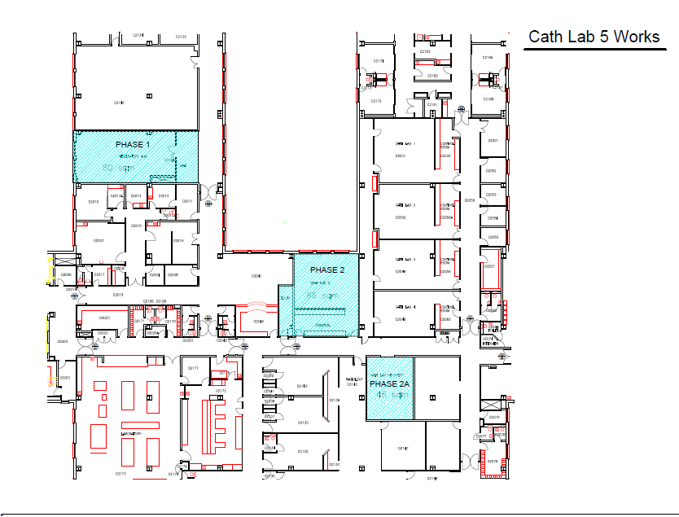

Appendix Two: Indicative Programme

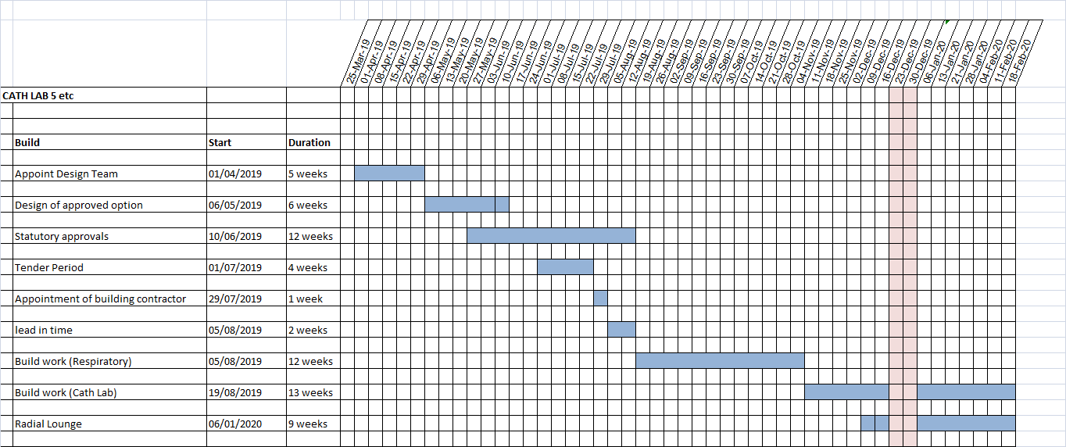

Appendix Three: Benefits Assessment Scoring
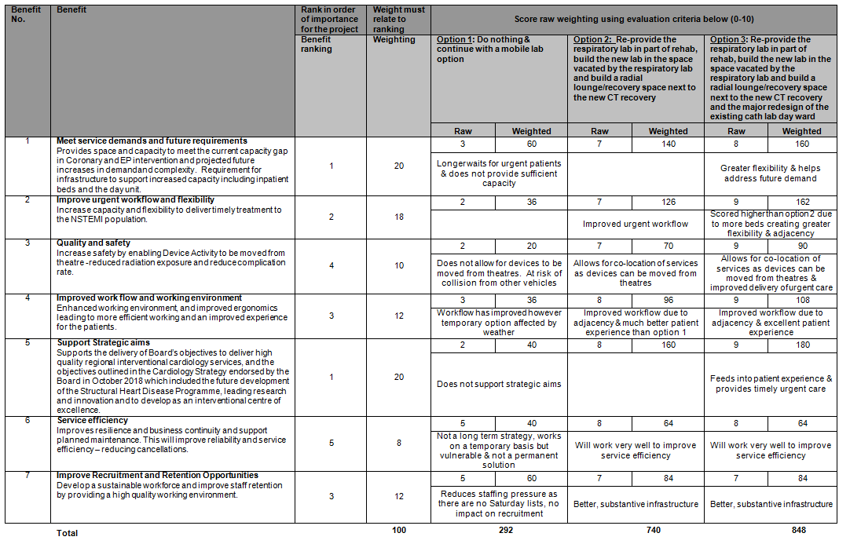

Appendix Four: Risk Assessment Scoring
