Golden Jubilee Foundation

Central Sterilisation Processing Department (CSPD)
Business Case

The future sustainability of our Sterilising Service

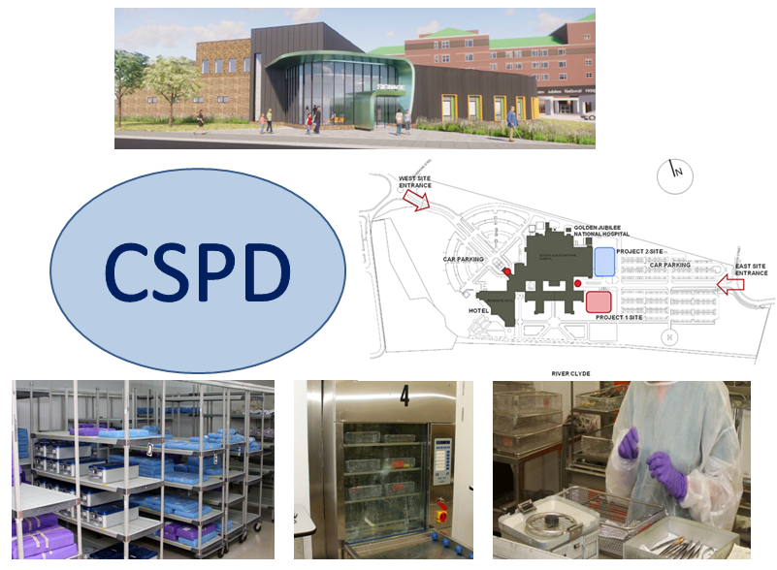

Table of Contents

Number | Item | Page
1. | Executive Summary | 2
2. | The Strategic Case | 9
3. | The Economic and Financial Case | 36
4. | Procurement Strategy | 47
5. | The Management Case | 48
6. | Appendices | 53

1. Executive Summary

1.1 Introduction

This business case has been prepared in support of the future sustainability of our Central Sterilisation Processing Department (CSPD).
The Central Sterilising and Processing Department (CSPD) within the Golden Jubilee National Hospital (GJNH) is part of the Golden Jubilee Foundation (GJF), which is a National Board providing regional and national services to support all Health Boards in Scotland.
The hospital is home to the Regional and National Heart and Lung services, and is the largest single-site elective Orthopaedic Centre in Scotland, performing over 25% of all Scottish hip and knee replacements. Following the most recent expansion in Ophthalmology we are currently providing 24.5% of all West of Scotland and 18.5% of all NHS Scotland cataract activity.
Our Board ambition of “putting people first to achieve and sustain excellence - in care, performance, quality, innovation and values” continues to shape our future strategy and our plans to support NHS Scotland. However we have an added focus on ‘Delivering Care through Collaboration’ as our future strategic intent as we develop plans in relation to the new Elective Centres, the NHS Scotland Academy provision and Innovation. Our Sterile Service function is core and essential to ensuring theatres are able to deliver this high level of quality to our patients and support the Board maintain its low infection rates.
The CSPD business case is therefore an important facilitator to delivering an effective theatre service and promotes wider clinical efficiency and productivity through better use of space, modern equipment and a sustainable workforce.
The Waiting Times Improvement Plan published in October 2018 outlines the significant level of investment in the Golden Jubilee’s elective centre developments. The plan describes further expansion in Ophthalmology, Endoscopy and General Surgery capacity ahead of the opening of both phases of the Golden Jubilee Elective Care Centre.
Over the next 25 years, there will be significant increases in the demand for procedures carried out within Ophthalmology (phase one) and Orthopaedics (phase two). In meeting this demand the GJF had been tasked by Scottish Government with planning the elective care requirements of the West Region population between now and 2035. As a National Board currently supporting every Health Board in Scotland, GJF will also engage with the North and East Regions to ensure there is continued support for each Health Board as necessary and to ensure there is robust capacity planning for additional elective care requirements to meet the predicted need for NHS Scotland by 2035.
Our future CSPD service will be aligned with the delivery of the Realistic Medicine agenda. This approach aims to support and empower all healthcare professionals to practice in a collaborative way, thereby improving effectiveness and reducing unnecessary variation.

In preparation for the forthcoming expansions a full review has been undertaken of our current Sterile Services facility and changes identified to create a sustainable CSPD service for the future as outlined in this business case.
The purpose of this Business Case is to recommend options for the future provision of Sterile Services at the Golden Jubilee National Hospital that is sustainable, flexible and responsive to meet future demands from the phased expansion programmes.
The following options are explored in more detail within the business case:
- Do minimum.

- A production area fit for future purpose in line with Scottish Health Protection Network (SHPN) 13 guidance. The recommendation is that we expand our CSPD department as part of the Phase 2 Expansion Programme.

- An equipment replacement programme with a range of options identified and associated cost as presented in section 2.6 and recommendation is to procure in 2021 4 double chamber washers, 4 sterilisers, 2 low temp hydrogen peroxide sterilisers (for robotics), 2 cart washers, 3 ultrasonic washers and plant maintenance equipment.

- The workforce model developed assumes space allocation of 1291m2 with a separate area for Endoscopy decontamination. The estates footprint and equipment replacement programme will influence the final workforce proposal and associated shift patterns required in line with the activity demand. Redesigning the existing CSPD service aligns with the Board’s strategy as follows:
Patient and Staff safety – decontamination is a combination of processes which includes cleaning, disinfection and sterilisation used to render reusable medical devices safe for staff to handle and make it safe for each subsequent patient use.
Clinical outcomes and effectiveness – reusable medical devices, including robotics, being available for use in the appropriate condition timeously for all its theatre procedures.
Safe, effective and person centred – developing the trainer role and ensuring development of the workforce for future sustainability and making GJF an exemplary place of work, supporting recruitment and retention of staff, providing an environment, equipment and workforce model conducive to better ergonomics, workflow, staff morale and work life balance.
During the Benefits and Risk Workshop, the following realistic and achievable options were evaluated and presented in this business case. An overview of the assessments is given in the table below:

Options | Risk and Benefits Assessment |  | Financial Assessment
Options | Benefit Score | Risk Score | Net Present Cost (£,000) | Equivalent Annual Cost (£,000) | Financial Ranking
Option 1: Do minimum | 365  (lowest benefit) | 146  (highest risk) | 15,103.38 | 1,510,338.26 | 1
Option 2: Expand to meet additional demands of Phase 1 and 2 by expanding existing facilities | 702  (second highest benefit) | 96  (second lowest risk) | 37.050.40 | 1,089,718.58 | 3
Option 3: New build as part of Expansion Programme to meet additional demands of Phase 1 and 2 | 890  (highest benefit) | 82  (lowest  risk) | 34,794.40 | 1,023,365.17 | 2

Table 1: Overview of Risk and Benefit and Financial Assessments

Based on the appraisal the business case recommends approval of option 3 - new build included in the phase two expansion, including purchase of equipment.

1.2 How this document has been produced

Following the Board’s approval of the CSPD Strategy, the Steering Group continued to meet to develop the full business case (FBC). This FBC will look to fully exploit the quality and efficiency benefits which are offered by the installation of new decontamination equipment and technology and the estates footprint required to accommodate the equipment and future workforce.
Information collated over the past year has been used to explore operational hours required to meet future demands presented as scenarios in this FBC. The scenarios demonstrate an interdependency of the future Estate footprint and equipment replacement programme proposed as a result of the future anticipated patient activity, which will determine the future workforce model required.
This document brings together work undertaken on the project to date and presents it in a format compliant with the Scottish Capital Investment Manual (SCIM) – Business Case Guide.

Preparatory work for The Business Case has included:

- Options Framework Workshop (June 2018);

- Benchmarking with other Scottish Decontamination Units;

- Establishment of a Steering Group to support the development of the CSPD Strategy leading to development of the Full Business Case. The Group has explored how best to demonstrate the clinical, economic and strategic impact of the phased expansion programme on CSPD’s ability to continue meeting demands, ensure optimal delivery of the Board’s objectives, and support the Board vision of leading quality, innovation and research;

- Visit to comparable new build unit in NHS Ayrshire & Arran to view their double ended steriliser installation to assess if the design could be considered as part of a future layout of GJF CSPD;

- Explored with other sites the cost for a potential decant which would be essential in option 2;

- Explored use of onboard steam option and rate of satisfaction with another Board using this due to high energy dependency;

- Revising the workforce tool to present a future workforce model responsive to workload demands;

- Involving Health Facilities Scotland to provide advice on space requirements and machines; and

- A Risks & Benefits workshop (6 February 2019).

1.3 Structure of the Business Case

The Business Case has been prepared in line with the agreed standards and format for Business Cases. The document is based on the format of the well-established “Five-Case Model” for business cases, exploring the project from five perspectives:

- The Strategic Case explores the case for change – whether the proposed investment is necessary and whether it fits with the overall direction and CSPD service needs and wider Surgical Division and Board strategy.
- The Economic and Financial Case asks whether the solution being offered represents best value for money – it requires alternative solution options to be considered and evaluated. It also asks whether the financial implication of the proposed investment is affordable.
- The Commercial Case tests the likely attractiveness of the proposal to developers – whether it is likely that a commercially beneficial deal can be made.
- The Management Case highlights implementation issues and demonstrates that the CSPD facility is capable of delivering the proposed solution on behalf of the Golden Jubilee Foundation Board.

The business case takes account of the information presented in the Strategy approved at SMT in November 2018, where the CSPD Strategy concluded that:

- The existing facilities are limited in space and storage and not conducive to staff health and well-being. The Options Framework, having explored a wide range of options suggests a future approach that funding should either be secured to refurbish the existing facilities or relocate to a different area, preferably on-site. The option to relocate off site was discounted due to the many unknown factors and potential cost, and is not in keeping with the current approach to the delivery of core NHS services;
- Any decision within the forthcoming business case to replace ageing equipment with new automated loading machines, would deliver the potential to reduce turnaround times, increase throughput, improve flexibility, be more efficient and cost effective and impact the workforce model in the long term by reducing manual handling time;
- There is a requirement for the development of a sustainable workforce model fit for the future that is able to service increased activities and provide flexibility; and
- Training and development opportunities should be explored linking with local Colleges to ensure prospective and existing staff meet accreditation as Healthcare Scientists; and there is ongoing support for the recruitment and retention of staff.

The figure overleaf outlines the format for presenting the CSPD Business Case:

.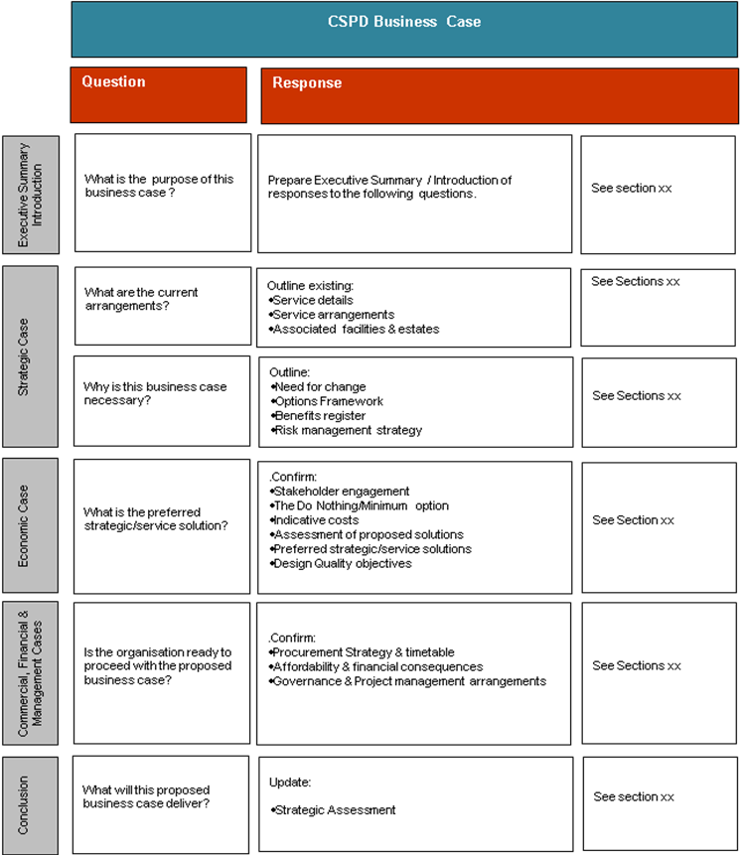
Figure 1: Structure of the CSPD Business Case

1.4 The Strategic Case

In preparation for the forthcoming expansions a full review has been undertaken of our current decontamination facility and changes identified to create a sustainable CSPD service for the future as outlined in this business case.
In response to the impact the projected increase in activity will have on CSPD, the Business Case focuses on the following needs for change to build a robust and sustainable long term facility:
- Estates footprint – enhancing existing working environment to enable appropriate capacity, improved ergonomics, workflow and staff morale
- Equipment – a clear replacement programme capable of delivering efficient working
- Effective Workforce model – staffing structures, shift patterns and training programmes, including development opportunities

1.5 The Economic and Financial Case

Three options proposed for future sustainability of CSPD were evaluated:

Option 1: Status Quo – do minimum

Option 2: Expand to meet additional demands of Phase 1 and 2 by expanding existing facilities

Option 3: New build as part of Expansion Programme to meet additional demands of Phase 1 and 2

Risk and Benefits Appraisal

The options were subject to review at a Risk and Benefit Workshop and option 3 (new build as part of the Expansion Programme) was found to offer the most benefit for the least amount of risk. Options 2 (refurbishing the existing facilities) and 3 (a new build) both offered scope for providing future sustainability, delivering a decontamination service that is safe and effective and meets quality management system ISO 13485:2016 and the essential requirements in Annex 1 of the Medical Devices Directive 93/42/EEC. Furthermore it was deemed a priority that for the decontamination service to meet future service demands it requires space, capacity, and improved workflow in an enhanced working environment with new improved and automated equipment and a sustainable workforce, which both options (2 and 3) could provide.

However, the benefit and risk profiles of Option 2 were not as favourable as Option 3 due to some existing building constraints limiting the predicted ability to improve workflow and impacting on the future resilience of the facility in respect of modular design and construction.

Option 1 was assessed as offering the lowest benefit at the highest risk. This option would be highly unlikely to meet future service demands as activities increase resulting from the planned Expansion Programme. And whilst this option has minimal risk associated with funding availability or project overspend, it is suboptimal, presenting a high risk from a workable space and sustainability of workforce. It will not future proof the decontamination service and could present a single point of failure for the entire Phase 1 and 2 Expansions. On the basis of this analysis, option 3 was determined to be the preferred way forward.

Economic Appraisal

The results of the economic appraisal are as follows:

Description | Option 1 –  Do minimum  £,000 | Option 2 – Expand existing CSPD facilities  £,000 | Option 3 – Build new CSPD as part of Expansion  £,000
NPC | 15,103.38 | 37,050.40 | 34,794.40
EAC | 1,510,338.26 | 1,089,718.58 | 1,023,365.17
Rank of financial appraisal | 1 | 3 | 2
Table 2: Results of the Economic Appraisal

The assumptions within the economic appraisal are as follows:

- The discount factor applied is 3.5%
- Exclusive of VAT

The Financial Case

Although the financial assessment favours option 1 as the most affordable, option 3 presents the most added value in terms of efficiency and ability to deliver a quality decontamination service that meets the needs of the Expansion Programme.

Capital Funding
The funding for the capital elements for the project have been identified as coming from three different funding sources with these being:

- Building costs – included in phase two costs;

- Equipment costs associated with additional activity – included in phase two costs;

- Direct Replacement of equipment for current equipment – included in the Board’s formula capital; and

- Equipment that is not currently owned by the Board – would be treated as a service development, this is identified as equipment associated with Thoracic robotic equipment,

Key Risks and Uncertainties

Risks and uncertainties will be reviewed and managed throughout the life of the project; however, specific risks and uncertainties identified as part of the Business Case process are highlighted below.

Risks

Description | Control Measure
Estates – refurbishment of existing area if option 2 approved | Plans to manage possible service disruption and/or decant the CSPD service to Inverclyde are being explored for the refurbishment period
Equipment – ageing and breaking down | A phased procurement plan for new equipment will be developed to mitigate risks of equipment failing or requiring increased time for maintenance or repair
Washers not capable of decontaminating robotics - the GJNH Central Sterilisation Processing Department (CSPD) is unable to support a robotic assisted thoracic surgery (RATS) service at present as it does not have the type of washers required for the instruments | To mitigate this issue, Cowlairs is currently the decontamination provider for our robotic equipment.  The financial assumptions within this business case assume outsourcing the decontamination of robotic instruments/endoscopes for an 18 month period with a view to repatriation as part of the CSPD development strategy/business case
Workforce – staff buy in to changes in operational hours and availability of appropriately trained staff | Early engagement will commence regarding plans for a revised workforce model and the appointment of a training role will support the preparation of training plans to develop CSPD staff
CSPD not able to meet quality management system (ISO 13485) requirements and new Medical Device Regulation | To mitigate this risk the business case recommends expanding the space to cope with demand to provide a safe working environment with adequate training facilities

Uncertainties
Description | Control Measure
The new equipment proposed assumes more efficient working not quantifiable at present which could have potential impact on future equipment and workforce requirements | Throughput and time to process instruments will be monitored once new automated double chamber WD and steriliser equipment is installed. True indication of capacity will only be available following the evaluation
The training provisions to achieve Healthcare Scientist status has not been agreed at Regional or National level | GJF is collaborating with the local College and Pearson, the awarding body regulated by SQA Accreditation (Scotland), to establish a suitable training programme and collaborating with Regional and National Sterile Service Groups to ensure that the approach taken meets requirements

Demand for the service may exceed capacity | Referrals to the service will be monitored using established processes and where required capacity plans can be implemented to ensure that access to the service is maintained during short term surges
The impact of EU withdrawal and possible implications for the Board and associated services is as yet unknown | Close monitoring of the impact of EU withdrawal will continue via the Board’s Enterprise Risk Management framework with identified risks flagged and managed appropriately

1.6 The Commercial Case

The procurement route to market for the sterilisation equipment required to deliver this project will be by means of the National Procurement Scotland Framework NP143/17 – Decontamination Equipment and Associated Maintenance, Accessories and Consumables.
1.7 The Management Case

A Steering Group with representatives from the Operations Management, CSPD, Theatres, HR, Partnership, Finance, Estates, external experts from Health Facilities Scotland, Procurement and Performance and Planning was convened to progress the data and information required to develop this business case.

On approval of the business case the function of this group would change to become the Project Implementation Group. The Group will agree frequency of meetings and will provide regular reports on the progress of the project to the Senior Management Team.

2. Strategic Case
2.1 Strategic Context

As already mentioned GJF has been tasked by Scottish Government with planning the elective care requirements of the West Region population between now and 2035. As a National Board supporting every Health Board in Scotland, GJF will also engage with the North and East Regions to ensure there is continued support for each Health Board as necessary and to ensure there is robust capacity planning for additional elective care requirements to meet the predicted need for NHS Scotland by 2035.
The GJF expansion programme has been structured in two phases as follows:
- Phase One – delivery of additional Ophthalmology elective care capacity (2020 to 2035);
- Phase Two – delivery of additional Orthopaedic and other surgical elective care capacity (2020/21 to 2035)
The purpose of the CSPD Business Case is to present potential options for the future provision of Sterile Services that is safe and effective, sustainable, flexible and responsive as well as affordable to meet future demands from the phased expansion programmes.

The FBC will also consider how the CSPD service will retain flexibility to respond to future developments within Heart and Lung Services.
The need for change resulting from the expansion programme is influenced by the following factors:
- Limitations of the existing Estates footprint to accommodate increased throughput to meet planned expansion and increased activities;
- Equipment aging (> 12 years) and due for replacement. New equipment presents opportunities for automated processes being more efficient and cost effective;
- Workforce model – needing to be fit for the future and sustainable; and
- The rising retirement age to 67 and beyond.
Furthermore in 2017 the Property Asset Management Strategy (PAMS) identified asset based issues relating to CSPD space and equipment replacement and identified an additional space requirement of 235m2 at the time.
2.2 Organisational Overview
The Central Sterilising and Processing Department (CSPD) within the Golden Jubilee National Hospital (GJNH) is part of the Golden Jubilee Foundation (GJF), which is a National Board providing regional and national services to support all Health Boards in Scotland. All services are located on the GJNH site and the hospital is home to the Regional and National Heart and Lung services, and is the largest single-site elective Orthopaedic Centre in Scotland. In addition to all activity associated with the Heart & Lung Centre and supporting almost all NHS Boards with Orthopaedics, the GJF provides Ophthalmology, General Surgery and Endoscopy services to 13 Health Boards across Scotland.
The GJF also places a key focus on research, continuous learning and promotion of strong links with academia and industry. Decontamination Services were recently awarded Healthcare Science recognition and forming strategic partnerships with local academic institutions is vital for developing our future workforce and presenting opportunities for continuous learning and innovative developments.
2.3 Business Strategy & Aims

Since its Board’s establishment in 2002 the Golden Jubilee has consistently demonstrated flexibility and responsiveness in delivering the services Scotland needs. In the past 17 years, the Golden Jubilee has grown and evolved into the home of regional and national heart and lung services, a world renowned orthopaedic centre and a major provider for cataract surgery. The Golden Jubilee’s ability to respond to changing national pressures in developing and expanding new services has been key in the delivery of national waiting time targets and health priorities for Scottish patients.

Looking ahead to next steps for the Board, the Golden Jubilee has been identified for development as the West of Scotland’s elective care centre in response to increasing capacity challenges in NHS Scotland. To meet the rising demand from the West region, the footprint of GJNH will be expanded through the construction of a new wing which will contain additional operating theatres, outpatient consultation areas and diagnostic facilities.

Our Sterile Service function is core and essential to ensuring theatres are able to deliver a high quality service to our patients and support the Board maintain its low infection rates. In recognition of the importance of this function in our ability to carry out the proposed increased surgical procedure, the Board supported the proposal to include CSPD in the design plans for the expansion.
CSPD services at GJNH, along with all other Scottish Decontamination Units, submit quarterly reports to a National Benchmarking database. When benchmarked with their NHSS Boards, GJNH Sterile Service delivers low costs per item; the lowest number of defects reported by user and exceeds the Scottish average in items processed per operator, as seen in the figures below for first quarter performance in 2018-19.
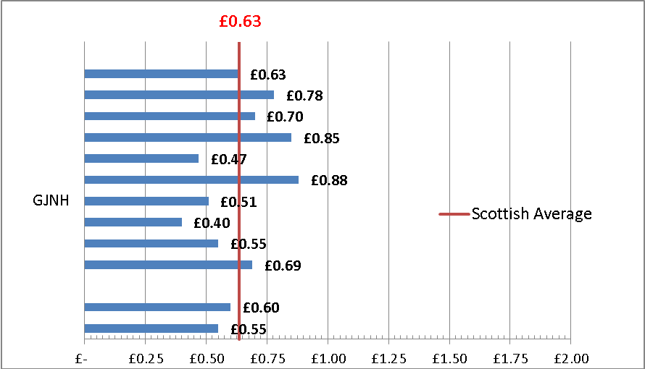

Figure 2: Scottish Sterile Services Units total cost per item for Q1 in FY 2018-19
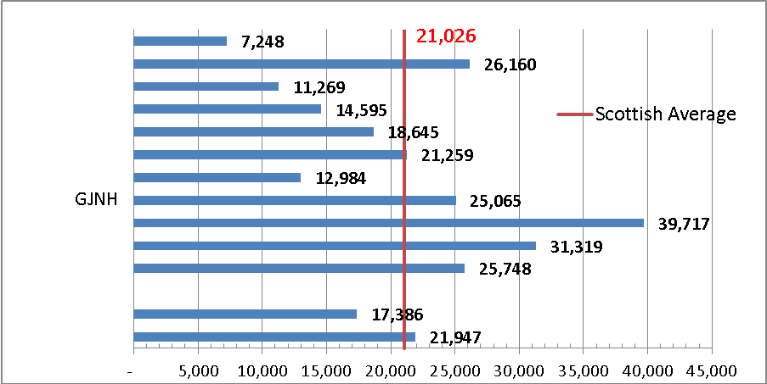

Figure 3: Scottish Sterile Services items processed per operator in Q1 FY 2018-19
Both the National Clinical Strategy for Scotland (2016) and the National Health and Social Care Delivery Plan (2016) call for transformational change in planning services at national, regional or local level as appropriate.

The Government acknowledges challenges in meeting increased demands identified in the Health and Social Care Delivery Plan and has committed to complete investment in new elective treatment capacity and expanding the Golden Jubilee National Hospital by 2021 with an aim to ensure there is high quality and adequate provision of elective care services to meet the needs of an ageing population.

The Waiting Times Improvement Plan published in October 2018 outlines the significant level of investment in developing the elective centre. The plan also describes further expansion in Ophthalmology, Endoscopy and General Surgery capacity ahead of the opening of both phases of the Golden Jubilee Elective Care Centre.
The Realistic Medicine vision is that:
‘By 2025, everyone who provides healthcare in Scotland will demonstrate their professionalism through the approaches, behaviours and attitudes of Realistic Medicine’.

Our CSPD Strategy aligns with the delivery of the Realistic Medicine agenda. This approach aims to support and empower all healthcare professionals to practice in a collaborative way and is structured around the following pillars:
1. Shared decision making
2. Personalised approach to Care
3. Reduce harm and waste
4. Reduce unnecessary variation in practice
5. Manage risk better
6. Becoming innovators
The CSPD Strategy and this business case are therefore important in facilitating an effective theatre service delivery and promote wider clinical efficiency and productivity by reducing unnecessary variation in range of instruments used and through better use of space, modern equipment and a sustainable workforce.
2.4 Other Organisational Strategies
Our Board ambition of “putting people first to achieve and sustain excellence - in care, performance, quality, innovation and values” continues to shape our future strategy and our plans to support NHS Scotland. However we have an added focus on ‘Delivering Care through Collaboration’ as our future strategic intent as we develop plans in relation to the new Elective Centres, the NHS Scotland Academy provision and Innovation. Our Sterile Service function is core and essential to ensuring theatres are able to deliver this high level of quality to our patients and support the Board maintain its low infection rates.
The emerging West of Scotland Regional Design and Discussion document has a clear focus on the requirement for services to be delivered in a sustainable way, maximising full use of new technologies and specialist services. The Golden Jubilee Elective Centre development will be pivotal to meeting the future West of Scotland demand for Ophthalmology (Cataract Surgery), Orthopaedics, Endoscopy and selected General Surgery elective procedures.
The West of Scotland Regional Delivery Discussion Document shared vision and common purpose is:
- Improving health and wellbeing;
- Increasing care and quality;
- Delivering on finance and efficiency; and
- Better workplace with a focus on staff
And therefore how we provide our services requires radical changes in:
- Workforce availability
- Workforce adaptability
- Workforce affordability
Acknowledging these factors identified, the CSPD Strategy reviewed the existing CSPD service and this FBC considers the resulting reconfiguration required to meet the increased activity up to 2035 and to provide a sustainable service fit for the future.
All workforce modelling is underpinned by the GJF workforce vision which states:
‘We will create and support a talented, resilient, healthy, technologically advanced and agile workforce that will work with patients encouraging self management to improve their health and well being.’
Staff have a ‘can do’ attitude, working diligently so that we can continue to deliver services, avoid theatre cancellations and continue to care for people.
The Property Asset Management Strategy (PAMS) identified asset based issues relating to CSPD space and equipment replacement.
It recognised that:
- the existing facility is not capable of handling the projected activity throughput, and
- as a result of multiple previous service expansions, the current facility is already being used as flexibly as possible to deliver services and cannot respond to further service change to enable expansion
The site master plan developed in 2016 identified that CSPD currently occupies 660m2 and identified an additional space requirement of 235m2 based on expansion activity assumptions.
2.5 Existing Arrangements - Current Service Provision
The purpose of this section is to provide an overview of current service provision and outline the case for change.
Decontamination is a combination of processes, which includes the cleaning, disinfection and sterilisation of all Reusable Medical Devices (RMD). Manufacturers instruction for use (IFU) must be followed to ensure that on completion of the process all RMD will be safe for further patient use.
The decontamination process is intended to:
- make the item safe for staff to handle without presenting an infection hazard; and
- make the item safe for use on a patient.
In addition to all activity associated with the Heart & Lung Centre, the GJF provides Orthopaedic, Ophthalmology, General Surgery and Endoscopy services to 13 Health Boards across Scotland, supporting almost all NHS Boards with Orthopaedics.
2.5.1 Theatre Activity
GJNH operates with 16 theatres (15 inpatient theatres and 1 endoscopy room) plus one mobile theatre unit carrying out a total of 21,611 cases anticipated in 2019/20 covering all specialties serviced by CSPD.

The table below shows current and proposed activities and number of theatres by specialty as at April 2019 requiring a CSPD decontamination service. The rows highlighted in pink show the additional proposed activity and additional theatre numbers anticipated for 2022 and 2035, and are subject to change as the demand model is being agreed:

Specialty  by Year | Theatres | Cases | Theatres | Cases | Theatres | Cases | % change by 2035*
Specialty  by Year | 2019/20 | 2019/20 | 2022 | 2022 | 2035 | 2035 | % change by 2035*
Ophthalmology | 2 + 1 mobile | 8,250 | 4 | 11,182 | 6 | 18,387 | 123%
Endoscopy predictions (Upper/Lower GI) | 1  Procedure Room | 3050 | (1.5) | 6,164 | 3.5 | 10,745 | 252%
Ortho Joints (incl Revisions) | 5 | 4003 | 6 | 5,185 | 8.5 | 6,813 | 70%
General Surgery | 2 | 1,080 | 2 | 1,952 | 4 | 2,828 | 162%
Plastics Minor / Hand Surgery | 2 | 450 | 2 | 832 | 4 | 1,296 | 188%
Ortho Minors (Ankle/Foot) | 2 | 1,481 | 2 | 1,705 | 4 | 1,938 | 31%
Cardiac | 4 | 1487 | 4 | 1,487 | 4 | 1,487 | 0%
Thoracic | 2 | 1329 | 2 | 1,329 | 2 | 1,329 | 0%
Transplant | (Cardiac) | 11 | (Cardiac) | 11 | (Cardiac) | 11 | 0%
Cardiology | N/a | 470 | N/a | 470 | N/a | 470 | 0%
Total | 15 + 1 mobile + (1) Procedure Room | 21,611 | 18 + (1.5) Procedure Rooms | 30,317 | 24.5 + (3.5) Procedure Rooms | 45,304 | 110%

Table 3: Number of theatres and cases by specialty for 2019/20, 2022 and 2035 as of April 2019 Note*: Percentage is calculated from baseline activity at 2019/20

Table 3 shows the projected patient activity as reported to the Board and the anticipated number of procedures outlined in Phase one and two expansion programme. This demonstrates an increase from 21,611 cases in 2019/20 to 45,304 in 2035, a potential 110% increase, which will result in a significant increase in instrument decontamination required.

CSPD also provides a service to Critical Care, the Dental department and patient areas, reprocessing instruments as required; this activity is not included in this table.

The department delivers a high quality service and is fully compliant with the Quality System ISO13485, the Glennie Technical Requirements and the Essential Requirements of Medical Devices Directive 93/42/EEC and the relevant associated standards.

Glennie Technical requirements were introduced in Scotland following an extensive review of Sterile Service Departments in 2000. All units were required to adopt the technical requirements in order to meet compliance. This led to remodeling of decontamination services where a number of individual units were centralised into one large unit.

All Sterile Service Departments operate a Quality Management System (QMS) ISO 13485:2016. Notified body audits are carried out six monthly or annually depending on the notified bodies.

GJNH CSPD has recently moved to annualised audits with their notified body LR (Lloyds Register).

(As per National Services Scotland (NSS) Health Facilities Scotland Scottish Health Technical Memorandum 01-01 (September 2018) – Decontamination of medical devices in a Central Decontamination Unit Part A – Management)

Clinical users have high levels of confidence in the service provided, testament to the delivery of a quality service that demonstrates consistently positive response times.

2.5.2 Estates Infrastructure

The CSPD facility at the GJNH is a purpose built department situated on the ground floor of the hospital occupying 660m2 as identified in the site master plan. The department is located directly below Theatres; separate internal lifts allow direct transfer of equipment from the CSPD department to and from theatres.

The section below describes the current footprint and functions of CSPD facilities:
Area (m2) | Locations | Function
CSPD (660m2) Includes all rooms, partitions, lift shafts, service risers etc. | Level 1 ground floor directly below theatres with separate internal lifts to allow direct transfer of equipment between theatres and CSPD | Purpose built; responsible for reprocessing used surgical instruments and other medical equipment by cleaning, disinfecting, packing and sterilising; distribute to relevant areas within instrument carts
Lobby/Gown/Drying Area (34.9m2) | Ante room to washroom for gowning up and storage areas | Dressing room stores gowns, shoes and masks, as well as storing washing liquids for various machines
Decontamination Wash Room (93.6m2) | Accessed on level 1 via gowning area. Contains dirty lift, 2x3 sinks, 5 washer disinfectors, and cart washer. Access to Endoscopy processing room | Unloading carts; manually washing contaminated instruments; manually process ophthalmic hand piece; load instruments into ultrasonic machines; load trays into washers. Load contaminated returned carts/trolleys into cart washer. Tracking and traceability of all items processed
Endoscopy Processing Dirty (19.4m2) | Accessed from decontamination wash room. 2 washers used for Endoscopy. | Leak test and manually wash scope in sink to prepare for loading washer/disinfector. Tracking and traceability of all endoscopes
Endoscopy Processing Clean (22.8m2) | Accessed via separate area from corridor along from the offices. | Unloading washer/disinfector, transfer to carts for transfer to theatre – Sure Store, is a vacuum process for retaining scopes in a useable condition long-term. Tracking and traceability of all endoscopes
Gown (7.9m2) | Ante-room to Packing room | Area to don hats and dedicated shoes before entering a controlled environment
Packing Room (72.4m2) | Accessed from corridor and central to the department with 7-8 packing tables and 2 prep tables for packing trays and supplementary instruments | Quality checking instruments and packing trays in preparation for sterilising process. Individual instruments packed separately at workstation. Tracking and traceability of all items processed

Sterilising Room (122.2m2) | Accessed from corridor, containing 3 sterilisers, coded racks and carts ready for loading | Loading trays into sterilisers and cooling instruments/trays after sterilising. Sterile packs placed in coded racks for storage and ready to load into carts. Tracking and traceability of all items processed and later despatched
Range of storage areas (79m2); (20.46m2); (2m2); and (6m2) | Adjacent to sterilising room and throughout the department | Storing sterile instruments before transferring to theatres and storing materials required for the decontamination processes; storing chemicals and area for equip clean up; storing some spare instruments if required for replacements
Rest Room / Computer hub | On level 1 opposite the administrative accommodation | Staff rest room and computer hub for elearning
Theatre Lifts | All theatres are located within the main inpatient theatre suite on level 3 of the hospital and connect to CSPD via two separate internal lifts (breaks down on occasions) | Use lifts with carts to transport used instruments from theatres to CSPD and transporting clean equipment to theatres for storage or immediate use. Larger carts are used to manually transport sterile trays to theatres for orthopaedics in external lifts
Offices and support accommodation (56.5m2) | The administrative accommodation is open plan located on level 1 adjacent to the sterile area and includes Quality Supervisor and Endoscopy office and etching facility for instruments and traceability records. Separate offices for Manager and Production Supervisor. | Required environment for managerial and admin duties, staff meetings
DSR – Domestic Services Room (4.4m2) | Accessed via Gown area to packing room | Storing equipment and supplies for cleaning the general production areas and support areas.
Table 4: CSPD facilities and footprint, location and functions
The current CSPD floor plan and dimensions are shown in Appendix 1.
The existing footprint already presents the following constraints:
- space to accommodate more machines and additional workstations;
- storage space;
- area for training; and
- no natural daylight impacting on staff morale.

In future there will be an increased requirement for space to:
- process increasing number of instruments as demands increase by specialty;

- process robotic devices, which require specialised equipment and dedicated processes; and

- train new and existing staff to meet Healthcare Science accreditation as current facilities have no dedicated training space.

2.5.3 Equipment
All of the reprocessing equipment is over 12 years old with a maximum lifespan of 15 years or until parts for repairs are no longer available. As activity demands are expected to significantly increase there is a risk of increasing frequency of breakdowns and taking longer for repairs while sourcing replacement parts.

The reprocessing equipment to support the current decontamination service includes:
- Ultrasonic Cleaners x 2
- Single Chamber Washer Disinfectors x 5
- Sterilisers x 3

Current Equipment Capacity
Data extrapolated from neQIS IPR (Quality Information software System Independent Product Release) for the past year (August 17 – end July 18) was used to calculate number of cycles processed and operational percentage utilisation per week.

Scottish Health Technical Memorandum SHTM 2010:2 (sterilisers) and SHTM 2030:1 (washer disinfectors) define the utilisation factor ‘expressed as a percentage of the number of operational hours’ i.e. the fraction of the open hours for which the machines are available to process loads. The utilisation is typically influenced by several factors including:

- Delivery schedules from clinical areas i.e. Theatres
- Time and staff availability for loading and unloading
- Start-up and shut-down time each day (approx. one hour/day)
- Planned maintenance and breakdown time
- Routine, periodic and annual testing (approx 52 hours per week).
The SHTM recommends that the utilisation factor should typically be 55% for sterilisers and 60% for washer disinfectors (WD) to allow for a steriliser or WD to be withdrawn from service for planned maintenance and periodic testing without jeopardising production.

Precise estimations of utilisation are difficult to make with clinical workloads continually developing and changing. SHPN 13:1 and the recently published SHTM01-01 therefore do not mention utilisation factors; however the previous version Scottish Health Protection Network Guidance (SHPN) 13 recommends an assumed utilisation factor of 60% for most types of washer disinfectors. Health Facilities Scotland (HFS) recommend using these figures to ensure maintaining service continuity during periods of machine breakdowns and testing schedules.

Currently, the usage of GJF sterilisers is 64.7%, which exceeds the recommended utilisation factor. The usage and age (>12 years) of the washer disinfectors and sterilisers is now impacting on the increased frequency of device breakdowns and repairs required.

Table 5 below shows the maximum production cycles in the current 12 hour day for the sterilisers and washer disinfectors:
Equipment Utilisation | 3 Sterilisers | 5 Washers
Maximum production cycles in 12 hour day | 27 | 64
Maximum production cycles in 12 hour day with 1 machine down | 18 | 51.2
Running % open 66 hours / week / machine (i.e. utilisation factor) | 64.67% | 58.6%
Table 5: Maximum production cycles in 12 hour day with all machines functional and 1 machine down

Based on the activity tracked for 12 months on the neQIS software (independent product release system) the actual production cycles for 2017/18 (verified in 18/19 – no major changes) for the 3 sterilisers was 19.40 cycles per day and for 5 washer disinfectors 46.71 cycles as shown in table 6 below.

 | Total production cycles 30/7/17 to 30/7/18 (baseline) | Variable Increase % | Cumulative | Sterilisers per 12 hour day |  |  | Washer Disinfector per 12 hour day |  | Age of equipment in Years
 | Predicted production cycles FY 2018/19 | 0 | 0.0% | 5335 | 19.40 |  | 12844 | 46.71 | 12
 | Predicted production cycles FY 2019 | 2 | 1.8% | 5442 | 19.79 |  | 13101 | 47.64 | 13
 | Predicted production cycles FY 2020 | 9 | 10.7% | 5931 | 21.57 |  | 14280 | 51.93 | 14
 | Predicted production cycles FY 2021 | 14 | 26.7% | 6762 | 24.59 |  | 16279 | 59.20 | 15
 | Predicted production cycles FY 2022 | 5 | 32.4% | 7100 | 25.82 |  | 17093 | 62.16 | 16
 | Predicted production cycles FY 2023 | 3 | 37.0% | 7313 | 26.59 |  | 17606 | 64.02 | 17
 | Predicted production cycles FY 2024 | 3 | 41.6% | 7532 | 27.39 |  | 18134 | 65.94 | 18
Note: Indicates short term capacity & which year this is reached - not sustainable based on 12 hour day.

Table 6: Illustrating current production cycles, predicted throughput and ‘tipping’ point
Key Points:

- Based on the predicted expansion figures, the service would manage current activity levels until 2023 (26.59 sterilisers and 64.02 washer disinfectors) with all machines fully functional

- If either one steriliser or washer disinfector is out of action and creating a backlog, the service is unlikely to be manageable even in the short term during 2019 for sterilisers and 2020 for washers.

- In the short term shift patterns will need to be revisited in partnership to account for the phase 1 increase.

Table 6 therefore illustrates the capacity of the respective devices and the year in which the service experiences a ‘tipping point’ for processing instruments is reached and the service is no longer sustainable, especially in the likelihood of one machine not being available due to tests or repairs. The data provided is dependent on the variable percentage increase year on year and aligns to the projected activities provided by the expansion team and Finance and is subject to change (Appendix 2).

2.5.4 Existing Workforce Model
All workforce modelling is underpinned by the GJF workforce vision and values.
Staff demonstrate a ‘can do’ attitude, working diligently so that we can continue to deliver services, avoid theatre cancellations and continue to care for people.

Demographics

The table below represents current age / gender demographic for CSPD, with 50% of staff being in 46-60 age range. This will be for consideration over the next 15 years for our future workforce and recruitment.
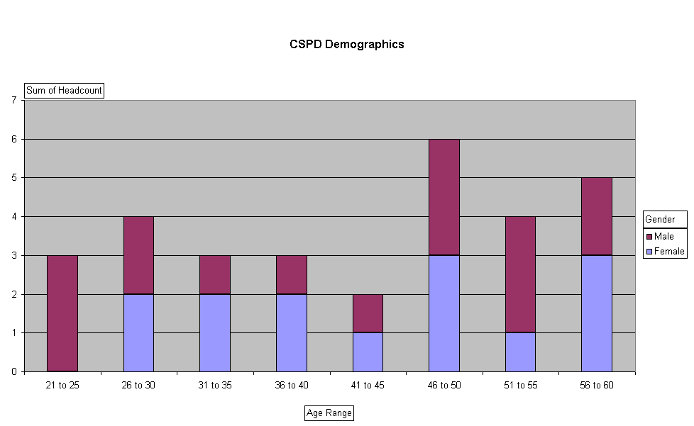
Figure 4: CSPD demographics representing age and gender
Outline of existing workforce
CSPD currently has 28.93 WTE staff ranging from Band 2 – 8A and following a review of the service in 2015 the department now operates six days per week, Monday to Saturday. There are three shifts currently in operation Monday to Thursday 8am to 4pm, 10am to 6pm and 12noon to 8pm. Friday’s shift differs slightly with staff normally finishing at 6pm. Saturday shift is 8am to 4pm and each staff member will rotate through the various shifts every three weeks, with the requirement to work every third Saturday. There is a Supervisor on each of the three shifts subject to leave and availability and each Supervisor is responsible for 6 - 7 staff.

The table below shows current CSPD workforce as at start March 2019, including the newly appointed Trainer Supervisor Role due to start May 2019 and includes previous year’s non-recurring efficiencies. The workforce table is split to show non-production staff (table 7a) and production staff (table 7b).
Non- Production Position | AfC Band | Staff In Post WTE | Budgeted WTE
Department Manager | 8A | 1.00 | 1.00
Production Manager | 6 | 1.00 | 1.00
Decontamination Trainer | 4 | 1.00 | 1.00
Quality Supervisor | 4 | 1.00 | 1.00
Engineer Test Person | 6 | 1.00 | 1.00
Engineer Maintenance | 5 | 1.00 | 1.00
Total |  | 6.00 | 6.00
Table 7a: Current Staffing Profile Non-Production Staff
There are 6.00 WTE Budgeted non-production staff as shown in table 7a.
Production Position | AfC Band | Staff In Post WTE | Budgeted WTE
Production Supervisor | 4 | 3.00 | 3.00
Senior Technician | 3 | 4.10 | 5.63 (1.53 vacant)
Technician (Trained) | 2 | 7.33 | 8.46 (1.13 vacant)
Technician (Trainee) | 2 | 7.00 | 7
Senior Technician CSPD / Endoscopy (dual trained) | 3 | 0.5 | 0.5
CSPD / Endoscopy (Dual trained) | 2 | 2.00 | 2.72 (0.72 vacant)
Total |  | 23.93 | 27.31(3.38 vacant)
Table 7b: Current Staffing Profile – Production Staff
There are 27.31 WTE Budgeted production staff including 3.38 WTE production posts vacant as shown in table 7b above.

NB: Table 7 was updated from Strategy – reflecting disinvestment in production staff and reinvestment in training post at Band 4 and includes posts previously submitted as non-recurring efficiencies.

At end of March 2019 the total CSPD staffing compliment is 28.93 WTE in post and 33.31 WTE budgeted posts with 3.38 WTE posts vacant (production and non-production staff combined). The new Trainer Supervisor has been appointed and is anticipated will start July 2019.

Section 2.6.3 and Appendix 5 show the workforce calculations used to determine future workforce requirements to meet projected activities.

2.5.5 Training

There are 7 Trainee Technicians at various stages in training who start on Band 2 entry level. Training is currently delivered in-house by the Senior Technicians and Supervisors to complete competencies aligned to work instructions according to the Quality Management System (QMS). All Trainees are required to work through the CSPD competencies covering packing, decontamination and sterilising to be signed off by the supervisors. Training in each area, at present, can take between 3 – 5 months dependant on the individual, time available for training or the need for prioritising processing of instruments.

As part of their training and to increase their knowledge in decontamination Technicians currently undertake the Institute of Decontamination Science (IDSc) Technical Certificate. Work is underway to incorporate the technical certificate into the Healthcare Science qualification pathway. The Healthcare Science (HCS) roles will in future require specific training and qualifications to achieve the recognised HCS status that demonstrates minimum requirements to do the job.

Workforce Challenges

The following present challenges impacting on the workforce and staff morale:

- Existing size of department and inability to accommodate more staff to process instruments;
- Work life balance – flexibility to meet demands of expansion;
- Shift patterns are structured to meet demand; and
- Requirement for consistent approach to training. Currently 5 Senior Technicians train and act as mentors.

Space is a constraint which has been particularly challenging when training new staff but also at peak periods of the day, when the packing area is full to capacity and staff work back to back with little manoeuvrability between packing tables.
A larger production area could accommodate more staff numbers during peak production periods and as activity increases enable recruitment of more staff to reduce turnaround times. This will clearly impact on any decision taken in respect of operational opening hours per week.
The appointment of the trainer role will provide a consistent approach to training and enable appropriate reallocation of duties to senior technician

2.6 Business Needs

The decontamination of instruments is a critical component to meeting the Board’s strategy for delivering a safe, effective and person-centred service. In response to the impact the projected increase in activity resulting from the Expansion Programme will have on CSPD, the Business Case focuses on the following changes to build a robust and sustainable long term facility:

- Estates footprint – enhancing existing working environment to enable appropriate capacity, improved ergonomics, workflow and staff morale
- Equipment – a clear replacement programme capable of delivering efficient working
- Effective Workforce model – staffing structures, shift patterns and training programmes, including development opportunities

2.6.1 Estates footprint
As mentioned earlier the Property Asset Management Strategy (PAMS) already identified asset based issues relating to CSPD space and equipment replacement, recognising that:
- the existing facility is not capable of handling the projected activity throughput, and
- as a result of multiple previous service expansions, the current facility is already being used as flexibly as possible to deliver services and cannot respond to further service change to enable expansion

The CSPD Project Team sought the advice of Paul Howard, Authorising Engineer and Andrew Tweedie Environment Manager (Decontamination Team), Health Facilities Scotland in determining indicative space requirements for a CSPD department with the capacity to manage the activity associated with the elective care centre expansions.

Using the Health Building Note (HBN 13) and Scottish Health Protection Network Guidance (SHPN) 13 guidance on the planning and designing of Sterile Services, and the current projected requirement for equipment, the initial recommendation was that we allocate 1000m2 to our CSPD department.

In the process of producing the business case, a Schedule of Accommodation (SoA) for Phase 2 Expansion was developed. This provides detail of the future space requirements, and identified a required space allocation of 1291m2 to accommodate up to 5 double chamber washer disinfectors, 6 porous load sterilisers, 2 low temperature sterilisers (to repatriate robotics) and 18 packing stations to be phased in with activity demands. (Appendix 3)
The numbers of washer disinfectors and sterilisers to be procured at the point of commissioning is based on theatre activity and realistic shift patterns to deliver the service within acceptable turnaround times. Final decision on equipment can only be determined once a full evaluation has taken place. Capacity will be available for 5 double chamber washer disinfectors and 6 sterilisers to meet projected demands up to 2035.
SMT and the Expansion Programme Board have supported the inclusion of CSPD within the design plans for the Phase 2 new build and this business case aims to secure funding.

Future Delivery Options
As noted during the Options Framework workshop, the option to outsource the whole CSPD service was discounted based on the many unknown factors, potential cost and not being in line with the current direction relating to the delivery of core NHS services.

There is added value and qualitative benefit of managing this service locally and onsite, avoiding logistics and cost of transport and potential incidences of trays with torn wrap, which could cause increased cancellation rates impacting on theatre cases.

The options evaluated focused on the estates footprint, as the space allocated determines the equipment able to install and the workforce able to accommodate to process instruments. The options were:

Option 1: Status Quo – do minimum

Option 2: Expand to meet additional demands of Phase 1 and 2 by expanding existing facilities

Option 3: New build as part of Expansion Programme to meet additional demands of Phase 1 and 2

The option to extend or refurbish the existing facilities includes areas currently occupied by Stores on Level 1. Refurbishing the existing CSPD footprint and extending into stores as shown below only provides 1000m2. Following detailed discussions with the design team the Schedule of Accommodation (SoA) requires a larger footprint to accommodate circulation, engineering and plant which is estimated at 1491m2. It is possible to reduce this estimate by 2020m2 by aligning the assumptions with a longer working day and therefore spreading the load.

Refurbishing the existing department (option 2) would require CSPD to be either divided into separate operational and refurbishment areas or require a full decant of the services off site to enable refurbishment to proceed.

Either option would cause significant operational issues in maintaining a safe and reliable CSPD service during the construction and equipment install periods.

Note: if decanting offsite, to continue to meet ISO 13485 a suitable storage area is needed on return of sterile equipment and space for case carts prepared by CSPD staff for theatres.

Figure 5: Refurbishing plan of existing facility – option 2:

AECOM provided a detailed review of both options 2 and 3 with indicative costs. Creating a new facility is likely to cost less due to risk factors identified above to meet HAI requirements, cost of decanting services and requirement to work out of hours to accommodate the service. The new build will share in the cost of the overall expansion build.

The following points are reflected in the indicative costs below:
- Significant operational risks relating to service delivery
- Includes allowance for re-provision of stores space elsewhere on Level 1
- Risk allowance is higher to reflect PSCP view of construction risk
- Costs exclude any equipment as this would be supplied through the NHS.

Option 2 - Indicative Costs for refurbishing existing CSPD space:


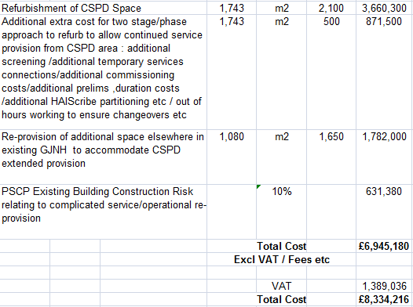
Figure 6a: Complete refurbishment of existing CSPD area in level 1 and extended refurb space at stores to provide 1743m2 of refurbished space.
The option to create a new facility i.e. option 3, would allow CSPD to continue delivering existing decontamination services and move into new build once complete. Creating a new facility in a different location with sufficient space will enable purchase of new decontamination equipment to be installed prior to CSPD moving, without disruptions to existing services.
In determining the costs for this option, the following points have been incorporated:
- Includes additional costs around ground conditions as a share of the overall build;
- Includes allowance for stripping out CSPD equipment within existing space; and
- Costs exclude any equipment as this would be supplied through NHS.

Option 3 - Indicative Costs for new CSPD build in Phase 2:
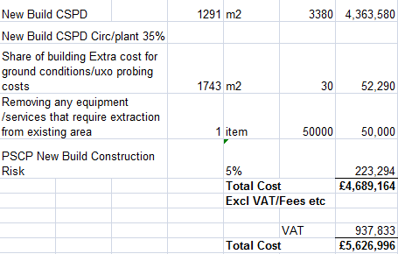
Figure 6b: Cost of provision of a new build in level 1 Phase 2, removing 35% circulation/plant
NB: 35% for new build can be shared with other departments in Phase 2 but in refurbishment option this is an integral cost.

A new facility, that is purpose built onsite, will enable the delivery of further innovation, improved patient flow and improve patient experience. In order to support this innovation there is however a requirement for a new state of the art facility which supports ‘best in class’ or ‘world class’ models of care, facilitating improved patient flow and increased clinical productivity.

Functional Content Diagram – option 3

Figure 7: Diagram as per appendix 4 in GJF Phase 2 Clinical Brief v12 Final

Key facilities required to support the CSPD expansion of service include:

- Entrance facilities

- Contaminated (dirty) returns facilities

- Equipment/instrument cleaning, disinfecting & drying (Wash) facilities comprising of 4 x double-chamber (12 or 18 din baskets) washer disinfectors (WD) and automated handling system. 3 x manual wash stations and 3 x ultrasonic washer disinfectors

- Equipment/instrument inspection, assembly & packing (IAP) facilities comprising of 18 workstations and associated support accommodation

- Equipment/instrument sterilising facilities comprising of 4 x porous load sterilisers and 2 x low temperature sterilisers (H2O2) to repatriate the robotic equipment onsite

- Office and Staff facilities

- Support facilities – Facilities Management (FM) and supplies

The CSPD service expansion does not include the processing and decontamination of flexible endoscopes, although includes dual trained staff. The scopes will be processed within a dedicated decontamination facility integral to the proposed new endoscopy unit.

The CSPD does not provide a service to customers external to the GJF.

It is assumed that the CSPD engineering workshop / office currently located outside the CSPD department will remain in its current location. Should larger workshop space be required the CSPD engineers can access the larger hospital estates and engineering workshop.

Utility Service Provisions – Plant Room
Ideally and to minimise additional cost the plant room should be adjacent to the department reducing pipe run, duct work etc.

Current ventilation is tapped off another system. The new plant requires being fully independent according to SHPN 13, but space/location constraints could have significant implications.

SHPN 13 Part 1:2011, which is the Scottish Health Planning Note 13 states that:

- The air handling system should run continuously.

- The ventilation plant for the Inspection Assembly and Packing Room (IAP) should be separate from plant serving other areas. Duplex systems should be considered with regard to minimizing production downtime and if selected these systems should be validated.

The utility of steam provision was explored for a complete refurbishment of CSPD and a new installation, with all equipment replaced as per procurement plan.

Washer disinfectors can be supplied with either steam or electric heating for heating water for washing phase and air for drying.

The current central steam provision is piped to a header (or headers) for distribution to the machines.

An alternative option where each item of equipment generates its own steam internally was explored in brief, and whilst this would have reduce the carbon foot print from a diesel perspective, this was dismissed due to impact on the required power supply per machine and infrastructure required for each unit.

Weighing up advantages and disadvantages along with long term risks and capital/revenue cost the Steering Group recommended continuing with central steam provision as this powers the majority of equipment in CSPD.

NB: Capital Cost for utility services are combined with equipment capital cost in the next section.

2.6.2 Equipment Replacement Opportunities

All the decontamination equipment is over 12 years old and requires a detailed replacement programme in line with the refurbishment of the department or new build. Increasing operational hours of working to accommodate increased activities would increase production cycles, but the increased usage could lead to more breakdowns due to the age (>12 years) of the equipment unless these are all replaced.

Table 6 had illustrated capacity of the respective devices and year in which the service experiences reaching the ‘tipping point’ i.e. 2022/23 for processing instruments when the service is no longer sustainable, especially in the likelihood of one machine not being available due to tests or repairs. Already further increases are unlikely to be manageable even in the short term during 2019/20 if either one steriliser or decontamination washer is out of action.

The data provided is dependent on the variable percentage increase year on year and aligns to the projected activities provided by the expansion team and Finance and is subject to change (Appendix 2).

Phased replacement of some existing sterilisers / WDs may be required as an interim measure if breakdowns become unsustainable for continued service delivery.
Calculating anticipated decontamination equipment required based on cycle times, recommended utilisation factor and operational hours per week:

Year | 2019-20 |  | 2020-21 |  | 2021-22
Decontamination Equipment | Sterile | WD | Sterile | WD | Sterile | WD
Yearly production cycles* | 5442 | 13101 | 5931  *** | 14280  *** | 6762 | 16279
Av cycle time minutes | 55.7 | 45.7 | 55.7 | 45.7 | 55.7 | 45.7
Recommended utilisation factor | 55% | 60% | 55% | 60% | 55% | 60%
Opening hours per week | 66 | 66 | 72 | 72 | 78 | 78
Equipment required** | 2.8 | 5.0 | 2.8 | 5.0 | 2.9 | 5.3
Table 8a: Phase 1 calculating equipment and operational hours per week required as predicted activity increases
Note that 2021-22 shows increased orthopaedic activity anticipated to start only in the last quarter of the financial year.
Appendix 4 provides further detail of calculations used.
Note*: Yearly production cycle was taken from the neQIS (Independent Product Release) for one year from July 2017 to July 2018 providing a baseline of productivity and applying yearly proposed activity percentage increase was used to calculate future production cycles. This excludes Endoscopy.
Note**: Current number of machines is 3 x sterilisers and 5 x Washer Disinfectors (WD)
Note***: Increase in production cycles has variable impact according to specialty and number of instruments to be processed per patient
Year | 2022-23 |  |  | 2025 |  |  | 2030 |  |  | 2035
Decontamination Equipment | Sterile | WD | DWD | Sterile | WD | DWD | Sterile | WD | DWD | Sterile | WD | DWD
Yearly production cycles* | 7100 | 17093 | 17093 | 7758 | 18678 | 18678 | 8994 | 21653 | 21653 | 9831 | 23668 | 23668
Av cycle time minutes | 55.7 | 45.7 | 45.7 | 55.7 | 45.7 | 45.7 | 55.7 | 45.7 | 45.7 | 55.7 | 45.7 | 45.7
Recommended utilisation factor | 55% | 60% | 60% | 55% | 60% | 60% | 55% | 60% | 60% | 55% | 60% | 60%
Opening hours per week | 84 | 84 | 84 | 94 | 94 | 94 | 120 | 120 | 120 | 120 | 120 | 120
Equipment required** | 2.9 | 5.2 | 3.4 | 2.8 | 5.0 | 3.3 | 2.5 | 4.6 | 3.0 | 2.8 | 5.0 | 3.3
Table 8b: Phase 2 calculating equipment and operational hours per week required as predicted activity increases, and DWD is Double Chamber washer disinfector
NB: Robotic equipment has not been included in productivity assumptions, the decontamination of this equipment will be repatriated on commissioning of the new unit.
The new low plasma sterilisers will be required for the robotic cameras; however the instrumentation will be processed through the washer/disinfectors and steam sterilisers replacing Video assisted thoracic surgery (VATs) instrumentation.
Variables in these calculations are:
- Operational opening hours per week

- Recommended utilisation factor (SHTM recommend max 55% for sterilisers & 60% for WDs)

- Average cycle times (dependant on machines. New equipment may differ)
This model demonstrates that new equipment will be required for Phase 2 to process increase in predicted activity in orthopaedic and other specialties going forward. Otherwise this will cause an increase in turnaround times and necessitate the purchase of more instruments to fulfil theatre demands.

Current WD capacity is 12 DIN baskets per load and in future looking to purchase double-chamber WD with the ability to process 18 DIN baskets per load, and is dependant on the configuration of the internal wash racks procured. Double chamber washers will enable a reduction in the overall number of single chamber WD and space that would otherwise be required. However this does mean that if one double-chamber WD is down for maintenance or repair, that there is a higher reduction in cycles lost for that period.

This calculation does not show Endoscopy equipment required as part of Phase 2 expansion and will be presented in Phase 2 business plan.

As part of the reprovision of CSPD and as potential future service development, the team are exploring machine automation to improve existing processes, thereby reducing turnaround times and increasing production cycles and throughput of equipment. Automation also reduces manual handling, thereby reducing potential for musculoskeletal injuries and will streamline machine loading and unloading more efficiently and effectively.

A Double chamber WD has the potential to reduce overall cycle times, although actual timings will not be known until validation of the equipment has been carried out.

Capital Cost for Estates and Equipment

Utility services including steam, Reverse Osmosis (RO) water and ventilation require to be factored in to overall cost estimated as follows:

Plant for Services | Description | Numbers required | Total cost
Reverse Osmosis (RO) Plant | Veolia Osiris Duplex | 1 | £65,244
Steam Boiler* | Certuss | 3 | £145,002
Steam Generators* | CSM (detail) | 3 | £228,000
Plant and Equipment Maintenance (10%) |  | For above | £43,825
Ventilation | Air Handling Unit(s) | 2 | £200,000
Services interconnections* | Steam header / steam pipework / duct work | N/a | £200,000
Air pressure/temperature/humidity | Monitoring |  | £1,800
Total Excluding VAT |  |  | £883,871
VAT |  |  | £176,774
Total Including VAT |  |  | £1,060,645

Equipment | Description | Quantity | Total Cost
Washer Disinfectors | Automated loading/unloading DoubleChamber | 4 | £500,664
Sterilisers | Automated loading/unloading | 4 | £310,688
Low Temperature Steriliser | Low temp function – accommodate Robotics | 2 | £176,870
Theatre Cart washer | For Theatre carts | 2 | £166,964
Ultrasonic Steelco | Ultrasound machines required | 3 | £63,900
Transfer Hatches | Goldsworth - equipment | 2 | £20,000
Total Excluding VAT |  |  | £1,239,086
VAT |  |  | £247,817
Total Including VAT |  |  | £1,486,903
Table 9: Cost for Service Provisions and Equipment

Equipment listed are proposed according to existing suppliers on the National procurement list and present indicative costs that include installation and commissioning and provides total costs that exclude and include VAT.

In summary indicative costs including VAT:

Option | Estates | VAT - Estates | Equipment | Service Provisions | VAT -Equipment & Service Provisions | Total (including all VAT)
1 | £0 | £0 | £1,239,086 | £0 | £247,817 | £ 1,486,903
2 | £6,945,180 | £1,389,036 | £1,239,086 | £883,871 | £424,591 | £10,881,764
3 | £4,689,164 | £937,833 | £1,239,086 | £883,871 | £424,591 | £ 8,174,544

NB - the equipment required in option 1 does not fit into the existing estate without carrying out a full refurbishment.

Note this does not include cost for decant in Option 2.

2.6.3 Future Workforce

As previously suggested there are different variables that could potentially impact on the workforce model we initially adopt. The size of our existing facility is key to this. If the department footprint was to increase creating more space, this could:

- increase the capacity
- house more washers and sterilisers
- increase number of packing tables for processing instruments
- accommodate more staff
- facilitate change in shift patterns
- reduce the turnaround time; and
- provide a more efficient service

A production area fit for future purpose in line with SHPN 13 guidance will influence the final workforce proposal and associated shift patterns required in line with the activity demand. Furthermore the choice of equipment, such as single or double chamber and automated load and unloading will impact on our future workforce model. Both estate footprint and equipment will need confirmed before an optimal workforce model can be finalised.

Given our activity will be increasing each year, it is recognised that the working week will need extended to provide an increase in production hours.

The workforce tool developed in 2014 was used to help determine staffing numbers required to meet the growing service demands. By using projections of the number and type of procedures planned to be carried out between 2019 and 2035, it is possible to determine the capacity throughput to calculate the number of additional staffing hours required year on year.

Based on the proposed activities additional staff will be required as from 2020/21 as shown in the table below, and refer to Appendix 5 to view the detail of calculations.

CASE | % CSPD Hrs required | Cases per Year
CASE | % CSPD Hrs required | Phase 1 |  | Phase 1 & 2
CASE | % CSPD Hrs required | 2019/ 2020 | 2020/ 2021 | 2022 | 2025 | 2030 | 2035
Eyes (Ophthalmology) | 7% | 8250 | 10700 | 11182 | 12692 | 15412 | 18387
Orthopaedic Joints | 25% | 4003 | 5024 | 5785 | 5651 | 6273 | 6813
Orthopaedic Minors | 8% | 1481 | 1673 | 1705 | 1787 | 1892 | 1938
General | 7% | 1080 | 1627 | 1952 | 2269 | 2651 | 2828
Plastic | 7% | 450 | 779 | 832 | 973 | 1176 | 1296
Cardiac | 17% | 1487 | 1487 | 1487 | 1487 | 1487 | 1487
Thoracic | 9% | 1329 | 1329 | 1329 | 1329 | 1329 | 1329
Transplant | 17% | 11 | 11 | 11 | 11 | 11 | 11
Cardiology | 3% | 470 | 470 | 470 | 470 | 470 | 470
Endoscopy |  | 3050 | 4427 | 6164 | 7535 | 9422 | 10745
TOTAL Cases per Year |  | 21611 | 27527 | 30917 | 34204 | 40123 | 45304
TOTAL Cases per Month |  | 1801 | 2294 | 2576 | 2850 | 3344 | 3775
Total Hours Required per Month |  | 3824 | 4801 | 5269 | 5751 | 6669 | 7502
WTE Production Staff required | ** | 23.47 | 29.47 | 32.34 | 35.30 | 40.94 | 46.05
Table 10: Workforce calculations

Note 1*: shaded cells in grey show projected increased activity

Note 2**: WTE required is for production staff only (including Endoscopy) and does not account for Manager, Deputy, Engineers, Quality Supervisor or Trainer (to be added to overall staff numbers)

Endoscopy decontamination is considered within the phase 2 build as an integral component of the endoscopy department. However Endoscopy decontamination comes under the remit of CSPD and going forward CSPD staff will be dual trained to provide flexibility across both areas and has been included in the workforce calculations above. A small number of staff have already been dual trained in both areas. A dedicated ‘supervisor’ will be required to accommodate the revised infrastructure.

It is anticipated that changes in shift patterns will be necessary to meet the increasing demands of the service. The department currently has several members of staff working part time hours providing a degree of flexibility to the staff and the service. Staff will continue to work their contracted working hours, however a degree of flexibility will be required to ensure their working hours fit with any new proposed workforce model. Changes to the current shift pattern and operational working hours could further help support staff with their work life balance. It is recognised a phased approach to changing the workforce model will be required up to 2035 in order to meet the growing demands of the service.

See table below and appendix 6 for potential models of shift patterns to meet required operational hours.

Opening Hours | Current |  | Option 1 |  | Option 2 |  | Option 3 |  | Option 4 |  | Option 5
Opening Hours | Time | Hrs | Time | Hrs | Time | Hrs | Time | Hrs | Time | Hrs | Time | Hrs
Monday | 8-8 | 12 | 8-8 | 12 | 8-10 | 14 | 8-10 | 14 | 8-10 | 14 | 8-8 | 24
Tuesday | 8-8 | 12 | 8-10 | 14 | 8-10 | 14 | 8-10 | 14 | 8-10 | 14 | 8-8 | 24
Wednesday | 8-8 | 12 | 8-10 | 14 | 8-10 | 14 | 8-10 | 14 | 8-10 | 14 | 8-8 | 24
Thursday | 8-8 | 12 | 8-10 | 14 | 8-10 | 14 | 8-10 | 14 | 8-10 | 14 | 8-8 | 24
Friday | 8-6 | 10 | 8-6 | 10 | 8-10 | 14 | 8-10 | 14 | 8-10 | 14 | 8-8 | 24
Saturday | 8-4 | 8 | 8-4 | 8 | 8-4 | 8 | 8-4 | 8 | 8-10 | 14 | closed | 0
Sunday | closed | 0 | closed | 0 | closed | 0 | 9-3 | 6 | 8-6 | 10 | closed | 0
Total | 66 |  | 72 |  | 78 |  | 84 |  | 94 |  | 120
Table 11: Model of shift patterns to meet operational hours per week
Note:
- Future capacity and workforce figures indicate that extending the operational working hours could meet the increase in activity during phase 1 of the expansion. There are various options available in respect of operational working hours and extending from the current 66 hours to 72 and 78 hours per week year on year appears to be the most viable option, as per table 8a. This option would meet the increase in activity until 2021/2022 and provide some flexibility and scope to further develop and train our workforce in preparation for phase 2. This could be achieved by extending the working day to 10pm, three and five days per week for 72 and 78 hours respectively. It is anticipated these would be the only changes necessary until phase 2 is commissioned in 2022. This option will mean a significant change for staff and it is recognised the challenges this may bring in terms of travel arrangements. Early engagement with staff and staff side colleagues is important to enable us to address any concerns. (See Appendix 6 for options of operational hours and shift pattern)
- 24/7 working has been considered and justification for this, both in terms of projected activity and cost effective production is not evident from the proposed activity figures for phase 1. 24/7 working would require a significant volume of staff trained in all three areas of decontamination to ensure the department could operate to the current high standard. At present only half of our technicians are fully trained with the remaining staff still working towards their competencies. Whilst training has been actively progressed, it is recognised that space constraints within the existing department will impact on the ability to train new technicians in addition to training our existing workforce. Our workforce tool indicates that a further 6 WTE will need to be recruited to meet the demands of phase 1 by 2020/21. This combined with progressing training for our existing technicians could be challenging. Whilst the new training role will play a key factor in progressing training, moving to 24/7 would be a risk to our ability to successfully develop our workforce, both in preparation for phase 2, but also for the implementation of Healthcare Science framework.
- Recruitment of fully trained CSPD technicians is challenging, therefore the majority of technicians begin at entry level Band 2 with no formal previous experience or qualifications in decontamination required. Throughout Scotland the practice to date has been on the job training and learning whilst working towards the IDSC technical certificate. This has implications in terms of workforce, the current capacity to train technicians, and the time taken to be certified as competent and qualified to work in decontamination. It could be an opportunity to develop our workforce by adopting a training academy model, enabling staff to work towards a clearly defined competency framework whilst working within the service.
- When reviewing our workforce model, we also need to consider the different factors that could impact on our workforce, such as the size of the department, allowing us to add to the number and size of washers and sterilisers housed within the department, with potential for automated loading equipment. This would increase the capacity and the turnaround time, enabling us to provide a more efficient service. This will be a factor when considering our workforce model for phase 2 of the expansion.

2.6.4 Training and Apprenticeships

The service will expand significantly to meet the needs of the expanding clinical services - as part of this there is a requirement to consider training needs for new staff. This will be fully explored within the phase 2 workforce plan and within the hospitals wider plans to expand the existing training academy approach.
Opportunities for further developing current CSPD staff include:
- Defining roles;
- Further development of existing skills in the workforce, including People Management / Leadership;
- Introduction of a trainer role to develop a more robust training programme and help with the introduction of the Healthcare Science career pathway framework; and
- Apprenticeships - exploring future entry level and Golden Jubilee Foundation becoming an accredited Apprenticeship Centre.

In addition to reviewing staffing numbers and workforce model, this is an opportunity to improve the existing skills of our workforce. By providing role clarity, particularly to the senior team and making changes to the operational way of working, we could potentially improve communication, team morale and increase team effectiveness.
Some of our existing staff have been trained in both CSPD and Endoscopy, however the overall aim is to train sufficient staff in both specialties to provide cross cover. A training post has now been appointed to and will assist with this training and ensure consistent high quality training is delivered throughout the department. This postholder will work closely with the senior team to devise a structured training programme within the department. This will ensure that we have an appropriately trained workforce, with the relevant skills and knowledge to continue to provide a high quality Decontamination service. The introduction of this role will further develop the staff within CSPD by ensuring that all staff are adequately supported and continually assessed as competent in their role. The trainer will work closely with staff to provide effective constructive feedback about their learning and development whilst ensuring they are meeting the competencies within decontamination.
This training role will play an integral part in assisting with the implementation of a formalised training programme, given Sterile Services have now been awarded status under the Healthcare Science career pathway framework and recognised as Healthcare Scientists. This will have a positive impact on recruitment, retention and succession planning. Individuals choosing to establish a career in decontamination services, will now have a structured career progression framework to enable them to progress their learning and skills, whilst potentially having this recognised through the award of Agenda for Change Banding (Band 3) on completion of their technician training.

Future Training and Apprenticeship

The GJF places a key focus on continuous learning and promotion of strong links with academia and industry. The GJF is on both the UK and European map for innovative practice and is developing further strategic partnerships with academic institutions.

Decontamination staff in Scotland having recently been awarded Healthcare Science (HCS) recognition will be required to achieve an academic qualification. The introduction of a career framework means that, in future, there may be an opportunity to recruit apprentices on to the Healthcare Science training pathway at level 2 (Band 2). Currently, our Band 2 CSPD Technicians have the opportunity to work towards the Institute of Decontamination Science (IDSc) Technical Certificate involving practical experience gained through decontamination training, followed by an exam. It is anticipated the technical certificate will be incorporated into the new training pathway, potentially at level 3 of the HCS career pathway framework (see Appendix 7).

Decontamination staff developing their knowledge and skills will now have the opportunity to progress through the HCS career framework. Meetings have already been held with West of Scotland College and Pearson, the awarding body regulated by SQA Accreditation (Scotland) currently providing the BTEC technical certificates, to determine how the curriculum could be delivered in the future. Whilst initial discussions have been positive, it is recognised this is a national framework. Therefore guidance in respect of the implementation of any academic qualifications and training courses will need to be given by IDSc for implementation nationwide.

The introduction of this new framework may mean that all decontamination staff currently holding the IDSc technical certificate level 3 may be awarded HCS Career Pathway Framework Stage 3. This potentially equates to Healthcare Science Support Worker Higher Level, Agenda for Change Band 3. This has implications for our existing workforce, given our decontamination technicians are currently Agenda for Change Band 2.

Again, it is anticipated that further guidance, including transition arrangements and timescales for implementation will be communicated by IDSc. In order to prepare for this change within our Board, early engagement with staff side representatives and Human Resources will be key in identifying which staff are affected and meet the criteria to be awarded Agenda for Change Band 3 (Healthcare Support Worker Higher Level). Currently we have eight Band 2 technicians working towards the level 3 technical certificate. It is anticipated they will complete this in 2020/2021, therefore may be eligible to be awarded Band 3 if this qualification is recognised under the new framework.

The introduction of the new framework may provide us with an opportunity to review our current internal competency sign off procedure with the new framework. This would provide a more structured learning experience for staff and enable them to progress through the competencies and formal qualification more proficiently.

The training post plays a key role in devising a formalised training programme. Each technician progressing their departmental competencies will have a formalised training plan outlining their training, learning, competencies and timescales for completion. It will also ensure the department has a robust training programme.

Healthcare Scientist Career Pathway as per Institute of Decontamination is demonstrated in Appendix 7.

The provision of £150k is made at time of writing this business case for future training opportunities.

In Summary:

Estates

The revised space requirement identified is 1291m2, with separate Endoscopy suite, to accommodate equipment and workforce model required to meet anticipated activity demands

Equipment

Identified needing to procure 4 sterilisers / 4 double chamber washers / 2 low temperature sterilisers / 2 cart washers and 3 Ultrasonic washers.

Calculated equipment required aligned to increases in activity modelled on range of operational hours from 66 to 120 hours per week (24/5). Need to consider that:
- Age of equipment by 2030 will be 8 years
- Continuous production reduces lifecycle of machines
- 24/5 production is 23 hours, not 24 hours over 5 days
- Potential for increased disruption if machines break down and need ongoing maintenance of equipment; and
- 24/5 and number of machines reduce contingency

Workforce

Increased operational hours per week required to be phased in to meet demand and considered 24/5. 24/5 (120 hours per week over 5 days) presents the following challenges:
- Volume of staff required to cover shifts
- Ability to recruit – staff untrained, needing to establish workforce and develop training academy
- Cost of unsocial hours
- Staff engaging with change
- Reduced flexibility
- Achieving work life balance

2.7 Constraints & Dependencies

CSPD function is to meet demand from Theatres and avoid backlogs. Increasing operational hours per week but creating a smaller footprint and reducing number of machines will severely impact on process flow with potential to cause backlogs and risks achieving the increasing Theatre workload demands and potential non compliance of National guidance and regulatory standards. Saving space on Washer Disinfectors/packing areas requires space to be allocated elsewhere for storing contaminated carts waiting to be decontaminated. Build up of carts and ability to prioritise will be constrained within normal working hours.

In the event of the existing CSPD being refurbished Greater Glasgow & Clyde have indicated that they would positively support GJNH the use of their facility at Inverclyde during the hours where it is not in use by the GG&C Decontamination Unit. Furthermore they indicated that rental of the premises would not be subject to a charge, and GJNH has allowed £16k in the financial analysis for any charges incurred for Heat, Light and Power.

3. Economic and Financial Case

3.1 Main Business Options

A Risk and Benefit Appraisal Workshop took place on Wednesday 6 February 2019 with the below noted attendees to assess the non-financial benefits associated with a range of options. The session was facilitated by the Head of Strategy and Performance.

Name | Job Title
Lynn Graham | Head of Operations, Surgical Division
Carole Anderson | Head of Strategy and Performance
Birgit Clark | Project Lead
Barbara Casey | CSPD Manager
Karen Boylan | Theatre Services Manager
Rhona Wilson | Directorate Accountant
Robert Stewart | Equipment and Compliance Manager
Paul Hogg | Engineering Operations Manager
Susan Robertson | Prevention and Control of Infection Nurse
Jane Christie-Flight | Employee Director / UNITE Staff Side Representative
Ann Sinclair | Unison Staff Side Representative
Tracy Glenny | CSPD Production Manager
Paul Howard | Authorising Engineer Manager (Health Facilities Scotland)
Andrew Tweedie | Senior Technical Advisor (Health Facilities Scotland)

Previously an Options Framework workshop held 14th June 2018 explored a wide range of potential future options to inform the CSPD Strategy and provided the focus for short listing options to include in this business case.

The following key objectives (outcomes/outputs) were agreed at the Options Framework workshop:

- Increase capacity;
- Increase flexibility;
- Improve turnaround times; and
- Increase end user satisfaction.

In order to meet these objectives the CSPD aims to deliver a high quality service for the population of Scotland with patients at the centre by providing a safe service, which is fit for the future, uses the most up to date and effective techniques and equipment and is a centre for learning.
The Options framework looked at the following categories and range of options:
- Scope – Current to Future expansion
- Service Solution – Do Minimum to Maximum
- Service Delivery – Status Quo to Maximum
Capital Funding

The funding for the capital elements for the project have been identified as coming from three different funding sources with these being:

- Building costs – included in phase two costs;
- Equipment costs associated with additional activity – included in phase two costs;
- Direct Replacement of equipment for current equipment – included in the Board’s formula capital; and
- Equipment that is not currently owned by the Board – would be treated as a service development, this is identified as equipment associated with Thoracic robotic equipment,

These categories were measured against the agreed Critical Success Factors which were:

Key Critical Success Factors (CSFs) | Broad Description
Strategic fit and business needs | How well the option:  - meets our Board Objectives : planning / implementation of expansion programme and all associated surgical services  - supports Regional and National collaboration
Supports Innovation approach | How well the option:  - supports the Board’s vision of delivering world class quality services, including innovative technical developments  - supports audit and research across all specialties

Safe and Effective Service | How well the option:  - meets requirement of ISO 13485, our quality assurance management system  - maximises resources to ensure processes followed are most cost effective and efficient  - sustains and improves productivity and reliability  - provides a safe and appropriate working and training environment
Potential achievability and sustainability | How well the option:  - can be delivered in a timely manner  - matches the level of skills required for successful delivery (right people, right time, right skills)  - enables the service and the workforce to be flexible  - minimises service disruption
Capacity and capability | How well the option:  - matches the ability to provide sufficient capacity to meet future demand up to 2035  - supports training requirements  - supports technological advances  - is able to provide a responsive service to meet end-users’ satisfaction
Potential affordability | How well the option:  - can be delivered within anticipated funding levels  - delivers the opportunity for economic benefit

Based on the analysis of the Options Framework the following short list of options were identified and agreed at the Benefits and Risk Workshop:

- Option 1: Status Quo – do minimum
- Option 2: Expand to meet additional demands of Phase 1 and 2 by expanding
existing facilities
- Option 3: New build as part of Expansion Programme to meet additional
demands of Phase 1 and 2

Affordability

The financial impact is detailed within the business case.

The capital funding to support this project is from the three funding streams below:-.
- Building costs – included in phase two costs;
- Equipment costs associated with additional activity – included in phase two costs;
- Direct Replacement of equipment for current equipment – included in the Board’s formula capital; and
- Equipment that is not currently owned by the Board – would be treated as a service development, this is identified as equipment associated with Thoracic robotic equipment.

The recurring revenue funding assumptions details are as reflected below;
- Funding support from Scottish Government for all revenue costs associated with staffing and depreciation.
- Funding support from all non pay/marginal costs from the West of Scotland Region recurrently

This is on the basis of the current Golden Jubilee National Hospital model and Phase 1 Elective Centre Expansion.
3.2 Short-listed Options

The final options for review by Risk and Benefits Appraisal were:
Option 1: Do minimum
All the equipment is over 12 years old and reliability of the equipment/machines is expected to decrease and failure rates increase in line with well established equipment management principles. This has been financially modelled through the economic analysis. The planned equipment replacement programme exists to address this issue before it becomes an operational risk.

The Board’s Planned Equipment Replacement Programme lays out a structured approach to equipment replacement and the management of associated risks. Guidance on the replacement of medical equipment is produced by the MHRA and the Scottish Government. In addition, the Health Building Note (HBN 13), the Scottish Health Protection Network Guidance (SHPN) 13 guidance and the Scottish Health Technical Memorandum for the technical requirements provide specific guidance on the planning and designing of Sterile Services and the replacement of decontamination washers and sterilisers.

Option 2 and 3: Replace the equipment utilising the existing NHS NSS procurement framework and extend the footprint to a maximum of 1291m2 including 33% internal circulation and plant to the CSPD department

Use the Board’s existing medical equipment acquisition process to purchase a replacement via the National Procurement / Health Facilities Service’s process.

The procurement route to market for the sterilisation equipment required to deliver this project will be by means of the National Procurement Scotland Framework NP143/17 – Decontamination Equipment and Associated Maintenance, Accessories and Consumables.
The use of a Mini Competition requires the Board to invite all suppliers named within the specific lot to provide a response to the Invitation to Tender (ITT) and Specification document(s). The Board must adopt the weighted criteria used by National Procurement when awarding the original Framework.

3.3 Benefits Appraisal

At the workshop the group discussed the proposed benefits criteria in detail and following some modifications a total of six benefits were agreed for review. These benefits were then ranked and weighted according to how important they were seen to be in achieving the aims of the business case.

Ref | Benefit Heading (Critical Success Factor) | Ranking | Weighting
B1 | Quality and Safety (Safe and Effective Service)  Provides a decontamination service that meets quality management system ISO 13485 and the new MDR 2017 (Medical Device Regulation) and provides a safe and appropriate working and training environment. | 1 | 25
B2 | Improved work flow and working environment (Potential achievability and sustainability)  Ensuring reusable medical devices are decontaminated in a timely manner to meet service demands. Enhanced working environment, new automated machines and improved ergonomics leading to more efficient working. | 4 | 15
B3 | Support Strategic aims (Strategic fit and business needs)  Meets Board objectives i.e. planning / implementation of expansion programme and all relevant clinical services. Supports National and Regional collaboration. | 3 | 18
B4 | Service efficiency (Potential affordability)  Replacing the old equipment with new providing an improved automated function. This will improve service efficiency, reliability and improve workforce cost and cost per instrument processed (include utilities) | 5 | 12
B5 | Opportunities for developing Healthcare Science Technical workforce (Supports innovative approach and new technology)  Develop a sustainable workforce and provide opportunities for training (potentially trainees from other Boards) by delivering in-house training or apprenticeships. This will support the career development of our own Healthcare Science Technical Workers and improve staff retention. | 6 | 10
B6 | Meet service demands and future requirements (Capacity and capability)  Provides space and capacity to meet additional demands of expansion in a range of specialty areas and enables repatriation of robotic device decontamination. Capacity of any new equipment is maximised, including containers. Provides resilience as a feature of a modular design and construction. | 2 | 20
Total |  |  | 100

Scoring was undertaken on an individual basis with each member of the group required to assess the extent to which each of the options met the criteria using a scoring scale of 0 (could hardly be worse) to 10 (could hardly be better). The outcome of scoring the options is detailed below with copy of the full spreadsheet detailed in Appendix 8.

Option | Weighted  Score | % of Maximum Possible Score of 1000 | Rank
Option 1: Do minimum  Potential to change workforce model and replace equipment, but no additional space | 365 | 36.5% | 3
Option 2: Do something  Expand and refurbish existing facilities and replace equipment | 702 | 70.2% | 2
Option 3: Do something/Full investment  New build as part of Expansion Programme and replace equipment with new automated | 890 | 89% | 1

As Option 1 entailed the lowest level of change from the status quo (delivering the decontamination service in the existing facilities with no additional space) demonstrated the constraints in meeting demands of the future expansion and therefore received the lowest benefit score.

Options 2 and 3 were found to offer benefits across all benefit categories to varying degrees. However creating a new build within the specified footprint as part of the Expansion Programme represented the most significant change from the status quo in offering the best design opportunities for housing new automated machines to improve workflow and efficiencies, as well as an improved work environment to meet service demands. Furthermore a new build offers most benefit in progressing the strategic aims and meet Quality and Regulation requirements.

3.4 Risk Assessment

At the workshop the group discussed the proposed risk criteria in detail and following some modifications a total of twelve risks were agreed for review.

Cluster | Ref | Heading
Financial | R1 | Funding availability  The funding required to progress the project is not made available
Financial | R2 | Project overspend (Equipment & Service delivery)  The combined spend for the project will go over budget, exceeding the costs identified or incurring unplanned recurring costs.
Financial | R3 | Unrealised planned efficiencies/assumptions  Failure to realise financial efficiencies i.e. utilisation and production process, automated machines. Information not robust to substantiate efficiencies.
Regulation | R4 | Ability to meet quality audit  Unable to meet regulatory requirements or provide a safe and appropriate working and training environment.
Reputation | R5 | Damage to reputation of GJF as providing high quality and efficient sterile services  Not being able to deliver level of quality or high standard of decontamination on a timely basis, benchmarked against comparable peers.
Operational | R6 | Unable to fully support all patient activity as a result of expansion  Throughput is lower than expected or unable to deliver full range of services.
Operational | R7 | Known demand exceeds designed capacity  Requirement for sterile services exceeds ability to meet demands as a result of increased activities over and above planned capacity.
Operational | R8 | Equipment failure  Risk of equipment failure due to high volume and turnaround times or age of equipment resulting in reduced throughput.
Operational | R9 | Access to external contingency  Requirement to access external contingency or reliance on third parties.
Operational | R10 | Service / Infrastructure failure  Risk of increased cost in relation to infection control measures or contingency costs if needing to outsource decontamination.
Workforce | R11 | Workforce  Inability to recruit or train sufficient numbers of staff to deliver revised workforce models. Inability to engage the current workforce.
Technology | R12 | Asset lifespan  Risk of obsoletion if existing equipment is not replaced as it reaches end of lifespan or does not keep pace with new technical developments.

Thereafter, each of the options was appraised against the identified risks in terms of the impact/likelihood of occurrence the outcome of which is detailed below. Full scoring details are included in Appendix 8.

Option | Risk  Score | Risk Ranking
Option 1: Do minimum  Potential to change workforce model and replace equipment, but no additional space | 146 | 3
Option 2: Do something  Expand and refurbish existing facilities and replace equipment | 96 | 2
Option 3: Do something/Full investment  New build as part of Expansion Programme and replace equipment with new automated | 82 | 1

Option 3 demonstrated the lowest risk on the basis that it addressed risks to the Board’s reputation in meeting demands of the Expansion Programme, had a low risk of equipment obsolescence within a ten year period, low risk of equipment failure with replacement of new automated equipment and less risk of service or infrastructure failure resulting from a new build.

Both Option 2 and 3 scored similarly presenting higher financial risks if funding was not made available and 2 scored highest risk of project overspend in refurbishing existing facilities and impact on services. However risk of service and infrastructure failure scored higher if refurbishing existing facilities.

Option 1 was the most risky option in terms of meeting regulatory requirements and ability to meet future patient activity as a result of the expansion and ability to provide high quality and efficient Decontamination services. Option 1 is suboptimal presenting high risk due to limited space availability, provision of equipment and sustainability of workforce and will therefore not future proof the decontamination service. Option 1 could be a single point of failure for the entire Phase 1 and 2 Expansions and likely impact on Board’s reputation.

Risk and Benefit Summary

The table below summarises the findings of the Risk and Benefits appraisal:

Options | Risk and Benefits Assessment
Options | Benefit Score | Risk Score
Option 1: Do minimum – maintain status quo | 365  (lowest benefit) | 146  (highest risk)
Option 2: Expand to meet additional demands of Phase 1 and 2 by expanding existing facilities | 702  (second highest benefit) | 96  (second lowest risk)
Option 3: New build as part of Expansion Programme to meet additional demands of Phase 1 and 2 | 890  (highest benefit) | 82  (lowest risk)

Based on this assessment Option 3 (new build as part of Expansion Programme to meet additional demands of Phase 1 and 2) is recommended subject to financial appraisal.

3.5 Net Present Cost (NPC)/Net Present Value (NPV) Findings

The Capital costs included within each of the three options are based on indicative quotes received.

The three options considered under the financial appraisal are shown below;
- Option 1: Status Quo – do minimum

- Option 2: Expand to meet additional demands of Phase 1 and 2 by expanding existing facilities.

- Option 3: New build as part of Expansion Programme to meet additional demands of Phase 1 and 2

Capital Product | Option 1  £,000 | Option 2 – Expand to meet additional demands of Phase 1 and 2 by expanding existing facilities  £,000 | Option 3 – New build as part of Expansion Programme to meet additional demands of Phase 1 & 2  £,000
Total Refurbishment/New Build cost | 0 | 8,334 | 5,627
Total Equipment to support CSPD process | 1,487 | 1,487 | 1,487
Total Service Provisions to support CSPD process | 0 | 1,061 | 1,061
Table 12: Capital Cost including VAT

The Capital Build and Equipment Costs have been compiled on the following basis:-

- Option 3 - the circulation cost has been excluded from the total as this area is shared with other departments within Phase 2 of the Expansion

- Option 3 is based on the standard guideline of £4k per square metre (sq m) (as advised by Elective Centre Programme Director)

- The circulation cost is an integral part in Option 2 so cannot be excluded.

- This business case reflects NDC price range and makes assumptions on the equipment requirements based on space availability. Option 1 is compromised in the selection of equipment available to purchase due to the limitation of space.

- The business case assumes that new Service Provision costs will not be charged in option 1 as any equipment replaced will be ‘like for like’.

- Depreciation has been calculated on the basis of Equipment 10 year life and Build/Refurbishment 34 year life

- The costs are including VAT

Revenue Costs

The revenue costs of each of the three options are described in the table below and are compared to the current baseline costs of providing Decontamination services to reflect the increase for the proposed additional activity and redevelopment.

 | Option 1 – Do minimum  £,000 | Option 2 – Expand to meet additional demands of Phase 1 and 2 by expanding existing facilities  £,000 | Option 3 – New build as part of Expansion Programme to meet additional demands of Phase 1 & 2  £,000
Current baseline costs
April 2018 – March 2019
Direct revenue costs
Staffing – Production | 544 | 544 | 544
Total Staffing costs April 2018 – March 2019 | 544 | 544 | 544
neQIS | 8 | 8 | 8
Maintenance | 2 | 2 | 2
Consumables cost (wrapping, detergent, others etc.) | 201 | 201 | 201
CSPD outside Sterilisation incl. Transport | 21 | 0 | 0
Total Consumables costs April 2018 – March 2019 | 232 | 211 | 211
Staffing - Production
Increased staffing due to Expansion – 2020-2021 | 82 | 82 | 82
Increased staffing due to Expansion – 2021-2022 | 142 | 142 | 142
Increased staffing due to Expansion – 2022-2023 | 49 | 49 | 49
Increased staffing due to Expansion – 2025-2026 | 94 | 94 | 94
Increased staffing due to Expansion – 2030-2031 | 186 | 186 | 186
Increased staffing due to Expansion – 2035-2036 | 194 | 194 | 194
Direct Staffing - Production costs increase phased over 2020 – 2035 | 747 | 747 | 747

HCS Review – Band 2 to Band 3 staff – 2020/2021 | 221 | 221 | 221
HCS Review – Band 2 to Band 3 staff – 2021/2022 | 122 | 122 | 122
HCS Review – Band 2 to Band 3 staff – 2022/2025 | 55 | 55 | 55
Direct Staffing - Production costs increase phased over 2020 – 2035 | 398 | 398 | 398
Direct Supplies
Increased Consumables due to Expansion – 2020-2021 | 34 | 34 | 34
Increased Consumables due to Expansion – 2021-2022 | 43 | 43 | 43
Increased Consumables due to Expansion – 2022-2023 | 18 | 18 | 18
Increased Consumables due to Expansion – 2025 | 35 | 35 | 35
Increased Consumables due to Expansion – 2030 | 65 | 65 | 65
Increased Consumables due to Expansion – 2035 | 54 | 54 | 54
Direct Supplies - costs increase phased over 2020 – 2035 | 249 | 249 | 249
Total Direct Revenue Costs | 1,394 | 1,394 | 1,394

Depreciation | 212 | 417 | 350

Total Recurring Revenue cost | 1,606 | 1,811 | 1,744
Table 13 – Revenue Cost including VAT

The revenue costs have been compiled on the following basis:-

- As Sterile Services have been recognised as Healthcare Scientists, staff will be able to progress their learning and skills by way of technician training and on completion of this they will increase to Agenda for Change Banding (Band 3). Assumption is made that all existing staff will complete this training in phases. There is separate provision within the Boards Financial plan for the Healthcare Scientists review from financial year 2020/21.
- There is a need to provide additional computers throughout the facility in options 2 & 3.
- The costs are including VAT

 | Option 1 – Do minimum  £,000 | Option 2 – Expand to meet additional demands of Phase 1 and 2 by expanding existing facilities  £,000 | Option 3 – New build as part of Expansion Programme to meet additional demands of Phase 1 & 2  £,000
Non Recurring Revenue Costs Direct Supplies 2022
Production staff working at Inverclyde Night shift for 6 months 2022 |  | 154
Production staff Travelling Time to Inverclyde for 6 months 2022 |  | 152
Drivers for Transport to Inverclyde for 6 months |  | 64
Inverclyde Nightshift Staff required for 6 months |  | 27
Additional Instrumentation required |  | 200
Inverclyde 6 months Utilities – nominal charge |  | 16
Increased PC costs |  | 8 | 8
Total Non Recurring Revenue Cost | 0 | 621 | 8
Table 14: Non-recurring Revenue cost including VAT

The non recurring revenue costs have been compiled on the following basis:-

- Option 2 involves the refurbishment and expansion of the existing space within the main hospital building. To accomplish this there would be a requirement to decant staff to Inverclyde Royal Hospital (IRH) CSPD and they can only accommodate GJNH staff and instruments at night due to their own service provision during the day. This scenario means that CSPD staff will need to work exclusively night shift, assuming for 6 months, and this additional cost is reflected in the option – i.e. night shift salary cost less established day time salary costs;

- In addition Option 2 also reflects the travel time needed by GJNH staff to Inverclyde and return back to Hospital base, where staff side colleagues have requested that staff are remunerated for this travel time;

- Due to the need for transportation of staff and instrumentation from GJNH to Inverclyde there is the requirement to utilise the GJNH porters/drivers to support with this decant which has an associated cost for the 6 month period;
- The costs for the hire of this transportation i.e. a minibus and two lorries, one for clean instrumentation and one for dirty instrumentation, is needed for the 6 month decant during the refurbishment;

- There is also a necessity for the hire of containers at both GJNH and Inverclyde to store the instrumentation both before and after the decontamination process;

- In consultation with the Theatres Manager it is apparent that there is a need for additional instrumentation if Option 2 is selected as there may be an increased time in the turnover of the decontamination process and instrumentation must be available in the event of an emergency situation;

- IRH CSPD have also advised that they will require one WTE Band 5 to work alongside GJNH staff for the 6 month period;

- Although IRH CSPD have indicated that rental of the premises would not be subject to a charge, the business case recognises a provision for charges incurred for Heat, Light and Power during the refurbishment period ; and

- The costs are including VAT

Summary of all Total Costs | Option 1 – Do minimum  £,000 | Option 2 – Expand to meet additional demands of Phase 1 and 2 by expanding existing facilities  £,000 | Option 3 – New build as part of Expansion Programme to meet additional demands of Phase 1 & 2  £,000
Total of all Capital Build/ Refurbishment/Equipment/Service Provisions | 1,487 | 10,882 | 8,175
Total Direct Production Staffing Recurring Revenue – Increased staffing due to Expansion | 747 | 747 | 747
Total Direct Production Staffing Recurring Revenue – HCS Review | 398 | 398 | 398
Total Direct Supplies Recurring – Additional costs due to increased activity | 249 | 249 | 249
Total Non Recurring Production Staff, Travel and Instrumentation | 0 | 621 | 8
Depreciation | 212 | 417 | 350
Grand Total | 3,093 | 13,314 | 9,927
Table 15: Summary of all Total Costs including VAT

NB the capital equipment cost included is based on replacing the existing single chamber washers with 4 multi or double chamber washers; estate provision has been made for 5 machines as advised by HFS as contingency. Similarly the cost is included for 4 sterilisers and HFS has advised there would be a need for up to 6 sterilisers. This requirement will be re evaluated post procurement evaluation informing the capital plan accordingly.

3.6 Preferred Option

The option appraisal process demonstrates that Option 3 is the preferred option.
 | Option 1 | Option 2 | Option 3
Benefits assessment | 365 (3) | 702 (2) | 890 (1) highest benefit
Financial assessment | 1 | 3 | 2
Economic assessment | 1 | 3 | 2
Risk assessment | 146 (3) | 96 (2) | 82 (1) lowest risk
Overall rank of options | 3 | 2 | 1

4.0 Procurement Strategy

The procurement of equipment for CSPD is covered in the National Framework and will not require the OJEU. The specifications required to meet our needs and criteria for our evaluation will need to be specified.
The procurement route to market for the decontamination equipment required to deliver this project will be by means of the National Procurement Scotland Framework NP143/17 – Decontamination Equipment and Associated Maintenance, Accessories and Consumables.
This Framework Agreement is fairly comprehensive and consists of 10 specific lots covering all types of decontamination equipment including all equipment required for this project:-
Lot 1 CDU Washers
Lot 2 CDU Sterilizers
Lot 3 Low Temperature Sterilizers
Lot 4 EDU Washers
Lot 5 EDU Dryers
Lot 6 EDU Reverse Osmosis
Lot 7 LDU Washers
Lot 8 LDU Sterilizers
Lot 9 Lab Sterilizers
Lot 10 Probe Sterilizers

The National Framework includes guidance on the required route to market, and for each of the above lots, with the exception of Lots 7 & 8 which are not within the remit of this project, is by means of a mini competition restricted to the suppliers awarded for each specific lot.

The use of a Mini Competition requires the Board to invite all suppliers named within the specific lot to provide a response to the Invitation to Tender (ITT) and Specification document(s). The Board must adopt the weighted criteria used by National Procurement when awarding the original Framework.

The mini competition process is not governed by preset time lines; however there is a requirement to observe best procurement practice within the process. Given the complexity of the equipment required a suggested timeline to support the process is included below:-
Day 1 – Invitation to Tender (ITT) pack issued to all suppliers nominated within the National Framework. Allow 4 weeks for suppliers to submit responses.
Day 29 – Tender Closure - Bids received. Allow 6 weeks for financial and technical / clinical evaluation of bids, and identification of the successful bidder(s)
Day 71 – Formal Award of Contract and commencement of the 10 Day Mandatory Standstill Period as per procure best practice.
Day 82 – End of Standstill and Confirmation of the Contract Award to the successful bidder(s).
The minimum time to conduct the tender process and to successfully award a contract is therefore 12 weeks, to which the lead time for the manufacture, delivery, installation, certification / validation, would be require to be added.

5. Management Case

5.1 Project Management Arrangements

Project Management Team
Surgical Division Associate Director of Operations will chair the CSPD Steering Group and be responsible for overseeing and ensuring the work of the project in implementing the business case is delivered in line with objective.

Overall responsibility for the project sits with the Director of Operations as nominated Executive Lead.

Key functions with individual involvement are highlighted below. Identification of named individuals and firm definition of the roles and responsibilities would form part of the initial appraisal exercise should it be approved.

- Finance
Monitoring and reporting of financial elements of the project (in line with SG requirements) will be the responsibility of the Assistant Finance Director.

- Clinical and Corporate Representation
The following key individuals will be involved in the project:

  - Director of Operations;
  - Associate Director of Operations, Surgical Services;
  - Head of Estates and Facilities;
  - Assigned Performance and Planning Project Manager.

A Steering Group with representatives from the Operations Management, CSPD, Theatres, HR, Staff Side, Finance, Estates, external experts from Health Facilities Scotland, Procurement and Performance and Planning was convened to progress the data and information required to develop this business case.

On approval of the business case this function of this group would change to become the Project Steering Group. The Group will agree frequency of meetings and will provide regular reports on the progress of the project to the SPG and Senior Management Team.

Project Timeline

Period | Activity during this period
May – July 2019 | Appoint to Trainer role
22 May 2019 | Submission to Capital Group
June2019 | Submission to SMT for approval
June 2019 | Submission to Board for approval
June 2019 | Plans developed
July – December 2020 | Proceed with plans to refurb / new build
July – December 2020 | Proceed procurement of machines
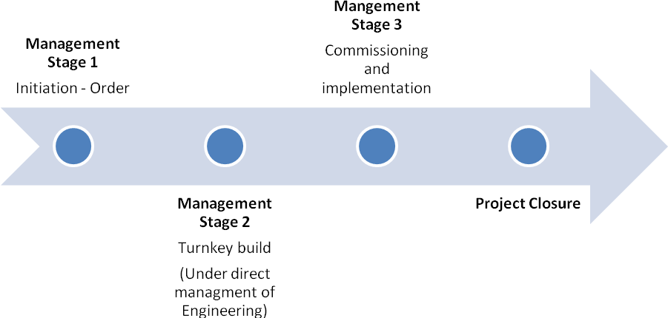
Deliverables from Management stage 1 - by the beginning of June 2019

Deliverable (product) | Responsible
Project brief | Project Manager
Business case | Project Manager
Product specification | Project Manager / CSPD Manager
Medical Equipment Group | Chair of Medical Equipment Group
Capital Group sign off | Chair of Capital Group
SMT sign off | Project Executive
Board Sign off | Project Executive

Deliverables from Management stage 2 and stage 3 – By end December 2019

Deliverable (product) | Responsible
Management Stage 2 project plan - Implementation | Project Manager
User training plan | CSPD Manager / Trainer
Acceptance reports | Engineers / Procurement
User training update report | CSPD Manager / Trainer
Commissioning report | Medical Physics / Procurement
Hand over of Product | Senior users

Project Closure – By the end of March 2020

Deliverable (product) | Responsible
Lessons learnt report | Project Manager
Project closure report | Project Manager

The project will be subject to continual assessment of ongoing risks and reaction to incidents.

5.2 Benefits Realisation Arrangements

A Benefits Realisation Plan will be developed to assess whether the intended benefits of the project are realised.

Prior to any refurbishment or new build the Plan will contain a detailed description of the desired benefits of this Business Case and a description of what each benefit being realised will look like along with baseline data. This information will be updated throughout the project period.

The following key benefits have been identified at the onset of this project:

The preferred option provides a footprint of 1291m2 to accommodate more and improved equipment to meet future capacity and has the potential for training facilities and opportunities for revising the workforce model. A new build presents the opportunity to plan the layout for improved workflow and take into account learning from challenges in other facilities and new builds. Phase 1 activity can be managed in current facilities, but may require extending operational hours until new build is completed for Phase 2.

Benefit | Description | Success Criteria
Supports Strategic aims | Meets Board Objectives in planning / implementing expansion programme to meet future service demands | CSPD services and processes demonstrate ability to meet future service demands
Improved Quality and Safety | New facility equipped with new equipment able to provide a safe and appropriate working and training environment | Meets ISO 13485 standards and new MDR 2017 (Medical Device Regulations)

Improved workflow and working environment | Enhanced working environment and new automated machines enable improved ergonomics leading to more efficient working | Maximising efficiency by reducing turnaround time and meeting activity demand
Improved service efficiency | Replacing the old equipment with new providing an improved automated function | Demonstrate improved service efficiency calculated by reduced turnaround times, reliability (reduced breakdowns), improved workforce cost and cost per instrument processed
Improved training opportunities | Develop a sustainable workforce and provide opportunities for training (potentially trainees from other Boards) by delivering in-house training or apprenticeships. This will support the career development of our own Healthcare Science Technical Workers and improve staff retention. | Staff achieving new HCS status i.e. Training role established – increased number of staff trained – partnership with local college.
Ability to meet service demands | Provides space and capacity to meet additional demands of expansion in a range of specialty areas and enables repatriation of robotic device decontamination.  Capacity of any new equipment is maximised, including containers. Provides resilience as a feature of a modular design and construction. | Sufficient space allocated to house recommended equipment specifications, able to repatriate robotic device decontamination. Projections in line with phase 1 and phase 2 extension.
Successful implementation of refurbishment / new build | New build / refurbishment in place for 2021/22 | CSPD established in new facility, with a responsive workforce model and new equipment within required time

5.4 Risk Management Arrangements

Given the complexity of the project a risk management process will be put in place. The following table details the current identified risks along with mitigation and management arrangements. This will be a key focus of the project steering group.

The following key risks have been identified at the onset of this project for options 2 and 3.

Risk Cluster |  | Risk Description |  | Control Measure
Financial
Project overspend (Equipment & Service Delivery) | The combined spend for the project will go over budget, exceeding the costs identified or incurring unplanned recurring costs |  | Costs will be tightly controlled through the process and escalate early indications of changing costs
Unrealised planned efficiencies/ assumptions  (Risk following implementation?) | Failure to realise financial efficiencies i.e. utilisation and production process, automated machines. Information not robust to substantiate efficiencies |  | Develop processes to monitor utilisation rates and production process to inform level of efficiencies
Regulation
Unexpected change in regulatory standards | A regulatory change may be introduced forcing a change in specification and increasing costs beyond expected tolerances. Examples would include changes to EU regulations |  | This threat will continue to be monitored throughout the project. This maybe particularly relevant with the EU withdrawal deadline.
Operational
Unable to fully support all patient activity during build/installation | Allocation of space, equipment and workforce model do not support the projected activity |  | Ensure replacement equipment is fully capable and plan operational hours and workforce required to meet demands.
Installation disruption | Installation of new equipment will create disruption in surrounding areas (unless entire service decants externally) |  | The supplier turnkey plan will be agreed with Engineer Lead and Steering Group and will be monitored closely
Unexpected turnkey/new build or equipment delays | Delays to commissioning new build and/or equipment due to unforeseen problems. Delays to go live date due to unforeseen equipment problems |  | Progress of turnkey/new build installation will be monitored with regular supplier updates to Project Board. These will be reported in summary and by exception.
Requirement to access external contingency | Requirement to access external contingency or reliance on third parties based on an increased level of activity |  | Build in contingency with external facilities in the event of major disruptions
Service / Infrastructure failure | Risk of increased cost in relation to infection control measures or contingency costs if needing to outsource decontamination |  | Liaise with Infection Control/Estates/3rd Parties to manage risk
Workforce
Workforce Model | Inability to recruit or train sufficient numbers of staff to deliver revised workforce models within required time. Inability to engage the current workforce |  | Early engagement and recruitment of staff to support training and changes in workforce model

5.5 Project Evaluation

A project close report will be written following completion of the project, and a post project review undertaken six months later within which lessons learned will be described. Benefits realisation will also be undertaken to assess the extent to which the benefits described in this business case were delivered, and for appropriate learning to be gained on both successes and challenges in delivering them.

6. Appendices
Appendix 1 - Current CSPD Estates footprint and dimensions
Room no | Function (Non-production) | m2 |  | Room no | Function (Production) | m2
D1097 | CSPD Office | 26.30 |  | D1134A | Packing | 72.4
D1097A | CSPD Managers Office | 11.60 |  | D1137A | Sterilizers | 122.2
D1135 | DSR | 4.40 |  | D1126 | Sterile Storage | 79
D1128A | Gown | 7.90 |  | D1129,1130 1130 | Lobby/Drying/ Gown | 34.9
D1127 | Linen | 19.80 |  | D1134 | Decontamination | 93.6
D1098 | Dept Managers Office | 9.50 |  | D1105 | Endoscopy Processing Dirty | 19.4
D1137 | Plant (sterilisers) | 26.00 |  | D1102 | Endoscopy Processing Clean | 22.8
D1105A | Chemical Store | 2.00
D1106 | Plant | 12.00
D1106A | Store | 6.00
D1131 | Equip Clean up and Storage | 20.46
D1101 | 2 Person Endoscopy Office | 9.10
n/a | Entrance | 9.20
 | Sub-total | 164.26 |  |  | Sub-total | 444.3
 | Sub-Total | 608.56
Gross internal floor space (GIA) - Total |  | 660.00m2 | includes partitions, service risers, lift shafts etc

Appendix 2 - Proposed Activity per Specialty for Expansions Phase 1 & 2 (as per OBC Expansion Programme)
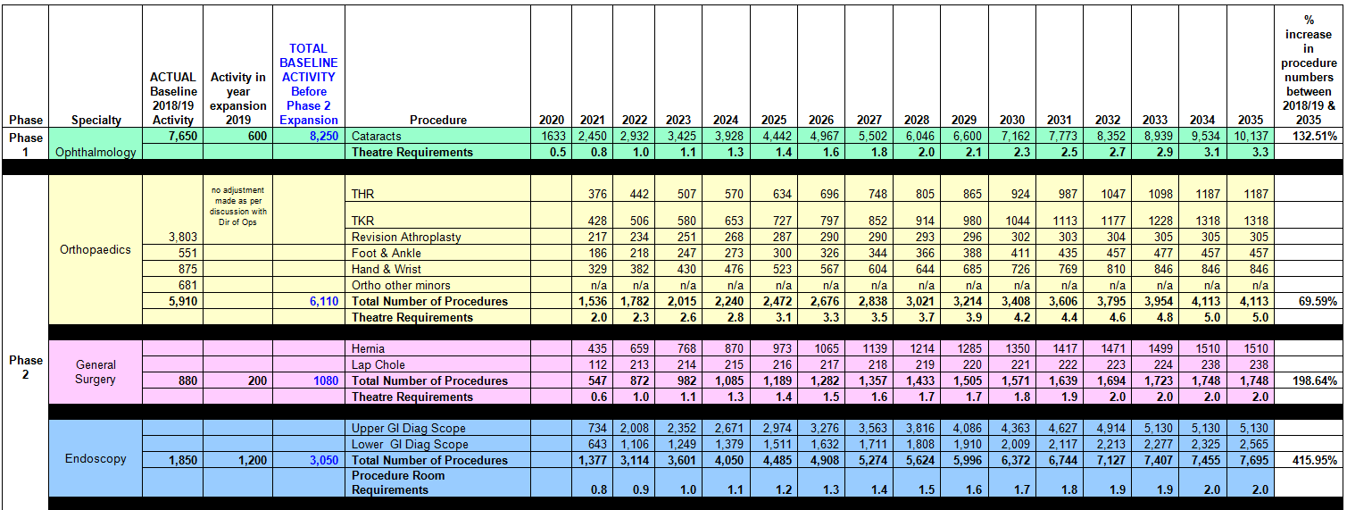

Appendix 3 – Schedule of Accommodation (showing total of 1491m2)

Appendix 4 – Calculations to demonstrate decontamination equipment required according to operational hours of working

Appendix 5 – Workforce Tool Calculations - based on projected activity resulting from the expansions
CASE | % CSPD Hrs required | Cases per Year
CASE | % CSPD Hrs required | Phase 1 |  |  | Phase 1 & 2
CASE | % CSPD Hrs required | 2018/ 19 | 2020/ 21 |  | 2022 |  | 2025 |  | 2030 |  | 2035
Eyes (Ophthalmology) | 7% | 8,250* | 10,700 |  | 11,182 |  | 12,692 |  | 15,412 |  | 18,387
Orthopaedic Joints | 25% | 4,003 | 5,024 |  | 5,785 |  | 5,651 |  | 6,273 |  | 6,813
Orthopaedic Minors | 8% | 1,481 | 1,673 |  | 1,705 |  | 1,787 |  | 1,892 |  | 1,938
General | 7% | 1,080 | 1,627 |  | 1,952 |  | 2,269 |  | 2,651 |  | 2,828
Plastic | 7% | 450 | 779 |  | 832 |  | 973 |  | 1,176 |  | 1,296
Cardiac | 17% | 1,487 | 1,487 |  | 1,487 |  | 1,487 |  | 1,487 |  | 1,487
Thoracic | 9% | 1,329 | 1,329 |  | 1,329 |  | 1,329 |  | 1,329 |  | 1,329
Transplant | 17% | 11 | 11 |  | 11 |  | 11 |  | 11 |  | 11
Cardiology | 3% | 470 | 470 |  | 470 |  | 470 |  | 470 |  | 470
TOTAL Cases per Year |  | 18,561 | 23,100 |  | 24,753 |  | 26,669 |  | 30,701 |  | 34,559
TOTAL Cases per Month |  | 1,547 | 1,925 |  | 2,063 |  | 2,222 |  | 2,558 |  | 2,880
CSPD Hours Per Case | 1.80** | (Contact working hrs = CSPD hrs per case x cases per month)
Contact Working hrs required |  | 2,790 |  | 3,472 |  | 3,721 |  | 4,009 |  | 4,615 |  | 5,195
Average Hours for Ward/Dept per month | 2.05hrs/ day | 44 |  | 44 |  | 44 |  | 44 |  | 44 |  | 44
Supervisor Management time hrs per month | 4hrs/day | 87 |  | 87 |  | 87 |  | 87 |  | 87 |  | 87
Dispatch time for Eyes from Phase 1 | 0.66hrs/ day |  |  | 14 |  | 14 |  | 14 |  | 14 |  | 14
Predictable Absence | 22% | 614 |  | 764 |  | 819 |  | 882 |  | 1,015 |  | 1,143
Total Hrs Required per Month |  | 3,535 |  | 4,381 |  | 4,685 |  | 5,036 |  | 5,775 |  | 6,483
Average Contracted Monthly Hrs | 163
WTE Production Staff required |  | 21.70 |  | 26.89 |  | 28.75 |  | 30.91 |  | 35.45 |  | 39.79
Endoscopy (Cases per Year) |  | 3,050 |  | 4,027 |  | 6,164 |  | 7,535 |  | 9,422 |  | 10,745
TOTAL Cases per Month |  | 254 |  | 369 |  | 514 |  | 628 |  | 785 |  | 895
CSPD Hours Per Case | 0.93 | (Contact working hrs = CSPD hrs per case x cases per month)
Contact Working hrs required |  | 237 |  | 344 |  | 479 |  | 586 |  | 733 |  | 836
Predictable Absence | 22% | 52 |  | 76 |  | 105 |  | 129 |  | 161 |  | 184
Total Hrs Required per Month |  | 289 |  | 420 |  | 585 |  | 715 |  | 894 |  | 1020
Average Contracted Monthly Hrs | 163
Endoscopy WTE required |  | 1.78 |  | 2.58 |  | 3.59 |  | 4.39 |  | 5.49 |  | 6.26
Total WTE Production Staff required | *** | 23.47 |  | 29.47 |  | 32.34 |  | 35.30 |  | 40.94 |  | 46.05
Note 1*: shaded cells in grey show projected increased activity
Note 2**: CSPD Hours per case is average times in hours to perform tasks required in CSPD to process equipment
Note 3***: WTE required is for production staff only and does not account for Manager, Deputy, Engineers, Quality Supervisor or Trainer (to be added to overall staff numbers)

Appendix 6 – Workforce Model Options

These options will be considered to minimise impact on the Decontamination Service as Theatre demands increase.

Options for CSPD processing model:

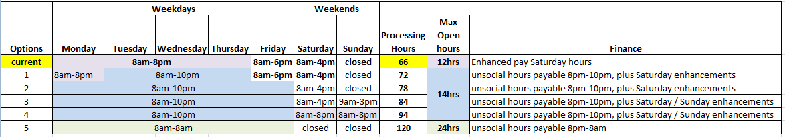
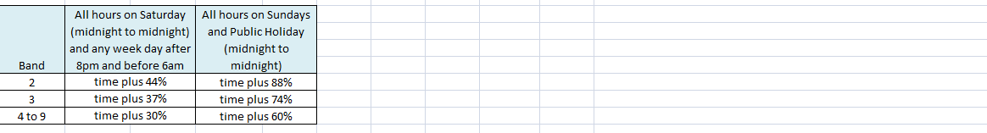
Note: Model presents a range of options available with maximum opening hours ranging from 12 – 24 hours over 5, 6 or 7 days, recognising this requires early engagement with staff and clear indication of actual operational hours required.

Appendix 7 – Career Pathway

Appendix 8 – Risk and Benefit Workshop Scoring
Justification for Options agreed and decisions taken in scoring benefits and risks:
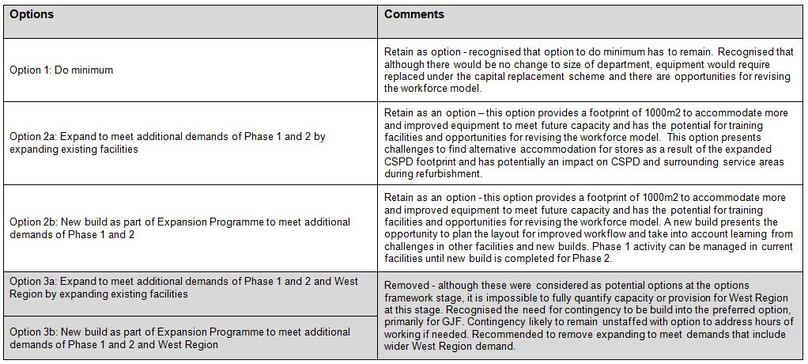
Note: With option 3a and 3b being removed, option 2b was changed to option 3.

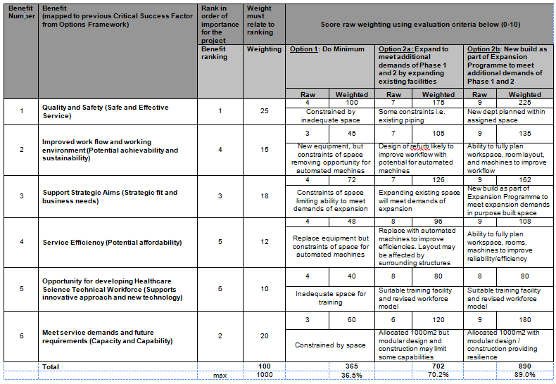

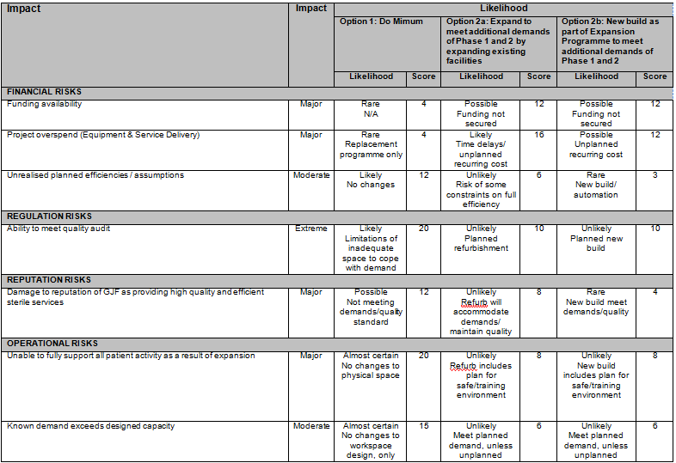
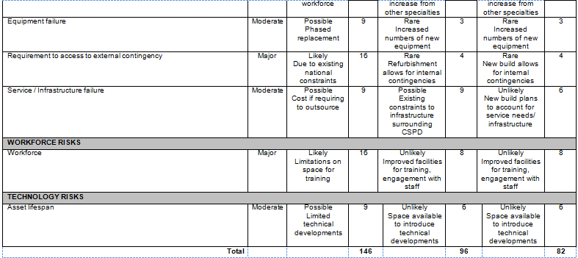

https://www.gov.scot/publications/waiting-times-improvement-plan/
www.gov.scot/Publications/2016/02/8699
http://www.gov.scot/Resource/0051/00511950.pdf
https://www.gov.scot/publications/waiting-times-improvement-plan/
(Executives, September 2017) West of Scotland Position Paper Final
SHPN 13 Part 1 Decontamination Facilities: Central Decontamination Unit Version 1: May 2011 Page 46 of 240 ©Health Facilities Scotland, a division of NHS National Services Scotland.
(2.12 The Department of Health strategy pertaining to the reprocessing of re-usable surgical instruments is that local reprocessing should be the exception rather than the norm and that automated washing methods are preferred to manual cleaning. – from HBN 26 Facilities for Surgical Procedures)
MHRA, Managing Medical Devices, 2015
CEL 35, Scottish Government, 2010, A policy for property and asset management

