Board Meeting: | 20 June 2019
Subject: | Board Performance Report
Recommendation: | Board members are asked to:  Discuss and Note X  Discuss and Approve  Note for Information only

____________________________________________________________________

- Introduction

The Board is asked to discuss the content of the performance report covering matters discussed at the May 2019 meeting of the Performance and Planning Committee.

- Board Exception Report – Key Performance Indicators (KPIs)
- Effective KPIs
- Person-centred KPIs
- Safe KPIs

- Divisional Exception Reports
(a) Surgical Services
(b) Regional and National Medicine

- Waiting lists – Cardiac Surgery, Thoracic Surgery and Cardiology.

- Corporate Balanced Scorecard (Appendix 1)

2 Recommendation

The Board is asked to note the update for the current reporting period.

Jann Gardner
Chief Executive
6 June 2019

(Carole Anderson, Head of Strategy and Performance)

Board Exception Report
Improved performance
Same performance
Worse performance

Effective Board Performance update – June 2019
KPI | Details |  | Tolerance |  | Jan 2019 |  | Feb 2019 |  | Mar 2019 |  | Target | On Track
Elective Acute Ward Bed Occupancy | Combined occupancy position for NSD, 2 East, 2 West, 3 East, 3 West |  | >90.1% = Red  86-90%= Green  78-85.9% = Amber  <77.9% = Blue |  | 77.4% |  | 79.4% |  | 81.3% |  | 86-90%
Interventional Cardiology Wards Bed Occupancy | Combined occupancy position for 2C, 2D and CCU |  | 87.4%- 100% = R  81% -87.3% = G  77%-80.9%= A  <76.9% = B |  | 86.0% |  | 85.1% |  | 81.7% |  | 81-87.3%
Critical Care Wards Bed Occupancy | Combined occupancy position for ICU1, ICU2, HDU2, HDU3 |  | ≥ 84.8% = R  73 – 84.7% = G  63.4 – 72.9% = A  ≤ 63.3% = B |  | 68.6% |  | 74.8% |  | 76.8% |  | 70-90%
Analysis
Overall bed occupancy in the elective acute wards increased by 1.9% in March compared to February. Wards 2 East, 2 West and the National Services ward all reported decreases in occupancy. Ward 3 East reported a small increase whilst Ward 3 West recorded a 17.9% increase.
Overall occupancy levels in the cardiology wards remained within the “green” target range for the fifth successive month during March. Wards 2C and 2D both reported occupancy levels above the target range. CCU’s occupancy levels decreased by over 8% for the second successive month.
Bed occupancy within the critical care units increased by 2% during March compared to February. Both of the high dependency units reported substantial increases in occupancy. HDU2 reported an increase of over 10%. This was the third successive substantial increase in bed occupancy in the unit. HDU3 increased by almost 10% having also reported a large increase during February.
Effective Board Performance update – June 2019
KPI |  | Details | Tolerance | Feb 2019 |  | Mar 2019 |  | Apr 2019 |  | Target |  |  | On Track
Ophthalmology Cancellation Rate |  | Percentage of Ophthalmology patients cancelled on day of procedure | Achieved = G  Not Achieved = R | 3.1% |  | 3.5% |  | 2.2% |  | Monthly 3% cancellation rate
Plastic Surgery Cancellation Rate |  | Percentage of Plastic Surgery patients cancelled on day of procedure | Achieved = G  Not Achieved = R | 4.6% |  | 4.2% |  | 0.0% |  | Monthly 3% cancellation rate
Cardiac Surgery Cancellation Rate |  | Percentage of Cardiac Surgery patients cancelled on day of procedure | Achieved = G  Not Achieved = R | 18.9% |  | 10.8% |  | 11.3% |  | Incremental reduction from baseline position of 12% to 10% by March 2020
General Surgery Cancellation Rate |  | Percentage of General Surgery patients cancelled on day of procedure | Achieved = G  Not Achieved = R | 14.8% |  | 9.6% |  | 9.7% |  | Incremental reduction from baseline position of 9% to 7% by March 2020
Orthopaedic Cancellation Rate |  | Percentage of Orthopaedic patients cancelled on day of procedure | Achieved = G  Not Achieved = R | 3.5% |  | 3.2% |  | 3.6% |  | Monthly 3% cancellation rate
Endoscopy Cancellation Rate |  | Percentage of Endoscopy patients cancelled on day of procedure | Achieved = G  Not Achieved = R | 5.4% |  | 6.0% |  | 9.7% |  | Incremental reduction from baseline position of 6% to 5% by March 2020

Effective Board Performance update – June 2019
KPI | Details | Tolerance | Feb 2019 | Mar 2019 | Apr 2019 | Target | On Track
Thoracic Surgery Cancellation Rate | Percentage of Thoracic Surgery patients cancelled on day of procedure | Achieved = G  Not Achieved = R | 5.2% | 8.6% | 9.0% | Incremental reduction from baseline position of 5% to 4% by March 2020
Cardiology Cancellation Rate | Percentage of Cardiology patients cancelled on day of procedure | Achieved = G  Not Achieved = R | 0% | 9.5% | 6.8% | Monthly 4% cancellation rate
Analysis
Challenging stretch targets have been set for 2019/20 cancellation rates, aiming to improve our cancellation rates, which are the lowest in the country. During April only ophthalmology and plastic surgery met these challenging improvement targets, with plastic surgery reporting no cancellations from the 43 scheduled procedures during the month.
There were 17 cardiac surgery cancellations during April, this was an increase of two on March. Six of the cancellations were due to the patient not being fit and a further six of the cancellations were due to a lack of operating time. During April there were 12 thoracic surgery cancellations, an increase of one on March. Four of the cancellations were due to a lack of operating time with a further four due to the patient not being fit. There were 18 endoscopy cancellations in April; eight of the cancellations were related to patient attendance for appointments. A campaign with the aim of reducing the number of patients who do not attend for their endoscopy procedures has started. Seven general surgery procedures were cancelled in April; an improvement of three on the ten cancellations in March. Four of the seven cancellations in April were due to the procedure not being required. There were 13 orthopaedic cancellations during April, one fewer than in March. Reduced activity in April has resulted in an increase in the cancellation rate overall. The most common orthopaedic cancellation reason in April was due to the patient not being fit. During April three cardiology procedures were cancelled, a reduction of one compared to March. All of the cardiology cancellations in April were due to the patients not being fit.

Effective Board Performance update – June 2019
KPI | Details |  | Tolerance |  | Feb 2019 |  | Mar 2019 |  | Apr 2019 |  | Target |  |  | On Track
Treatment Time Guarantee (TTG) | Percentage of patients admitted within 12 weeks |  | 100% = Green  95-99.9% = Amber  ≤94.9% = Red |  | 90.7% |  | 93.5% |  | 93.4% |  | 0
Analysis
In April 1,273 (93.4%) patients were treated within 12 weeks. Ten fewer patients (90) were treated over the 12 weeks TTG in April than in March however reduced activity due to public holidays in April did see the percentage treated reduce very slightly (by 0.1%). The patients treated beyond their 12 week guarantee date were comprised of 33 coronary, 34 electrophysiology, four device and 19 cardiac surgery patients.
KPI |  | Details |  | Jan 2019 |  | Feb 2019 |  | Mar 2019 |  | Apr 2019 |  | Target | On Track
Cardiac Surgery Day of Surgery Admission Rate |  | Target for 15% of Cardiac Surgery major procedure admissions to be DoSA by March 2019 |  | 8.9% |  | 13.2% |  | 15.9% |  | 8.7% |  | 15% by March 2019
Orthopaedic Day of Surgery Admission Rate (Primary Joint Replacement) |  | Target for 70% of Orthopaedic Primary Joint Replacement admissions to be DoSA, rising to 75% from October 2018. |  | 60.9% |  | 65.3% |  | - |  |  |  | 75% from October 2018
Thoracic Surgery Day of Surgery Admission Rate |  | Target for 44% of Thoracic Surgery admissions to be DoSA by March 2019 |  | 24.2% |  | 18.8% |  | - |  |  |  | 44% by March 2019
Analysis
In February 169 orthopaedic and 12 thoracic patients were admitted as DoSA. Six cardiac surgery patients were admitted as DoSA in April. Absence among the anaesthetist team during February and March meant fewer patients than anticipated were assessed at the pre-operative assessment clinic where suitable DoSA candidates are identified, impacting the rates for April.

Safe Board Performance update – June 2019
KPI | Details | Tolerance | Q2 2018/19 | Q3 2018/19 | Q4 2018/19 | Target | On Track
MRSA/MSSA bacterium | Maintain a rate of 0.12 cases per 1000 acute occupied bed days | ≤0.12 = G  >0.12 = R | 0 | 0.25 | 0.17 | ≤0.12 = G
Clostridium difficile infections (CDI) in ages 15+ | Maintain at 0.10 cases per 1000 total acute occupied bed days or lower | ≤0.10 = G  >0.10 = R | 0 | 0 | 0 | ≤0.10 = G
During quarter four of 2018/19, there were two reported instances of MRSA/MSSA. This was above the local target of 0.12 instances per 1000 acute occupied bed days but was below the national target of 0.24 instances per 1000 acute occupied bed days.
No instances of CDI have been reported since June 2018.

Person Centred Board Performance update – May 2019
KPI |  |  | Details |  | Tolerance |  |  | Jan 2019 |  |  | Feb 2019 |  |  | Mar 2019 |  |  |  | Target |  | On Track
Stage Two complaints responded to within 20 days. |  |  | Measured as a percentage of complaints received. |  | >75% = Green  75% - 60% = Amber  <60% = Red |  |  | 40% |  |  | 60% |  |  | 0% |  |  |  | >75%
Analysis
During March, there were eight Stage One complaints and two Stage Two complaints. Seven of the eight Stage One complaints were responded to within five days; neither of the Stage Two complaints were responded to within 20 days. The Stage Two complaints which were not responded to within the target 20 days were due to a delay in a response to one complaint being returned to Clinical Governance. The second complaint response was delayed as it required clarification on medication guidance with another Health Board.
KPI | Details |  |  |  |  | Tolerance |  |  | Jan 2019 |  |  | Feb 2019 |  |  | Mar 2019 |  | Target |  |  | On Track
Sickness Absence | Percentage hours lost due to staff sickness absence as reported via SWISS |  |  |  |  | Achieved = Green  Not achieved = Red |  |  | 5.20% |  |  | 4.55% |  |  | 4.48% |  | ≤4%
Analysis
Sickness absence in March was reported at 4.48%, the lowest sickness absence rate for our Board since September 2017. This was also below the NHS Scotland total of 5.23% for the 22 Scottish NHS Boards.
KPI |  | Details |  | Tolerance |  |  | Feb 2019 |  |  | Mar 2019 |  |  | Apr 2019 |  |  | Target |  |  | On Track
TURAS PDR - Actively using TURAS for annual PDR |  | Maintain at 80% or above |  | ≥80% = G  ≤79.9% = R |  |  | N/A |  |  | N/A |  |  | 55% |  |  | ≥80%
The first reporting of TURAS data shows that 55% of staff had a completed annual PDR at the end of April. This is a 35% decrease on the last reported position in January 2018. The PDR completion rate for each division was as follows:
- Corporate – 59%
- Hotel – 62%
- Regional and National Medicine – 66%
- Surgical Services – 47%
It was highlighted that there had been issues with signing off completed PDRs. This has been resolved and an improved performance is expected next month. The target of 80% is expected to be achieved by June.

Surgical Services Division Performance Board Performance Update – June 2019

ISSUE | ACTION | RESPONSIBLE LEAD | TIMESCALE
Critical Care | Within critical care three band two posts have been advertised. These roles will support patient flow and ensure that tasks currently undertaken by the registered nurse are set to staff with the appropriate skill range.  During March and April there was no impact on elective cases due to bed availability or staffing within the critical care units. | Lynn Graham | Ongoing
Wards | Surgical bed pressures across 3 East and 3 West have remained a challenge. The demands on the wards have triggered some opportunities around the creation of an improvement group focused on areas such as criteria led discharge and changes to existing systems to improve flow. | Lynn Graham | Ongoing

ISSUE | ACTION | RESPONSIBLE LEAD | TIMESCALE
Cardiac Surgery | Cardiac surgery continues to remain under pressure as the demands on the service continue. Referrals to the service increased during the first three months of the year, a period which coincided with the introduction of the mobile cath lab. As at 2 May 2019, there were 348 patients on the cardiac surgery waiting list.  Overall activity within 2018/19 was 7% higher than in 2017/18, with the service performing 1,355 major cardiac cases. During April, over 100 cases were delivered despite being a peak holiday period.  The period of sustained increased demand has created an accumulation of long waiting patients which have proved challenging to treat within the 12-week Treatment Time Guarantee. In March, 20 patients were treated over the TTG and in April, 19 patients were treated over 12 weeks. The service continues to maximise opportunities where possible to recover from this position. However any impact is unlikely to be seen without recurring investment.  Anaesthetic assessment continues to be a central feature of the cardiac outpatient model, with plans to explore how this could be adopted to benefit thoracic patients. The model is dependent on availability of consultant anaesthetists however; assessment levels dropped in March and April largely due to some significant consultant absence. The pharmacy posts to further supplement the model were recruited to in March with the new service aiming to commence imminently.  A lead nurse took up post in the cardiac enhanced recovery after surgery (ERAS) programme in April 2019. Priority has been given to the identification of improvement work linked to criteria led discharge and ward flow. A group focused on critical care ERAS has been created and the ERAS methodology is being revamped within cardiac surgery. | Lynn Graham | Ongoing
Thoracic | The thoracic service has now successfully treated over 90 patients with a planned Robotic Assisted Thoracic (RATs) procedure. The fourth thoracic surgeon has now undergone robotic training with his first list being carried out in early May. As the expertise and number of patients build within the thoracic surgeon group, the benefits of the minimally invasive approach are beginning to be realised.  Some challenge has been experienced with decontamination arrangements for robotic instrumentation, currently provided through a service level agreement with Cowlairs. A local resolution is being sought by the responsible managers at the same time as weekly activity is ramping up.  A visit to Oxford was undertaken in April to review their enhanced monitoring beds for thoracic patients. The visit generated learning and opportunities for ERAS and pathway re-design to be explored within this service. This has now been presented back to the thoracic group which is looking at ways to take this forward. One such area being explored is the thoracic outpatient model to try and optimise opportunities for pre-operative assessment and patient education within this patient group.  In March and April all patients have been treated within the 12 weeks treatment time guarantee (non cancer patients) and all cancer patients have been treated within the 31 day pathway. | Lynn Graham | Ongoing

Orthopaedics | The orthopaedic DoSA rate for April was 65%. A series of small changes to the DoSA admission process for remote and rural patients have demonstrated a positive impact on specific theatre lists. As a result, five patients spent a day less in hospital which was positive for them and the service. Work has now begun to develop a standardised admission process for patients from remote and rural areas.  Positive improvement has been made towards the ambitious length of stay trajectories established at the start of 2019 and performance continues to exceed 2018 expectations. During March 32% of patients undergoing primary total hip replacement were discharged on post-operative day (PoD) 1 and in April this was 25% with an eight month median of 23%.  Additional resource, for one year, allocated to the ERAS orthopaedic work stream has provided capacity to re-energise the CALEDonian programme and review inpatient flow. Work has already started on reviewing established pathways in relation to national priorities including: day of surgery admission, early mobilisation, structured post operative care, and hydration.  Two newly appointed band 4 staff, facilitated through SPG funding, have now started vetting patients in clinic. Early results indicate that 30% of patients have not progressed to nurse pre-operative assessment for reasons of social or medical unavailability. This means patients have not had unnecessary tests carried out and the pre-operative practitioners see fewer patients who subsequently fail pre-operative assessment.  Funding awarded by the Scottish Government has allowed two nurses to review orthopaedic and cardiac patients in clinic as part of the pre-operative anaemia programme. This aims to manage anaemic patients ensuring they are in an optimal condition to undergo surgery. To date, 11 orthopaedic patients and 22 cardiac patients have been started on oral iron and two cardiac patients have been given IV iron. | Christine Divers | Ongoing
Ophthalmology | Patients continue to be recruited from outpatients to replace ‘on the day’ theatre cancellations. This is receiving positive patient feedback and ensuring that theatre time is maximised.  The Clinical Educator has now been in post for several weeks. They have worked in clinic, theatres and with the expansion team to familiarise themselves with the role. Staff continue to visit theatres/clinics.  Input from the division continues to shape the workforce redesign in both outpatients and theatres as work progresses in the development of the new unit. | Lynn Graham | Ongoing

Regional and National Medicine Division Performance Board Performance Update – June 2019

ISSUE | ACTION | RESPONSIBLE LEAD | TIMESCALE
Scottish National Advanced Heart Failure Service (SNAHFS) Transplant Update | One transplant has been carried out during 2019/20. There are 21 patients on the waiting list, two of which are urgent.  The associate Director of Operations is an observer to the NSD (National Services Division) SNAHFS major review, which has met twice. The report of the findings will be submitted to NSSC by December 2019. | Lynne Ayton | Ongoing
Scottish Adult Congenital Cardiac Service (SACCS) | Preparation for the SACCS peer review in July is well underway with regular ‘state of readiness’ meetings. NSD have advised that this will be followed by a major review of the service in 2020.  As at 15 May 2019 there were 1700 patients on the return waiting list, an increase of 26 compared to April. 571 patients waited beyond their recall date, and of these patients 470 had no appointment date.  Measures have been put in place to address the shortfall but to date these are having minimal impact. Patients are able to access Specialist Nurses if their symptoms change and/or if they have concerns and these contacts will expedite appointments if clinically appropriate. Additional consultant capacity is required to address this issue, including MRI and ECHO. | Lynne Ayton | Ongoing

Interventional Cardiology | The coronary waiting list position is starting to rise again following the decommissioning of the mobile cath lab.  Activity continues as planned whilst confirmation of non-recurring funding to increase capacity is awaited. The planned activity will not meet demand thus waiting times will start to grow, with patients expected to exceed their 12 week TTG in June.  The business case for the fifth cath lab has been approved by the Project Board and will now progress through the Capital Group, SMT and finally the June Board. Whilst capital funding has been secured the revenue has yet to be agreed.  As previously reported significantly increasing the capacity in electrophysiology (EP) is problematic due to small staffing teams and recruitment challenges.  During Quarter Four the process of “batching” EP cases based on the procedure and increasing the number of simple cases on a list was initiated. The total activity over this period was 138 procedures which is 10% higher than plan. However, referrals during this period also increased which has resulted in the waiting list growing.  Negotiations with the Scottish Government have allowed planning to begin for an electrophysiology capable, mobile cath lab to be on site for eight weeks in early autumn.  As at 15 May there were 74 patients on the device waiting list with five patients waiting over 12 weeks. Additional lists have been secured which has resulted in a reduction in the total waiting list size. | Lynne Ayton | Ongoing
Transcatheter aortic valve implantation (TAVI) | Following the success of the first year, the service has developed a transition plan to increase activity in line with the National Planning Board recommendations, which are still to be ratified by the CEOs in June. It is anticipated that GJNH will be asked to deliver approximately 130 procedures in 2019/20 and it is fundamental that this increase does not compromise the existing service. The key factor in ensuring there is no impact on other activity is the availability of inpatient beds, and we are working closely with surgical colleagues to ensure that beds are available. Some of the developments in the service which are likely to be implemented in Year 2 as the service evolves are:  - Introduction of a second valve  - Review of anaesthetic protocol with a view to move towards conscious sedation for non complex patients  - Review of vascular cover – moving towards on call cover for majority of lists  - Increase number of procedures carried out per day from 3 to 4 for non complex  - Admission of patients to 2C /2D instead of CCU immediately post procedure. | Lynne Ayton | Ongoing
Scottish Pulmonary Vascular Unit (SPVU) | Two outreach clinics for review patients in NHS Lothian have now taken place with positive patient feedback.  The increase in outreach clinics, in conjunction with the consultant appointment has enabled the service to increase clinic capacity and improve access for patients at the same time as reducing the regular Waiting List Initiative clinics.  The numbers of patients waiting for inpatient / diagnostic procedures have also decreased. As of 13 March 2019 there were 11 patients on the waiting list, compared to a peak of over 40 during the summer of 2018. | Lynne Ayton | Ongoing
Radiology | Radiology waiting times work against full year plan remains ahead of target. Reduced capacity within radiologists reporting sessions, as a result of a UK shortage, coupled with high scanning activity, is causing a backlog with reports, however reporting on urgent scans continues to be prioritised. An intensive review will commence reporting to the Performance and Planning Committee in July.  The second CT scanner was operational, two weeks ahead of schedule. The cardiac applications will be operational from June, providing full functionality of the new scanner.  The primary MRI scanner has now been replaced with the first patient scheduled to be scanned on 27 May 2019. | Lynne Ayton | Ongoing

Cardiac Surgery Inpatient Waiting List
This is a snapshot of the cardiac surgery inpatient waiting list as at 2 May 2019 with a total of 348 patients waiting for surgery. Approximately 72% of the total waiting list are patients that are on the available waiting list (249 patients) and 28% (99 patients) were unavailable.

Figure 2: As a percentage of the total waiting list, the number of unavailable patients was 23% (82 patients) were for medical reason and 5% (17) were patients advised unavailability.

Figure 1 | Figure 2
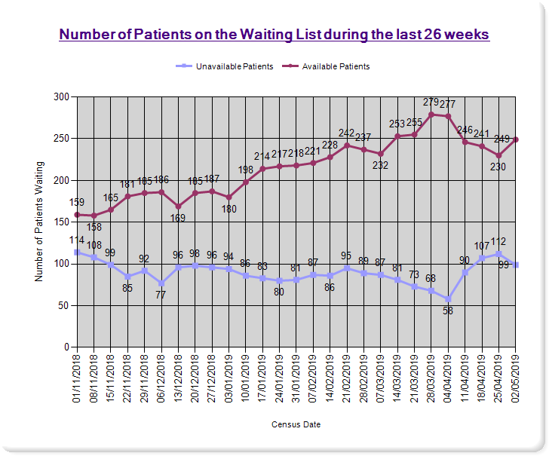 | 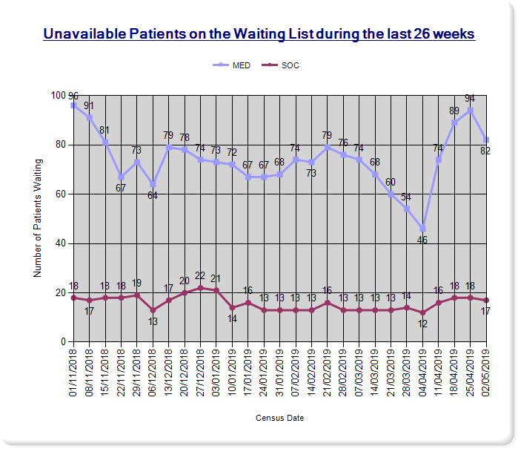
Thoracic Surgery Inpatient Waiting List

As of 2 May 2019 there were 89 patients (Figure 4) on the Thoracic Surgery Inpatient waiting list.

The distribution of patients is 73% (65 patients) on the available waiting list and 27% (24 patients) were on the unavailable list.

Figure 5: As a percentage of the total waiting list there were 8 patients (9%) medically unavailable patients and 16 patients (18%) advised that they were unavailable.

Figure 4 | Figure 5
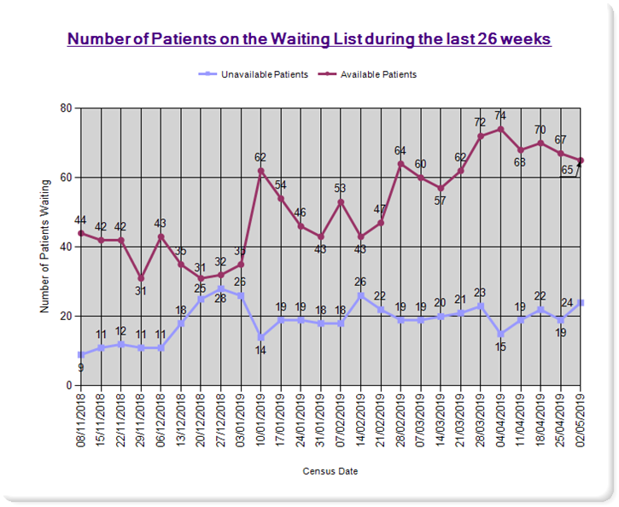 | 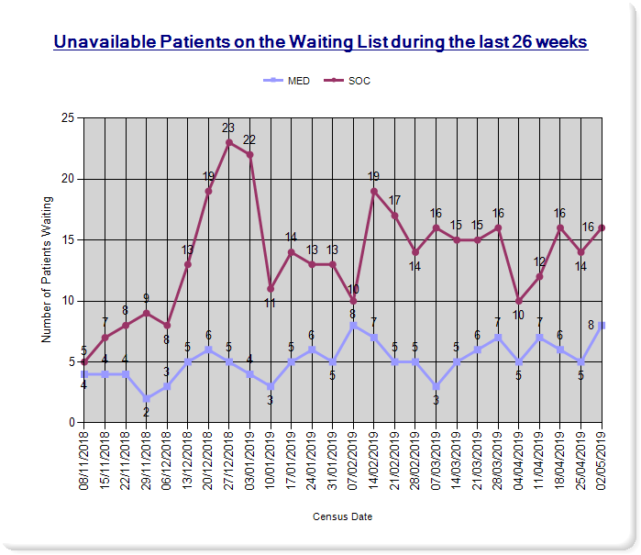

Cardiology Inpatient Waiting List
Figure 6 illustrates the number of cardiology patients on the waiting list during the last 26 weeks. On 23 May 2019 a total of 993 patients were on the cardiology waiting list with around 97% (965) patients on the available list. In addition to this, 3% (28) of patients were unavailable. The number of people on the cardiology inpatient waiting list has increased by 11% on the previous reporting period (up from 891 patients).

Figure 6
