**NWTCB – Revenue and Capital Report to 30 April 2019**

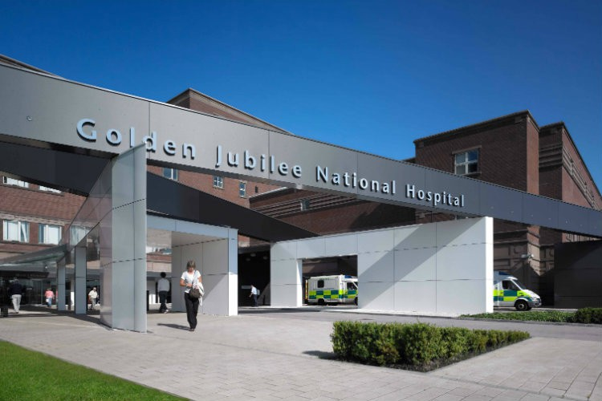

This finance report describes the financial position for the first month of financial year 2019/20 ending April 2019.

|  |
| --- |
| **The Board are asked to**   * **Note the financial position for month one up to April 2019 for the financial year 2019/20** * **Note the key messages as highlighted including agreed actions** * **Note the key risks and management of these** |
| **Key Messages**   * Total surplus as at Month one (1) of £1.217m (includes both core and non-core expenditure). * This is in line with the Forecast Financial Plan of £1.00m under-spend against core RRL by the end of quarter 1- June 2019. * The Core surplus is made up of the following:- * Income – above target by £111k year to date. * Core expenditure – under-spend of £1,067k year to date. * Non-core expenditure reflects an under-spend of £39k year to date. * As final Divisional budget sign off has not yet taken place the budget position reflects the roll forward recurring baseline as at April 2019. 19/20 pay award and superannuation increased costs are reflected from April 2019 within each Division’s expenditure and will be a driver of the current overspend by circa £500k. Pay award has been budgeted but not yet allocated to divisions. This is reflected in the actions below. The superannuation increase has not been budgeted. As described in the financial plan the Board is anticipating funding from UK and SG Government to cover the superannuation increase. Budget will be reflected once this allocation has been received. * Efficiency Savings target of £4.807m reflects a gap of £955k at this point but work continues with budget managers and Divisions to bring this in line. * There are no reasons, at this early stage in the financial year, that cause any undue concern. It is therefore anticipated that the Board will achieve the target agreed with the Scottish Government Health and Social Care Directorate and the delivery of our approved financial plan. |

**Key Actions Agreed in this Period**

* **Efficiency Savings**

As Highlighted above there remains a gap of £955k in detailed efficiency schemes to achieve the current annual 2019/20 £4.807m target. Most of the schemes identified at this stage are earmarked as recurring.

**ACTION:** Final budget meetings will aim to identify further efficiency opportunities within the Board and quantify any schemes identified and not yet calculated. Cost containment will be a focus at all levels to support achievement of the financial plan target. As per the financial plan if there remains a significant gap by September 2019 the internal escalation process will commence.

* **Scottish Government three year Pay policy**

Year two of the three year pay deal applied from 2019/20 and indicates an average pay rise of 2.57% across the AFC bands. The pay award has been implemented from April 2019 across all AFC staff group at this stage.

**ACTION:** Provision has been made for Medical and Dental, Senior Managers and Executives Pay award not yet implemented. Budget will be allocated from Month 2 reporting once final budget sign off agreed. This is planned for May 2019.

* **Scottish Government Superannuation**

Following a recent consultation, the Department of Health and Social Care (DHSC) has confirmed that the employer contribution rate was to **increase** from 14.3 per cent to 20.6 per cent (20.68 per cent including the 0.08 per cent scheme administration levy) from 1 April 2019. This has been implemented across all staff groups. The Board forecast cost of this is calculated as £4m.

**ACTION:** Provision has been made for the income from Scottish Government and held in reserve. Budget will be allocated from Month 2 reporting once final budget sign off agreed across the Divisions.

* **Annual Operational Plan meeting with Scottish Government**

Following the submission of the Boards Annual Operational Plan to Scottish Government, agreement of funding assumptions will be discussed through GJ Annual Operational plan meetings and the financial plan future funding forecast will reflect the outcome of these discussions.

**ACTION:**  Subject to final approval of GJ income assumptions from Scottish Government the RRL forecast will be amended to reflect agreed outcome.

**Financial Risk Considerations noted in this period**

It was assumed the Board would receive waiting times monies for the Interventional Cardiology and EP waiting times pressures. This income is currently being pursued from the referring Health Boards with a detailed business case planned to be presented to the May Board meeting. Scottish Government have allocated in year monies to manage the pressure while the Health Board discussions continue. Non recurring funding was received in 18/19 and used to fund the temporary mobile cath lab. In anticipation of full year recurring funding substantive nursing staff appointments were agreed in 18/19 to the full year value of £255k. There is a risk of financial exposure if the Health Board funding is not approved. The in year non recurring monies from Scottish Government will support this pressure until September/October.

# Month one (1) Revenue Position

**Introduction**

This paper gives details of the financial results for the period ending 01 April 2019, as reported to the Scottish Government Health and Social Care Directorate (SGHSCD). Budget meetings with Divisional and Corporate managers are now in final stages with budget plans, efficiencies and financial pressures reviewed and agreed, taking cognisance of the activity changes, recurring and non-recurring costs pressures, and any new funded developments. Final Division and service budget sign of will be complete by May 2019 reporting in line with the financial plan process

The Finance team are also reviewing all current and potential sources of non-recurring income to ensure every opportunity is maximised.

For the purpose of understanding the financial data tabled within this report the following guidelines are provided:

* All Income budget and actual figures are presented as credit values (in brackets), a positive variance value against income reflects an improved performance against income plan whereas a negative variance is reflective of an underperformance contrary to income plan.
* All Expenditure budget and actual values are shown as positive figures; a positive variance value against expenditure reflects a favourable under-spend against budget plan whereas a negative variance is reflected of an adverse performance on budget plan.

Before progressing into the detail of the financial position the next section summaries any key developments noted in this period that have taken place within the wider NHS environment that may impact on the financial planning of the Board.

These are summarised below:

**NSI Business Intelligence Finance Tableau Visualisation Tool**

As part of Digital development and Innovation, the NHSScotland Directors of Finance approved a business case to design and build a Business Intelligence (BI) platform for the NHSScotland finance community this is designed to improve reporting of financial information to budget holders.

Implementation of this system will incur a one-off cost to the Board of £8k and recurring investment of £3k per annum, which has been provided for within the financial plan.

National Shared Services (NSS) and National Single Instance (NSI) plan to roll out the Finance Tableau system for Board implementation by the end of Quarter 1 – June 2019. The GJ Finance training lead is in the final stages of completing the detailed training to be the Finance Tableau local expert for future reports or dashboard requests from within the finance team.

A collective list of all budget managers is being reviewed to share with NSS/NSI technical team for system level access set-up and Finance are linking with e-health to ensure appropriate access on budget managers PC/laptops is in place for point of implementation. The plan is to roll out the system to the Finance team for the first few months to build experience and knowledge before full roll-out to all Divisions for self service Finance Dashboard and reporting access (planned from Month 6). The Directorate Accountants will liaise with the budget holders in advance of this.

**Clinical Waste Contract and service Contingency**

At the previous National Directors of Finance meeting on 11th April NHS NSS tabled an update paper on the Contingency costs for 2018/19 which are being funded up by Scottish Government via NSS.

For 2019/20 all contingency costs from April 2019 to July 2019 will require to be supported locally and are subject to contract position with individual suppliers and on new contract provider Tradebe commencing future service from August 2019. Assumptions have been made within the Board financial plan to manage these costs however any movement in this timeline will require further financial consideration and will require to be managed within the Boards financial plan. This will be closely monitored.

The following section of the report now provides additional analysis of the financial position as at 30 April 2019.

**summary of the overall year to date position**

|  |  |  |  |  |  |  |
| --- | --- | --- | --- | --- | --- | --- |
|  | **Annual Budget** | **YTD Budget** | **YTD Actual** | **YTD Variance** | **Original Fin Plan Annual Budget** | **Year End Forecast Budget** |
|  | **£m** | **£m** | **£m** | **£m** | **£m** | **£m** |
| **Area** |  |  |  |  |  |  |
| **Income/Funding Core** |  |  |  |  |  |  |
| Scottish Government Allocation (RRL), including Health Boards SLA Top-slice | (79,817) | (6,696) | (6,696) | 0 | (79,937) | (79,817) |
| Other Income (including GJCH and Heart & Lung) | (65,374) | (5,329) | (5,440) | 111 | (65,253) | (65,374) |
| **Total Core Funding/Income** | **(145,190)** | **(12,025)** | **(12,136)** | **111** | **(145,190)** | **(145,190)** |
| **Expenditure Position** |  |  |  |  |  |  |
| Pay | 81,689 | 6,799 | 7,569 | (770) | 81,689 | 81,689 |
| Non Pay | 63,501 | 5,226 | 3,389 | 1,838 | 66,558 | 66,558 |
| **Total Core Expenditure Position** | **145,190** | **12,025** | **10,958** | **1,067** | **145,190** | **145,190** |
|  |  |  |  |  |  |  |
| **Total Core Surplus/(Deficit)** | **0** | **0** | **1,178** | **1,178** | **0** | **0** |
| **Non-Core Position** |  |  |  |  |  |  |
| Non Core Funding | **(6,765)** | **(548)** | **(798)** | **250** | **(6,765)** | **(6,765)** |
| Non-Core Expenditure | **6,765** | **548** | **759** | **(211)** | **6,765** | **6,765** |
| **Total Non Core Position** | **0** | **0** | **39** | **39** | **0** | **0** |
|  | **0** | **0** | **1,217** | **1,217** | **0** | **0** |
| **Total GJF Surplus/(Deficit)** |  |  |  |  |  |  |

Our financial performance compared to budget is shown on the diagrams below as at Month 1:

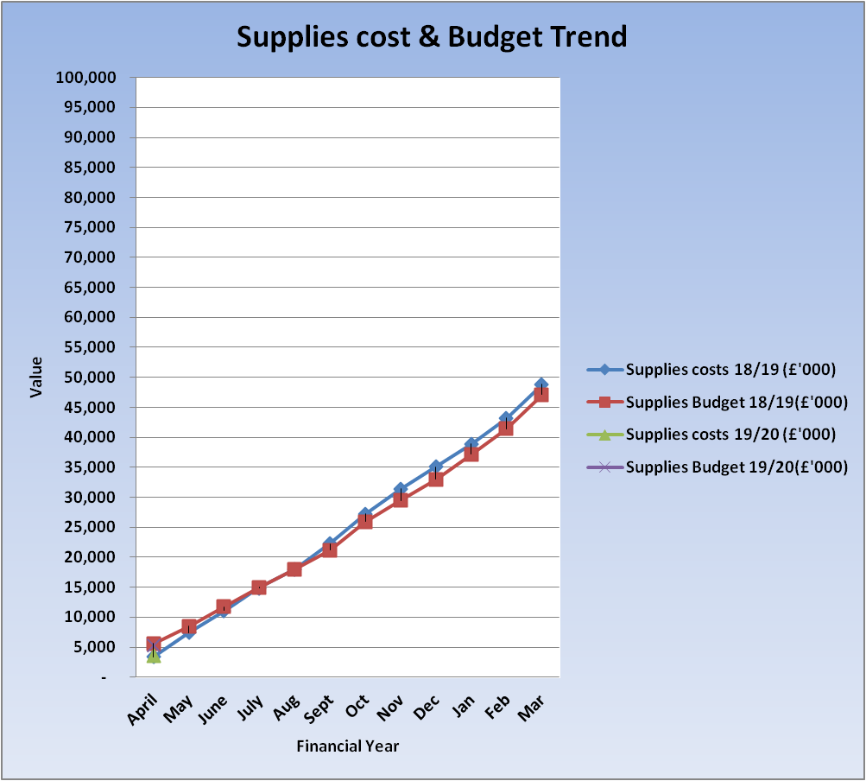

* the **pay** graph above reflects both, year to date budget and year to date actual spend for financial year 2018/19 and 2019/20, these are plotted on the graph but as the 2019/20 values reflect month one (1) only at this point the trend analysis is not yet clear. Although it should be noted that as at April 2018 budget was £6,573 and actual expenditure £7,011 compared to April 2019 budget of £6,549 and £7,569 which refects an increase in cost of £558k due mainly to AFC pay award and superannuation increase applied from April 2019.
* the **non-pay** graph above reflects both, year to date budget and year to date actual spend for financial year 2018/19 and 2019/20, these are plotted on the graph but as the 2019/20 values for month one of the financial year reflects an underspend position and is due to reserves held in place for pay/superannuation impact and financial plan pressures and developments yet to be released on agreement of final Divisional budget sign off.

Due to inclusion of only one month data reported for 2019/20 at this stage the above provides limited information but this will be developed as the year progress and will allow identification of any major shift in either cost or budget or both.

**Efficiency Savings**

At month one (1), efficiency savings schemes are not yet fully defined and calculated whilst the work continues in agreeing the full year target and the divisional and corporate budgets are finalised by the budget holders. For the full year target there remains a gap of £955k to achieve financial plan target and this will be monitored against the forecast projected below. Note this gap has reduced from the £1.4m gap described within the financial plan so good progress is being made. The savings achieved reported from month 3 will be shown in the table and graph below to demonstrate achievement against planned trajectory.

|  |  |  |  |
| --- | --- | --- | --- |
| **Cumulative value of efficiency savings as at the end of:** | | **Total Plan** | **Total Achieved** |
|  | | **£000s** | **£000s** |
| April | | 0 | **n/a** |
| May | | 0 | **n/a** |
| June | | 590 | 0 |
| July | | 900 | 0 |
| Aug | | 1,251 | 0 |
| Sept | | 1,765 | 0 |
| Oct | | 2,134 | 0 |
| Nov | | 2,690 | 0 |
| Dec | | 3,115 | 0 |
| Jan | | 3,689 | 0 |
| Feb | | 4,201 | 0 |
| Mar | | 4,807 | 0 |
|  | | |  |  |  |  |  |  |  |

The financial position is now described further.

### Details of the financial performance analysed into specific income and funding sources are noted in the table below. This includes scrutiny of the key movements and pressure areas.

**Income Analysis**

|  |  |  |  |  |  |  |
| --- | --- | --- | --- | --- | --- | --- |
|  | **Annual Budget** | **YTD Budget** | **YTD Actual** | **YTD Variance** | **Original Fin Plan Annual Budget** | **Year End Forecast Budget** |
|  | **£m** | **£m** | **£m** | **£m** | **£m** | **£m** |
| ***Area*** |  |  |  |  |  |  |
| **Income/Funding Core** |  |  |  |  |  |  |
| Scottish Government Allocation (RRL) | (61,872) | (5,200) | (5,200) | 0 | (61,992) | (61,872) |
| Core RRL – Health Boards SLA Top-slice | (17,945) | (1,495) | (1,495) | 0 | (17,945) | (17,945) |
| **Total Core Income/Funding** | **(79,817)** | **(6,696)** | **(6,696)** | **0** | **(79,937)** | **(79,817)** |
| SLA above the 10% threshold | - | - | - | - | - | - |
| Heart & Lung - Cardiac | (28,319) | (2,360) | (2,376) | 16 | (28,319) | (28,319) |
| Heart & Lung - Thoracic | (9,137) | (761) | (791) | 30 | (9,137) | (9,137) |
| Heart & Lung – Cardiology (including SPVU) | (19,973) | (1,664) | (1,564) | (100) | (19,973) | (19,973) |
| Golden Jubilee Conference Hotel | (5,121) | (314) | (314) | (1) | (5,000) | (5,121) |
| Other | (2,823) | (229) | (395) | 166 | (2,823) | (2,823) |
| **Total Other Income** | **(65,374)** | **(5,329)** | **(5,440)** | **111** | **(65,253)** | **(65,374)** |
|  |  |  |  |  |  |  |
| **Total Core Funding/Income** | **(145,190)** | **(12,025)** | **(12,136)** | **111** | **(145,190)** | **(145,190)** |

Total core income/funding position to date is £0.111m or 0.92% over year to date budget plan.

Total core full year income forecast is reported as £145.190m in line with current annual budget and original financial plan position. Adjustments are made on a monthly basis to the forecast income to include all income movements as they are notified to the Board from Scottish Government and other NHS Boards. Key movements identified from Annual Operational plan discussions will be updated and reflected from month 2 reporting onward.

|  |
| --- |
| * Non-WoS Cardiac, Thoracic, Cardiology and SPVU activity (including all NSD nationally funded services) reflect a net under performance of (£54k). The most significant position is noted within Cardiology/SPVU and is associated with a reduction in Non-WoS referrals in month as this activity is unplanned and known to fluctuate. |
| * (£1k) adverse in month performance and year to date performance for Golden Jubilee Conference Hotel income, this is partly due to a small improvement in room sales of £1k and a small performance behind plan of (£2k) within conference/food & beverage. |
| * £166k in month improved performance for other income and specifically related to Research and development projects. |

Trans Aortic Valve activity (TAVI) at the GJ commences into 2019/20. As at the end of Month one (1) reporting the Board has undertaken 7 cases. An updated position on the final TAVI criteria, activity numbers and future planning will be presented to the Chief Executive (CE) meeting in June and the forecast income and costs will be included within the next months report.

Total non-core funding for the year reflects a forecast of £6.765m as per the original financial plan, due to movement in Depreciation from forecasted future Capital projects and impairment increase. This will be reflected from month 2 reporting. The impairment value will be monitored in year with the key driver being the implementation of the new Cath Lab in 19/20 which is likely to increase the assumed £150k currently within the capital plan.

The base Revenue Resource Limit (RRL) is detailed in table 3 below which have been advised to the Board for financial year 2019/20. Further adjustments to the RRL will be presented in future reports.

**Anticipated Scottish Government RRL allocations:**

No RRL allocation for Month one has been received this routinely follows Annual Operational plan meetings and historically is received as the first allocation in early June each year.

|  |  |  |  |
| --- | --- | --- | --- |
| **Core Revenue Allocation** | **Included in Operational plan** | **Recurring/Non-recurring** | **Value - £m** |
| **Core Allocation planned as at April 2019** |  |  | **£79.937** |
|  |  |  |  |
|  |  |  |  |
| Therefore any future core anticipated allocation adjustments different to original financial plan will be reflected in the table above. | | | |
| **Non- Core Allocation** |  |  |  |
| **Non-core Allocation planned as at April 2019** |  |  | **£6.765** |
| Any non-core anticipated allocation adjustments deviating from original financial plan will be reflected in the table above. | | | |
| **Total Available funding** |  |  | **£86.702** |

**Golden Jubilee Core Expenditure brokendown by Pay and Non Pay per Division:-**

|  |  |  |  |  |  |
| --- | --- | --- | --- | --- | --- |
| ***Area*** | **Annual Budget £m** | **YTD Budget £m** | **YTD Actuals £m** | **YTD Variance £m** | **Year End Forecast Budget £m** |
| ***Surgical Directorate*** |  |  |  |  |  |
| Pay - Clinical | 42,724 | 3,557 | 3,710 | (153) | 42,724 |
| Pay - Non Clinical | 1,606 | 134 | 132 | 2 | 1,606 |
| Supplies - Clinical | 16,844 | 1,404 | 1,389 | 15 | 16,844 |
| Supplies - Non Clinical | (230) | (20) | 238 | (257) | (230) |
| ***Total Surgical*** | **60,945** | **5,075** | **5,469** | **(394)** | **60,945** |
|  |  |  |  |  |  |
| ***Regional & National Medical Directorate*** |  |  |  |  |  |
| Pay - Clinical | 19,691 | 1,641 | 1,956 | (315) | 19,691 |
| Pay - Non Clinical | 1,030 | 86 | 87 | (1) | 1,030 |
| Supplies - Clinical | 8,809 | 734 | 767 | (32) | 8,809 |
| Supplies - Non Clinical | 2,037 | 186 | 177 | 10 | 2,037 |
| ***Total Regional & National Medical Directorate*** | **31,567** | **2,647** | **2,987** | **(339)** | **31,567** |
|  |  |  |  |  |  |
| ***Corporate*** |  |  |  |  |  |
| Pay - Clinical | 1,242 | 103 | 223 | (119) | 1,242 |
| Pay - Non Clinical | 12,339 | 1,028 | 1,197 | (168) | 12,339 |
| Supplies - Clinical | 61 | 5 | (1) | 6 | 61 |
| Supplies - Non Clinical | 34,096 | 2,779 | 689 | 2,090 | 34,096 |
| ***Total Corporate*** | **47,738** | **3,916** | **2,107** | **1,808** | **47,738** |
|  |  |  |  |  |  |
| ***Hotel*** |  |  |  |  |  |
| Pay – Non Clinical | 3,056 | 250 | 265 | (15) | 3,018 |
| Supplies – Non Clinical | 1,884 | 137 | 130 | 7 | 1,933 |
| ***Total Hotel*** | **4,940** | **387** | **395** | (8) | **4,951** |
|  |  |  |  |  |  |
| ***Total Core Expenditure*** | **145,190** | **12,025** | **10,958** | **1,067** | **145,190** |

**The key issues are:**

**Surgical Clinical – Pays (£153k)**

***Medical Staffing – (£73k)***

* Junior Doctor’s net pressure associated with Agency Cover for vacancies within the Orthopaedic Divisional management team are progressing recruitment to minimise cost pressures.
* Waiting list payments/sessions covering sickness absence, study leave and vacancies, most significantly Anaesthesia.
* Recurring Medical session costs worked on behalf of GG&C, clinical lead in organ donation (CLOD) with anticipated funding due of. As this is first month reporting income receipt not yet in place from relevant Heath Boards.
* Surgical Division pressures are partly offset by an underspend within Ophthalmology & Plastic Surgery reflecting £51k favourable variance, as in prior year this is a result of activity behind Plan.
* Additional Endoscopy and General Surgery activity continues with funding anticipated via RRL from Scottish Government
* The aim to reduce waiting list initiative payments is a continued focus on efficiency review discussions, Medical Management team meeting is still to take place but actions have been agreed to progress this.

**Nursing Staff – (£32k)**

* AFC pay award and superannuation budget not yet realised to Divisions in month one and therefore Surgical nursing reports a small pressure as a result of this but we will see an improvement on allocation in Month 2.

**Clinical Support – (£47k)**

* AFC pay award and superannuation budget not yet realised to Divisions in month one and therefore Surgical clinical support reports a small pressure of (£47k) as a result of this but we will see an improvement on allocation in Month 2.
* There is continued Perfusion vacant hours, partly offsetting Band 7 to 8a
* Theatres vacancies and new starts into nursing versus Operating Department Practitioners (ODP’s)
* Orthopaedic Physician Assistant vacancies (partly offset against medical agency noted in Orthopaedics above)

**Surgical Non-Clinical Supplies – (£257k)**

* This is driven by the Theatre recurring efficiency target held against efficiency account this will be re-aligned against actual surgical supplies savings heading as fully achieved in 2018/19. This does not impact on the reported bottom line and is purely an efficiency target that requires the negative efficiency budget transferred to the surgical supplies line under Clinical supplies where the actual efficiency has been achieved.

**Regional & National Medical Clinical Pays – (£315k)**

**Medical Staffing - (£156k)**

* Continuing WLI sessions cover, particularly within SACC’s and TAVI non-recurring prior to recruitment and income receipt for month one.
* University of Glasgow funding for Cardiologist sessions
* Remaining resolution to the Laboratories GG&C SLA with NHS GG&C around activity provision

**Nursing Staff – (£85k)**

* There continues to be a pressure which is mainly due to bank nursing and overtime for staffing An update paper from the previous nursing actions paper has been received and is under review and bank nursing charges are being reviewed in detail from GGC invoicing to ensure reasons for cover aligns with escalation process.

**Clinical Support – (£75k)**

* AFC pay award and superannuation budget not yet realised to Divisions in month one and therefore clinical support reports a pressure as a result of this but we will see an improvement on allocation in Month 2.

**Regional & National Medical Clinical Supplies - (£32k)**

**Pharmacy - £48k**

* Favourable variance - the main area of under-spend driving this position is specifically from SACC’s homecare drugs as budget reflects roll-forward baseline. The budget/NSD funding profile will align with this from month 2.

**Cath Lab - (£98k)**

* Overspend as previously reported is an ongoing pressure and budget/ efficiency discussions has requested a variation in products/ devices review from within Cardiology similar to Orthopaedic.

**Corporate Directorate Clinical Pays – (£119k)**

**Nursing Staff – (£90k)**

* Over-spend in Research nursing due to budget allocated on non-recurring basis and not reflected in baseline roll-forward, this will be included for month 2 reporting.

**Corporate Directorate Clinical Non-Pays – (£168k)**

* AFC pay award and superannuation budget not yet realised to Divisions in month one and therefore clinical support/Admin report a combined pressure as a result of this but we will see an improvement on allocation in Month 2.

**Corporate Directorate Non-Clinical Supplies - £2,168k**

* Reserves reflect the positive variance against Corporate as the holding area for financial planning pressures including pay ward superannuation etc and planned developments in line with phased implementation. Month 2 will see allocation of pay award and superannuation budget from reserves and any other cost pressures and cash releasing efficiencies identified and agreed in final Divisional budget approval.

**Hotel Non-Clinical Pay – (£15k)**

Performance in April was behind plan by and the Hotel is now slightly behind budget by (£15k) year to date. Whilst this figure is not causing concern at this stage, the Hotel will continue to monitor this closely against income performance

**Efficiency Savings Programme**

### Efficiency Savings Programme

As outlined above, a detailed Programme Tracker report captures the progress for the Efficiency plan. These are categorised in terms of Risk Assessment in addition to work-stream areas. The table below reflects the planned forecast against the trajectory as per original financial plan. As some schemes have yet to be calculated and normal reporting aligns from month 2 this actual position against forecast will be reported in future months.



**This section of the report is focused on the current forecast financial position**

The following table shows the core financial Out-turn against plan and forecast trajectory as

described within our financial plan. This shows the Board is on plan to deliver in line with the

trajectory at this early stage.

|  |  |  |
| --- | --- | --- |
| **Revenue Outturn** | **RRL Plan Surplus/(Deficit)** | **RRL Actual Surplus/ (Deficit)** |
| **Saving / (Excess) against Core RRL as at the end of:** | **£000s** | **£000s** |
| April | 0 | 1178 |
| May | 0 | 0 |
| June | 1,000 | 0 |
| July | 825 | 0 |
| Aug | 600 | 0 |
| Sept | 300 | 0 |
| Oct | 175 | 0 |
| Nov | 0 | 0 |
| Dec | 0 | 0 |
| Jan | 0 | 0 |
| Feb | 0 | 0 |
| Mar | 0 | 0 |

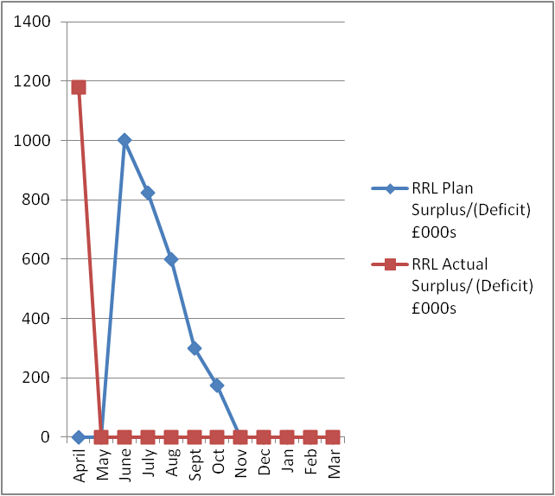

**Financial Risk Considerations**

This section highlights to the Board any key risks currently facing the organisation

in achieving its revenue financial targets.

**Movement in Income**

* Outcome of Annual Operational plan discussions with Scottish Government in line with

Developments and funding assumptions with RRL section of Financial plan, with particular reference to cardiology and EP.

**Medical Staffing cost pressures**

* Slow impact from efficiency related projects to reduce waiting list initiative costs

**Nursing**

* Overtime and Bank reliance in Regional & National Medicine, this is currently being reviewed by

the Director of Nursing.

**Efficiency Savings gap**

* Although the current unidentified balance reduced from £1.488m at original financial planning submission to current gap of £0.955m. Active discussions continue with the Divisions and Corporate services.

**Horizon Scanning**

* Brexit preparedness, likely impact of October 31 revised deadline.

# The Month One Capital Position

### Capital Spend

At the end of month one there has been no capital expenditure incurred, this is in line with the plan for the year as the majority of the spend routinely takes place in the second half of the year. Plans are in progress in line with the approved Capital Plan

**Capital – Detail**

The three elements which make up the capital budget as agreed with the Board and SGHSCD for 2019/20 are noted below:-

* Formula Capital – this allocation is the money that the Board is provided with the fund all capital requirements within year that are not subject to approval by National Capital Investment Group. This funding is broken down into three components:-
* Estates (Building Infrastructure)
* Medical Equipment and
* IM&T
* Capital Stimulus Monies – this allocation was provided by SGHSCD to increase imaging capacity across Scotland, the residual balance in year of £1.922m has been agreed with SGHSCD with the monies in year planned to contribute to cath lab five and finalising with replacement of the cardiac MRI. This is included with the formula capital in the table below.
* Elective Centre Funding – this is the Board allocation for the funding of the development at the site and is split between phase one and phase two. Phase one relates to the Ophthalmology expansion with funding of £10.473m included in the plan for the year, this spend will vary dependent progress throughout the year.

Phase two relates to the creation of a new facility to increase Orthopaedic Surgery capacity, £421k has been allowed in the capital plan in year with regard to this. The plan was submitted before any recent developments and progression of this development. It has been agreed with Scottish Government that this estimate will be revised to be in line with the updated Outline Business Case currently being developed.

**The Formula Capital**

The base formula allocation for 2019/20 is £2.691m, this year the capital stimulus money has been assumed as part of this allocation which brings the allocation to £4.613m. The detail of what has been included in the plan for the year has been agreed at the capital group meeting on 13 February 2019 with a revision undertaken on 8 May 2019. The anticipated spend is summarised in the table below:-

|  |  |  |
| --- | --- | --- |
| **Area** | **2019/20**  **£000s** | **Spend to 30 April**  **£000ms** |
| Property | 1,837 | - |
| Medical Equipment | 2,296 | - |
| IM&T | 480 | - |
| **Formula** | **4,613** | **-** |

Through the capital group (informed by the Medical Equipment Group, the PAMS group and the e-Health Steering Group) we have undertaken a detailed review of all the plans which form part of these allocations to ensure that all items within the plan will be undertaken in the current year. The likely area that will be subject to change is the expenditure relating to cath lab five, subject to final agreed revenue funding by the Health Boards.

Detailed reports will be presented to the Capital Group on a monthly basis to ensure that spend can be monitored against budget and corrective action taken when necessary.

**The Capital Stimulus**

Residual balance of the capital stimulus money (originally £5m) is £1.922m. The majority of this is earmarked to support the provision of a fifth cath lab and associated building works. These funds are included with the formula capital this year, in agreement with SG.

**The Elective Centre**

The spend for the elective centres will be monitored as in prior year by the cost control group for the project, with two separate valuations being considered with detailed cost control reports being presented to SMT. As there has been no spend in period one this section will be updated for future reports.

**Director of Finance**

**14 May 2019**

Golden Jubilee Foundation Values Statement



**Finance Values to Deliver this Vision:-**

**F**uture Focused – we will constantly identify emerging changes that will impact on the department and incorporate them into the way we work

**I**ntegrity – we will adhere to our responsibilities to ensure that the vision of the department is delivered effectively

**N**ew skills and support – we will strive to find practical, effective and innovative solutions to achieve the required outcomes

(can do) **A**ttitude – we will strive to ensure that the culture of the department supports a can do approach

i**N**novative thinking – we will ensure that we embrace new innovative ways of working to continually improve our practices

**C**ulture – we will work together collaboratively and in recognition of the contribution that person makes to the Department’s objectives, in doing this we will recognise the value of all points of view and treat everyone equally

**E**xpertise – we are a reliable source of accurate information and sound financial advice