Board Meeting: | 1 August 2019
Subject: | Board Performance Report
Recommendation: | Board members are asked to:  Discuss and Note X  Discuss and Approve  Note for Information only

__________________________________________________________________

- Introduction

The Board is asked to discuss the content of the performance report covering matters discussed at the July 2019 meeting of the Performance and Planning Committee.

- Board Exception Report – Key Performance Indicators (KPIs)

- Effective KPIs
- Person-centred KPIs
- Safe KPIs

- Divisional Exception Reports

(a) Surgical Services
(b) Regional and National Medicine

- Waiting lists – Cardiac Surgery, Thoracic Surgery and Cardiology.

- Corporate Balanced Scorecard (Appendix 1)

2 Recommendation

Board members are asked to note the update for the current reporting period.

Jann Gardner
Chief Executive
19 July 2019
(Carole Anderson, Head of Strategy and Performance)

Board Exception Report
Improved performance
Same performance
Worse performance

Effective Board Performance update – July 2019
KPI | Details |  |  |  | Tolerance |  | Mar 2019 |  | Apr 2019 |  |  |  | May 2019 |  | Target |  |  | On Track
Elective Acute Ward Bed Occupancy | Combined occupancy position for NSD, 2 East, 2 West, 3 East, 3 West |  |  |  | >90.1% = Red  86-90%= Green  78-85.9% = Amber  <77.9% = Blue |  | 81.3% |  | 77.0% |  |  |  | 78.6% |  | 86-90%
Interventional Cardiology Wards Bed Occupancy | Combined occupancy position for 2C, 2D and CCU |  |  |  | 87.4%- 100% = R  81% -87.3% = G  77%-80.9%= A  <76.9% = B |  | 81.7% |  | 84.3% |  |  |  | 82.8% |  | 81-87.3%
Critical Care Wards Bed Occupancy | Combined occupancy position for ICU1, ICU2, HDU2, HDU3 |  |  |  | ≥ 84.8% = R  73 – 84.7% = G  63.4 – 72.9% = A  ≤ 63.3% = B |  | 76.8% |  | 73.6% |  |  |  | 71.2% |  | 73-84.7%
Analysis
Overall bed occupancy in the elective acute wards increased by 1.6% in May compared to April. Wards 2 East, 2 West and the National Services ward all reported increases in occupancy. Ward 3 East and Ward 3 West occupancy rates decreased.
Overall occupancy levels in the cardiology wards remained within the “green” target range for the seventh successive month during May.
April ICU1's bed occupancy was reported at 75.8%. This is the highest occupancy reported for the ward in the scorecard period (since April 2016). ICU1’s occupancy level then reduced by 11.2% in May. Overall bed occupancy within the critical care units increased by 2.4% in May compared to April.
A paper on the reporting of bed occupancy within the organisation was presented to the group. The paper recommended that a single KPI recording the total bed occupancy of the whole hospital should be created with the tolerances set to represent the aggregated totals of the existing KPIs. The total hospital bed occupancy will be reported on the new Integrated Performance Report (IPR) dashboard. Detailed reporting of ward level occupancy by area will combine the two high dependency units being reported as a single entity. The three cardiology wards will also be combined for reporting purposes. The group agreed the recommendations and accepted that the changes would be implemented in time for the creation of the second IPR in August.
KPI |  | Details |  |  | Tolerance | Mar 2019 |  | Apr 2019 |  |  | May 2019 |  |  | Target |  |  |  |  | On Track
Ophthalmology Cancellation Rate |  | Percentage of Ophthalmology patients cancelled on day of procedure |  |  | Achieved = G  Not Achieved = R | 3.5% |  | 2.2% |  |  | 2.9% |  |  | Monthly 3% cancellation rate
Plastic Surgery Cancellation Rate |  | Percentage of Plastic Surgery patients cancelled on day of procedure |  |  | Achieved = G  Not Achieved = R | 4.2% |  | 0.0% |  |  | 0.0% |  |  | Monthly 3% cancellation rate
General Surgery Cancellation Rate |  | Percentage of General Surgery patients cancelled on day of procedure |  |  | Achieved = G  Not Achieved = R | 9.6% |  | 9.7% |  |  | 6.7% |  |  | Incremental reduction from baseline position of 9% to 7% by March 2020
Cardiology Cancellation Rate |  | Percentage of Cardiology patients cancelled on day of procedure |  |  | Achieved = G  Not Achieved = R | 9.5% |  | 6.8% |  |  | 2.0% |  |  | Monthly 4% cancellation rate
Cardiac Surgery Cancellation Rate |  | Percentage of Cardiac Surgery patients cancelled on day of procedure |  |  | Achieved = G  Not Achieved = R | 10.8% |  | 11.3% |  |  | 12.1% |  |  | Incremental reduction from baseline position of 12% to 10% by March 2020
Orthopaedic Cancellation Rate |  | Percentage of Orthopaedic patients cancelled on day of procedure |  |  | Achieved = G  Not Achieved = R | 3.2% |  | 3.6% |  |  | 3.4% |  |  | Monthly 3% cancellation rate
Endoscopy Cancellation Rate |  | Percentage of Endoscopy patients cancelled on day of procedure |  |  | Achieved = G  Not Achieved = R | 6.0% |  | 9.7% |  |  | 7.9% |  |  | Incremental reduction from baseline position of 6% to 5% by March 2020
Thoracic Surgery Cancellation Rate |  | Percentage of Thoracic Surgery patients cancelled on day of procedure |  |  | Achieved = G  Not Achieved = R | 8.6% |  | 9.0% |  |  | 5.7% |  |  | Incremental reduction from baseline position of 5% to 4% by March 2020
Analysis
During May, the challenging stretch targets for 2019/20 cancellations were met by ophthalmology, general surgery, cardiology and plastic surgery. For the second month in succession there were no cancellations in plastic surgery.
There were 18 cardiac surgery cancellations during May, an increase of one on April. Six of the cancellations were due to the patient not being fit. Five cancellations were due to a lack of operating time as a result of case complexity or prioritisation of urgent cases. In thoracic surgery there were seven cancellations, a decrease of five compared to April. Three of the thoracic cancellations were related to emergency procedures taking priority. There were 15 endoscopy cancellations in May. A reduction of three compared to April. Eleven of the cancellations (10 Did Not Attend, one Could Not Attend) were related to patient attendance for appointments. A campaign with the aim of reducing the number of patients who do not attend for their endoscopy procedures has started. There were 15 orthopaedic cancellations, two more than in April. However increased activity in May has seen the cancellation rate decrease. The most common orthopaedic cancellation reason in May was due to the patient not being fit.

KPI |  |  | Details |  | Tolerance |  | Mar 2019 |  |  | Apr 2019 |  |  | May 2019 |  | Target |  |  | On Track
Treatment Time Guarantee (TTG) |  |  | Percentage of patients admitted within 12 weeks |  | 100% = Green  95-99.9% = Amber  ≤94.9% = Red |  | 93.5% |  |  | 93.4% |  |  | 94.2% |  | 0
Analysis
In May 1,446 (94.2%) patients were treated within 12 weeks. There were 89 patients treated over the 12 weeks TTG in May, one less than in April. The patients treated beyond their 12 week guarantee date were comprised of 11 coronary, 45 electrophysiology, 10 device, two lead extraction and 21 cardiac surgery patients.

KPI |  |  |  | Details |  |  | Mar 2019 |  | Apr 2019 |  |  | May 2019 |  |  |  | Target | On Track
Cardiac Surgery Day of Surgery Admission Rate |  |  |  | Target for 20% of Cardiac Surgery major procedure admissions to be DoSA by March 2020 |  |  | 15.9% |  | 8.7% |  |  | 7.6% |  |  |  | ≥20% by March 2020
Orthopaedic Day of Surgery Admission Rate (Primary Joint Replacement) |  |  |  | Target for 75% of Orthopaedic Primary Joint Replacement admissions to be DoSA. |  |  | 56.1% |  | 59.4% |  |  | 54.4% |  |  |  | ≥75% from October 2018
Thoracic Surgery Day of Surgery Admission Rate |  |  |  | Target for 40% of Thoracic Surgery admissions to be DoSA. |  |  | 22.5% |  | 26.4% |  |  | 23.3% |  |  |  | ≥40%
Analysis
In May, 166 orthopaedic and 20 thoracic patients were admitted as Day of Surgery Admissions (DoSA).
Five cardiac surgery patients were admitted as DoSA in May. Absence among the anaesthetic team during Spring meant that fewer patients than anticipated were assessed at the pre-operative assessment clinic where suitable DoSA candidates are identified, impacting on the DoSA rates for April and May.

Safe Board Performance update – July 2019
KPI | Details | Tolerance | Q3 2018/19 | Q4 2018/19 | April 2019 | Target | On Track
MRSA/MSSA bacterium | Maintain a rate of 0.12 cases per 1000 acute occupied bed days | ≤0.12 = G  >0.12 = R | 0.25 | 0.17 | 0 | ≤0.12 = G
Clostridioides difficile infections (CDI) in ages 15+ | Maintain at 0.10 cases per 1000 total acute occupied bed days or lower | ≤0.10 = G  >0.10 = R | 0 | 0 | 0 | ≤0.10 = G
No instances of MRSA/MSSA bacterium were reported during April.
No instances of CDI have been reported since June 2018.

Person Centred Board Performance update – July 2019
KPI |  |  | Details |  | Tolerance |  |  | Feb 2019 |  |  | Mar 2019 |  |  | Apr 2019 |  |  |  | Target |  | On Track
Total complaints. |  |  | Measured as a percentage of patient activity. |  | ≤ 0.10% = Green  0.11% - 0.14% = Amber  ≥0.15% = Red |  |  | 0.08% |  |  | 0.12% |  |  | 0.12% |  |  |  | ≤0.10%
Stage One complaints responded to within 10 days. |  |  | Measured as a percentage of complaints received. |  | >75% = Green  75% - 60% = Amber  <60% = Red |  |  | 100% |  |  | 88% |  |  | 71% |  |  |  | >75%
Stage Two complaints responded to within 20 days. |  |  | Measured as a percentage of complaints received. |  | >75% = Green  75% - 60% = Amber  <60% = Red |  |  | 60% |  |  | 0% |  |  | 50% |  |  |  | >75%
Analysis
During April, there were seven Stage One complaints and two Stage Two complaints.
Five of the seven Stage One complaints received during April were responded to within five days. In both instances where the five-day response target was not met, attempts had been made to contact the patient prior to day five. There was a delay in Executive sign off for one of the two Stage Two complaints received in April. This resulted in one complaint exceeding the 20 day response target.
During May, there were six Stage One complaints and seven Stage Two complaints.
KPI | Details |  |  |  |  | Tolerance |  |  | Feb 2019 |  |  | Mar 2019 |  |  | Apr 2019 |  | Target |  |  | On Track
Sickness Absence | Percentage hours lost due to staff sickness absence as reported via SWISS |  |  |  |  | Achieved = Green  Not achieved = Red |  |  | 4.55% |  |  | 4.48% |  |  | 4.28% |  | ≤4%
Analysis
The SWISS sickness absence figure reported for April was 4.28%, the lowest sickness absence rate since April 2017. This was also below the NHSScotland reported rate of 5% across all 22 Scottish NHS Boards.

KPI |  | Details |  | Tolerance |  |  | Apr 2019 |  |  | May 2019 |  |  | Jun 2019 |  |  | Target |  |  | On Track
TURAS PDR - Actively using TURAS for annual PDR |  | Maintain at 80% or above |  | ≥80% = G  ≤79.9% = R |  |  | 55% |  |  | 64% |  |  | 67% |  |  | ≥80%
The first reporting of TURAS data showed that 55% of staff had a completed annual Personal Development Review (PDR) at the end of April. There has been continued improvement on this figure over May and June.
The June PDR completion rate for each division was as follows:
- Corporate – 64% (up 1%)
- Hotel – 90% (up 5%)
- Regional and National Medicine – 79% (up 1%)
- Surgical Services – 58% (up 5%)

Surgical Services Division Performance Board Performance Update – July 2019

ISSUE | ACTION | RESPONSIBLE LEAD | TIMESCALE
Critical Care | During May, there was a reduction in the cardiology bed requirement to 32 bed days from 48 bed days in April. This reduced the unpredictable admission rate. There was no impact on elective cases due to staffing or bed availability during May. | Lynn Graham | Ongoing
Wards | The surgical bed pressures across 3 East and 3 West have remained a challenge. The demands on the wards have triggered some opportunities with the creation of an improvement group focused on criteria led discharge and systems improvements to improve flow. This project, with a dedicated “Discharge Team” within 3 East, commenced on the week beginning 24 June 2019 with initial positive feedback. | Lynn Graham | Ongoing
Cardiac Surgery | Activity levels remain high with 341 major cardiac cases undertaken within the first three months of 2019/20. This is in line with the high activity levels seen within 2018/19. Over 35% of patient activity was within the urgent and emergency group, meaning that the waits for true elective patients continue to grow with a few patients now waiting over 26 weeks.  The service continues to struggle to keep up with referral demand and to meet the 12-week Treatment Time Guarantee (TTG) whist aiming to ensure that clinically appropriate timescales are met for patients. In May, 41 patients breached the TTG and in June this increased to 56 patients.  Opportunities to recover from this position continue to be maximised. Approval has been granted to open the unfunded Friday theatre with recruitment underway to allow this small scale increase in capacity of approximately six patients per month. Given the sustained growth within the service, the impact is unlikely to be significant without a re-vamp of the current theatre model through more radical re-design and investment to meet the changes in demand.  Anaesthetic assessment continues to be a central feature of the cardiac outpatient model, with plans to explore how this could be adopted to benefit thoracic patients. The model is dependent on availability of consultant anaesthetists. Assessment levels dropped over the spring largely due to some significant consultant anaesthetist absence. | Lynn Graham | Ongoing
Thoracic | The thoracic service has now successfully treated over 105 patients with a planned Robotic Assisted Thoracic Surgery (RATS) procedure. A fourth thoracic surgeon has completed his robotic training and proctorship is in place. As the expertise builds and numbers of patients treated by RATS increase within the thoracic surgeon group, the benefits of the minimally invasive approach are beginning to be realised.  A group is taking forward the learning from a visit to Oxford in April to review enhanced monitoring beds for thoracic patients within this unit. A study day is planned for August for the ward nursing staff. Protocols are in draft form and it is hoped a pilot will commence in September.  In May and June all non-cancer patients were treated within the 12-week treatment time guarantee and all cancer patients were treated within the 31-day pathway. | Lynn Graham | Ongoing
Orthopaedics | The orthopaedic DoSA rate for May was 55%. Continued scrutiny of individual theatre lists has resulted in some patients from remote and rural areas being able to follow a DoSA pathway, which was positive for them and the service. The work will be presented at the next available Continuing Medical Education session, with the intention of establishing a standardised DoSA process for this patient group.  During May, 26% of patients undergoing primary total hip replacement were discharged on post-operative day one with day one discharge accounting for 15% of overall activity.  As part of the programme to review in patient flow, the physiotherapy and nursing team undertook a 30-day challenge in May to optimise the number of patients who had the opportunity to get up on the day of surgery. It resulted in a 9% increase in patients up to sit on day zero and all patients being up by midday on post-operative day one.  Two newly appointed band four assistant practitioners, facilitated through Strategic Projects funding, have been vetting patients in clinic for three months. As a result, unnecessary testing has reduced with fewer patients failing pre-operative assessment. The assistant practitioners will also be assisting the nurse pre-operative practitioners manage the unavailable patient lists.  Funding awarded by the Scottish Government has allowed two nurses to review orthopaedic and cardiac patients in clinic as part of the pre-operative anaemia programme. This aims to manage anaemic patients, ensuring they are in an optimal condition to undergo surgery. To date a total of 41 patients have required treatment with four requiring intravenous (IV) Iron and 37 oral therapy. Out of the 41 patients treated, 23 were Cardiac and 18 were Orthopaedic patients. | Christine Divers | Ongoing
Ophthalmology | In preparation for the phase one expansion, a band four ophthalmology technician has been appointed and we are currently in the process of appointing a band five registered nurse. | Lynn Graham | Ongoing
Regional and National Medicine Division Performance Board Performance Update – July 2019

ISSUE | ACTION | RESPONSIBLE LEAD | TIMESCALE
Scottish National Advanced Heart Failure Service (SNAHFS) Transplant Update | Two transplants have been carried out during 2019/20.  NHS Blood and Transplant (NHSBT) has announced Organ Care System funding availability from 1 July 2019, which will allow for transplantation of organs donated after cardiac death. Following due governance, the team will be proctored by Papworth. A formal business case will follow, describing a collaborative service with the other transplant centres, which will progress to NHSBT for consideration. | Lynne Ayton | Ongoing
Scottish Adult Congenital Cardiac Service (SACCS) | Preparation for the SACCS peer review on 23 July is well underway with regular ‘state of readiness’ meetings. Self-assessment and key evidence documents have already been submitted. An SBAR describing the process and the likely risks including the single consultant cardiologist position was presented to the Executives on 22 June 2019.  As at 2 July, there were 1,749 patients on the return waiting list, an increase of 49 compared to May. A total of 618 patients waited beyond their recall date, and of these patients 546 had no appointment date.  As previously reported, without any material change in position, the measures put in place to address the shortfall are having minimal impact. If their symptoms change, patients are able to access Specialist Nurses who continue to expedite appointments if clinically appropriate. | Lynne Ayton | Ongoing
Interventional Cardiology | The coronary waiting list position is starting to rise again following the decommissioning of the mobile cardiac catheterisation laboratory (cath lab), with 115 patients breaching the TTG in May (from 71 in April).  Eleven patients are waiting over 26 weeks, nine of whom are Electrophysiology (EP) patients. The remaining two patients had unavailability after the initial breach, which does not stop the waiting time clock.  The business cases to support both the build and equipping of a new fifth cath lab were supported at the Board in June, pending revenue funding approval. The Associate Director of Operations is meeting with Operational teams in the West of Scotland to alert them to the pending funding requests, which will be made through the Directors of Finance group.  Non recurring funding has been authorised to hire a mobile lab for eight weeks during August and September. This will provide capacity for 60 additional EP procedures, reducing the wait by 6 weeks. Approximately 120 coronary procedures are also planned to be performed in the mobile lab. | Lynne Ayton | Ongoing
Transcatheter aortic valve implantation (TAVI) | The National Planning Board has recommended to deliver TAVI in Scotland across three regional centres with a single centre model for non transfemoral TAVI provision. The three centres are Royal Infirmary Edinburgh (RIE), Golden Jubilee National Hospital (GJNH) and Aberdeen Royal Infirmary with RIE the designated single centre for all non transfemoral TAVI.  The recommendation is that GJNH will accept referrals from the West of Scotland. It is projected that GJNH will deliver 130 transfemoral TAVI procedures per annum and refer approximately 22 patients to RIE for non transfemoral TAVI. | Lynne Ayton | Ongoing
Scottish Pulmonary Vascular Unit (SPVU) | The improvement in waiting times has been sustained with patients being assessed within 6-8 weeks of referral. These reduced waiting times have resulted in an overall reduction in the time from referral to diagnosis, which is reported as part of the national audit. The outreach clinics are continuing with plans to further expand outreach in Aberdeen. | Lynne Ayton | Ongoing
Radiology | The backlog position for reporting of scans in radiology continues to provide a challenge, with around 2,000 reports outstanding. An outsourcing solution has been agreed and pending successful connectivity, the backlog will reduce significantly and clear by the middle of August. There is a plan to maintain outsourcing to support the gap between examination and reporting capacity until a substantive solution is in place to increase Radiologist reporting. Funding the outsourcing is budget neutral against underspend on Consultant sessions.  Cardiac imaging demand continues to be significantly greater than capacity. This issue will be highlighted through the West of Scotland Regional Planning Group Cardiac clinical strategy and also through the National Planning Board Cardiac horizon scanning work. When possible the department provide additional sessions in an attempt to reduce waiting times. These exams are not reportable through TTG. | Lynne Ayton | Ongoing

Cardiac Surgery Inpatient Waiting List
This is a snapshot of the cardiac surgery inpatient waiting list as at 27 June 2019 with a total of 349 patients waiting for surgery. Approximately 72% of the total waiting list are patients that are on the available waiting list (252 patients) and 28% (97 patients) were unavailable.

Figure 2: As a percentage of the total waiting list, the number of unavailable patients was 21% (73 patients) were for medical reason and 7% (24) were patients advised unavailability.

Figure 1 | Figure 2
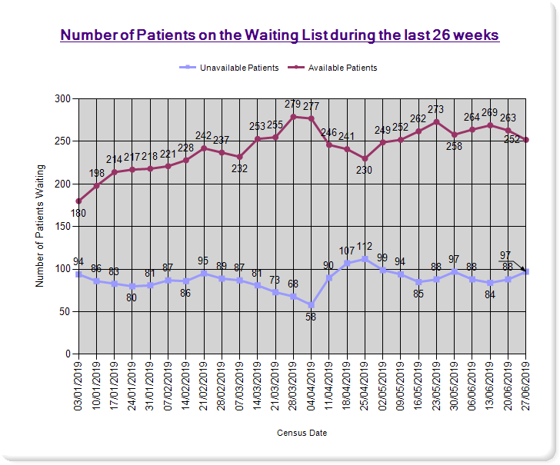 | 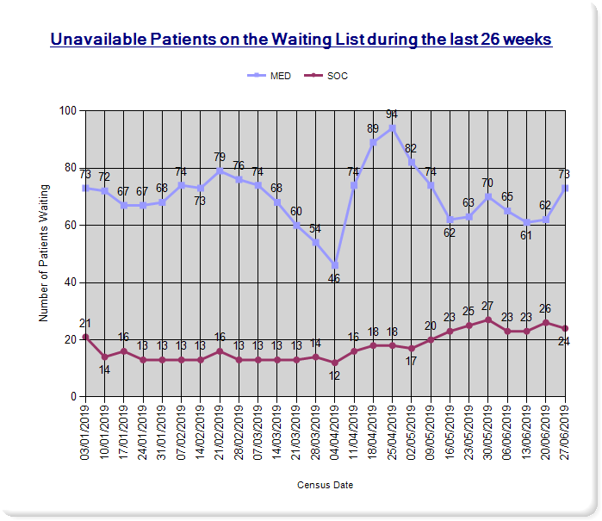

Thoracic Surgery Inpatient Waiting List

As of 27 June 2019 there were 93 patients (Figure 4) on the Thoracic Surgery Inpatient waiting list.

The distribution of patients is 75% (70 patients) on the available waiting list and 25% (23 patients) were on the unavailable list.

Figure 4: As a percentage of the total waiting list there were 6 patients (6%) medically unavailable patients and 17 patients (18%) advised that they were unavailable.

Figure 3 | Figure 4
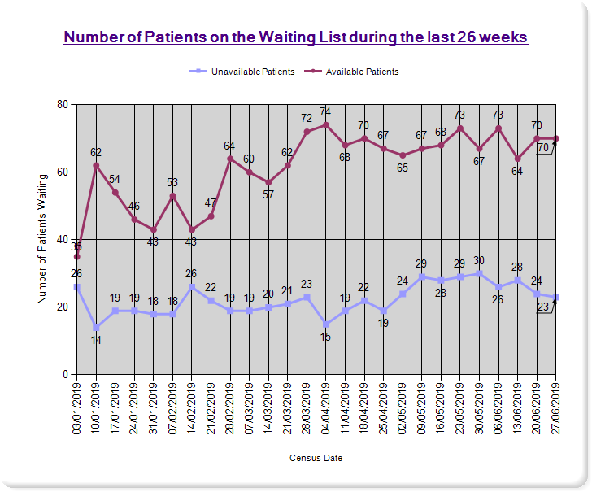 | 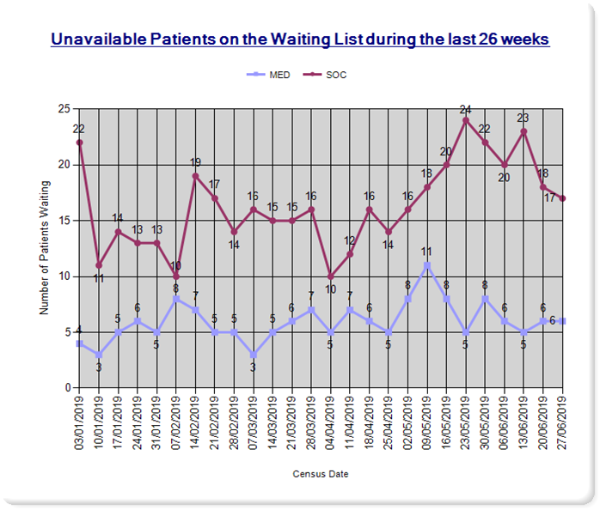

Cardiology Inpatient Waiting List
Figure 5 illustrates the number of cardiology patients on the waiting list during the last 26 weeks. On 4 July 2019 a total of 1055 patients were on the cardiology waiting list with around 96% (1018) patients on the available list. In addition to this, 4% (37) of patients were unavailable. The number of people on the cardiology inpatient waiting list has increased by 6% on the previous reporting period (up from 993 patients).

Figure 5
