

**NHS Golden Jubilee Revenue and Capital Report to 31 May 2019**

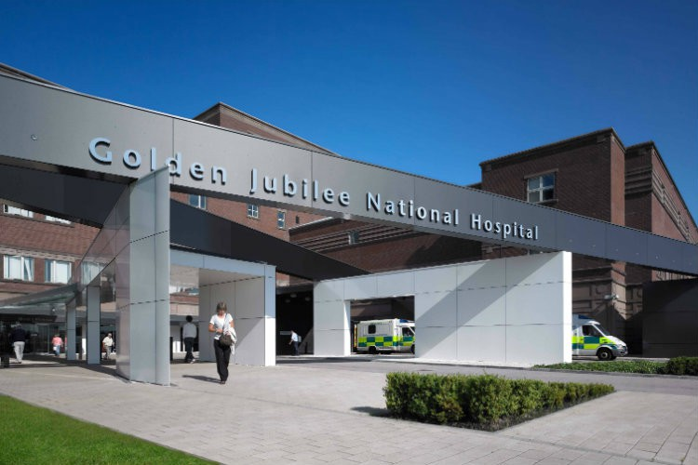

This finance report describes the financial position as at month 2, for the period ending 31 May 2019.

|  |
| --- |
| **The Board are asked to**   * Note the financial position for month 2, as at 31 May 2019 for the financial year 2019/20 * Note the key messages as highlighted including agreed actions * Note the key risks and management of these |
| **Key Messages**   * Total surplus as at Month two (2) of £1.094m (includes both core and non-core expenditure). * This is in line with the Forecast Financial Plan of £1.000m under-spend against core RRL by the end of quarter 1- June 2019. * The Core surplus is made up of the following: - * Income – above target by £0.016m year to date. * Core expenditure – under-spend of £1.049m year to date. * Non-core expenditure reflects an under-spend of £0.029m year to date. * Divisional budget sign-off is in final stage and therefore budget position reflects the roll forward recurring baseline as at April 2019 plus 2019/20 AFC pay award only. Superannuation increased costs are reflected from April 2019 within each Division’s expenditure and will be a driver of the current overspend by circa £0.600m. * Pay award for medical and Senior Management/Executive staff has been budgeted within reserves but not yet allocated to divisions as this has not yet been processed via payroll. The superannuation increase has been provided for on the basis of the 6% increase on budgeted wte. As described in the financial plan the Board is anticipating funding from Scottish Government (SG) to cover the superannuation increase however funding is calculated on the basis of the March’19 cumulative SPPA contributions for the Board. Budget will be released once this allocation has been received. * Efficiency Savings target of £4.807m reflects a gap of £0.955m at this point but some corporate schemes have yet to be defined and calculated and will reduce the gap further. Work continues with budget managers and Divisions to bring this in line. * There are no reasons, at this early stage in the financial year, that cause any undue concern. It is therefore anticipated that the Board will achieve the target agreed with the Scottish Government Health and Social Care Directorate and the delivery of our approved financial plan. |

**Key Actions Agreed in this Period**

* **Efficiency Savings**

As Highlighted above there remains a gap of £0.955m in detailed efficiency schemes to achieve the current annual 2019/20 £4.807m target. Most of the schemes identified at this stage are earmarked as recurring.

**ACTION:** Final corporate budget meetings identified some new schemes of smaller value to further reduce the £0.955m gap with some areas not yet calculated. Discussions continue at Divisional and finance meetings to remove the gap. Cost containment will be a focus at all levels to support achievement of the financial plan target. As per the financial plan if there remains a significant gap by September 2019 the internal escalation process will commence.

* **Scottish Government three year Pay policy**

Year two of the three year pay deal applied from 2019/20 and indicates an average pay rise of 2.57% across the AFC bands. The pay award has been implemented from April 2019 across all AFC staff group at this stage.

**ACTION:** Provision has been made for Medical and Dental, Senior Managers and Executives Pay award not yet implemented. Budget will be allocated on processing of agreed uplift once agreed.

* **Scottish Government Superannuation**

Following the recent consultation on the employer contribution rate **increase** from 14.3 per cent to 20.6 per cent a short life working group led by Scottish Government was compiled to identify the Scotland wide NHS impact. The outcome of this was that funding would be agreed on the March 2019 SSPA contributions on staff in post as which equated to £3.2m for GJ.

**ACTION:** Provision has been made for the income and cost of this increase in financial planning. This will be aligned to reflect agreed funding basis from Scottish Government and held in reserve. Budget will be allocated on receipt of funding from Scottish Government through RRL allocations.

* **Annual Operational Plan meeting with Scottish Government**

Following the submission of the Boards Annual Operational Plan to Scottish Government, agreement of funding assumptions will be discussed through GJ Annual Operational plan meetings and the financial plan future funding forecast will reflect the outcome of these discussions.

**ACTION:**  Subject to final approval by GJ income assumptions from Scottish Government (including £600k towards Cardiology or Cardiac activity pressures) then budget will be released accordingly and service plans put in place until final regional agreement on activity increases are funded.

**Financial Risk Considerations noted in this period**

It was assumed the Board would receive waiting times monies for the Interventional Cardiology and EP waiting times pressures. This income is currently being pursued from the referring Health Boards with a detailed business case planned presented to the May Board meeting. Scottish Government have allocated in year monies to manage the pressure while the Health Board discussions continue. Non recurring funding was received in 18/19 and used to fund the temporary mobile cath lab. In anticipation of full year recurring funding substantive nursing staff appointments were agreed in 18/19 to the full year value of £0.255m. There is a risk of financial exposure if the Health Board funding is not approved. The in year non-recurring monies from Scottish Government will support this pressure until September/October.

Superannuation funding will be based on the underlying March 2019 cumulative SPPA contributions versus staff whole time equivalent (wte) budget as previously earmarked within the boards financial plan. Any vacancies in place at March 2019 will not be incorporated and is the basis of the difference between budget calculations of £4m versus March’19 SSPA calculations of £3.2m and may impact on financial performance if there is significant difference in vacancy rates during 2019/20. In addition, there requires quantification of how much of the March’19 SSPA contributions would be covered via service level agreements (SLA).

# Month two (2) Revenue Position

**Introduction**

This paper gives details of the financial results for the period ending 31 May 2019, as reported to the Scottish Government Health and Social Care Directorate (SGHSCD). Budget meetings with Divisional and Corporate managers are now complete with budget plans, efficiencies and financial pressures reviewed and agreed, taking cognisance of the activity changes, recurring and non-recurring costs pressures, and any new funded developments. Final Division and service budget sign of will be complete in line with the financial plan process this month and a budget paper completed summarising the overall Board position.

The Finance team continue to drive focussed discussions with budget managers on potential sources of non-recurring income and cost containment to ensure every opportunity is considered.

For the purpose of understanding the financial data tabled within this report the following guidelines are provided:

* All Income budget and actual figures are presented as credit values (in brackets), a positive variance value against income reflects an improved performance against income plan whereas a negative variance is reflective of an underperformance contrary to income plan.
* All Expenditure budget and actual values are shown as positive figures; a positive variance value against expenditure reflects a favourable under-spend against budget plan whereas a negative variance is reflected of an adverse performance on budget plan.

Before progressing into the detail of the financial position the next section summaries any key developments noted in this period that have taken place within the wider NHS environment that may impact on the financial planning of the Board.

These are summarised below:

**NSI Business Intelligence Finance Tableau Visualisation Tool**

The GJ Finance training lead has completed the detailed training modules required to be the Finance Tableau local expert for future reports or dashboard requests from within the finance team. A training event in Edinburgh is arranged for 13th June for Finance Training leads and NSS to undertake a report development task within Tableau to consolidated skills development and identify any final training gaps.

A collective list of all budget managers has been shared with NSS/NSI technical team for system level access set-up and Finance have had discussion with e-health health intelligence analyst to ensure appropriate access on budget managers PC/laptops is in place for point of implementation from end of June 2019. The plan remains as to roll out the system to the Finance team for the first few months to build experience and knowledge before full roll-out to all Divisions for self-service Finance Dashboard and reporting access (planned from Month 6). The Directorate Accountants will liaise with the budget holders in advance of implementation.

**Clinical Waste Contract and service Contingency**

In discussion at the Corporate Finance Network it was confirmed that as a result of a combination of a contingency contract agreement with Viridor at Dunbar and the access to an Alternative Treatment plant through WH Malcolm that previous contingency cost reported to the April 2019 Director of Finance (DoF) meeting there had been further reduction in the contingency costs to July 2019.

Assumptions have been made within the Board financial plan to manage these costs however and this contingency cost movement along with any future provision changes will continue be closely monitored.

The following section of the report now provides additional analysis of the financial position as at 31 May 2019.

**summary of the overall year to date position**



The movement in the Scottish Government RRL forecast is as a result of increased baseline uplift higher than minimum 1.7% modelled within the financial plan and higher deduction towards territorial boards contribution to £15m than planned, the latter is planned to reduce back in line with original Financial Plan subject to NBC programme Board meeting.

Our financial performance compared to budget is shown on the diagrams below as at Month two:

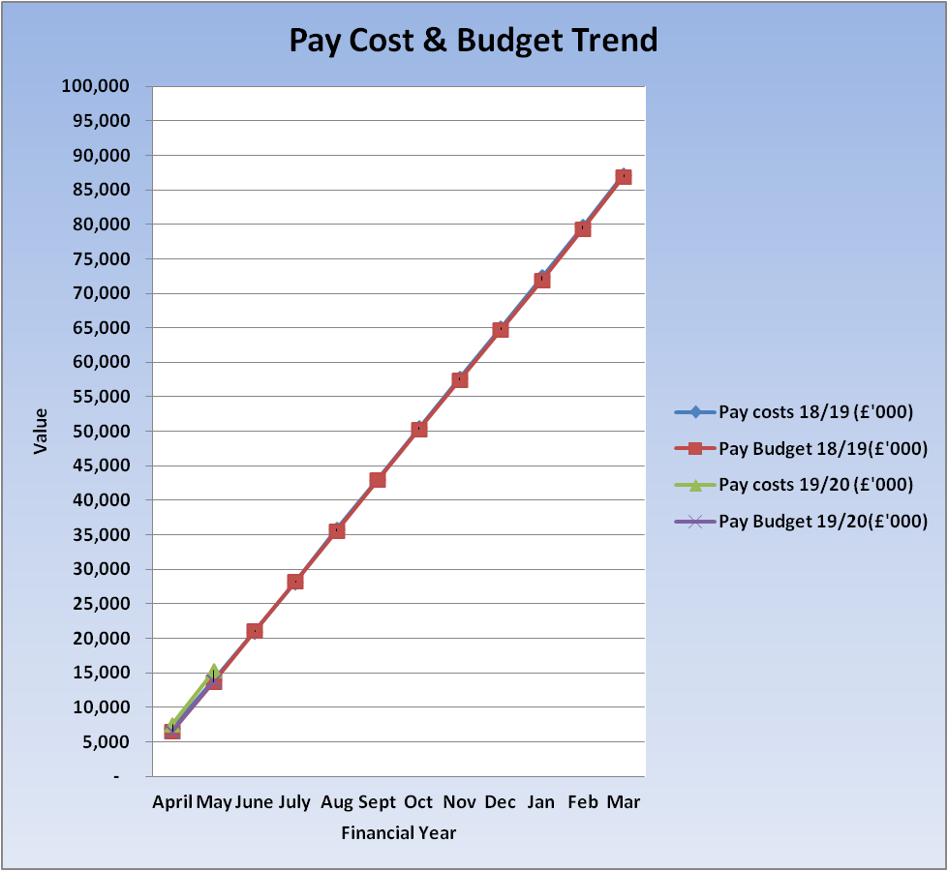

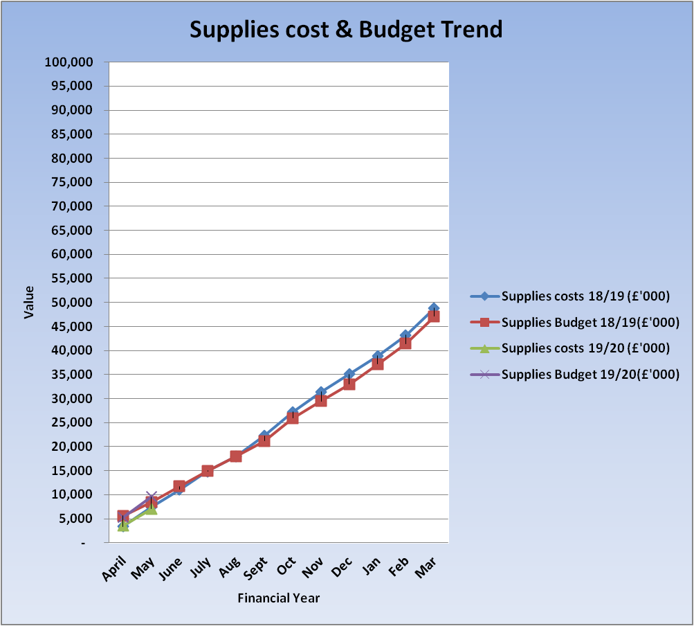

* the **pay** graph above reflects both, year to date budget and year to date actual spend for financial year 2018/19 and 2019/20, these are plotted on the graph but as the 2019/20 values reflect the first two months only at this point the trend analysis is not yet clear. Although it should be noted that as at May 2018 budget was £13,877 and actual expenditure £15,366 compared to May 2019 budget of £13,752 and £13,982 which refects an increase in cost of £1,384k due mainly to AFC pay award and superannuation increase applied from April 2019. Budget as at May 2019 only reflects the AFC budget allocation as received through RRL in May’19 however Superannuation funding is not yet received and is forecast on the basis of £3.2m at this stage. This represents circa £0.600m of the total pay adverse variance as at May 2019 reporting.
* the **non-pay** graph above reflects both, year to date budget and year to date actual spend for financial year 2018/19 and 2019/20, these are plotted on the graph with the 2019/20 values for month two of the financial year reflects an underspend position and is due to reserves held in place for pay/superannuation impact and financial plan pressures and developments yet to be released on agreement of final Divisional budget sign off. To date annual non-pays expenditure reflects a cost reduction of £0.333m.

Due to inclusion of only two months of data reported for 2019/20 at this stage the above provides limited information but this will be developed as the year progress and will allow identification of any major shift in either cost or budget or both.

**Efficiency Savings**

At month two (2), efficiency savings schemes are not yet fully defined and calculated while work continues in agreeing the full year target with corporate schemes being finalised by finance and the budget holders. For the full year target there remains a gap of £955k to achieve financial plan target and this will be monitored against the forecast projected below. Note this gap has reduced from the £1.4m gap described within the financial plan so good progress is being made, and the indicative additional corporate schemes once fully costed are likely to reduce the gap further by £200k. The savings achieved reported from month 3 will be shown in the table below to demonstrate achievement against planned trajectory.

|  |  |  |  |  |  |  |  |  |  |  |  |  |  |  |  |  |  |  |  |  |  |  |  |  |  |  |  |  |  |  |  |  |  |  |  |  |  |  |  |  |  |  |  |  |  |  |  |  |  |  |  |  |  |  |  |  |  |  |  |  |  |  |  |  |  |  |  |  |  |  |  |  |  |
| --- | --- | --- | --- | --- | --- | --- | --- | --- | --- | --- | --- | --- | --- | --- | --- | --- | --- | --- | --- | --- | --- | --- | --- | --- | --- | --- | --- | --- | --- | --- | --- | --- | --- | --- | --- | --- | --- | --- | --- | --- | --- | --- | --- | --- | --- | --- | --- | --- | --- | --- | --- | --- | --- | --- | --- | --- | --- | --- | --- | --- | --- | --- | --- | --- | --- | --- | --- | --- | --- | --- | --- | --- | --- |
| |  |  |  |  | | --- | --- | --- | --- | | **Cumulative value of efficiency savings as at the end of:** | | **Total Plan** | **Total Achieved** | |  | | **£000s** | **£000s** | | April | | 0 | **n/a** | | May | | 0 | **n/a** | | June | | 590 | 0 | | July | | 900 | 0 | | Aug | | 1,251 | 0 | | Sept | | 1,765 | 0 | | Oct | | 2,134 | 0 | | Nov | | 2,690 | 0 | | Dec | | 3,115 | 0 | | Jan | | 3,689 | 0 | | Feb | | 4,201 | 0 | | Mar | | 4,807 | 0 | |  | | |  |  |  |  |  |  |  | |  |  |  |  |  |  |  |

The financial position is now described further.

Details of the financial performance analysed into specific income and funding sources are noted in the table below. This includes scrutiny of the key movements and pressure areas.

**Income Analysis**



Total core income/funding position to date is £0.016m or 0.07% over year to date budget plan.

Total core full year income forecast is reported as £145.593m in line with current annual budget, this has increased from original financial plan as a result of the following;

* Increased baseline uplift higher than minimum 1.7% modelled within the financial plan.
* Higher deduction towards territorial boards contribution to £15m than planned, this is likely to reduce back in line with original Financial Plan subject to NBC programme Board meeting.
* Golden Jubilee Conference Hotel final income budget plan approved £0.121km higher than £5m modelled in financial plan submission at that stage.

Adjustments are made on a monthly basis to the forecast income to include all income movements as they are notified to the Board from Scottish Government and other NHS Boards. Key movements identified from Annual Operational plan discussions will be updated and reflected from month 2 reporting onward.

|  |
| --- |
| * Non-WoS Cardiac, Thoracic, Cardiology and SPVU activity (including all NSD nationally funded services) reflect a net under performance of (£0137m). The most significant position is noted within Cardiology/SPVU and is associated with a reduction in Non-WoS referrals and Non-NHS patient activity as unplanned and subject to variation in levels. |
| * (£0.015m) adverse in month performance and year to date performance for Golden Jubilee Conference Hotel income, this is mostly due to a reduction in bedrooms performance, with each room occupancy taking £70 from bottom line. |
| * £0.168m improved performance for other income and specifically related to Research and development projects. |

Trans Aortic Valve activity (TAVI) at the GJ commences into 2019/20. As at the end of Month two (2) reporting the Board has undertaken 15 cases. An updated position on the final TAVI criteria, activity numbers and future planning will be presented to the Chief Executive (CE) meeting in June and the forecast income and costs will be included within the next month’s report.

Total non-core funding for the year reflects a forecast of £6.765m as per the original financial plan, due to movement in Depreciation from forecasted future Capital projects and impairment increase. This will be reflected from month 3 reporting. The impairment value will be monitored in year with the key driver being the implementation of the new Cath Lab in 19/20 which is likely to increase the assumed £0.150m currently within the capital plan.

The base Revenue Resource Limit (RRL) is detailed in table 3 below which have been advised to the Board for financial year 2019/20. Further adjustments to the RRL will be presented in future reports

**Anticipated Scottish Government RRL allocations:**

May 2019 (month 2) reflects the first RRL allocation receipt and reconciles to the Boards Financial Plan and incorporates the recurring 2019/20 baseline, 2019/20 pay award and inflation uplift (2.5% of baseline combined) and the 2018/19 recurring allocations for MRI/Ultrasound and prior years Orthopaedic/Ophthalmology expansion. Anticipated allocations not yet received mainly include prior year expansions within Orthopaedic, Endoscopy, General Surgery and CT in addition to NHS Boards SLA Top slice, superannuation 6% increase, Outpatients framework and Research CSO/NRS funding;

|  |  |  |  |
| --- | --- | --- | --- |
| **Core Revenue Allocation** | **Included in Operational plan** | **Recurring/Non-recurring** | **Value - £m** |
| **Core Allocation planned as at May 2019** |  |  | **£56.112** |
| Anticipated Allocations |  |  | £24.107 |
|  |  |  |  |
| **Total Forecast RRL allocation** |  |  | **£80.219** |
| Therefore any future core anticipated allocation adjustments different to original financial plan will be reflected in the table above. | | | |
| **Non- Core Allocation** |  |  |  |
| **Non-core Allocation planned as at May 2019** | As per Finance plan to allocations made to date. |  | **£6.765** |
| Any non-core anticipated allocation adjustments deviating from original financial plan will be reflected in the table above. | | | |
| **Total Available funding** |  |  | **£86.984** |

**Golden Jubilee Core Expenditure brokendown by Pay and Non Pay per Division:-**

|  |  |  |  |  |  |
| --- | --- | --- | --- | --- | --- |
| ***Area*** | **Annual Budget £m** | **YTD Budget £m** | **YTD Actuals £m** | **YTD Variance £m** | **Year End Forecast Budget £m** |
| ***Surgical Directorate*** |  |  |  |  |  |
| Pay - Clinical | 43,524 | 7,252 | 7,413 | (161) | 43,524 |
| Pay - Non Clinical | 1,581 | 2,263 | 267 | (4) | 1,581 |
| Supplies - Clinical | 16,844 | 2,807 | 2,925 | (17) | 16,844 |
| Supplies - Non Clinical | (230) | (37) | 407 | (444) | (230) |
| ***Total Surgical*** | **61,720** | **10,285** | **11,012** | **(726)** | **61,720** |
|  |  |  |  |  |  |
| ***Regional & National Medical Directorate*** |  |  |  |  |  |
| Pay - Clinical | 20,103 | 3,350 | 4,130 | (779) | 20,103 |
| Pay - Non Clinical | 1,054 | 176 | 175 | 1 | 1,054 |
| Supplies - Clinical | 8,809 | 1,468 | 1,459 | 9 | 8,809 |
| Supplies - Non Clinical | 2,037 | 355 | 331 | 23 | 2,037 |
| ***Total Regional & National Medical Directorate*** | **32,003** | **5,349** | **6,095** | **(746)** | **32,003** |
|  |  |  |  |  |  |
| ***Corporate*** |  |  |  |  |  |
| Pay - Clinical | 1,268 | 211 | 454 | (243) | 1,268 |
| Pay - Non Clinical | 12,625 | 2,104 | 2,394 | (289) | 12,625 |
| Supplies - Clinical | 61 | 10 | 5 | 5 | 61 |
| Supplies - Non Clinical | 32,901 | 4,691 | 1,638 | 3,053 | 32,901 |
| ***Total Corporate*** | **46,855** | **7,016** | **4,491** | **2,526** | **46,855** |
|  |  |  |  |  |  |
| ***Hotel*** |  |  |  |  |  |
| Pay – Non Clinical | 3,130 | 520 | 534 | (14) | 3,053 |
| Supplies – Non Clinical | 1,884 | 309 | 299 | 9 | 1,893 |
| ***Total Hotel*** | **5,014** | **829** | **833** | **(5)** | **4,946** |
|  |  |  |  |  |  |
| ***Total Core Expenditure*** | **145,593** | **23,480** | **22,431** | **1,049** | **145,593** |

**The key issues are:**

**Surgical Clinical – Pays (£0.161m)**

***Medical Staffing – (£0.146m)***

* Junior Doctor’s net pressure associated with Agency Cover for vacancies within the Orthopaedic Divisional management team are progressing recruitment to minimise cost pressures.
* Waiting list payments/sessions covering sickness absence, study leave and vacancies, most significantly Anaesthesia. Across Anaesthetics, Cardiac and Orthopaedic medical WLI there was an increase in May 2019 of £61k compared to April 2019.
* Recurring Medical session costs worked on behalf of GG&C, clinical lead in organ donation (CLOD) with anticipated funding due of. As this is first two month reporting income receipt not yet in place from relevant Heath Boards.
* Surgical Division pressures are partly offset by an underspend within Ophthalmology & Plastic Surgery reflecting £88k favourable variance, as in prior year this is a result of activity behind Plan.
* Additional Endoscopy and General Surgery activity continues with funding anticipated via RRL from Scottish Government
* The aim to reduce waiting list initiative payments is a continued focus on efficiency review discussions, Medical Management team meeting is still to take place but actions have been agreed to progress this.

**Nursing Staff – £0.080m**

* Superannuation budget not yet realised to Divisions as at month two despite this Surgical nursing reports a small favourable position as a result of Critical Care, Orthopaedic wards and Theatres.

**Clinical Support – (£0.095m)**

* Superannuation budget not yet realised to Divisions as at month two and therefore surgical clinical support reports a small pressure of (£47k) as a result of this but we will see an improvement on allocation on funding receipt.
* Theatres vacancies and new starts into nursing versus Operating Department Practitioners (ODP’s)
* Orthopaedic Physician Assistant vacancies (partly offset against medical agency noted in Orthopaedics above)

**Surgical Non-Clinical Supplies – (£0.444m)**

* This is driven by the Theatre recurring efficiency target held against efficiency account this will be re-aligned against actual surgical supplies savings heading as fully achieved in 2018/19 on final budget upload. This does not impact on the reported bottom line and is purely an efficiency target that requires transferred to the surgical supplies line under Clinical supplies where the efficiency has been realised.

**Regional & National Medical Clinical Pays – (£0.779m)**

**Medical Staffing - (£0.289m)**

* Continuing WLI sessions cover, particularly within SACC’s and TAVI non-recurring prior to recruitment and income receipt to May2019.
* University of Glasgow funding for Cardiologist sessions
* Remaining resolution to the Laboratories GG&C SLA with NHS GG&C around activity provision

**Nursing Staff – (£0.108m)**

* There continues to be a pressure which is mainly due to bank nursing and overtime for staffing An update paper from the previous nursing actions paper has been received and is under review and bank nursing charges are being reviewed in detail from GGC invoicing to ensure reasons for cover aligns with escalation process and reworking of previous nursing paper being led by Nursing Director and Associate Nurse Director.

**Clinical Support – (£0.382m)**

* superannuation budget not yet realised to Divisions in month two and therefore clinical support reports a pressure as a result of this but we will see an improvement on allocation in Month 3.
* ORTS budget allocation for SLA agreed inflationary uplift to be released on agreed uplift.

**Corporate Directorate Clinical Pays – (£0.243m)**

**Nursing Staff – (£0.090m)**

* Over-spend in Research nursing due to budget allocated on non-recurring basis and not reflected in baseline roll-forward, this will be included for future reporting.

**Corporate Directorate Non-Clinical Pays – (£0.289m)**

* Property plant & equipment pressure partly due to Ophthalmology mobile additional funding not yet receipted from Scottish Government in addition to inflation pressure on utilities which will be managed through final budget release.

**Corporate Directorate Non-Clinical Supplies - £3.053m**

* Reserves reflect the positive variance against Corporate as the holding area for financial planning pressures including pay ward superannuation etc and planned developments in line with phased implementation. Month 2 will see allocation of pay award and superannuation budget from reserves and any other cost pressures and cash releasing efficiencies identified and agreed in final Divisional budget approval.

**Hotel Non-Clinical Pay – (£0.014m)**

Performance to May continues behind plan and the Hotel is now slightly behind budget by (£14k). Whilst this figure is not causing concern at this stage, the hotel will continue to monitor this closely.

**Efficiency Savings Programme**

### *Efficiency Savings Programme*

As outlined above, a detailed Programme Tracker report captures the progress for the Efficiency plan. These are categorised in terms of Risk Assessment in addition to work-stream areas. The table below reflects the planned forecast against the trajectory as per original financial plan. As some schemes have yet to be calculated and normal reporting aligns from quarter 1 i.e. June 2019 this actual position against forecast will be reported in future months, with the unidentified schemes currently reduced to £0.955m reflecting progress toward new schemes identified.



**This section of the report is focused on the current forecast financial position**

The following table shows the core financial Out-turn against plan and forecast trajectory as described within our financial plan. This shows the Board is on plan to deliver in line with the trajectory at this early stage.

|  |  |  |  |  |  |  |  |  |  |  |
| --- | --- | --- | --- | --- | --- | --- | --- | --- | --- | --- |
|  |  |  |  |  |  |  |  |  |  |  |
| **Revenue Outturn** | **RRL Plan Surplus/(Deficit)** | **RRL Actual Surplus/ (Deficit)** |  |  |  |  |  |  |  |  |
| **Saving / (Excess) against Core RRL as at the end of:** | **£000s** | **£000s** |  |  |  | | | | | |
| April | 0 | 1178 |  |  |
| May | 0 | 1065 |  |  |
| June | 1,000 | 0 |  |  |
| July | 825 | 0 |  |  |
| Aug | 600 | 0 |  |  |
| Sept | 300 | 0 |  |  |
| Oct | 175 | 0 |  |  |
| Nov | 0 | 0 |  |  |
| Dec | 0 | 0 |  |  |
| Jan | 0 | 0 |  |  |
| Feb | 0 | 0 |  |  |
| Mar | 0 | 0 |  |  |
|  |  |  |  |  |
|  |  |  |  |  |  | | | | | |

**Financial Risk Considerations**

This section highlights to the Board any key risks currently facing the organisation in achieving its revenue financial targets.

**Movement in Income**

* Outcome of Annual Operational plan discussions with Scottish Government in line with Developments and funding assumptions with RRL section of Financial plan, with particular reference to cardiology and EP. Scottish Government have confirmed £0.600m funding for Cardiology/EP subject to progressing discussions with relevant Regional Boards driving referral and activity increases. Formal conformation on the prior year expansions for Ophthalmology mobile, Endoscopy, General Surgery, Orthopaedic and CT has been requested from Scottish Government.

**Medical Staffing cost pressures**

* Slow impact from efficiency related projects to reduce waiting list initiative costs

**Nursing**

* Overtime and Bank reliance in Regional & National Medicine, this is currently being reviewed by the Director of Nursing in line with review undertaken in previous years that drove improvement in the Surgical Division.

**Efficiency Savings gap**

* Although the current unidentified balance reduced from £1.488m at original financial planning submission to current gap of £0.955m. Active discussions continue with the Divisions and Corporate services.

**Horizon Scanning**

* Brexit preparedness, likely impact of October 31 revised deadline.

**Superannuation Funding**

* Change in funding calculation basis to SPPA actual March 2019 cumulative contributions against 6% increase rather than Board budgeted wte and impact of offsetting reduction for Heart & Lung funding via the 3-year funding model.

# Non-Core Position

Non-core expenditure is defined as non-cash expenditure and is split as detailed below:

* Depreciation – this is an annual transfer from core RRL each year with the budget based on a detailed depreciation budget prepared annually in line with our approved capital plan and existing capital items.

Year to date this is showing a slight overspend, with this primarily due to the inclusion of projects that were completed in the last financial year, an update will be completed for month three to advise Scottish Government of the revised depreciation budget.

* Provisions – this is part of Annually Managed Expenditure and is managed and funded centrally. The original £0.040m estimate in 2019/20 will be reviewed on a monthly basis, with quarterly meetings being held with the CLO to review all claims and likely financial implications.

There was a decrease in the provision value year-to-date associated with the settlement of a small number of claims for which all associated provisions have been released

One of the large claims that the principle amount was agreed and paid in month two, remains live as we still require to agree the settlement of legal fees. Once this is completely settled a claim for reimbursement will be submitted.

Impairment – this also is part of Annually Managed Expenditure and is managed and funded centrally based upon an annual expected spend on building projects. The original estimate of £0.150m in 2019/20 is unlikely to be sufficient to fund the building costs likely to be incurred in the current financial year associated with the building work for Cath Lab Five. When the tendered costs are known and final plans signed of we will liaise with the appointed valuer to inform the level of impairment, at this point we will update SG

# Capital Position

**Capital Spend**

At the end of month two there has been no capital expenditure incurred, this is in line with the plan for the year as the majority of the spend routinely takes place in the second half of the year. Plans are in progress in line with the approved Capital Plan

**Capital – Detail**

The three elements which make up the capital budget as agreed with the Board and SGHSCD for 2019/20 are noted below:-

* Formula Capital – this allocation is the money that the Board is provided with the fund all capital requirements within year that are not subject to approval by National Capital Investment Group. This funding is broken down into three components:-
* Estates (Building Infrastructure)
* Medical Equipment and
* IM&T
* Capital Stimulus Monies – this allocation was provided by SGHSCD to increase imaging capacity across Scotland, the residual balance in year of £1.922m has been agreed with SGHSCD with the monies in year planned to contribute to cath lab five and finalising with replacement of the cardiac MRI. This is included with the formula capital in the table below.
* Elective Centre Funding – this is the Board allocation for the funding of the development at the site and is split between phase one and phase two. Phase one relates to the Ophthalmology expansion with funding of £10.473m included in the plan for the year, this spend will vary dependent progress throughout the year. there has been no expenditure in month, due to the timing of cost control meetings and amounts accrued at year-end

Phase two relates to the creation of a new facility to increase Orthopaedic Surgery capacity, £0.421m has been allowed in the capital plan in year with regard to this. The plan was submitted before any recent developments and progression of this development. It has been agreed with Scottish Government that this estimate will be revised to be in line with the updated Outline Business Case currently being developed. The spend for year-to-date is approx. £0.081m.

**The Formula Capital**

The base formula allocation for 2019/20 is £2.691m, this year the capital stimulus money (£1,922m) has been assumed as part of this allocation which brings the allocation to £4.613m. The detail of what has been included in the plan for the year has been agreed at the capital group meeting on 13 February 2019 with a revision undertaken on 8 May 2019. The anticipated spend is summarised in the table below: -

|  |  |  |
| --- | --- | --- |
| **Area** | **2019/20**  **£000s** | **Spend to 31 May**  **£000ms** |
| Property | 1,837 | - |
| Medical Equipment | 2,296 | 370 |
| IM&T | 480 | - |
| **Formula** | **4,613** | **370** |

The spend in month relates to the turnkey costs for the new MRI scanner.

Through the capital group (informed by the Medical Equipment Group, the PAMS group and the e-Health Steering Group) we have undertaken a detailed review of all the plans which form part of these allocations to ensure that all items within the plan will be undertaken in the current year. The likely area that will be subject to change is the expenditure relating to cath lab five, subject to final agreed revenue funding by the Health Boards.

Detailed reports will be presented to the Capital Group on a monthly basis to ensure that spend can be monitored against budget and corrective action taken when necessary.

**The Capital Stimulus**

Residual balance of the capital stimulus money (originally £5m) is £1.922m. The majority of this is earmarked to support the provision of a fifth cath lab and associated building works. These funds are included with the formula capital this year, in agreement with SG.

**The Elective Centre**

The spend for the elective centres will be monitored as in prior year by the cost control group for the project, with two separate valuations being considered with detailed cost control reports being presented to SMT. As there has been no spend in period one this section will be updated for future reports.

**Director of Finance**

**3 July 2019**

Golden Jubilee Foundation Values Statement



**Finance Values to Deliver this Vision:-**

**F**uture Focused – we will constantly identify emerging changes that will impact on the department and incorporate them into the way we work

**I**ntegrity – we will adhere to our responsibilities to ensure that the vision of the department is delivered effectively

**N**ew skills and support – we will strive to find practical, effective and innovative solutions to achieve the required outcomes

(can do) **A**ttitude – we will strive to ensure that the culture of the department supports a can do approach

i**N**novative thinking – we will ensure that we embrace new innovative ways of working to continually improve our practices

**C**ulture – we will work together collaboratively and in recognition of the contribution that person makes to the Department’s objectives, in doing this we will recognise the value of all points of view and treat everyone equally

**E**xpertise – we are a reliable source of accurate information and sound financial advice