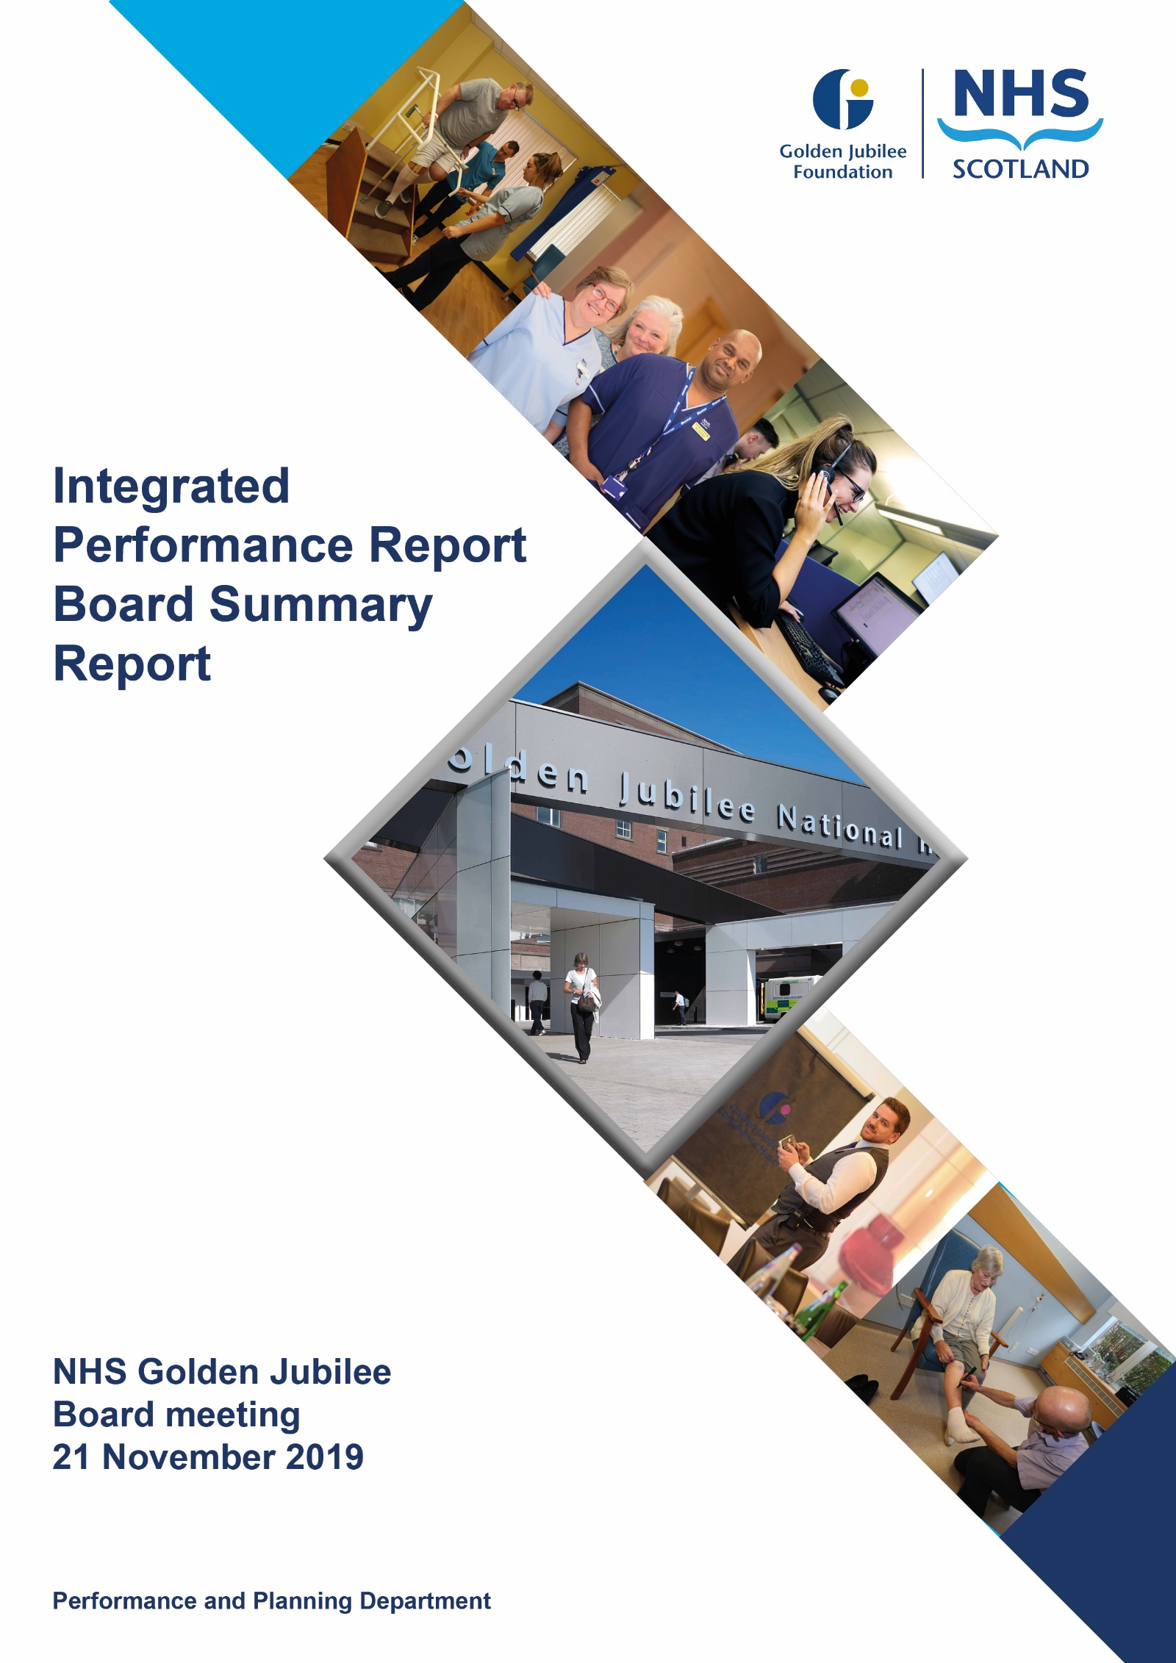

# Contents

**Introduction 2**

**Performance Summary Dashboard 4**

**Integrated Performance Report: Executive Summary 6**

# Section A: Introduction

The purpose of the Integrated Performance Report (IPR) is to provide assurance on NHS Golden Jubilee’s performance relating to National Standards, local priorities and significant risks.

The IPR comprises four section with each section being considered in detail by the appropriate Standing Committee:

* Section A Introduction
* Section B:1 Clinical Governance
* Section B:2 Staff Governance
* Section B:3 Finance, Performance & Planning

This Board Summary Report of the IPR is presented to the Board and contains the summaries from each section of the full IPR.

**Jann Gardner Colin Neil June Rogers**

**Chief Executive Director of Finance Deputy Chief Executive**

Performance Summary Dashboard – Guidance





Board Performance Dashboard – Part 1



Board Performance Dashboard – Part 2



Note: This Board performance dashboard aggregates KPIs indicators for Bed Occupancy and Cancellation rates into Hospital level performance.

At each meeting, the Standing Committees of NHS Golden Jubilee consider targets and standards specific to their area of remit using the Integrated Performance Report (IPR). There is a section of the IPR which provides a summary of performance Standards and targets identified as areas of note which is reproduced below. Topics are grouped under the heading of the Committee responsible for scrutiny of performance.

# Section B: 1 Clinical Governance

|  |  |  |
| --- | --- | --- |
| **Clinical Governance** | | |
| **KPI** | **RAG** | **Position:** |
| Total complaints (Stage 1 and 2) as a percentage of activity. |  | Position improved from 0.21% in July 2019 to 0.10% in August 2019 and achieved the threshold. The volume of complaints decreased from 17 to eight. |
| Stage 1 complaints response time |  | The target was not met in August 2019 with three out of five (60.0%) responses within the five day response threshold. |
| Stage 2 complaints response time |  | In August 2019 33% (1/3) Stage 2 complaints were responded to within 20 working days. |
| Mortality |  | The mortality figures for September 2019 were reported as seven. There were six deaths in August 2019. |
| Significant adverse events |  | There were two significant adverse event reviews in September 2019, one less than in August 2019 and within the set tolerance limit. |
| MRSA/MSSA cases |  | One instance of Staphylococcus aureus Bacteraemia (SAB) was reported in September 2019. |
| Clostridiodes Difficile |  | One Clostridiodes Difficile Infection (CDI) was reported in September 2019. |

**Clinical Governance Executive Summary**

Within the Clinical Governance section of the IPR, we are maintaining the existing indicators from the corporate balance scorecard relating to complaints and infections, and also proposing that we add the number of Significant Adverse Events (SAE) and crude hospital mortality as further indicators of safety. It must be stressed that neither indicator is necessarily suggestive of harm, as an SAE can be a low severity or near miss event, and not all deaths are preventable. However, both act as a prompt to review and consider learning and it is therefore felt useful to include and monitor the overall levels using statistical process charts.

In relation to mortality, the HSMR data continues to be published nationally on a quarterly basis; the charts below show the most up to date data showing the national trend and GJNH trend for crude unadjusted mortality and funnel plot for HSMR; for the period January. As you can see we remain significantly below the national average for crude mortality, March 2019 Scotland average was 2.8% and GJNH was 0.5%, though do mirror the trends throughout the year which is reassuring and within control limits for the HSMR. Updated charts will be shared when published:

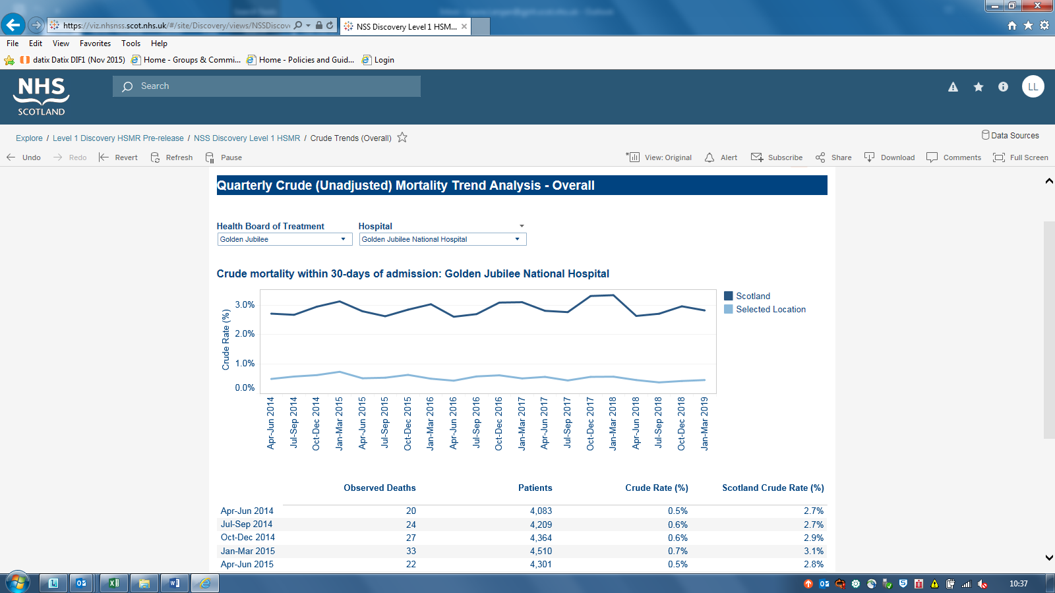

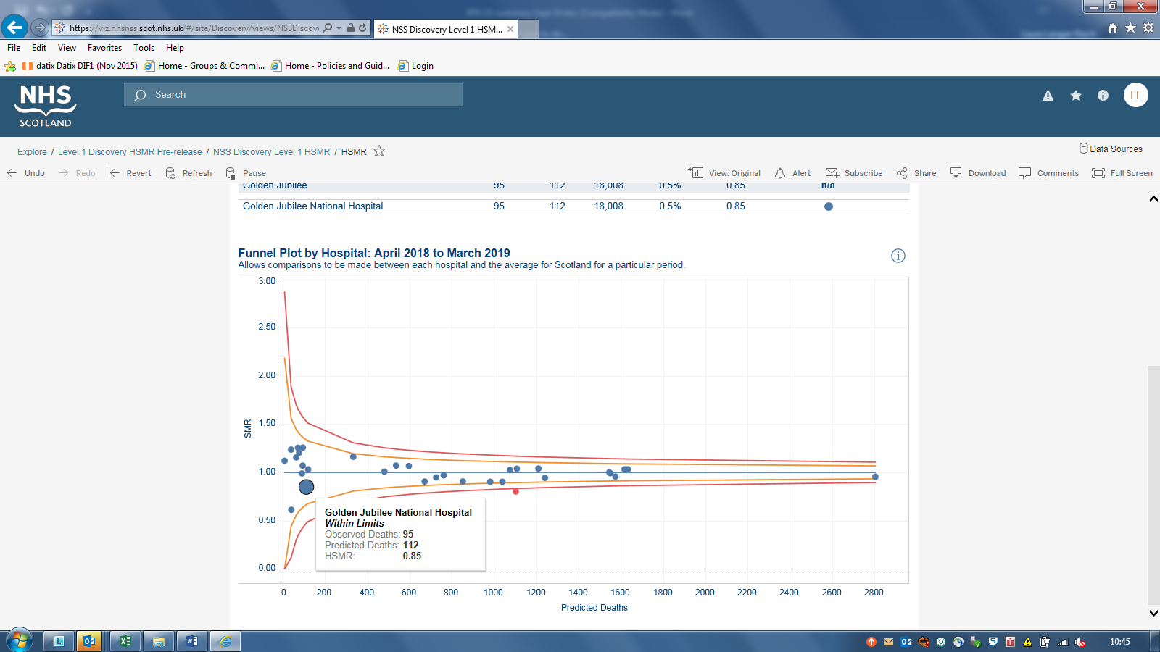

The overall levels of complaints peaked in July as previously reported at 17 overall; in August this has decreased with a significant reduction in stage 2 complaints with two received compared to eleven in the previous month totalling 6 overall.

Response times for stage 2 have seen a slight improvement at 33% however further work is underway as it is recognised this needs to improve. A paper is going to CGRMG in October outlining actions being implemented to support this.

With regards to stage 1 response times; we have to report by the 5 days’ timescale however inability to meet this can be due to the availability of complainant or staff to have detailed discussion. In all cases complainant has the option to escalate and to date all have been satisfied with the timescale of response.

**Key Healthcare Associated Infection Headlines**

***Staphylococcus aureus* Bacteraemia**

One MRSA bacteraemia to report in September. The patient involved had a very complex history with multiple hospital admissions.

***Clostridioides difficile* infection (previously known as *Clostridium difficile)***

One CDI to report in September. Past medical history of CDI. No link to any other cases.

**Hand Hygiene**

The bimonthly report from September demonstrates an overall compliance of 99% with hand hygiene opportunity and technique. Medical staff compliance has dropped from 98% to 95%.

**Cleaning and the Healthcare Environment- Facilities Management Tool**

Housekeeping Compliance: 98.94% Estates Compliance: 99.13%

Since mid-April, Boards have had issues submitting Facilities Management Tool (FMT) data to Health Facilities Scotland (HFS) due to failures with the national Domestic Monitoring Tool (DMT) system. The hardware system has failed again in September, affecting all Boards. Audit activity has reverted back to paper, impacting on the audit frequency for non-high risk areas.

**Surgical Site Infection (SSI)**

Knee & Hip replacement SSI rates within control limits.

Cardiac and CABG SSI rates within control limits.

# Section B:2 Staff Governance

|  |  |  |
| --- | --- | --- |
| **Staff Governance** | | |
| Disciplinaries, Grievances and Bullying |  | All three indicators were on target for September 2019. There were five disciplinaries which resulted in a warning. No grievance or bullying and harassment investigations were undertaken in September. |
| Local Sickness absence |  | There was a 0.3% improvement in sickness absence in September 2019 compared to August 2019, down from 4.5% to 4.2%.  There was a reduction in sickness absence in Surgical Specialties (from 6.0% to 5.7%). Regional and National Medicine increased (from 3.5% to 3.7%). |
| Medical appraisal with completed interview and form 4 |  | Reported position at end of September 2019 was 16.1% (20/124) against a target of 35% . |
| TURAS Appraisal rates |  | Decreased by one percent to 73% in September 2019 and remained below the required threshold of 80%. The Hotel (86%) was the only division to achieve the target for September. |
| Job Planning Surgical Specialties: Consultants |  | Surgical consultant job plans remain on target with 70%, (46/66), having an approved job plan. |
| Job Planning SAS & RNM Consultants |  | 11% (1/9) of SAS doctors and 35.3% (6/17) of RNM consultants had approved job plans by the end of September, up from zero for both groups in August. |

**Staff Governance Executive Summary**

Within the Staff Governance section of the IPR we continue to report on sickness absence rates, appraisal rates and medical job planning.

The September 2019 Sickness absence rates saw the Board’s sickness absence percentage decrease to 4.2% from 4.5%. This is accounted for by the decrease in sickness absence across all Directorates with the exception of Regional and National Medicine which had a slight increase of 0.2% in the Directorate sickness absence rates.

As with previous months, the greatest proportion of sickness absence was due to Anxiety/stress/ depression/other psychiatric illnesses”, which accounted for 34.7% of the Board’s sickness absence.

Information relating to directorate and departmental sickness absence rates continues to be circulated to Heads of Department on a monthly basis. Management, Occupational Health and the Human Resources Team continue to work together to support members of staff during their absences, and to work with staff members to reduce the number and length of sickness absences, assisting them to remain at work and return to work sooner. Occupational Health Physiotherapy offers rapid access to help alleviate musculoskeletal problems.

We undertook a mental health check survey from 2nd to 27th September 2019 in partnership with See Me, the national programme to end mental health stigma and discrimination. We received 490 responses from staff and we await the full analysis of the information and feedback from See Me which will support us to consider how we can address and improve the understanding of mental health, support those who might need help and increase confidence in disclosing mental health problems to managers and colleagues in the organisation.

73% of Agenda for Change staff have completed their appraisal as at the end of September. All managers continue to receive monthly progress reports in order to identify those staff who have completed an appraisal and which individuals within the department still require their appraisal. This information also highlights when the last appraisals were undertaken on TURAS.

We are undertaking an analysis of the staff governance data to compare sickness absence rates and TURAS appraisal completion rates to identify any departments where further support may be required where both areas are out with targets. This information continues to be gathered in order that action plans can be developed to identify which areas require additional support to overcome any barriers or challenges they might be facing.

# Section B:3 Finance, Performance and Resources

|  |  |  |
| --- | --- | --- |
| **Finance, Performance and Resources** | | |
| Finance – Manage within annual budget limit |  | The month six year to date results show a position of £24,000 above the annual budget target. This is an improvement on the deficit posted in month five. |
| Finance – Deliver Board efficiency target |  | The month six year to date results show total cash releasing savings of £1.429m against a target of £1.765m. |
| Cancer 31 Day |  | In August 2019 100% (31/31) patients on a cancer treatment pathway were reported as being seen within 31 days. |
| TTG: Number of patients who have breached the TTG |  | In September 2019 there were 110 patients who exceeded their twelve week treatment time guarantee. This included 32 cardiac surgery patients,8 coronary patients, 42 electrophysiology patients,19 device patients, four lead extraction patients and five patients on the cardiology inpatient waiting list. |
| TTG: Percentage of patients admitted within 12 weeks |  | The percentage of patients who were admitted within their twelve week treatment time guarantee decreased by 1.4% from 86.7% in August 2019 to 85.3% in September 2019. This reflects an increase in the number of patients admitted over twelve weeks (+16). |
| Stage of Treatment Guarantee – Inpatient and DC cases (Heart & Lung only) |  | Position deteriorated from 66.3% in August 2019 to 62.4% in September 2019 and remained below the threshold of >=90%. The number of patients treated over 12 weeks increased to 227 (+16) whilst the number of patients treated within 12 weeks decreased 377 (+40). |
| DOSA rate: Cardiac Surgery |  | The September DoSA rate for Cardiac Surgery was 16.7%. This represents a 10.1% increase with seven more patients admitted as DoSA in September 2019 compared to August 2019. |
| DOSA rate: Orthopaedics |  | The Orthopaedic DoSA rate for September 2019 was 60.8%, the same as in August 2019. There were 160 patients (out of 263 primary joint patients) admitted on the day of their procedure. The July, August and September DoSA rates are the three highest recorded DoSA rates. |
| DOSA rate: Thoracic Surgery |  | The Thoracic DoSA rate for September 2019 was 30.7%, a decrease of 1.9% compared to August 2019. Despite the decrease this represents only the third time a Thoracic DoSA rate of over 30% has been recorded since July 2015. |
| Theatre Cancellation Rates |  | Overall cancellations rates were 5.0%, an increase of 0.9% compared to August 2019. There were improvements in Orthopaedics 2.0% (-0.2%), Endoscopy 7.1% (-1.0%), Thoracic Surgery 4.7% (-2.6%) and Cardiology 2.9% (-1.9%). For the other specialties cancellation rates increased: Cardiac 13.1% (+3.6%), Ophthalmology 3.9% (+2.0%), General Surgery 10.1% (+2.8%), Plastic Surgery 4.2% (+1.7%). |
| Hospital Bed Occupancy |  | Hospital wide bed occupancy was reported as 78.4% in September 2019 compared to 78.1% in August 2019. The calculated ‘green’ range, based on combining individual ward thresholds is between 83% to 88%. |
| Hotel Overall Net profit |  | The September 2019 position was -19.0% compared to -17.7% in August 2019 and remains below target. |
| Hotel Patient Bed Night Usage |  | Patient bed night usage remained below target with the position worsening by 2.2% from -13.4% in August 2019 to -15.6% in September 2019. |
| Hotel Not for profit percentage |  | The percentage in September 2019 improved to 43.7% but remained slightly below the minimum threshold of 44% |

|  |
| --- |
| National Comparison Table, Corporate Dashboard, Waiting list & Productivity table |
| National figures for the position at the end of 2019 Quarter 2 show the GJNH as being the Board with the lowest number (five) and percentage (1.5%) of patients waiting over 12 weeks for an outpatient appointment. |
| ISD figures show the number of patients admitted to the GJNH who had waited over twelve weeks decreased, by 122, from 401 in 2019 Quarter 1 to 279 in 2019 Quarter 2. The percentage of patients admitted within 12 weeks increased from 76.6% to 80.5%, this increase saw the GJNH’s national rank rise from sixth to fifth. |
| The nationally reported elective cancellation rates decreased from 5.0% in July 2019 to 4.1% in August 2019, GJNH remains reported as having the lowest elective cancellation rate nationally. |
| Golden Jubilee performance against the national 31 Day Cancer target improved to joint first due to the reported performance of 100% in August 2019. |
| Business Services (5%), Communications and Corporate Affairs (6%) and Estates and Engineering (8%) reported sickness rates above the four percent threshold in September 2019. |
| The total inpatient waiting list month end position increased by 69 to 5122. The total outpatient waiting list decreased by 90 to 2383. |
| In September 2019 there were 110 patients who exceeded their twelve week treatment time guarantee. This included 32 cardiac surgery patients, eight coronary patients, 42 electrophysiology patients, 19 device patients, four lead extraction patients and five patients on the cardiology inpatient waiting list. |

**Business Performance Executive Summary**

**12 Week Treatment Time Guarantee**

**Cardiac Surgery**

In September, 110 patients exceeded their waiting time guarantee for cardiac surgery. The reason for this continues to be due to the increasing number of referrals, urgency of referrals and complexity of procedures which result in a requirement for increased theatre time. Agreement has been reached to progress the proposal to extend the working day in theatre to accommodate two/three patients being treated in a day. The Divisional team will prepare and progress an implementation plan to implement this change.

**Cardiology**

In September, 78 cardiology patients exceeded their waiting time guarantee. The mobile cath lab has now moved off site due to the commencement of the Phase 2 construction work. A solution to the cardiology challenges is anticipated when cath lab 5 becomes operational in April 2020.

**Day of Surgery Admission (DOSA)**

DOSA rates improved in cardiac surgery by 10.1% in September and the DOSA rate for orthopaedics in September remained the same as in August. However, the DOSA rate for thoracic surgery was slightly behind plan by 1.9%. The divisional management team continue to monitor delivery of this target and take corrective action as required.

**Theatre Cancellation Rates**

In September, the overall cancellation rate demonstrated an increase of 0.9% in comparison to the August data. There were improvements in Orthopaedics 2.0% (-0.2%), Endoscopy 7.1% (-1.0%), Thoracic Surgery 4.7% (-2.6%) and Cardiology 2.9% (-1.9%). However, cancellation rates increased in Cardiac 13.1% (+3.6%), Ophthalmology 3.9% (+2.0%) and Plastic Surgery 4.2% (+1.7%).

Active management of cancellations is an ongoing process for the divisions.

**SLA Performance**

At the end of September performance was 2% behind plan for the month and 5% behind the year to date plan. This demonstrates an improvement in comparison to the previous month

**Orthopaedics**

Orthopaedic joint replacements were behind the September target by 39 procedures, orthopaedic non joint activity was also behind the target by 13 procedures and foot and ankle surgery behind by 13 procedures. However, foot and ankle activity remains ahead of the year to date plan by 31 procedures.

Overall, the service utilised 391 orthopaedic theatre slots against a plan of 455 and they are now behind the year to date plan by 161 procedures. This is an unusual situation for the orthopaedic surgery service. Much of this shortfall was accumulated over the peak summer holiday period when there were a number of vacancies in theatre resulting in a significant reliance on agency staff to cover the orthopaedic sessions. In addition to the high level of vacancies, we have experienced consultant sickness absence and the willingness of the remaining consultants to cover additional sessions proved to be challenging. The team are currently working on an orthopaedic planner for both out patients and in patients in order to create a recovery plan.

**Ophthalmology**

For the first time this year there was an over performance of 28 ophthalmology procedures in September. However, the service remains behind the year to date plan by 182 procedures. New consultant appointments have been made and further opportunities continue to be actively explored. The first of the new consultants took up post in September. Our expectation is that we will see an improving situation as we progress through the year and we are hopeful that the current shortfall will be recovered.

**Endoscopy**

Endoscopy procedures carried out in September exceeded our plan by 10. The service is making progress towards recovering the shortfall in activity from earlier in the year. The year to date shortfall is now 45 procedures and we are confident that this will be recovered.

**Diagnostic Imaging**

Diagnostic imaging performed significantly behind the monthly plan by 62 examinations in the month of September. This is the third month in a row that the service has demonstrated a performance improvement. A second external provider has been employed to resolve our current backlog in reading examinations. Our expectation is that recovery of the shortfall will continue to improve over the coming months.

Activity in September demonstrated an improvement on the previous month, however recovery of the backlog is extremely challenging. The well documented impact of consultant availability continues to present particularly significant challenges.

The Recovery Group continue to meet on a weekly basis and remain focussed on identifying alternative solutions to challenges as they arise, addressing recruitment challenges and detailing a recovery plan for shortfalls by specialty.

**Financial Performance Executive Summary**

Financial Position as at Month 6, September 2019

**Revenue Position**

The total surplus as at Month 6, September 2019 amounts to £324k. This comprises of an income under-recovery of (£68k), a core expenditure underspend of £392k and a non-core underspend of £1k. This reported underspend position is in line with the original Financial Plan Forecast of a £300k underspend by the end of September 2019.

The forecast to the financial year-end at this point of the financial year remains to predict a break-even position against the Boards revenue position.

**Main Points to note**

* The YTD Budget across Expenditure headings amounts to c£71.3m, with the underspend above of £392k being split between pay, at £436k underspent, and non-pay, being (£44k) overspent. Whilst this overall position is favourable some pressures exist in Medical Pay lines due to excess costs to assist in meeting capacity demands, and within equipment repair and rental in non-pay, with both areas being subject of local reviews to define remedial actions. The income under-recovery is associated with some SLA activity being behind targeted plans at month 6.
* The Efficiency Savings target for the year amounts to £4.807m. At the end of September 2019, £3.757m of schemes have been identified, with £1.72m being recurring schemes and £2.037m non-recurring opportunities. At month 6 this reflects an in-year gap of £1.050m and a FYE gap of £2.007m, albeit further opportunities will be explored, and be of significant focus, via planned Performance Review Groups with the Divisions to source additional initiatives. Positively, £1.429k of cash releasing savings have been identified and achieved as at month 6.
* In addition to these savings schemes, there are cost avoidance and productivity schemes of c£1.44m, albeit these cannot be set against the target above. These schemes are under detailed scrutiny to assess the organisational benefits which can be recognised in year.
* The Clinical Waste contract and service contingency arrangements continue to be in transitional phase with the interim arrangements resulting in additional charges of c£14k per month from the contractor together with some internal costs to maintain service delivery. These costs have been factored into the Boards financial forecasts, recognising the full financial risk.
* The Hotel Expenditure position is (£27k) overspent following Pay Award funding, and reports a slight under-recovery in income, however on a YTD budget of c£2.6m, and with a backdrop of forecast increases in NHS and some Events Business, it is believed that this position is recoverable during the remainder of the financial year.
* At a previous Annual Operating Plan Meeting with Scottish Government colleagues, confirmation of funding was provided for key Waiting Times Improvement Plan funding, which also included Independent Sector activity funds. Monthly monitoring reports will be issued to Scottish Government by Board, Supplier and Specialty to capture current and forecast positions and aid robust national reporting. These funds have been issued on a non-recurring basis and will re-appear in our finance plan for 20/21.

**Capital Position**

* Formula Capital of £2.691m and Capital Stimulus funding of £1.922m combine to derive the overall allocation below of £4.613m of core capital funding split across the 3 key allocation headings, which at month 6 has an expenditure profile of £1.431m.

|  |  |  |
| --- | --- | --- |
|  | **Annual** | **Spend at** |
|  | **Budget** | **Month 6** |
| **Area of Spend** | **£000's** | **£000's** |
| Property | 1,837 | 439 |
| Medical Equipment | 2,296 | 992 |
| IM&T | 480 |  |
| Total | 4,613 | 1,431 |
|  |  |  |

* In addition to the above, Elective Centre Funding relating to phase one and phase two developments is received as a separate allocation. Phase one relates to the Ophthalmology expansion with funding of £10.473m included in the capital plan for the year. The in-year spend for phase one is £2.173m as at September 2019. Phase two relates to the creation of a new facility to increase Orthopaedic Surgery capacity, and an element has been allowed in the capital plan in year with regard to this. The Outline Business Case has been developed and close communication with SG colleagues is in place given the scale and importance of this key development. The in-year expenditure related to appropriate enabling works for phase two at the end of month 6 is £1.092m, which is informed in detail at internal cost control meetings. Therefore, the total Elective Centre spend stands at £4.264m at the end of Month 6.
* The Board forecast to remain within the Capital Resource Limit for the financial year to meet the financial targets for 2019/20.

**Hotel and Conference Centre Executive Summary**

September income was slightly behind budget and a small shortfall remains year to date. It is expected that the £5K variance to budget will be closed in October. Business for the rest of the year is looking strong although NHS bookings are still lower than expected.

The Hotel will be particularly busy over the next few months with a number of major clients including the UEFA, the Citizens’ Assembly of Scotland, Fantasy Con, the BMA and Energy Action.

The marketing focus for October is ‘Scottish Government’. The Business Development team recently had a display at St Andrews House which proved a useful activity to engage with Scottish Government colleagues and similar display will take place in both Victoria Quay, Edinburgh and Atlantic Quay, Glasgow, over the coming weeks.

Work continues to ensure the roll out of Bedroom 2020 and work to develop the two prototype rooms should commence before the end of October. A feasibility/ scoping exercise for the Riverside Project is due to commence and will inform a potential future business case related to increased business capacity and improved functionality. Further work to develop a sustainable financial plan as part of a long term strategy is being taken forward with the Director of Finance.

**Research and Innovation Executive Summary**

This report presents information for the second quarter of the 2019/20 financial year.

**Key Performance Indicators – summary**

|  |  |  |  |  |  |
| --- | --- | --- | --- | --- | --- |
| KPI |  | Target  (quarter 2) | Actual  (quarter 2) | Target 2019/20 | Actual 2019/20  Q1 & Q2 |
| 1.1 | Number of new research projects | 8 | 8 | 32 | 15 |
| 2.1 | GJRI income (invoiced) | £375,000 | £438,849 | £1,500,000 | £821,779 |
| 2.2 | Motion Analysis Lab income (year 3) | £29,500 | £7,000 | £118 ,000 | £11,750 |
| 3.1 | % Occupancy (training area) | 75% | 49% | 75% | 56% |
| 3.2 | % Occupancy (research facility) | 80% | 58% | 80% | 59% |

**KPI 1.1: Number of new research projects**

The number of new research project is slightly below target. It is likely that this is a temporary issue for the following reasons:

* There are approximately 25 projects at various stages in the set up process,
* A new national system for providing local information has been introduced,
* It has not been possible to progress anaesthetics related projects because of the requirement for additional staff in the relevant group. Information (VAF forms and an SBAR paper was sent to the finance department in March 2019.

It is not thought that this is a result of a Brexit effect given that the proportion of each project (commercial, NEF and eligible) remains similar to previous years.

**KPI 2.1: GJRI income (invoiced)**

This KPI is above target.

**KPI 2.2: Motion Analysis Lab income**

|  |  |  |  |
| --- | --- | --- | --- |
| **Current Issues** | Income significantly below target | | |
| **Context** | Target income as agreed during the development of the Motion Analysis Business Case has not been met. | | |
| **Key Actions for Improvement** | **Planned Benefits** | **Due By** | **Status** |
| SBAR to be drafted explaining the background behind the development and its intended use | SBAR to be sent to the orthopaedic surgeon group – who agreed the income targets set out in the Business Case – for a response.  SBAR also shared with Medical Director. | 30th September 2019 | 30th September 2019 |

**KPI 3.1: % Occupancy (training area)**

Current potential developments within the Clinical Skills area include the provision of dedicated IT space for medical students rotating into the Jubilee every 2 weeks; provision of dedicated space for Moving & Handling and Resuscitation training and the general increase in the requirement for training caused by the ongoing expansion.

**KPI 3.2: % Occupancy (research facility)**

|  |  |  |  |
| --- | --- | --- | --- |
| **Current Issues** | Occupancy below target | | |
| **Context** | The CRF facilitates follow-up for research projects. The total number of follow up events depends on recruitment targets for each project and numbers of follow up visits. Both metrics are variable which results in over occupancy (e.g. June 2017) and under occupancy (current situation). | | |
| **Key Actions for Improvement** | **Planned Benefits** | **Due By** | **Status** |
| Encourage research staff to use the CRF for participant visits if possible whilst acknowledging that other parts of the hospital will be better suited for some visit types. | Increased occupancy of the CRF | 31st December 2019 | Ongoing |