
Corporate Governance Annual Report 2023/24

NHS Golden Jubilee
Corporate Governance Annual Report 2023/2024

1 Background


The Blueprint for Good Governance – Second Edition (DL (2022)38) (the Blueprint) was published in November 2022 and emphasised the importance of excellence in corporate governance to maintain high standards of clinical, staff and financial governance. The Blueprint supports a consistent, effective and transparent governance approach across NHS Scotland.
NHS Golden Jubilee (NHS GJ) has implemented a number of developments to its governance framework to ensure that high quality corporate governance principles are embedded throughout the organisation and undertakes continuous review and improvement of the system.
This report outlines work conducted throughout 2023/2024 to augment and develop the corporate governance arrangements across NHS GJ. Further details on the Blueprint are noted later in the report.

2 Governance

The Board and Committees continued to meet regularly with a mixture of in person/hybrid for Board meetings and a virtual format using MS Teams for Board Committees.
The Board’s approach to governance ensured:

3 Board and Board Committees
Corporate Governance is the term used to describe our overall control system. It details how we direct and control our functions that the Board is responsible for:

The Board has a framework of Board Committees actively engaged in delivering the corporate governance system. These are:

Audit and Risk Committee
Clinical Governance Committee
Staff Governance and Person Centred Committee
Finance and Performance Committee
Strategic Portfolio Governance Committee
Remuneration Committee
The Governance Committees support the Board by undertaking detailed developmental work on its behalf, providing clear recommendations for Board approval and adoption. This role also ensures the Board receives appropriate assurance that its agreed strategies and frameworks are being properly delivered. The Corporate Governance Framework includes:

The Board and Board Committee meetings were reviewed during 2023/24 and a new schedule of meetings was proposed to facilitate one less Board/Governance cycle in the year. This proposal was taken to each Board Committee for approval with final approval at the Board on 25 July 2023. The same meeting frequency continues into 2024/25 as detailed in the Corporate Calendar (Appendix 2) which was agreed at the Board on 14 December 2023.
The Committee Chairs reflected over the past 12 months as follows:
Strategic Portfolio Governance Committee: Linda Semple


As Chair of the Strategic Portfolio Governance Committee, I can confirm the Committee has continued to ensure appropriate scrutiny and governance around the Committee agenda. The Committee has discharged its remit for 2023/24 in line with its approved Terms of Reference and ensured appropriate scrutiny and governance.
I am satisfied that the approach to the frequency of the meetings, breadth of the business undertaken and range of attendees at the meetings has allowed the Committee to fulfil its remit to fulfil its duties successfully throughout 2023/24.
I appreciate the support from all members of the Committee for their input in the development of the agenda and for the considerable work undertaken. I would also like to record my thanks to all the staff who have supported the Committee over this past year.

Staff Governance Person Centred Committee: Marcella Boyle

As Chair of the Staff Governance and Person Centred Committee, I can confirm the Committee has discharged its remit for 2023/24 in line with its approved Terms of Reference and ensured appropriate scrutiny and governance. I am satisfied that the approach to the frequency of the meetings, breadth of the business undertaken and the range of attendees at the meetings has allowed us to fulfil our remit. The Committee has also taken assurance that through the full delivery of its Annual Work Plan, there is evidence of the Committee addressing full coverage of the strands of the Staff Governance Standard.
I appreciate the support from all members of the Committee for their input in the development of the agenda and for the considerable work undertaken. I would also like to record my thanks to all the staff, past and present, who have supported the Committee over this past year. This has enabled the Committee to fulfil its duties successfully throughout 2023/24.
I would like to acknowledge the ongoing contribution of all our staff, particularly during another challenging year.
Clinical Governance Committee: Morag Brown


As Chair of the Clinical Governance Committee, I can confirm the Committee has supported continuous improvement in clinical, quality and safety at all times. Through the governance arrangements, the Committee will ensure safe and effective quality care that will have a focus on the management of risk, of improving care and delivering better outcomes.
I am satisfied that the approach to the frequency of the meetings, breadth of the business undertaken and range of attendees at the meetings has allowed the Committee to fulfil its remit.
The Committee has discharged its remit for 2023/24 in line with its approved Terms of Reference and ensured appropriate scrutiny and governance.
I would like to extend my sincere thanks to all members of the Clinical Governance Committee for their support and input into the development of the agenda and for the considerable work undertaken.

Audit and Risk Committee: Karen Kelly

As Chair of the Audit and Risk Committee, I can confirm the Committee has discharged its remit for 2023/24 in line with its approved Terms of Reference and ensured appropriate scrutiny and governance.
I appreciate the diligence and active governance from all members of the Committee throughout the last year and I would also like to record my thanks to all the staff, Internal and External Auditors who have supported the work of the Committee.

Finance and Performance Committee: Stephen McAllister

As Chair of the Finance and Performance Committee, I can confirm the Committee has discharged its remit for 2023/24 in line with its approved Terms of Reference and ensured appropriate scrutiny and governance.
I am satisfied that the approach to the frequency of the meetings, breadth of the business undertaken and range of attendees at the meetings has allowed the Committee to fulfil its remit.
I appreciate the diligence and active governance from all members of the Committee throughout the last year and I would also like to record my thanks to all the staff who have supported the work of the Committee.

Remuneration Committee
The remuneration of the Executive Team is central to the organisation’s ability to recruit and retain the calibre of team capable of delivering the substantial strategic agenda and responsibilities placed upon them by the Scottish Government. This committee is Co-Chaired by the Chair and Vice Chair of NHS GJ and its membership are the Board Governance Committee chairs.

Accountability for the efficient and effective use of public monies is paramount within the public sector. Therefore, any decision on remuneration issues must be fully supportable in public.

The Remuneration Committee, as a stand-alone Committee to the Board (which also reports to the Staff Governance and Person Centred Committee), is responsible for overseeing changes to the pay, terms and conditions of the Executive team and relevant senior managers in the above context and taking into account Scottish Government direction and guidance and standards of good corporate governance.

Expansion Programme Board
NHS GJ is responsible for planning the elective care requirements of the West Region population. To lead, steer and monitor all aspects of the development of Phase 2 Expansion programme NHS Golden Jubilee set up the Expansion Programme Board that works within the principles of the Blueprint for Good Governance – Second Edition, to ensure effective management, improved performance and ultimately good outcomes for all stakeholders. The Chair of the Expansion Programme Board is the Chair of NHS GJ.

Board Private
In addition, there was an extraordinary meeting organised by the Board and Committees, this was in relation to Transcatheter Aortic Valve Implantation (TAVI) in February 2024.
The allocation of Board Members to Committees was reviewed and full membership including details of the Chair of each Committee are noted in Appendix 1.

4 Non-Executive Directors and Board Development
Non-Executive Directors

NHS GJ Board currently includes nine Non-Executive Members, including the Board Chair.

Board Members are required to adhere to the national NHS Code of Conduct for Board Members which is incorporated into the Board’s Standing Orders.

Effective Board appraisal is a systematic assessment of how well the Board is performing in relation to its responsibilities and in contributing to the success of the organisation. Individual annual appraisals of the Board members to look at performance took place during 2023/24 along with completion of the statutory and mandatory training modules.

In 2032/2024 there were changes within the year to the Board as follows:
Welcome
Rebecca Maxwell was welcomed as a Non-Executive Director to the Board on 8 January 2024 with an office term of four years to provide capital programme experience.

Welcome
Lindsay MacDonald was welcomed as a Non-Executive Director to the Board on 8 January 2024 with an office term of four years. Lindsay MacDonald will become chair of the Audit and Risk Committee as the current chair is stepping down.

Farewell

The Board said goodbye to Steven Wallace in September 2023, NHS GJ Non-Executive with capital experience. The Board thanked him for his time.

Farewell
The Board said goodbye to Karen Kelly in March 2024. The Board thanked Karen Kelly for her Chairmanship of the Audit and Risk Committee and her almost seven years of service.

Board Development
In line with the Blueprint, NHS GJ recognised the place of the Board in achieving good governance. Securing high quality, effective and efficient organisational performance is dependent on the leadership skills of Board Members and the Executive Team.
Board Development is a key priority and to support this, a number of Board Seminars took place across the year. These interactive sessions focused on developing elements of the Board Strategy and embedding Non-Executive Director development throughout the Board calendar.

The Seminars included forums on:

Further Seminars are planned across 2024/2025 and Non-Executive board members contribute to the subject matters so that these are relevant and reflect the needs of all members.

A programme of Executive and Non-Executive virtual departmental walk rounds were delivered. The virtual sessions allowed key interactions between the Board and operational delivery teams. Sessions this year have included:
The further development of this engagement programme is a key part of the Board agendas going forward.


Celebrations for 2023/24



The Board celebrated the 75th anniversary of the NHS with tea and cake in the conservatory early July



The Board were joined by representatives from the Armed Forces to
present to the Board the Armed Forces Gold Award


NHS Golden Jubilee’s transplant retrieval team won the award
for ‘Excellence in Organ or Tissue Retrieval’ in this year’s NHS
Blood and Transplant and British Transplantation Societies’ UK
Awards for Excellence in Organ and Tissue Donation and
Transplantation

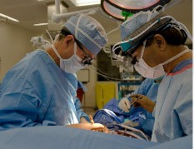
NHS Golden Jubilee was the first in NHS Scotland to perform Endoscopic Vein Harvesting (EVH), a much less invasive procedure for taking a vein from your leg to use as part of a coronary artery bypass graft to limit damage and improve recovery times


NHS Golden Jubilee retained their Gold Award status for the ‘Investors in Young People’ – this will be presented to the organisation in the New Year.

Long Service Awards
A programme of Long Service Award presentations was commenced early 2022 to support the recognition of the commitment and loyalty of staff who have made their career in the NHS. Awards are given to staff who have career service between 10 and 50 years. The further development of this engagement programme is a key part of the Board agendas moving forward.


The number of awards presented in 2023 and 2024 are as follows:
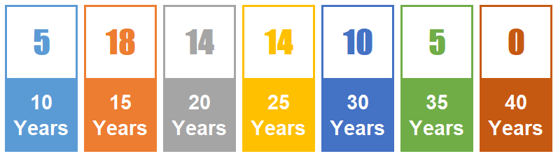

5 Executives to the Board

NHS GJ Board currently includes three Executive Members: Chief Executive, Medical Director and Director of Finance. In 2023/2024 there were changes within the year to the Board Members as follows:
Farewell
Michael Breen, Director of Finance, left the organisation in March 2024. The recruitment process for replacement was begun during his notice period with interviews scheduled for 23 and 26 April 2024.

Besides the three Board Executive Members, there are also four Executive Directors in NHS GJ. In 2023/2024 there were changes within the year to the Executive Directors as follows:
Welcome

6 Executive Directors

Carole Anderson, Director of Transformation, Strategy, Planning and Performance joined the Executive Directors in September 2024.

Welcome
Laura Smith, Director of People and Culture, joined NHS Golden Jubilee in January 2024.

Farewell

Gareth Adkins, Director of Strategy, Planning and Performance, left the organisation in July 2023.
.

Farewell

Serena Barnatt, Director of Workforce left the organisation in August 2023.


Nicki Hamer NHS GJ Head of Corporate Governance and Board Secretary developed a number of papers within the year and led on a number of key areas including:

7 Head of Corporate Governance and Board Secretary
- NHS Golden Jubilee Corporate Calendar and Committee and Board Work Plans for 2023/24 (Appendix 3). These were created to ensure robust governance and assurance processes are in place.
- Corporate Governance – Board Member Responsibilities
and Membership
      - Blueprint for Good Governance Improvement Plan
2024/25. This was created by the Board following the Blueprint for Good Governance Self-Assessment Survey.

To ensure effective provision is in place to facilitate the corporate governance agenda and support Executive and Non-Executive Directors an appropriate Corporate Administration function is required.

8 Corporate Administration
To augment the governance structure and to provide dedicated support to the Board and Committee Framework, the Deputy Head of Corporate Governance role evolved. During 2023/24 Christine Nelson was appointed to this role.

9 Integrated Performance Report
During the Financial Year 2019/2020 the Integrated Performance Report (IPR) was commissioned as the key high level corporate performance report for the year.
The IPR brings together all elements of the Board portfolio and providing a balanced scorecard report of performance to support the Governance Committees: Clinical Governance, Staff Governance and Person Centred and Finance and Performance.
In line with a commitment within the Blueprint for Good Governance Implementation Plan, a review of the construction of the NHS GJ IPR, including culture, will be carried out during 2024/25 to ensure the measures meet the requirements of the Board and its Governance Committees.

10 Corporate Governance Framework
Blueprint for Good Governance – Second Edition

The Blueprint for Good Governance-Second Edition (DL (2022)38) was published in November 2022. The Blueprint emphasises the importance of good corporate governance and describes how its adoption will help NHS Boards to improve their corporate governance system. It will deliver a consistent, effective and transparent governance approach across NHS Scotland.

Blueprint for Good Governance – Model

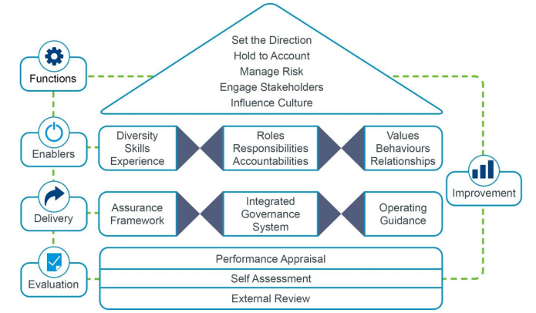

Blueprint Implementation Plan 2023/24

In November 2023, the Board completed a self-assessment survey and from the outcome of this self-assessment, the Blueprint for Good Governance Implementation Plan was formed. The Blueprint Implementation Plan for 2024/2054 should be seen as evolving and flexible as it will have to respond to any changes in the corporate governance arrangements for NHS Golden Jubilee and any decisions that come from NHS Scotland and Scottish Government.

Appendix 4 outlines the proposed Blueprint Implementation Plan for 2024/2025.

Active Governance

An active approach to governance requires having the right mix of people and skills on the Board and the Standing Committees. Board Members have to focus on the right things, consider the right evidence and respond in the right way. Board Members must pay close attention to the delivery of the organisation’s purpose, aims and values and concentrate their efforts on achieving the Board’s longer term corporate aims and objectives. Board Members must also have an understanding of current and past delivery of services in order to hold the executive leadership to account for the performance of the organisation. Board Members always have to have regard to the wider strategic and policy context in which they operate.

To assist Board Members in anticipating and identifying the risks and opportunities which could have a significant impact on the delivery of their objectives, their relationships with their stakeholders and their reputation, NHS Boards need to operate within a governance system that ensures that the right issues are considered by the right people, the right information is reviewed in the right format at the right time and the right level of scrutiny produces the right challenge and the right reaction.

The Board has actively considered changes to its governance arrangements throughout 2023/2024.

11 Recommendations

The Board are asked to note the Corporate Governance Annual Report 2023/2024.

Appendix 1: Board Committee Membership

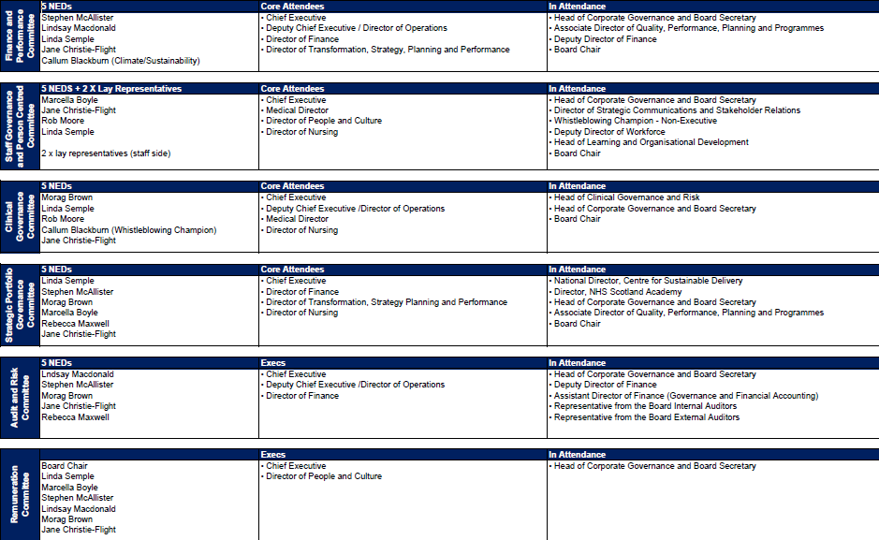

Appendix 2: Corporate Calendar
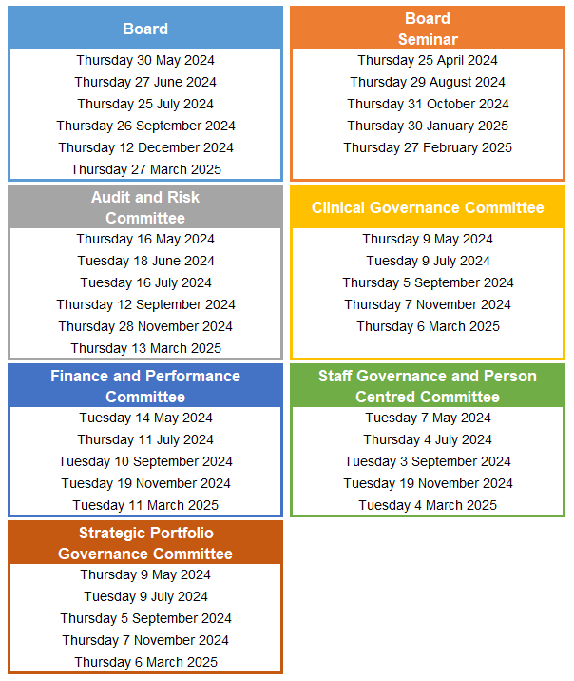

Appendix 3: NHS GJ Board Work Plan 2023/24

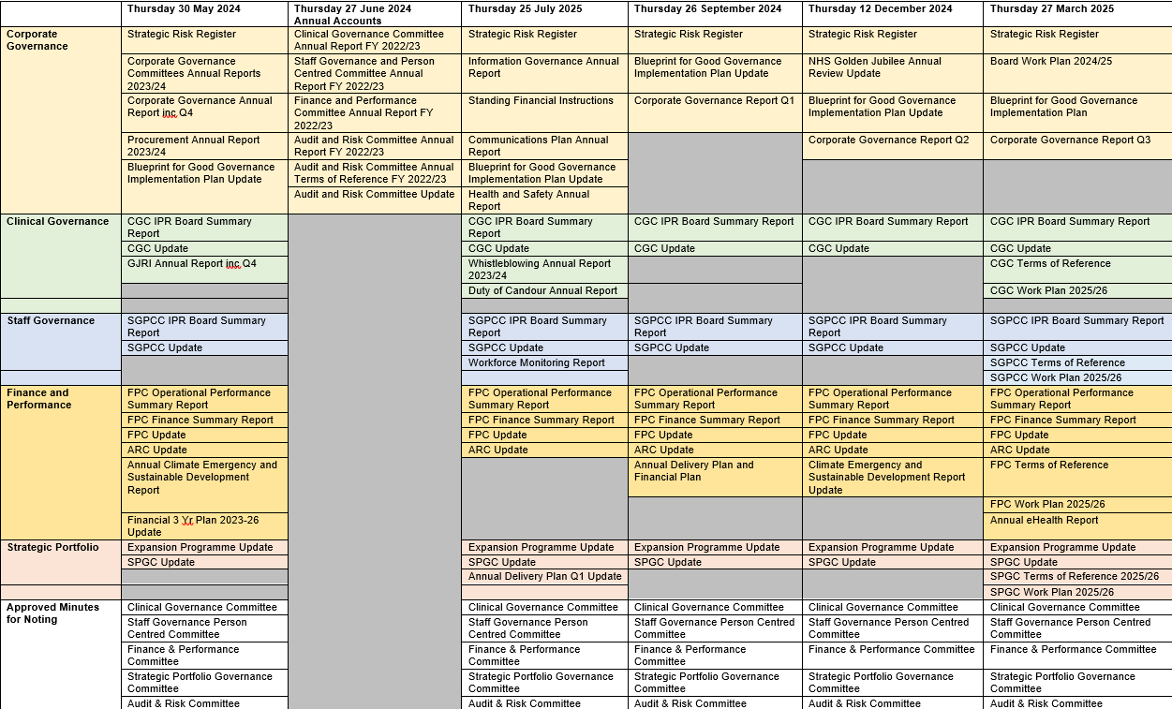

Appendix 4: Blueprint Implementation Plan 2023/24

Priority Area | Blueprint Function | High level Action | Interdependency | Lead | Timeline | Status | Intended Good Governance Outcome
Setting the Direction | Encourage and facilitate innovation, drive change and transform service delivery to support a culture of continuous improvement | 1. To discuss further within a facilitated Workshop  2. To support, where possible, wider community as an Anchor organisation | Board (Seminar) | Board Chair  Chief Executive  Director of Finance  Board Secretary | 31-Dec-24 | Open | Creation of a space to explore, encourage and facilitate discussions. Recognise the need for business change/service redesign along with financial challenges. Could Endowments support innovation and transformation - could it be promoted as Anchor projects.
Setting the Direction | Consider and make allocation decisions on budgets, areas for investment/disinvestment including any capital investments required to deliver strategic and operational plans | 1. To ensure Board Strategic Plan dates are committed to and do not waiver.  2. Effective National and Regional Planning is influenced  3. Longer term review of financial and activity planning  4. Review of KPIs for each Governance Committee | 1. Board  2. Executive Leadership Team  3. Finance and Performance  Committee (FPC)  4. All Governance  Committees | 1, 3, 4. Director of Transformation,  Strategy, Planning and  Performance  2. Chief Executive / Executive  Leadership Team  3. Director of Finance with  Director of Transformation,  Strategy, Planning and  Performance | 31-Mar-25 | Open | Review responsiveness to internal decisions and further influence regional planning. Review how to triangulate wealth of data held by the organisation
Holding to Account | Create a learning environment within the organisation, which embeds continuous improvement and quality management approaches and encourages innovation and promotes best practice | 1. Increase Board Visibility of improvement programmes  e.g. HEPMA, eRostering, etc.  2. Increase Board walkrounds  3. Use Board Seminar for QI discussion on improvement | Board /  Strategic Portfolio Governance Committee | Board Chair  Chief Executive  Board Secretary  Director of Transformation, Strategy, Planning and Performance | 31-Oct-24 | Open | Areas for improvement already in the pipeline i.e. QI structure and QI performance
Priority Area | Blueprint Function | High level Action | Interdependency | Lead | Timeline | Status | Intended Good Governance Outcome
Engaging Stakeholders | Meaningfully involve stakeholders and take account of their views in shaping the development of the Board's strategic and commissioning plans, priorities and the design of services. | To be discussed at a future Board Seminar session with outputs:  1. Ensure that patient feedback and involvement is  consistently reviewed to identify any gaps and is  shared with the Board.  2. Proposal to set up commissioning model within regional  planning arrangements  3. Relationships - Scottish Government, Civil Services,  Non-Executives to Non-Executives, attendance at  meetings (opportunity for all Board Members)  4. Embed strategic partnerships framework  5. Future Board Seminar on Comms Strategy | 1. Board  2. ELT / FPC  3. Board  4. Strategic Portfolio  Governance  Committee (SPGC)  5. Board | Board Secretary along with:  1. Director of Communications  and Stakeholder  Relationships  2. ELT  3. Board Chair / Chief Executive  4. Chief Executive  5. Board Secretary | 31-Dec-24 | Open | Who is a stakeholder to NHS GJ. Need to explore good stakeholder relationships i.e. high value/importance/ patients/staff. Need to be clearer on this to be able to action further i.e. commissioning, relationships, and strategic partnerships.  How do we further promote NHS GJ identity and the value of working with NHS GJ.
Influencing Culture | Ensure that the board creates a psychologically safe environment for staff to speak out, raise concerns and report them. | - To link into triangulation of performance (IPR) to include data on culture  2. Agendas to end with 'Debrief' item. This will allow Chairs to ascertain what went well, what did not go well and what could be done better to ensure constant review of the agenda management of the meeting. | 1. Staff Governance and  Person Centred  Committee (SGPCC)  2. Board / All Governance  Committees | - Director of Transformation,  Strategy, Planning and Performance / Director of People and Culture  2. Board Secretary | 31-May-24 | Open  Closed | Consideration of Integrated Performance Reporting around culture - how culture is defined - via mechanisms such as iMatter.  Clarity of how this is reflected in the work of the Governance Committees:  - Meetings/teams to allow  'speak out' and 'speak up'  - Review balance of data versus  progress/process of change
Diversity, Skills and Experience | Take a strategic succession planning approach in identifying gaps in the diversity, skills and experience required of the Board to inform future recruitment and undertake any targeted action required to address under-representation on the Board | - NHS GJ to influence process as much as possible  - Continued 1:1 discussions for training requirements and refresh of Board Skills Matrix  - Support for Chair/Chief Executive in delivery good news to other Boards who are not doing so well | Board | 1. Board Chair / Director of Strategic  Communications and Stakeholder  Relations  2. Board Chair / Board Secretary  3. All Board Members | 31-Mar-24 | Open | Consideration of Public Appointment process run by SG  Review training and skills requirement of Non-Executive Directors  Influencing of external stakeholders
Priority Area | Blueprint Function | High level Action | Interdependency | Lead | Timeline | Status | Intended Good Governance Outcome
Diversity, Skills and Experience | Actively seek opportunities to inform and contribute to the development of Scottish Government policies and strategies for healthcare in Scotland | - Maximise external relationships at every opportunity.  Review areas of policy where NHS GJ can influence | Board /  Strategic Portfolio Governance Committee | Board Members / Executive Leadership Team | 31-Mar-25 | Open | How do we influence. Ensure Board members are equipped to ask appropriate questions, constructively challenge and influence areas to promote NHS GJ model.
Roles, Responsibilities and Accountabilities | Maximise the effectiveness of the Board's Standing Committees and Advisory Committees within the system of governance, e.g. Area Clinical Forum (ACF)/Area Partnership Forum (AFP) in scrutinising, monitoring and evaluating progress towards achieving the Board's plans and priorities and escalating issues to the Board as appropriate | 1. Review what is currently in place and the decision-making around this.  2. Ensure continuous discussion going forward to enable NHS GJ to be an influencer. This includes representation on the National Planning and Delivery Board.  3. Non Executive Chairs to be involved in Scotland network of Committee Chairs | Board | Director of Transformation, Strategy, Planning and Performance / Board Secretary  Chief Executive | 31-Dec-24 | Open | To review Advisory Committees - what we have to inform and be part of the decision making process for business change.  Regional Planning - consideration of NHS GJ current  planning role in supporting all NHS Boards
The Assurance Framework | Measure the Board's performance by benchmarking results against those of similar organisations.  Review of information cascaded to sub Board level and upwards | Provide opportunity to triangulate data with reports and benchmarking information. Better oversight and consistency of system-wide assurance at Board level.  Review of internal governance of sub Board level | Board /  All Governance Committees | Director of Transformation, Strategy, Planning and Performance  Board Secretary | 30-Sep-24 | Open | Data in IPR to include broader sources to assist with triangulation and to refer to any live critical issues facing NHS GJ. IPR also to include description of trends, trajectories and benchmark with other Boards.  Use of promoting NHS GJ i.e. patient stories and keep doing these, not to be distracted by others issues.
The Integrated Governance System and the Operating System | Ensure Board Members have a clear understanding of the NHS Scotland Performance Management Framework, ladder of escalation and the positioning of the Board within this framework, now known as NHS Scotland: support and intervention framework | To understand what the compliance for the NHS Scotland Support and Intervention Framework means for NHS Golden Jubilee as a National Board. Draft interim Framework to be taken to Board Seminar for further consideration | Board /  Strategic Portfolio Governance Committee | Chief Executive | 01-Mar-24 | Open | To look at trajectories, trends and benchmarking again other Boards and how this will affect NHS GJ Annual Delivery Plan, especially if other NHS Boards are escalated.

