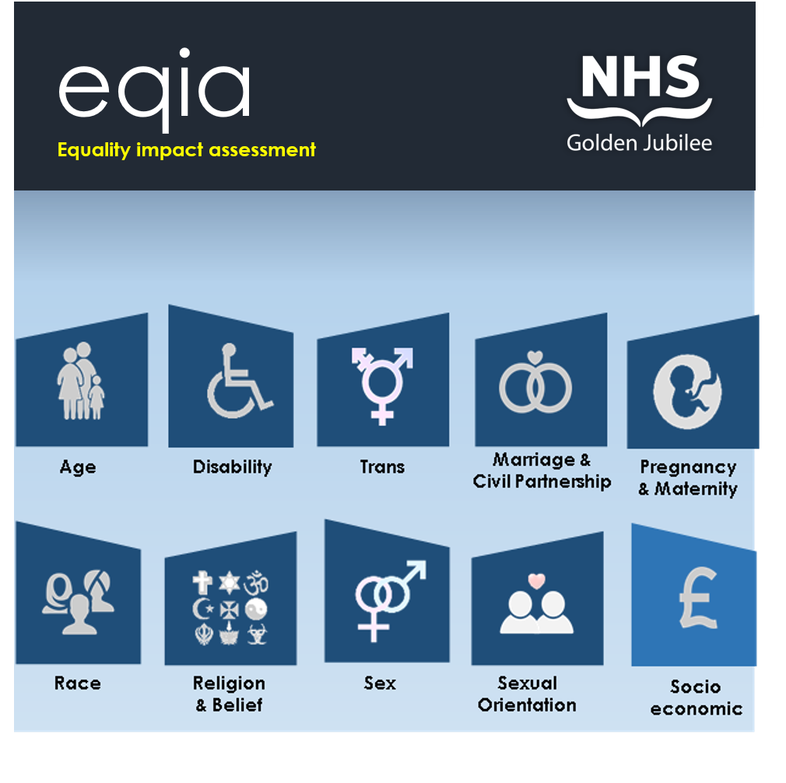
Name:  (policy/ procedure/ practice/ function) | Click or tap here to enter text.
Department: | Click or tap here to enter text.
Lead Contact: | Click or tap here to enter text.
EQIA Assessor: | Click or tap here to enter text.
Date: | Click or tap here to enter text.
Use this section to provide details about the status (new or existing) of the policy/practice/procedure/function and provide an outline of the proposal including aims, objectives and outcomes.
Please note: All tables within this report are expandable.
Status | New | Existing
Aims objectives & outcomes | Click or tap here to enter text.

NHS Golden Jubilee has a legal requirement under the Public Sector Equality Duty to have due regard to the need to:
- Eliminate unlawful discrimination, harassment and victimisation and other conduct prohibited by the Act.
- Advance equality of opportunity between people who share a protected characteristic and those who do not.
- Foster good relations between people who share a protected characteristic and those who do not.

Provide details of how the work will impact positively, negatively or neutrally on people who share the characteristics below.
It will be helpful to consider any access issues, health inequalities or experiences of discrimination that might impact these groups within your area of work. It will also be helpful to think about human rights and whether these will be impacted for any group. Our rights are described in the Human Rights Act. Some groups are also protected by specific conventions, which are highlighted for your information in the relevant sections below.
There is no word count – you should include the information you think is required. Please ensure the information you use is evidence based (e.g. articles, public involvement, previous work). There is space at section 8 for you to record the evidence sources you use in your assessment.

 | Age | Think about older people as well as children and young people, and their respective carers.  If children are specifically affected, use a Children’s Rights and Wellbeing Impact Assessment to provide more information. Consider our child protection policy.  Convention on the Rights of the Child
Positive impact |  | Click or tap here to enter text.
Negative impact |  | Click or tap here to enter text.
Neutral impact |  | Click or tap here to enter text.
 | Care Experience | Think about children and young people up to the age of 26 who have experience of being in care. This can include foster care/supported care, kinship care, residential care, or being looked after at home with the support of a supervision order.  NHS Golden Jubilee is named as a corporate parent under the Children and Young People (Scotland) Act 2014. You can find information and working examples of what this means for us in our Corporate Parenting Plan.
Positive impact
Negative impact
Neutral impact
 | Disability | Think about people with sensory impairments, communication difficulties, learning disabilities, physical impairments, energy impairments, autism spectrum disorders, mental health conditions and Deaf users of British Sign Language. You might also consider unpaid carers here.  Convention on the Rights of Person with Disabilities
Positive impact |  | Click or tap here to enter text.
Negative |  | Click or tap here to enter text.
Neutral impact |  | Click or tap here to enter text.
 | Trans Status | This is about trans / transgender people - anyone whose gender does not match the sex they were assigned at birth.  Understanding the Transgender Community – Human Rights Campaign
Positive impact |  | Click or tap here to enter text.
Negative impact |  | Click or tap here to enter text.
Neutral impact |  | Click or tap here to enter text.
 | Marriage & Civil Partnership | Are there any implications for people who are married or in a civil partnership?  Marriage and civil partnership discrimination – Citizen’s Advice Bureau
Positive impact |  | Click or tap here to enter text.
Negative impact |  | Click or tap here to enter text.
Neutral impact |  | Click or tap here to enter text.
 | Pregnancy & Maternity | Think about people who are pregnant, breast-feeding or who recently gave birth.  Convention on the Elimination of All Forms of Discrimination against Women
Positive impact |  | Click or tap here to enter text.
Negative impact |  | Click or tap here to enter text.
Neutral impact |  | Click or tap here to enter text.
 | Race | Think about people with non-white majority ethnicities. This includes gypsy/travellers.  Convention on the Elimination of all forms of Racial Discrimination
Positive impact |  | Click or tap here to enter text.
Negative impact |  | Click or tap here to enter text.
Neutral impact |  | Click or tap here to enter text.
 | Religion or Belief | Think about people who follow particular religions. For example: Judaism, Islam, Sikhism, Christianity etc. Are there particular beliefs or practices that might be impacted?  International standards on freedom of religion or belief
Positive impact |  | Click or tap here to enter text.
Negative impact |  | Click or tap here to enter text.
Neutral impact |  | Click or tap here to enter text.
 | Sex | Think about any differences for women compared to men, or vice versa.  Convention on the Elimination of all forms of Discrimination Against Women
Positive impact |  | Click or tap here to enter text.
Negative impact |  | Click or tap here to enter text.
Neutral impact |  | Click or tap here to enter text.
 | Sexual Orientation | Think about people who are lesbian, gay or bi or who have another minority sexual orientation (e.g. are not heterosexual / straight).  Combatting discrimination based on sexual orientation
Positive impact |  | Click or tap here to enter text.
Negative impact |  | Click or tap here to enter text.
Neutral impact |  | Click or tap here to enter text.
 | Socio-economic | Think about people living on low incomes and / or in deprived areas. If this is a strategic-level decision and the Fairer Scotland duty applies, you will need to give this characteristic detailed consideration. Otherwise, consider this as a cross-cutting issue(people who share a protected characteristic are more likely to experience poverty).  The Fairer Scotland Duty Interim Guidance for Public Bodies
Positive impact |  | Click or tap here to enter text.
Negative impact |  | Click or tap here to enter text.
Neutral impact |  | Click or tap here to enter text.

Where the policy/practice/procedure/function was identified to adversely affect (discriminate against) people who share a protected characteristic; provide details of how this impact will be eliminated, minimised or managed.
Protected Characteristic |  | Actions | Person Responsible
All Characteristics |  | Click or tap here to enter text. | Click or tap here to enter text.
 | Age | Click or tap here to enter text. | Click or tap here to enter text.
 | Care Experience | Click or tap here to enter text. | Click or tap here to enter text.
 | Disability | Click or tap here to enter text. | Click or tap here to enter text.
 | Trans Status | Click or tap here to enter text. | Click or tap here to enter text.
 | Marriage/Civil Partnership | Click or tap here to enter text. | Click or tap here to enter text.
 | Pregnancy & Maternity | Click or tap here to enter text. | Click or tap here to enter text.
 | Race | Click or tap here to enter text. | Click or tap here to enter text.
 | Religion or Belief | Click or tap here to enter text. | Click or tap here to enter text.
 | Sex | Click or tap here to enter text. | Click or tap here to enter text.
 | Sexual Orientation | Click or tap here to enter text. | Click or tap here to enter text.
 | Socio-economic | Click or tap here to enter text. | Click or tap here to enter text.

Provide an impact rating based on the degree to which the policy/practice/procedure/function will impact people who share a protected characteristic.

Impact Rating Key
Low
There is little or no evidence that some people are (or could be) differently affected by the policy/practice/procedure/function.

Medium
There is some evidence that people are (or could be) differently affected by the policy/practice/procedure/function.

High
There is substantial evidence that people are (or could be) differently affected by the policy/procedure/decision

Protected Characteristic |  | Low | Medium | High
 | Age
 | Care Experience
 | Disability
 | Trans Status
 | Marriage/Civil Partnership
 | Pregnancy & Maternity
 | Race
 | Religion or Belief
 | Sex
 | Sexual Orientation
 | Socio-economic

Provide details of stakeholder collaboration and consultation.
Refer to Appendix A for details of local and national charities and user groups which represent the Protected Characteristics defined by the Equality Act 2010.
Name and  Job title | Department or Organisation | Contact details
Click or tap here to enter text. | Click or tap here to enter text. | Click or tap here to enter text.
Click or tap here to enter text. | Click or tap here to enter text. | Click or tap here to enter text.
Click or tap here to enter text. | Click or tap here to enter text. | Click or tap here to enter text.
Click or tap here to enter text. | Click or tap here to enter text. | Click or tap here to enter text.
Click or tap here to enter text. | Click or tap here to enter text. | Click or tap here to enter text.
Click or tap here to enter text. | Click or tap here to enter text. | Click or tap here to enter text.
Click or tap here to enter text. | Click or tap here to enter text. | Click or tap here to enter text.

Regular reviews ensure that the policy, procedure or practice is kept up to date, and meets the requirements of current equality legislation.
Scheduled Review | Assigned contact | Review Date
 | Click or tap here to enter text. | Click or tap here to enter text.

Where a negative impact has been identified and remedial actions are being implemented, the policy owner should define a timescale for review.
Identified  Issue | Assigned contact | Review Date
Click or tap here to enter text. | Click or tap here to enter text. | Click or tap here to enter text.
Click or tap here to enter text. | Click or tap here to enter text. | Click or tap here to enter text.
Click or tap here to enter text. | Click or tap here to enter text. | Click or tap here to enter text.
Click or tap here to enter text. | Click or tap here to enter text. | Click or tap here to enter text.
Click or tap here to enter text. | Click or tap here to enter text. | Click or tap here to enter text.

Please detail all evidence and research utilised in order to support the rationale for this EQIA. (Include attachments where available).
Equalities Evidence Finder

Evidence & Research
Click or tap here to enter text.

EQIA’s with low impact ratings

If your EQIA demonstrates low impact ratings for each Protected Characteristic, then you are all set to go!
Please ensure that you email a copy of your EQIA to equalities@gjnh.scot.nhs.uk to allow us to maintain a central database of assessments for auditing purposes.
equalities@gjnh.scot.nhs.uk

EQIA’s with medium or high impact ratings

If your EQIA has identified any medium or high impacts for people who share a Protected Characteristic, you will need to share your assessment with the Service Design and Equalities Lead who will review and advise next steps.
Rob White: Service Design and Equalities Lead
robert.white@gjnh.scot.nhs.uk
5480

Organisational governance process
Next, you need to share the EQIA with the people you’re working with on your project, policy, process or practice. Not least because you should be proud of your work, but also because you should communicate the results of your assessment to project boards, organisational leaders, key stakeholders and others in a timely way, so that they can make informed decisions about the change you’re making.

EQIA Assessor: | Click or tap here to enter text.
Diversity and Inclusion Group Representative: | Click or tap here to enter text.
Sign-Off Date: | Click or tap here to enter text.

 | Age | - Age UK | www.ageuk.otg.uk
 | Care Experience | - Become | https://www.becomecharity.org.uk/
 |  | - CELCIS | www.celcis.org
 |  | - Who Cares? Scotland | www.whocaresscotland.org
 |  | - SCCYP | www.sccyp.org.uk
 | Disability | - RNIB Scotland | WWW.RNIB.ORG.UK
 |  | - Visibility | WWW.VISIBILITY.ORG.UK
 |  | - Action on Hearing Loss | www.actiononhearingloss.org.uk
 |  | - Dementia UK | www.dementiauk.org
 |  | - Alzheimer’s Society | www.alzheimers.org.uk
 |  | - Autism Alliance | www.autism-alliance.org.uk
 |  | - Scottish Autism | www.scottishautism.org
 |  | - Mind | www.mind.org.uk
 |  | - Scope | www.scope.org.uk
 | Trans Status | - Scottish Trans Alliance | www.scottishtrans.org
 |  | - Sparkie | www.sparkie.org.uk
 |  | - Mermaids UK | www.mermaidsuk.org.uk
 | Marriage/ Civil Partnership | - Equality Network | www.equality-network.org
 | Pregnancy & Maternity | - Maternity Action | www.maternityaction.org.uk
 | Race | - Race Equality Foundation | www.raceequalityfoundation.org.uk
 |  | - Ethnic Minority Foundation | www.emfoundation.org.uk
 | Religion or Belief | - Interfaith Scotland | www.interfaithscotland.org
 | Sex | - Equality Now | www.equalitynow.org
 |  | - Fawcett Society | www.fawcettsociety.org.uk
 | Sexual Orientation | - Stonewall Scotland | www.stonewall.org.uk
 |  | - West Dunbartonshire LGBT Network | www.lgbtwestdunbartonshire.com
 |  | - LGBT Youth Scotland | www.lgbtyouth.org.uk
 | Socio-economic | - The Poverty Alliance | www.povertyalliance.org
 |  | - Citizens Advice | www.citizensadvice.org.uk

